

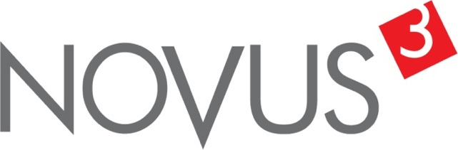

Spatial Feature Report

T: +27 12 364 2546 | E: info@novus3.co.za Postnet Suite 471, Private Bag X15,

Menlo Park, 0102**www.novus3.co.za**

engineered solutions

Disclaimer

This document contains data that was obtained from a live CP3 system at the moment the data was requested. The data is updated by users of the CP3 System and unless the system is locked for changes, this data may change on a daily basis. The reader is therefore cautioned not to place inappropriate reliance on the data unless there is certainty on the status of the data in terms of how recently it has been updated, how “clean” the data is (is there a quality control and/or verification process that was followed by the licensee of the CP3 system to ensure that data is checked and verified from time-to-time) and whether the correct baseline was queried. This report therefore provides a “snapshot in time”. Consequently, the document may be less relevant at a different time, or using a different financial baseline to query from.

At all times, all rights, title and interest in and to this material remains vested in the owner of this document and are copyrighted and protected by regulatory provisions. These materials may not be copied, reproduced, modified, published, uploaded, posted to websites or otherwise distributed in any way, without our prior written permission from the Licensee and Licensor (Nvous3 (Pty) Ltd) of the CP3 Software. The owner of this document does not grant any right to reproduce the materials. All our rights in this regard are and remain reserved.

Table of Contents

**No table of contents entries found.** (Right-click -> Update Field)

Spatial Query Report

This document was created *2022-05-04-16_06* from the **City of Tshwane Metropolitan Municipality** CP3 system.

The baseline **'2021/22 Planning + Rollover (20200901)'** with description: **'Duplicated from the 2020/21 Planning + Final Annexure A (20200625) Baseline'** was used. The spatial feature that was selected for the purpose of this report was: **'City of Tshwane Wards 2020'**.

This is a spatial feature report for the *City of Tshwane Metropolitan Municipality.* The data contained in this report was sourced directly from the municipality's live CP3 system. The information in this report therefore reflects the data as it was on *2022-05-04* when this report was requested. Any subsequent updates to the data contained the CP3 System related to the applicable baseline from which this reports was drawn, would therefore not reflect in this report.   
  
For the *City of Tshwane Metropolitan Municipality, the following spatial features are available for the purpose of developing* 'Spatial Query Reports' (similar to this report):

* City of Tshwane mSCOA Regional Segment
* City of Tshwane Regions
* City of Tshwane Wards 2020
* Specialised Activity Areas
* Strategic Urban Developments (SUD)



We hope you find this useful! Sincerely, *The Novus3 Team.*

# Introduction

The baseline that was queried for this report contains *1470* projects of which a total of *60 (4.08%)* projects do not have any recorded intersection (overlap) with City of Tshwane Wards 2020. The following spatial features are available for queries using this API profile:

* City of Tshwane mSCOA Regional Segment
* City of Tshwane Regions
* City of Tshwane Wards 2020
* Specialised Activity Areas
* Strategic Urban Developments (SUD)

The probable reasons for the 60 non intersecting projects reported are that:

* these projects simply do not have a location associated with them yet (most frequently the case with 'no-intersect' projects) or;
* the location that was captured for some of these projects, may have been in the wrong place (e.g. outside the boundaries of Tshwane - this is very rarely the reason).

It is important to take note of the 4.08% projects that do not intersect with City of Tshwane Wards 2020 feature when appraising this report.

The 4.08% of non-intersecting projects is a relative low percentage and therefore not much cause of concern for this particular report.

Figure 1.1: Intersecting vs Non-Intersecting Projects

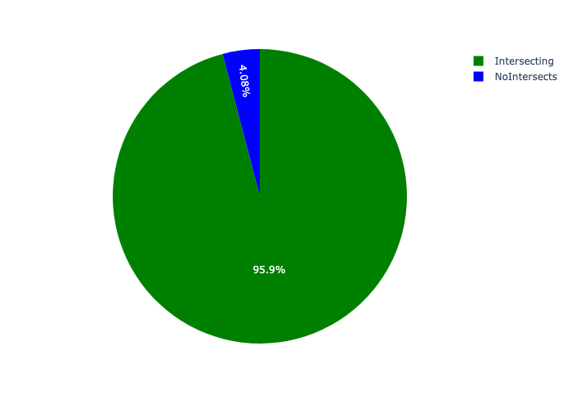

# Total Number of Projects and Total Capital Demand per City of Tshwane Wards 2020 - All Years

Table 2.1 below provides a concise summary of key statistical insights regarding the number of projects that are requesting funding in each of the City of Tshwane Wards 2020.

Table 2.1: City of Tshwane Wards 2020 Analysis - Number of Projects

|  |  |  |  |
| --- | --- | --- | --- |
| Description | Info (1) | Info (2) | Info (3) |
| Number of projects in all City of Tshwane Wards 2020 - Overview | Total in all City of Tshwane Wards 2020: 1410 projects | Average per City of Tshwane Wards 2020: 13.2 projects | 75th percentile of projects across all City of Tshwane Wards 2020: 16.0 projects |
| The highest number of projects | City of Tshwane Wards 2020: In Ward 58 | Number of projects in Ward 58: 83 | Percentage of total in Ward 58: 5.89% |
| The lowest number of projects: | City of Tshwane Wards 2020: In Ward 72 | Number of projects in Ward 72: 2 | Percentage of total in Ward 72: 0.14% |
| The 5 City of Tshwane Wards 2020 that collectively have with the highest number of projects | City of Tshwane Wards 2020: In Ward 105, Ward 96, Ward 3, Ward 50 and Ward 58 | Number of projects in Ward 105, Ward 96, Ward 3, Ward 50 and Ward 58 together: 245 | Percentage of total in Ward 105, Ward 96, Ward 3, Ward 50 and Ward 58 together: 17.38% |

Table 2.1 below provides a concise summary of key statistical insights regarding the total capital demand per City of Tshwane Wards 2020.

Table 2.1: City of Tshwane Wards 2020 Analysis - Capital Demand (R)

|  |  |  |  |
| --- | --- | --- | --- |
| Description | Info (1) | Info (2) | Info (3) |
| Capital demand in all City of Tshwane Wards 2020 - Overview | Total capital demand in all City of Tshwane Wards 2020: R48,877,051,174 | The average capital demand per City of Tshwane Wards 2020: R456,794,871 | The 75th percentile of capital demand for City of Tshwane Wards 2020: R535,756,262 |
| The highest capital demand | City of Tshwane Wards 2020: In Ward 96 | Capital Demand in Ward 96: R4,848,741,819 | Percentage of total in Ward 96: 9.92% |
| The lowest capital demand | City of Tshwane Wards 2020: In Ward 84 | Capital Demand in Ward 84: R129,083 | Percentage of total in Ward 84: 0.00% |
| The 5 City of Tshwane Wards 2020 that collectively have collective the highest capital demand: | City of Tshwane Wards 2020: In Ward 50, Ward 105, Ward 100, Ward 58 and Ward 96 | Capital Demand in Ward 50, Ward 105, Ward 100, Ward 58 and Ward 96 together: R13,732,335,514 | Percentage of total in Ward 50, Ward 105, Ward 100, Ward 58 and Ward 96 together: 28.10% |

The number of projects per City of Tshwane Wards 2020 and the capital demand per City of Tshwane Wards 2020 needs to be looked at together for better insight. Figures 2.1 and 2.2 assist with further graphical insight into some of the numbers that are provided in Tables 2.1 and 2.2.

Figure 2.1: The single City of Tshwane Wards 2020 with the highest value (Nr of Projects & Capital Demand) vs the rest

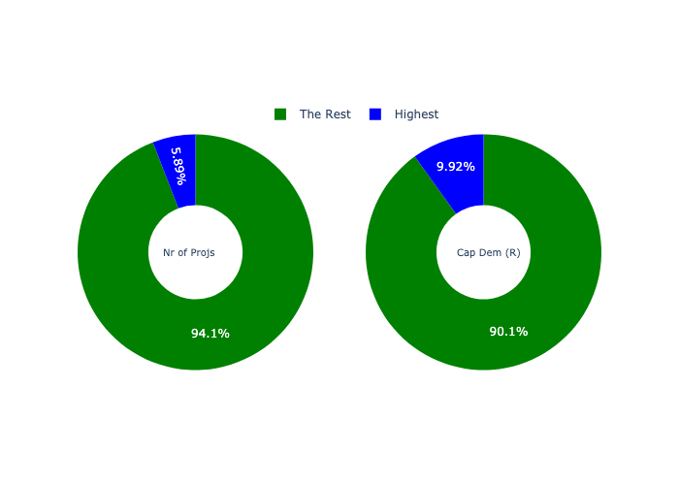

The highest number of projects in a single City of Tshwane Wards 2020 is in **Ward 58.** *That is 83 projects and this is 5.89% of the total number of projects.*The highest capital demand in a single City of Tshwane Wards 2020 is in **Ward 96.** *That is R4,848,741,819 and this amounts to 9.92% of the total capital demand.*

Figure 2.2: The 5 City of Tshwane Wards 2020 with the highest values (Nr of Projects & Capital Demand) vs the rest

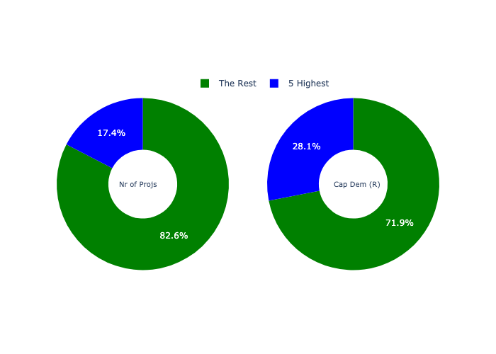

The 5 City of Tshwane Wards 2020 that collectively have with the highest number of projects are in **Ward 105, Ward 96, Ward 3, Ward 50 and Ward 58.** *That is 245 projects and this is 17.38% of the total number of projects.*The 5 City of Tshwane Wards 2020 that collectively have the highest capital demand are in **Ward 50, Ward 105, Ward 100, Ward 58 and Ward 96.** *That is 28.10% and this amounts to R13,732,335,514 of the total capital demand.*

The following figures provide a bar graph representation of the number of projects per City of Tshwane Wards 2020 with the colour of the bars representing the level of capital demand in each of these City of Tshwane Wards 2020.

Figure 2.3.1: Projects and Capital Demand per City of Tshwane Wards 2020 (1/3)

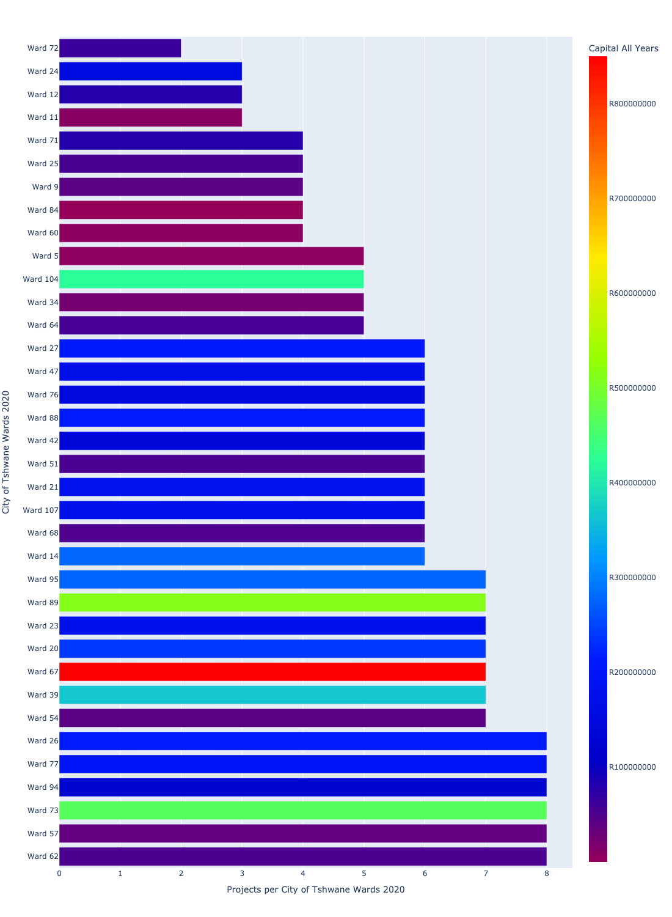

Figure 2.3.2: Projects and Capital Demand per City of Tshwane Wards 2020 (2/3)

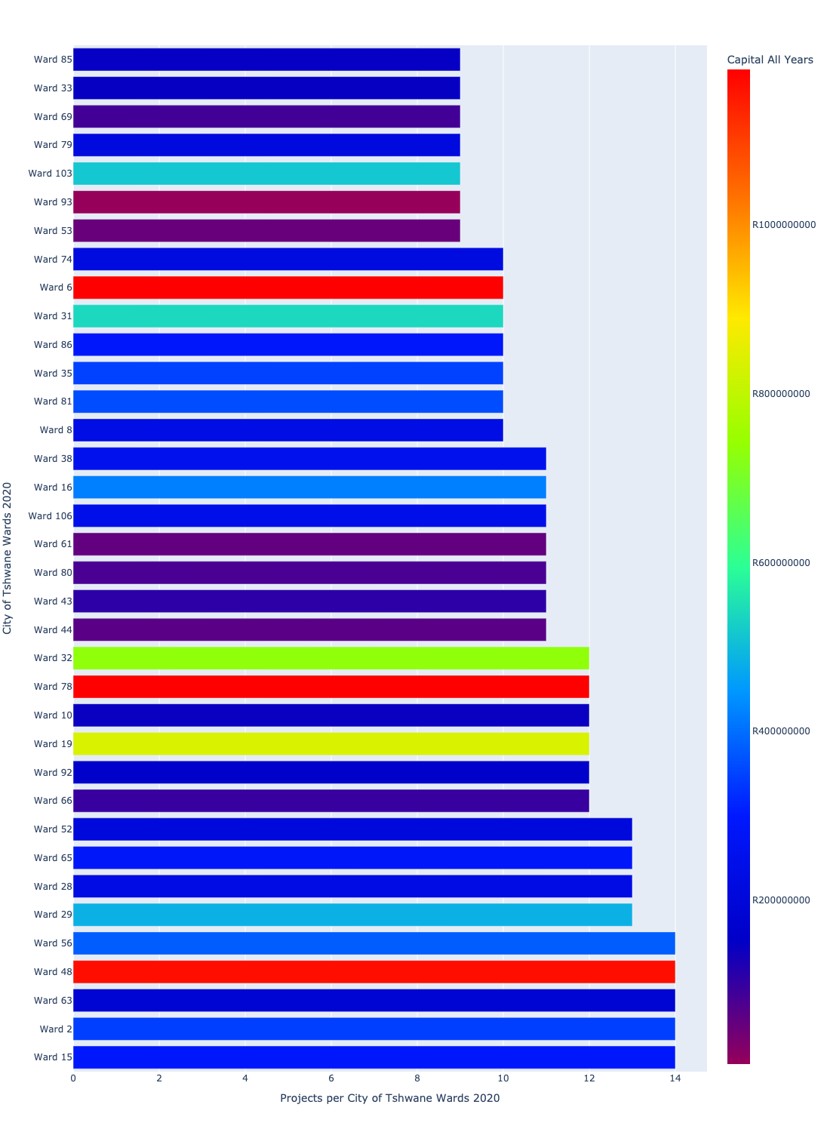

Figure 2.3.3: Projects and Capital Demand per City of Tshwane Wards 2020 (3/3)

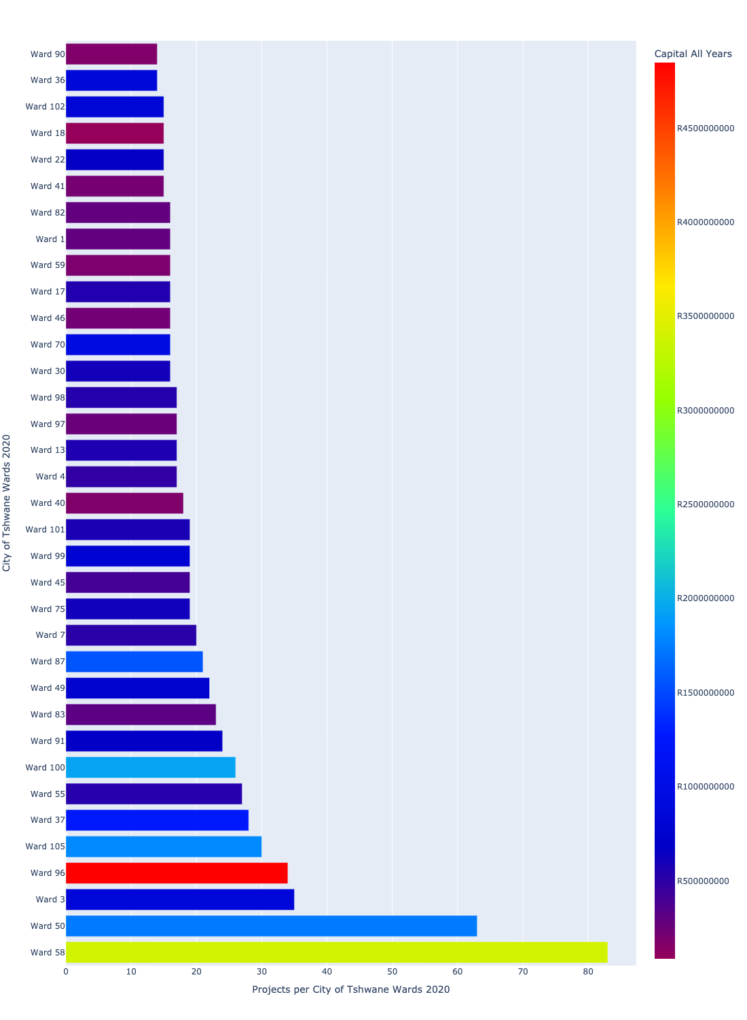

# Total Capital Demand per City of Tshwane Wards 2020 - All Years

There are different funding sources from which capital is requested. For the financial baseline that was selected for this report query (2021/22 Planning + Rollover (20200901)), the breakdown of capital demand for City of Tshwane Metropolitan Municipality per funding source is shown in Figure 3.1 below.

Figure 3.1: Capital Demand Per Funding Source

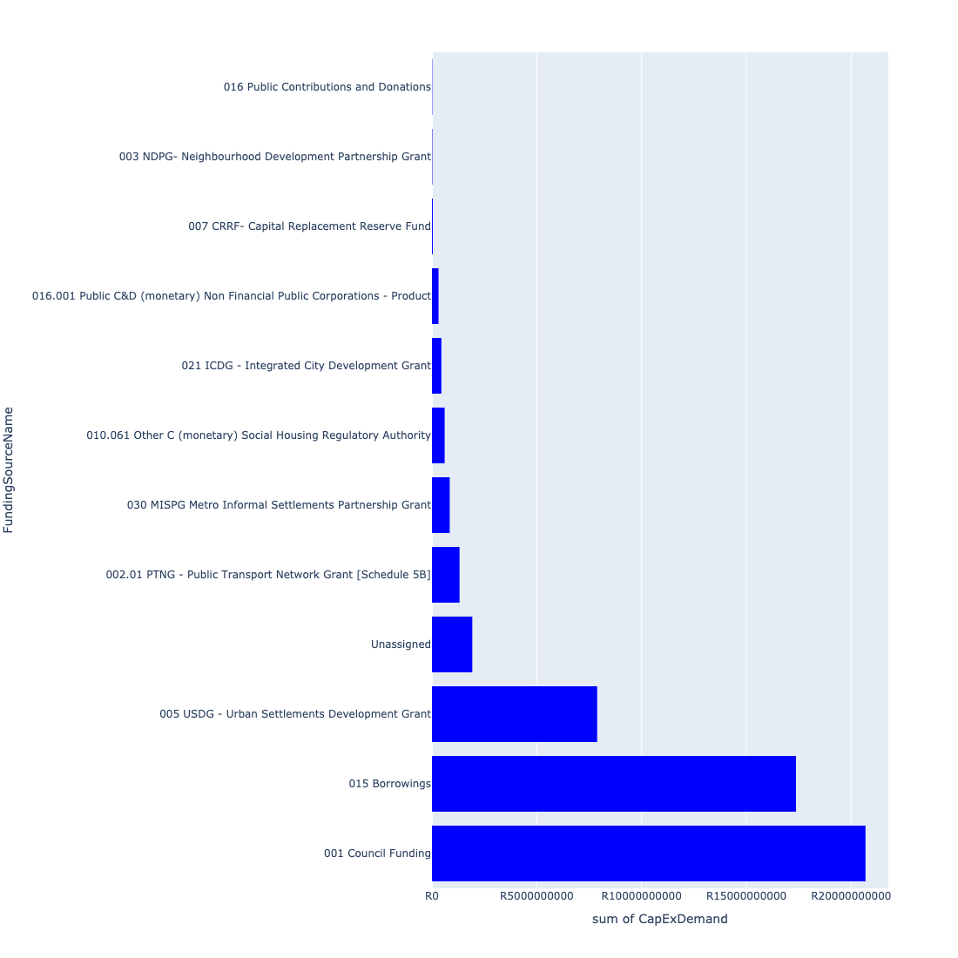

For the financial baseline that was selected for this report query (2021/22 Planning + Rollover (20200901)), the breakdown of capital demand for City of Tshwane Metropolitan Municipality per department is shown in Figure 3.2 below.

Figure 3.2: Capital Demand Per City of Tshwane Metropolitan Municipality Department

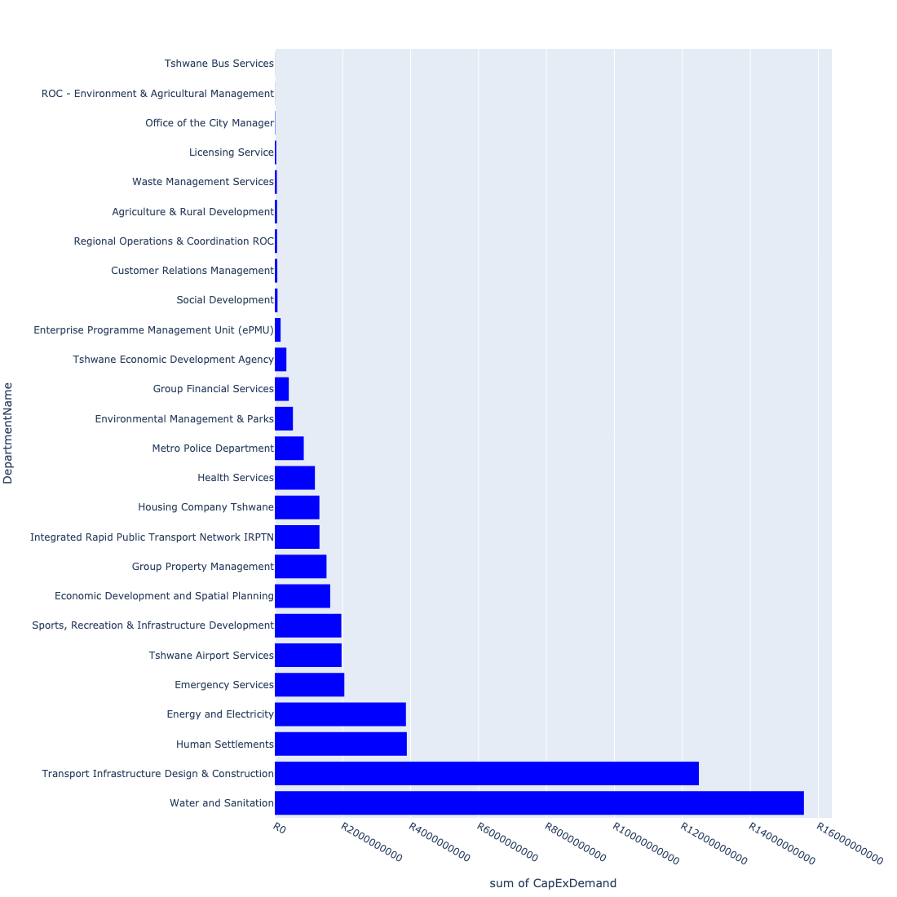

The following figures provide a histogram representation of the capital demand per City of Tshwane Wards 2020. A colour breakdown is provided of each year's sub-total that contribute towards the overall total capital demand of each City of Tshwane Wards 2020. Note that the capital demand beyond the first three years representing the Medium Term Expenditure Framework (MTREF - years 2022, 2023 and 2024) are generally more sparsely and less diligently populated, therefore less reliance should be vested on these outer years when appraising the overall capital demand. The reason for this is usually because of National Treasury's requirement for annual budget submissions spanning only over the MTREF (i.e. the next three years).

Figure 3.3.1: Capital Demand per City of Tshwane Wards 2020 - All Years (1/3)

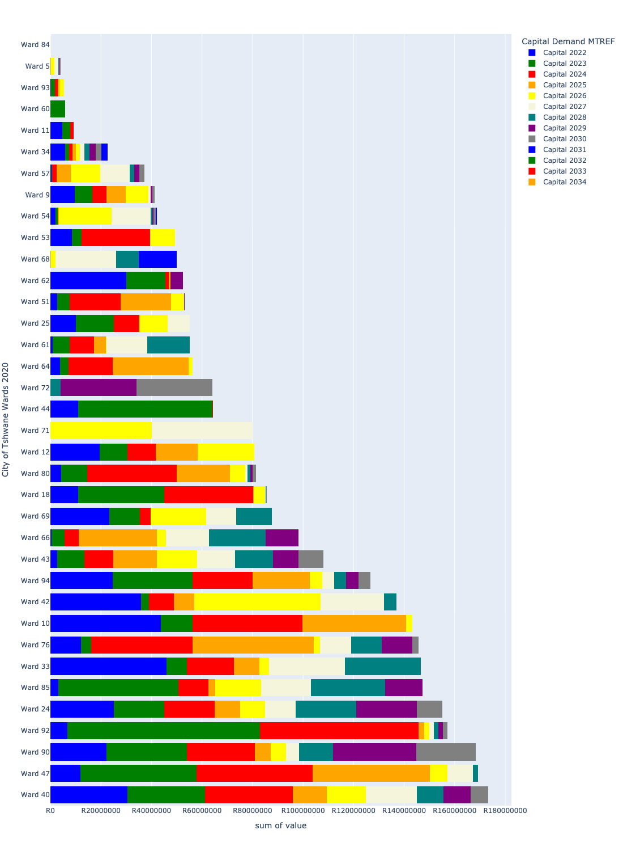

Figure 3.3.2: Capital Demand per City of Tshwane Wards 2020 - All Years (2/3)

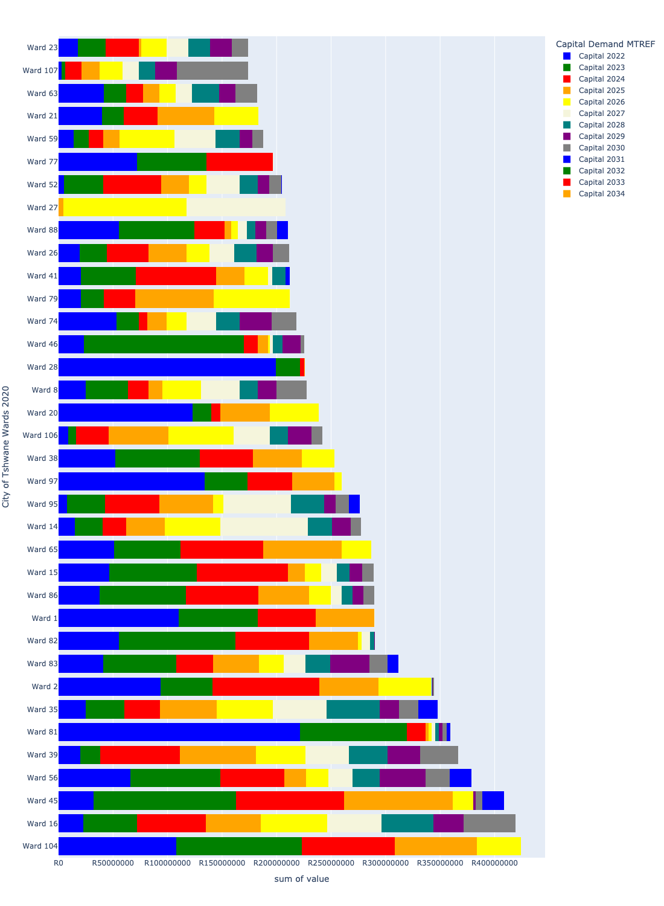

Figure 3.3.3: Capital Demand per City of Tshwane Wards 2020 - All Years (3/3)

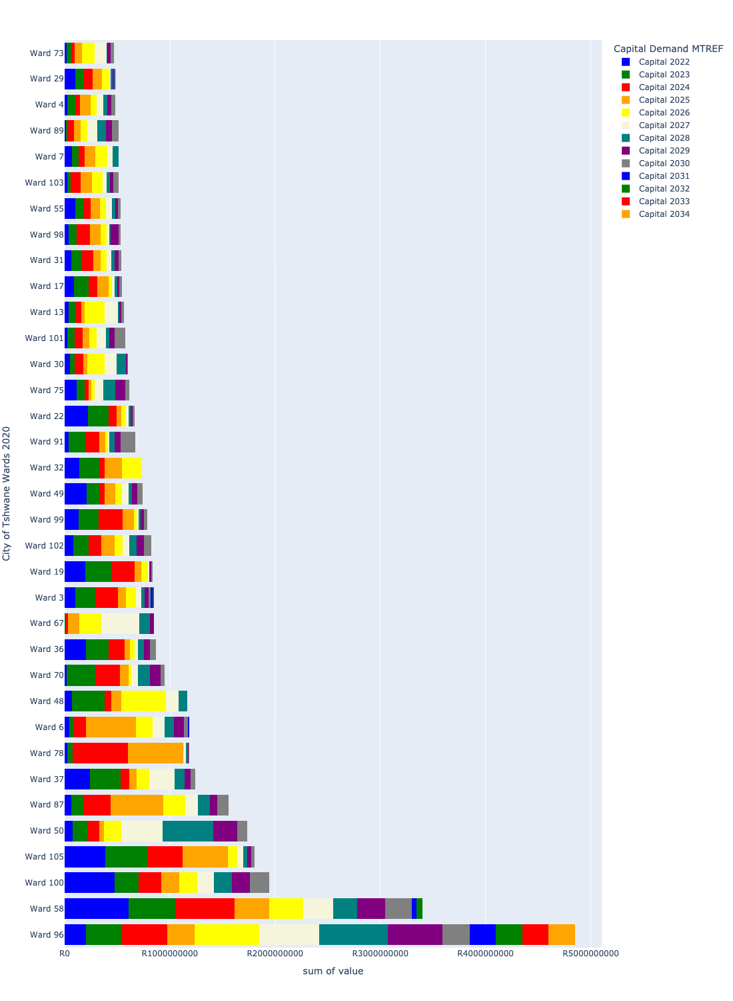

# Total Capital Demand per City of Tshwane Wards 2020 - MTREF only

Table 4.1 below provides a concise summary of key statistical insights regarding the total MTREF capital demand per City of Tshwane Wards 2020.

Table 4.1: City of Tshwane Wards 2020 Analysis - MTREF Capital Demand (R)

|  |  |  |  |
| --- | --- | --- | --- |
| Description | Info (1) | Info (2) | Info (3) |
| MTREF Capital demand in all City of Tshwane Wards 2020 - Overview | MTREF capital demand in all City of Tshwane Wards 2020: R21,480,882,812 | The average MTREF capital demand per City of Tshwane Wards 2020: R200,755,914 | The 75th percentile of MTREF capital demand for City of Tshwane Wards 2020: R241,084,347 |
| The highest MTREF capital demand | In City of Tshwane Wards 2020: Ward 58 | MTREF capital Demand in Ward 58: R1,612,749,354 | Percentage of total MRTEF capital demand in Ward 58: 7.51% |
| The lowest MTREF capital demand | In City of Tshwane Wards 2020: Ward 5 | MTREF capital Demand in Ward 5: R0 | Percentage of total MTREF capital demand in Ward 5: 0.00% |

The following figures provide a histogram representation of the capital demand per City of Tshwane Wards 2020. A colour breakdown is provided of each year's sub-total that contribute towards the overall MTREF total capital demand of each City of Tshwane Wards 2020.

Figure 4.1.1: Capital Demand per City of Tshwane Wards 2020 - MTREF Period (1/3)

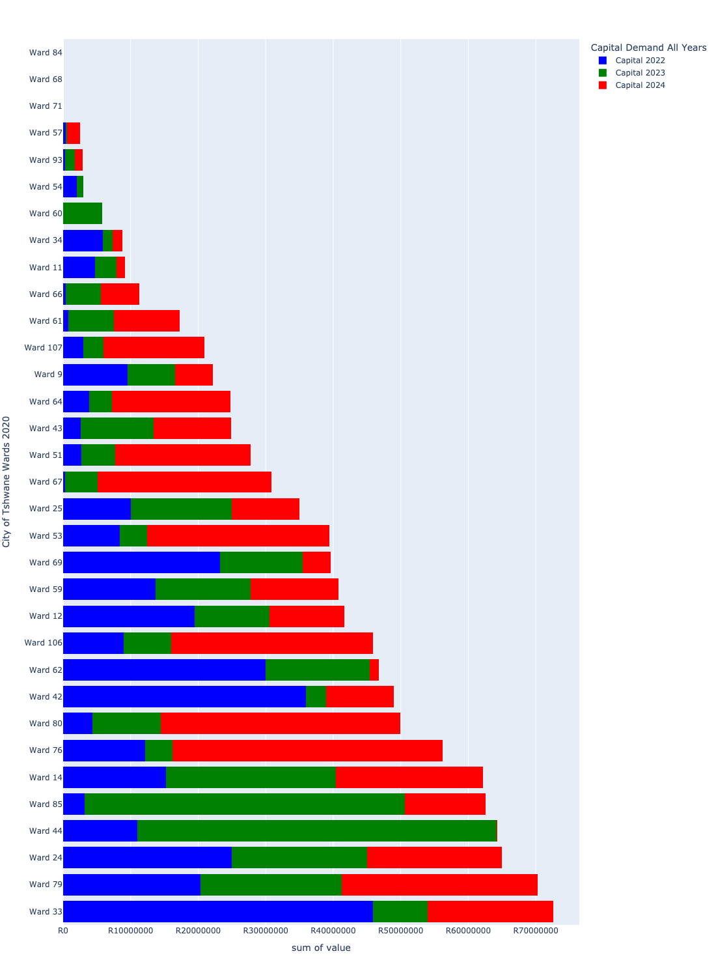

Figure 4.1.2: Capital Demand per City of Tshwane Wards 2020 - MTREF Period (2/3)

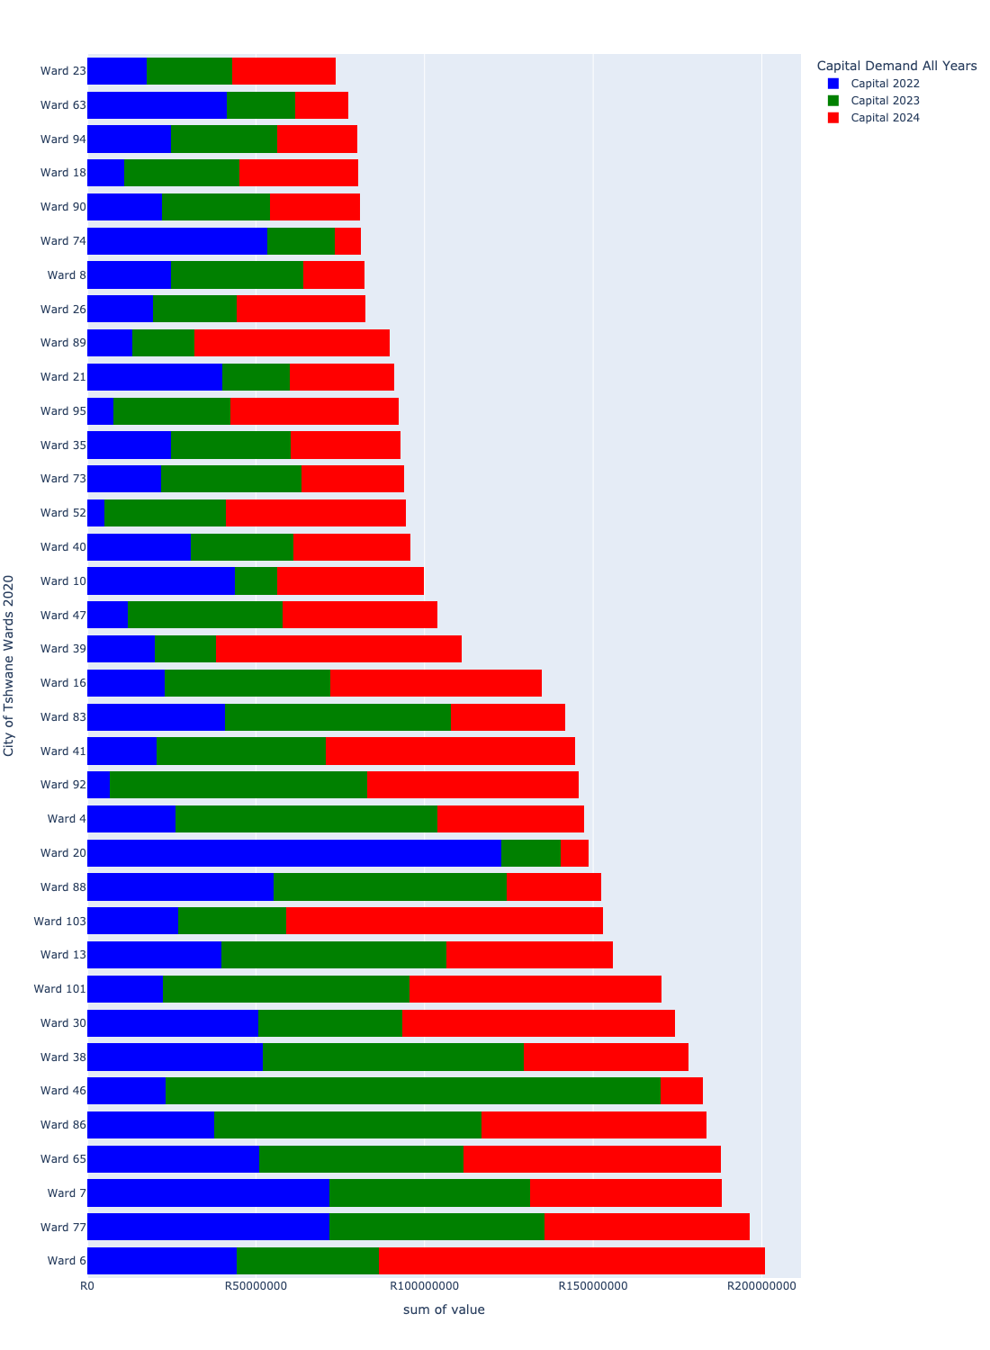

Figure 4.1.3: Capital Demand per City of Tshwane Wards 2020 - MTREF Period (3/3)

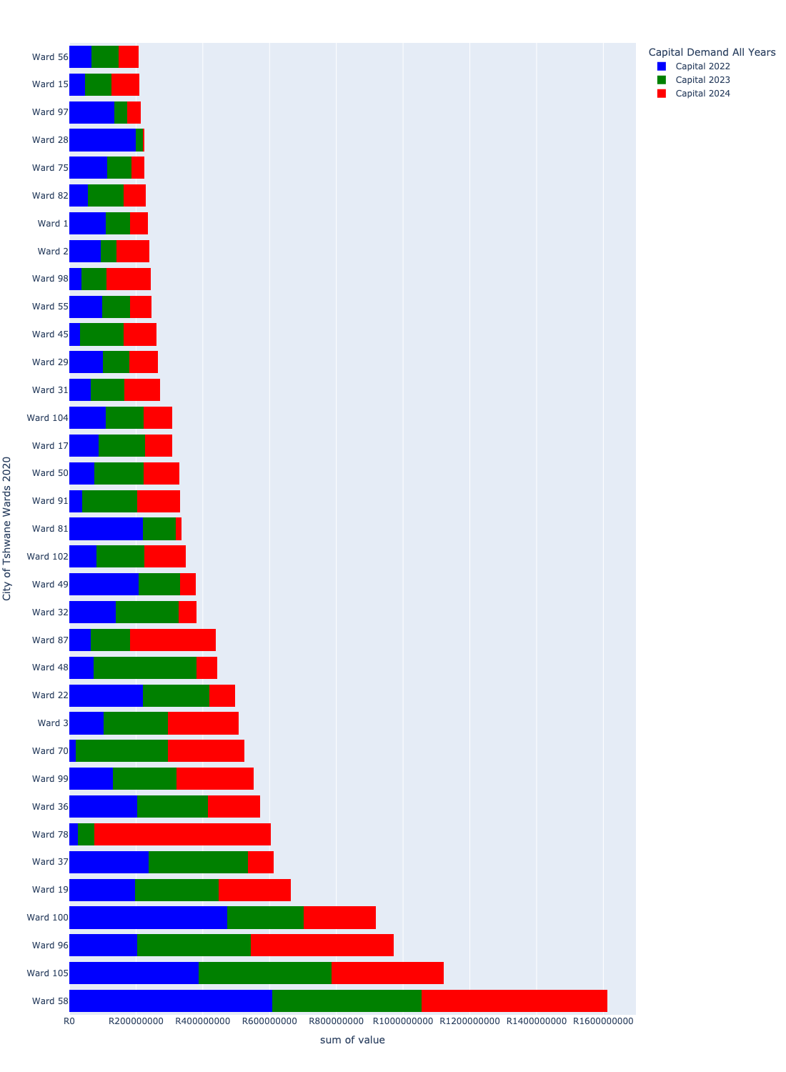

# Summary per City of Tshwane Wards 2020

## Ward 1

Figure 5.1: Ward 1 Funding Requests

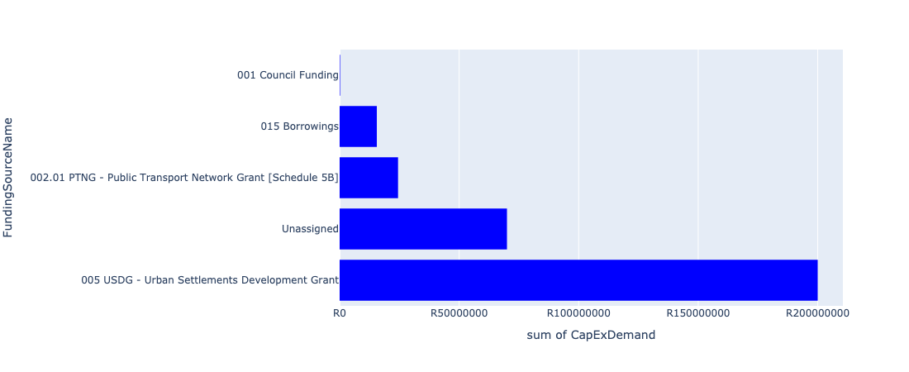

Figure 5.2: Ward 1 Departmental Requests

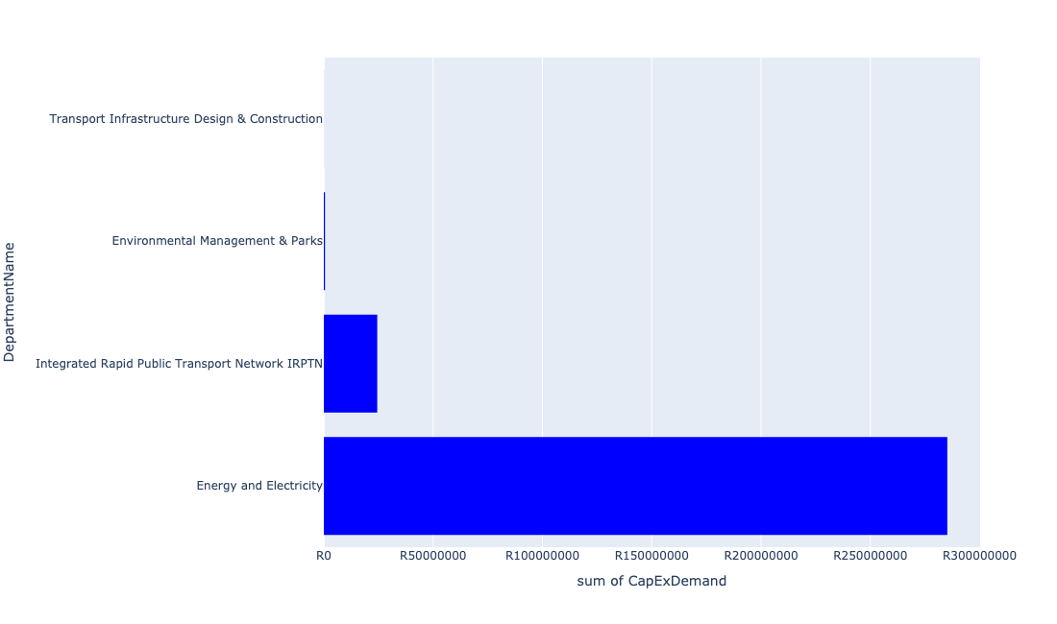

Table 5.1: Summary - Ward 1

|  |  |
| --- | --- |
| Item | Description |
| Total Capital Demand for Ward 1 - All Years | R290,194,308 Rank: 46 (1 = Highest) |
| Total Capital Demand for Ward 1 - MTREF | R236,117,933 Rank: 29 (1 = Highest) |
| Financial Years in which capital requirements are listed for Ward 1 | 2022, 2023, 2024, 2025, 2026, 2027, 2028, 2029, 2030 and 2031 |
| Financial Year with highest capital demand for Ward 1 | 2022 |
| Ward 1 intersecting feature used | Works Location |
| Total number of projects intersecting with Ward 1 | 16 Rank: 26 (1 = Highest) |

Table 5.2: All projects asking for budget in Ward 1

|  |  |  |  |
| --- | --- | --- | --- |
| Project ID | Project Name | Department | Project Budget |
| 712967744 | (712591) Design, Supply, Installation, Commissioning and Operational Support Of Advanced Public Transport Management System (APTMS) | Integrated Rapid Public Transport Network IRPTN | R621,109 (0.21%) Budget spread across: 2022 |
| 712971915 | Revitalisation of the City-Development of Non-Motorised Transport Masterplan | Transport Infrastructure Design & Construction | R34,961 (0.01%) Budget spread across: 2027 |
| 712967745 | (712591) Planning and Design of BRT Projects | Integrated Rapid Public Transport Network IRPTN | R21,678,940 (7.47%) Budget spread across: 2022, 2023, 2024 and 2025 |
| 712975456 | Upgrade of infrastructure of Magalies mountain | Environmental Management & Parks | R525,909 (0.18%) Budget spread across: 2022, 2023, 2024, 2025, 2026, 2027, 2028, 2029, 2030 and 2031 |
| 712974551 | (711706) Network Control System Extension | Energy and Electricity | R50,000,000 (17.23%) Budget spread across: 2022 and 2023 |
| 712974536 | (712872) Electricity Building Extension | Energy and Electricity | R20,000,000 (6.89%) Budget spread across: 2022 |
| 712974208 | (712872) Network Control Centre Reconfiguration | Energy and Electricity | R15,000,000 (5.17%) Budget spread across: 2022 |
| 712967498 | (712591) BRT Rationalization Infrastructure (Mixed Traffic Operations) | Integrated Rapid Public Transport Network IRPTN | R1,829,696 (0.63%) Budget spread across: 2022 |
| 712967094 | (713008) Construction of the Centralised Engineering Support centre Services. | Energy and Electricity | R200,000,000 (68.92%) Budget spread across: 2022, 2023, 2024 and 2025 |
| 712967091 | (713010) Infrastructure Fault Reporting and Dispatch (New) | Energy and Electricity | R200,000 (0.07%) Budget spread across: 2022 and 2023 |
| 712969042 | (712591) Capital Park Railway Bridges (Line 1A - WP6) | Integrated Rapid Public Transport Network IRPTN | R303,691 (0.10%) Budget spread across: 2022 |

## Ward 2

Figure 5.3: Ward 2 Funding Requests

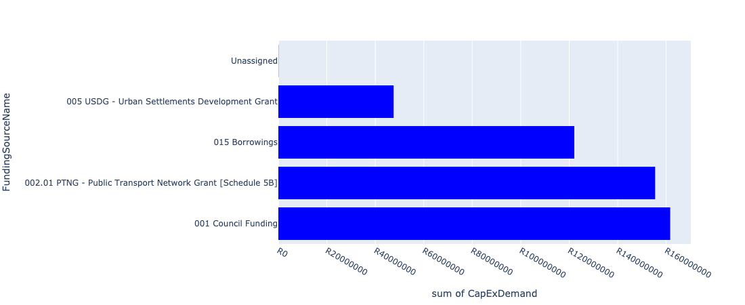

Figure 5.4: Ward 2 Departmental Requests

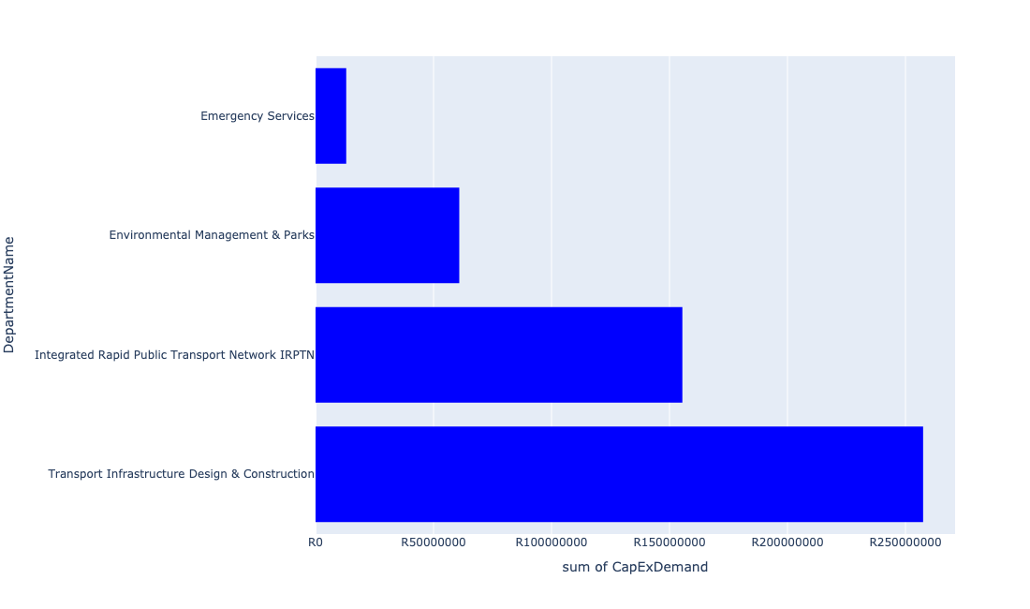

Table 5.2: Summary - Ward 2

|  |  |
| --- | --- |
| Item | Description |
| Total Capital Demand for Ward 2 - All Years | R344,582,719 Rank: 43 (1 = Highest) |
| Total Capital Demand for Ward 2 - MTREF | R239,001,072 Rank: 28 (1 = Highest) |
| Financial Years in which capital requirements are listed for Ward 2 | 2022, 2023, 2024, 2025, 2026, 2027, 2028, 2029, 2030 and 2031 |
| Financial Year with highest capital demand for Ward 2 | 2024 |
| Ward 2 intersecting feature used | Works Location |
| Total number of projects intersecting with Ward 2 | 14 Rank: 37 (1 = Highest) |

Table 5.3: All projects asking for budget in Ward 2

|  |  |  |  |
| --- | --- | --- | --- |
| Project ID | Project Name | Department | Project Budget |
| 712971915 | Revitalisation of the City-Development of Non-Motorised Transport Masterplan | Transport Infrastructure Design & Construction | R35,194 (0.01%) Budget spread across: 2027 |
| 712975456 | Upgrade of infrastructure of Magalies mountain | Environmental Management & Parks | R3,704,190 (1.07%) Budget spread across: 2022, 2023, 2024, 2025, 2026, 2027, 2028, 2029, 2030 and 2031 |
| 1342 | (712920) Rainbow Junction and Rehabilitation of the Apies River | Transport Infrastructure Design & Construction | R256,757,229 (74.51%) Budget spread across: 2022, 2023, 2024, 2025 and 2026 |
| 585 | (710902) Rehabilitation Of Roads | Transport Infrastructure Design & Construction | R683,741 (0.20%) Budget spread across: 2022, 2023, 2024, 2025, 2026, 2027, 2028, 2029 and 2030 |
| 712974886 | (712591) Line 1B (Wonderboom - Akasia) | Integrated Rapid Public Transport Network IRPTN | R10,000,000 (2.90%) Budget spread across: 2022 |
| 712974274 | (712591) Wonderboom Intermodal Facility (Hector Pieterson Station) | Integrated Rapid Public Transport Network IRPTN | R145,450,000 (42.21%) Budget spread across: 2022 |
| 178 | (713083) Urban Regeneration of Wonderboom Emergency Services Station | Emergency Services | R13,000,000 (3.77%) Budget spread across: 2022 |
| 712970703 | (713044) Tshwane North Cemetery | Environmental Management & Parks | R57,200,000 (16.60%) Budget spread across: 2022, 2024 and 2025 |

## Ward 3

Figure 5.5: Ward 3 Funding Requests

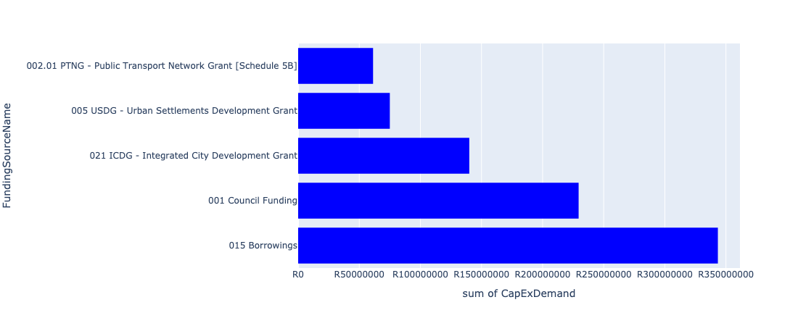

Figure 5.6: Ward 3 Departmental Requests

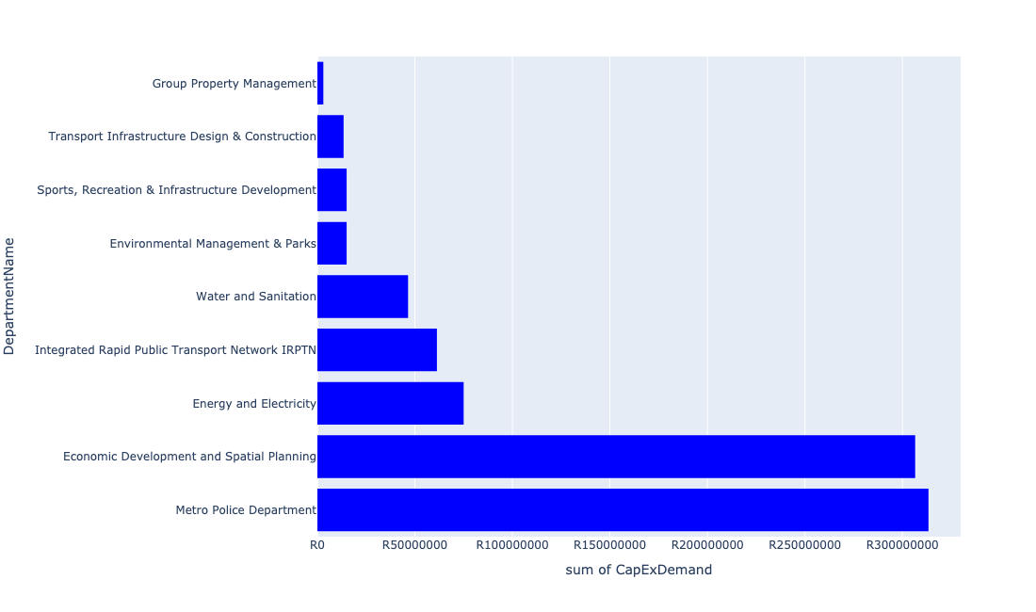

Table 5.3: Summary - Ward 3

|  |  |
| --- | --- |
| Item | Description |
| Total Capital Demand for Ward 3 - All Years | R849,140,834 Rank: 14 (1 = Highest) |
| Total Capital Demand for Ward 3 - MTREF | R507,293,505 Rank: 11 (1 = Highest) |
| Financial Years in which capital requirements are listed for Ward 3 | 2022, 2023, 2024, 2025, 2026, 2027, 2028, 2029, 2030, 2031 and 2032 |
| Financial Year with highest capital demand for Ward 3 | 2024 |
| Ward 3 intersecting feature used | Works Location |
| Total number of projects intersecting with Ward 3 | 35 Rank: 3 (1 = Highest) |

Table 5.4: All projects asking for budget in Ward 3

|  |  |  |  |
| --- | --- | --- | --- |
| Project ID | Project Name | Department | Project Budget |
| 712975520 | Upgrading of ripening center | Economic Development and Spatial Planning | R43,257,573 (5.09%) Budget spread across: 2022, 2023, 2024, 2025, 2026, 2027, 2028, 2029, 2030, 2031 and 2032 |
| 712975443 | Supply and installation of generators for Tshwane Market | Economic Development and Spatial Planning | R5,950,002 (0.70%) Budget spread across: 2022, 2023, 2024, 2025, 2026, 2027, 2028, 2029, 2030, 2031 and 2032 |
| 712975019 | Decongestion of the inner city- Provisioning of New off street holding facilities within the inner city – CBD as per the 04 identified sites | Transport Infrastructure Design & Construction | R13,389,119 (1.58%) Budget spread across: 2022, 2023, 2024, 2025, 2026, 2027, 2028, 2029 and 2030 |
| 712974352 | (712591) Line 3: CBD to Atteridgeville - Section 1 (CBD - Pretoria West) | Integrated Rapid Public Transport Network IRPTN | R4,225,401 (0.50%) Budget spread across: 2022 |
| 712972958 | (712827) Specialised Vehicles | Economic Development and Spatial Planning | R20,073,228 (2.36%) Budget spread across: 2022, 2023, 2024, 2025, 2026, 2027, 2029, 2030, 2031 and 2032 |
| 712972946 | (712591) Wonderboom Intermodal Facility (Building Works) | Integrated Rapid Public Transport Network IRPTN | R52,656,598 (6.20%) Budget spread across: 2022 |
| 712971915 | Revitalisation of the City-Development of Non-Motorised Transport Masterplan | Transport Infrastructure Design & Construction | R42,322 (0.00%) Budget spread across: 2027 |
| 712974353 | (712591) Line 3: CBD to Atteridgeville - Section 2 (Pretoria West - Atteridgeville) | Integrated Rapid Public Transport Network IRPTN | R4,406,591 (0.52%) Budget spread across: 2022 |
| 712975527 | Design ,Supply and install market surveillance system | Economic Development and Spatial Planning | R4,700,000 (0.55%) Budget spread across: 2022, 2023, 2024, 2025, 2026, 2027, 2028, 2029, 2030, 2031 and 2032 |
| 712975517 | Installation of high mast lights | Economic Development and Spatial Planning | R10,650,000 (1.25%) Budget spread across: 2022, 2023, 2024, 2025, 2026, 2027, 2028, 2029, 2030, 2031 and 2032 |
| 712975510 | Upgrading of perforated roller doors at Tshwane market | Economic Development and Spatial Planning | R2,990,000 (0.35%) Budget spread across: 2022, 2023, 2024, 2025, 2026, 2027, 2028, 2029, 2030, 2031 and 2032 |
| 712975408 | Upgrading of market Halls roofs | Economic Development and Spatial Planning | R78,900,000 (9.29%) Budget spread across: 2022, 2023, 2024, 2025, 2026, 2027, 2028, 2029, 2030, 2031 and 2032 |
| 712975390 | (712279) Tunnel 132/11kV Substation | Energy and Electricity | R75,000,000 (8.83%) Budget spread across: 2025, 2026 and 2027 |
| 712975289 | Upgrade elevator metro police HQ | Group Property Management | R1,400,000 (0.16%) Budget spread across: 2025 |
| 712975278 | 712967311_01 Upgrade dock levellers at Tshwane Fresh Produce Market Banana Ripening plant | Group Property Management | R1,650,000 (0.19%) Budget spread across: 2022 |
| 712975150 | (71212WS)Witkoppies Spruit Bulk Sewer | Water and Sanitation | R45,000,000 (5.30%) Budget spread across: 2023, 2024, 2026 and 2027 |
| 712975077 | (712121NK) New Kwaggasrand flow diversion and Outfall Sewer | Water and Sanitation | R1,500,000 (0.18%) Budget spread across: 2023 and 2024 |
| 712975003 | Security and visitor infrastructure Upgrades for Kwaggaspruit Resort | Environmental Management & Parks | R15,000,000 (1.77%) Budget spread across: 2022, 2023 and 2024 |
| 712974825 | (713023) Inner City Regeneration - CBD areas | Economic Development and Spatial Planning | R140,000,000 (16.49%) Budget spread across: 2022, 2023, 2024, 2025, 2026, 2027, 2028 and 2029 |
| 712967121 | (712878) Upgrading of Pilditch Stadium - cycle track | Sports, Recreation & Infrastructure Development | R15,000,000 (1.77%) Budget spread across: 2026 |
| 712967075 | Establishment of a TMPD Command and Communication Centre (C3) | Metro Police Department | R313,000,000 (36.86%) Budget spread across: 2022, 2023, 2024 and 2025 |
| 712974129 | (712500) Postal Franking Machine | Metro Police Department | R350,000 (0.04%) Budget spread across: 2022 |

## Ward 4

Figure 5.7: Ward 4 Funding Requests

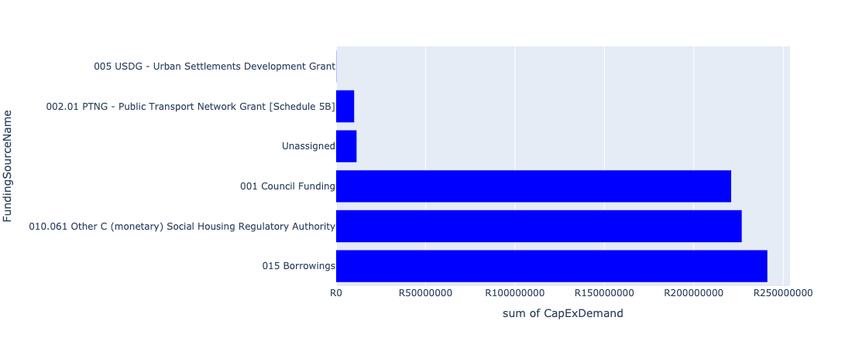

Figure 5.8: Ward 4 Departmental Requests

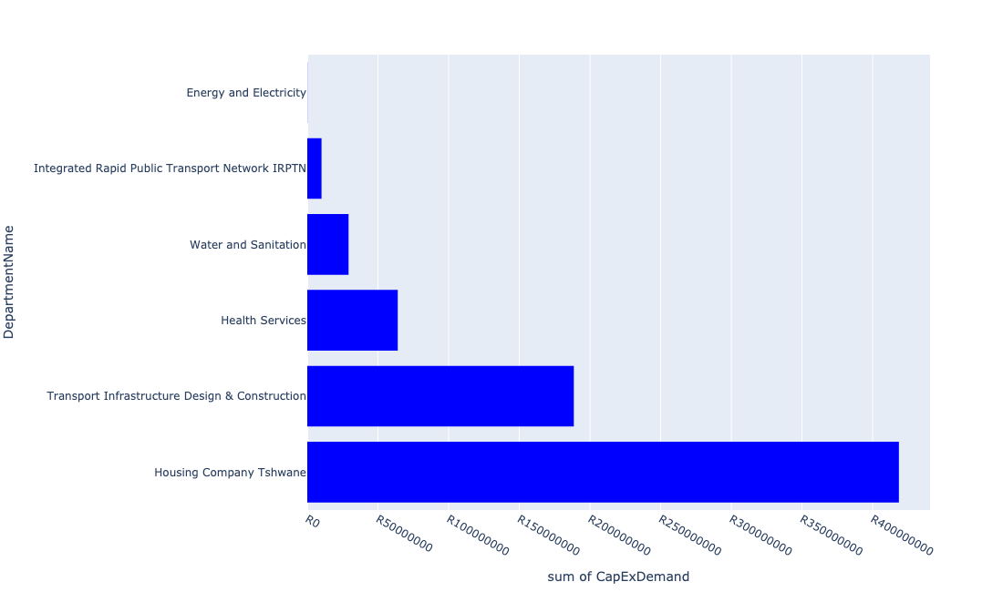

Table 5.4: Summary - Ward 4

|  |  |
| --- | --- |
| Item | Description |
| Total Capital Demand for Ward 4 - All Years | R483,667,168 Rank: 33 (1 = Highest) |
| Total Capital Demand for Ward 4 - MTREF | R147,397,732 Rank: 49 (1 = Highest) |
| Financial Years in which capital requirements are listed for Ward 4 | 2022, 2023, 2024, 2025, 2026, 2027, 2028, 2029 and 2030 |
| Financial Year with highest capital demand for Ward 4 | 2025 |
| Ward 4 intersecting feature used | Works Location |
| Total number of projects intersecting with Ward 4 | 17 Rank: 20 (1 = Highest) |

Table 5.5: All projects asking for budget in Ward 4

|  |  |  |  |
| --- | --- | --- | --- |
| Project ID | Project Name | Department | Project Budget |
| 712971915 | Revitalisation of the City-Development of Non-Motorised Transport Masterplan | Transport Infrastructure Design & Construction | R80,139 (0.02%) Budget spread across: 2027 |
| 712974118 | (712279) Rama City 132kV power line | Energy and Electricity | R118,085 (0.02%) Budget spread across: 2023, 2024 and 2025 |
| 712974191 | Upgrading of the bridge in Longmore Road a Tributary of the sand River, The Orchards | Transport Infrastructure Design & Construction | R43,327,385 (8.96%) Budget spread across: 2026, 2027, 2028, 2029 and 2030 |
| 712967745 | (712591) Planning and Design of BRT Projects | Integrated Rapid Public Transport Network IRPTN | R10,069,016 (2.08%) Budget spread across: 2022, 2023, 2024 and 2025 |
| 585 | (710902) Rehabilitation Of Roads | Transport Infrastructure Design & Construction | R99,882,034 (20.65%) Budget spread across: 2022, 2023, 2024, 2025, 2026, 2027, 2028, 2029 and 2030 |
| 712973710 | Construction of a ±900m stormwater system in Karenpark (Akasia SMP - Network 3A) 4 | Transport Infrastructure Design & Construction | R19,270,579 (3.98%) Budget spread across: 2027, 2028, 2029 and 2030 |
| 712975143 | (712121NO) New Orchards X41 Outfall Sewer | Water and Sanitation | R9,600,000 (1.98%) Budget spread across: 2027, 2028 and 2029 |
| 712975093 | (710411Y_ NR) New Roodepoort PS | Water and Sanitation | R10,000,000 (2.07%) Budget spread across: 2023, 2024 and 2025 |
| 712975086 | (712121NTO) New The Orchards X43B Outfall Sewer | Water and Sanitation | R9,600,000 (1.98%) Budget spread across: 2027, 2028 and 2029 |
| 712974553 | Construction of The Orchards flood attenuation structure in the Kaalplaas Spruit, The Orchards | Transport Infrastructure Design & Construction | R26,000,000 (5.38%) Budget spread across: 2025, 2026 and 2027 |
| 712973731 | Extension of Karen Park Clinic | Health Services | R64,000,000 (13.23%) Budget spread across: 2025, 2026, 2027 and 2028 |
| 712972967 | Chantelle x39 construction of 600 social housing units | Housing Company Tshwane | R418,546,410 (86.54%) Budget spread across: 2022, 2023, 2024 and 2025 |

## Ward 5

Figure 5.9: Ward 5 Funding Requests

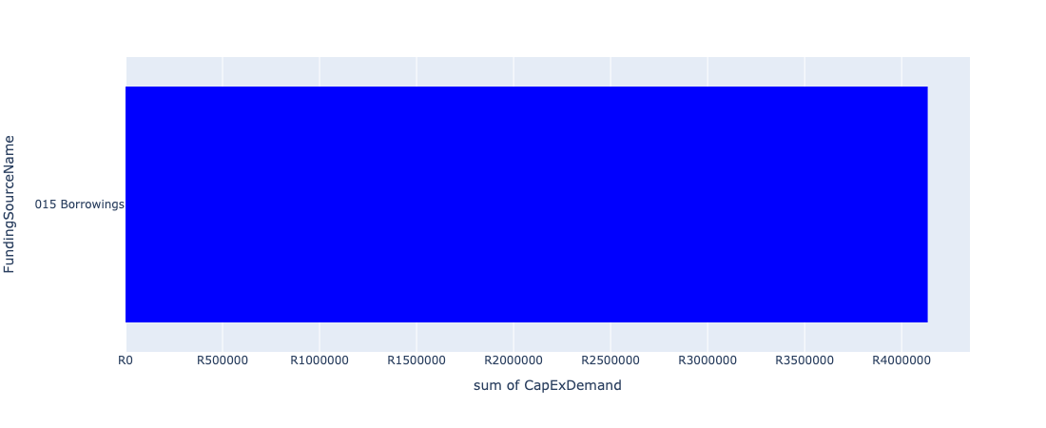

Figure 5.10: Ward 5 Departmental Requests

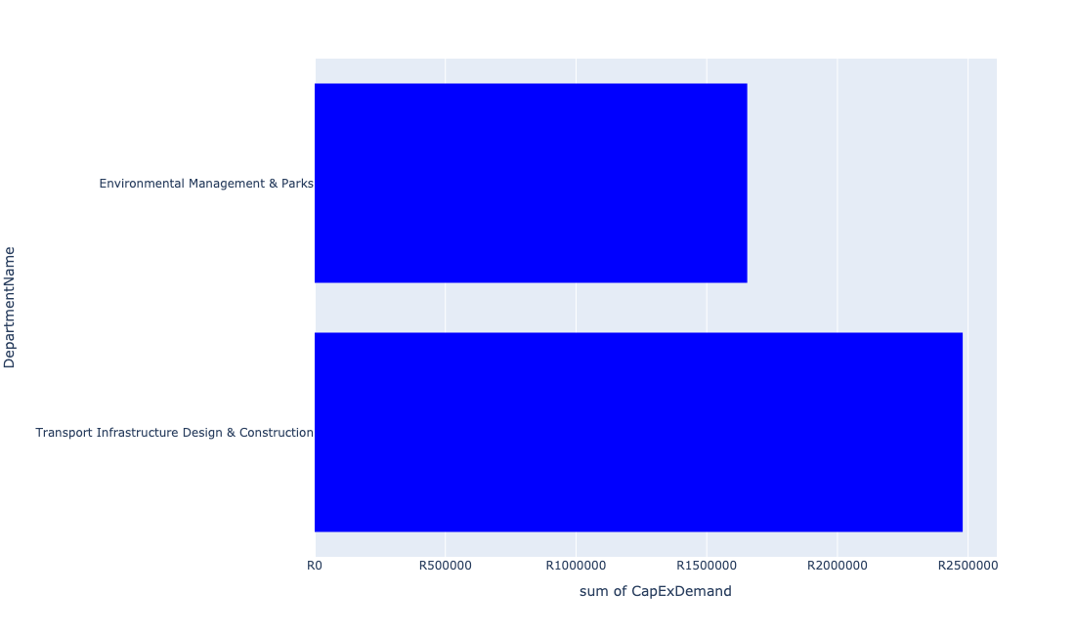

Table 5.5: Summary - Ward 5

|  |  |
| --- | --- |
| Item | Description |
| Total Capital Demand for Ward 5 - All Years | R4,134,215 Rank: 106 (1 = Highest) |
| Total Capital Demand for Ward 5 - MTREF | R0 Rank: 106 (1 = Highest) |
| Financial Years in which capital requirements are listed for Ward 5 | 2025, 2026, 2027, 2028, 2029, 2030 and 2031 |
| Financial Year with highest capital demand for Ward 5 | 2027 |
| Ward 5 intersecting feature used | Works Location |
| Total number of projects intersecting with Ward 5 | 5 Rank: 96 (1 = Highest) |

Table 5.6: All projects asking for budget in Ward 5

|  |  |  |  |
| --- | --- | --- | --- |
| Project ID | Project Name | Department | Project Budget |
| 712971915 | Revitalisation of the City-Development of Non-Motorised Transport Masterplan | Transport Infrastructure Design & Construction | R30,475 (0.74%) Budget spread across: 2027 |
| 712975456 | Upgrade of infrastructure of Magalies mountain | Environmental Management & Parks | R1,654,948 (40.03%) Budget spread across: 2022, 2023, 2024, 2025, 2026, 2027, 2028, 2029, 2030 and 2031 |
| 712974173 | Major Stormwater Network 3B in Veronica Street, Montana | Transport Infrastructure Design & Construction | R2,448,792 (59.23%) Budget spread across: 2026 and 2027 |

## Ward 6

Figure 5.11: Ward 6 Funding Requests

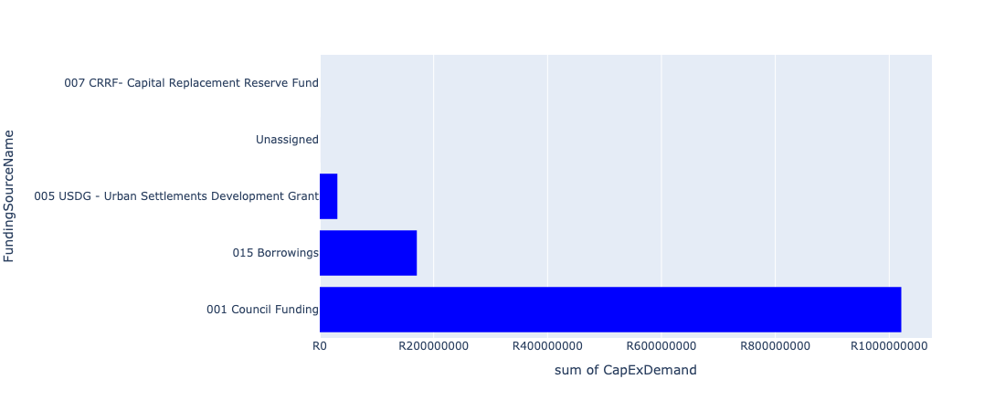

Figure 5.12: Ward 6 Departmental Requests

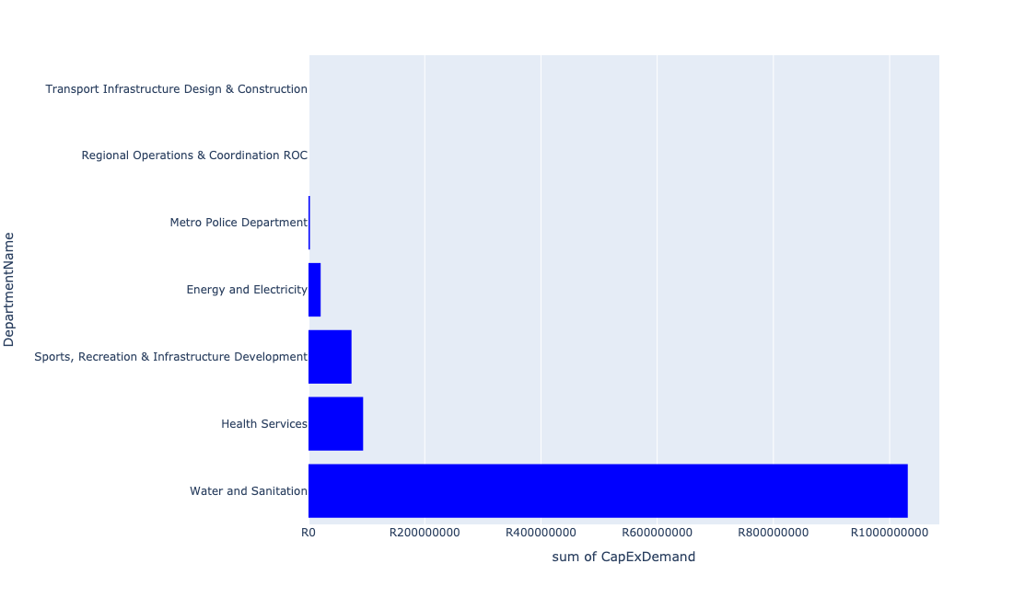

Table 5.6: Summary - Ward 6

|  |  |
| --- | --- |
| Item | Description |
| Total Capital Demand for Ward 6 - All Years | R1,184,197,080 Rank: 9 (1 = Highest) |
| Total Capital Demand for Ward 6 - MTREF | R201,032,791 Rank: 36 (1 = Highest) |
| Financial Years in which capital requirements are listed for Ward 6 | 2022, 2023, 2024, 2025, 2026, 2027, 2028, 2029, 2030 and 2031 |
| Financial Year with highest capital demand for Ward 6 | 2025 |
| Ward 6 intersecting feature used | Works Location |
| Total number of projects intersecting with Ward 6 | 10 Rank: 61 (1 = Highest) |

Table 5.7: All projects asking for budget in Ward 6

|  |  |  |  |
| --- | --- | --- | --- |
| Project ID | Project Name | Department | Project Budget |
| 712971915 | Revitalisation of the City-Development of Non-Motorised Transport Masterplan | Transport Infrastructure Design & Construction | R5,893 (0.00%) Budget spread across: 2027 |
| 712970748 | R6 Machinery and Equipment to ensure basic infrastructure reliability | Regional Operations & Coordination ROC | R6,892 (0.00%) Budget spread across: 2022 and 2023 |
| 712975437 | Sub-Project: TMPD Station - Mamelodi (Extension 10) | Metro Police Department | R2,439,139 (0.21%) Budget spread across: 2022, 2023 and 2024 |
| 712974121 | (712279) Wildebees - Elland 132kV Power line | Energy and Electricity | R20,917,594 (1.77%) Budget spread across: 2023 and 2024 |
| 712974544 | (710411F2) Baviaanspoort WWTW Phase3: 40Ml/d extension project on new site with link outfall sewer | Water and Sanitation | R1,194,577 (0.10%) Budget spread across: 2024, 2025, 2026, 2027, 2028 and 2029 |
| 712974541 | (710411F1) Baviaanspoort WWTW Phase 2: 20Ml/d extension using alternative technologies, new sludge infrastructure & tertiary treatment | Water and Sanitation | R1,030,000,000 (86.98%) Budget spread across: 2022, 2023, 2024, 2025, 2026, 2027, 2028 and 2029 |
| 712967124 | (712941) Greening of Sports fields | Sports, Recreation & Infrastructure Development | R74,000,023 (6.25%) Budget spread across: 2022, 2023, 2024, 2025, 2026, 2027, 2028, 2029, 2030 and 2031 |
| 712973984 | Replacement of Mamelodi West Clinic | Health Services | R94,000,000 (7.94%) Budget spread across: 2022, 2029, 2030 and 2031 |

## Ward 7

Figure 5.13: Ward 7 Funding Requests

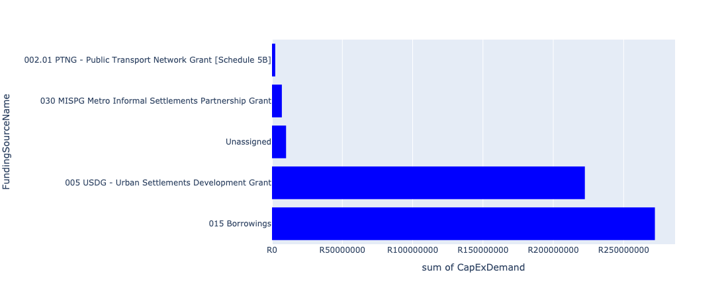

Figure 5.14: Ward 7 Departmental Requests

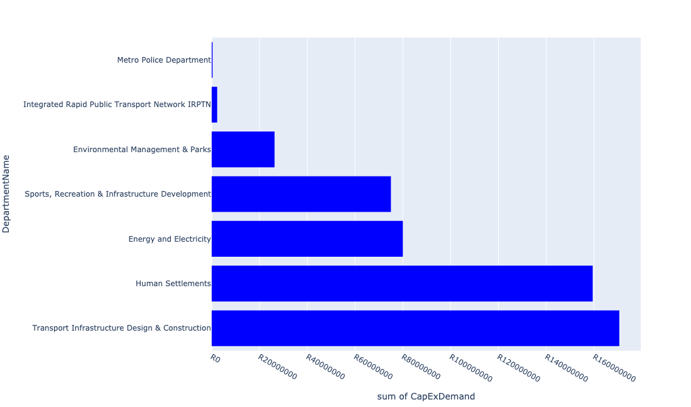

Table 5.7: Summary - Ward 7

|  |  |
| --- | --- |
| Item | Description |
| Total Capital Demand for Ward 7 - All Years | R513,520,092 Rank: 31 (1 = Highest) |
| Total Capital Demand for Ward 7 - MTREF | R188,063,628 Rank: 38 (1 = Highest) |
| Financial Years in which capital requirements are listed for Ward 7 | 2022, 2023, 2024, 2025, 2026, 2027 and 2028 |
| Financial Year with highest capital demand for Ward 7 | 2026 |
| Ward 7 intersecting feature used | Works Location |
| Total number of projects intersecting with Ward 7 | 20 Rank: 13 (1 = Highest) |

Table 5.8: All projects asking for budget in Ward 7

|  |  |  |  |
| --- | --- | --- | --- |
| Project ID | Project Name | Department | Project Budget |
| 712971915 | Revitalisation of the City-Development of Non-Motorised Transport Masterplan | Transport Infrastructure Design & Construction | R124,843 (0.02%) Budget spread across: 2027 |
| 712975413 | Sub-Project: TMPD Station - Kwaggasrand / Atteridgeville | Metro Police Department | R364,494 (0.07%) Budget spread across: 2023 |
| 712975348 | (712279) Saulsville 132/11kV Substation | Energy and Electricity | R80,000,000 (15.58%) Budget spread across: 2025, 2026 and 2027 |
| 712975007 | Security and visitor infrastructure upgrades at GaMothakga Recreational Resort | Environmental Management & Parks | R26,309,221 (5.12%) Budget spread across: 2022, 2023 and 2024 |
| 712974540 | Construction of major storm water Network 2A in the vicinity of Motheberebe Street, AtteridgevilleProject | Transport Infrastructure Design & Construction | R442,161 (0.09%) Budget spread across: 2025 and 2026 |
| 712974353 | (712591) Line 3: CBD to Atteridgeville - Section 2 (Pretoria West - Atteridgeville) | Integrated Rapid Public Transport Network IRPTN | R2,285,902 (0.45%) Budget spread across: 2022 |
| 712967629 | (710863) Bulk Reservoir - Fort West X4&5 | Human Settlements | R50,000,000 (9.74%) Budget spread across: 2022, 2023 and 2024 |
| 712967626 | (710863) Water provision - Fort West X4 | Human Settlements | R6,000,000 (1.17%) Budget spread across: 2022 |
| 712967609 | (710864) Sewer provision - Fort West X4 | Human Settlements | R7,000,000 (1.36%) Budget spread across: 2022 |
| 712967345 | (711712) Development of Saulsville hostels | Human Settlements | R29,440,467 (5.73%) Budget spread across: 2022, 2023 and 2024 |
| 712967167 | (712260) Lotus Gardens multi-purpose sport facility | Sports, Recreation & Infrastructure Development | R40,000,000 (7.79%) Budget spread across: 2025 and 2026 |
| 1004 | (712522) Collector Road Backlogs: Atteridgeville | Transport Infrastructure Design & Construction | R170,000,000 (33.10%) Budget spread across: 2025, 2026, 2027 and 2028 |
| 17 | (713068) Lotus Gardens Library | Sports, Recreation & Infrastructure Development | R35,000,000 (6.82%) Budget spread across: 2025 and 2026 |
| 712967602 | (710865) Construction of roads & stormwater - Fort West X5 | Human Settlements | R67,000,000 (13.05%) Budget spread across: 2022, 2023 and 2024 |

## Ward 8

Figure 5.15: Ward 8 Funding Requests

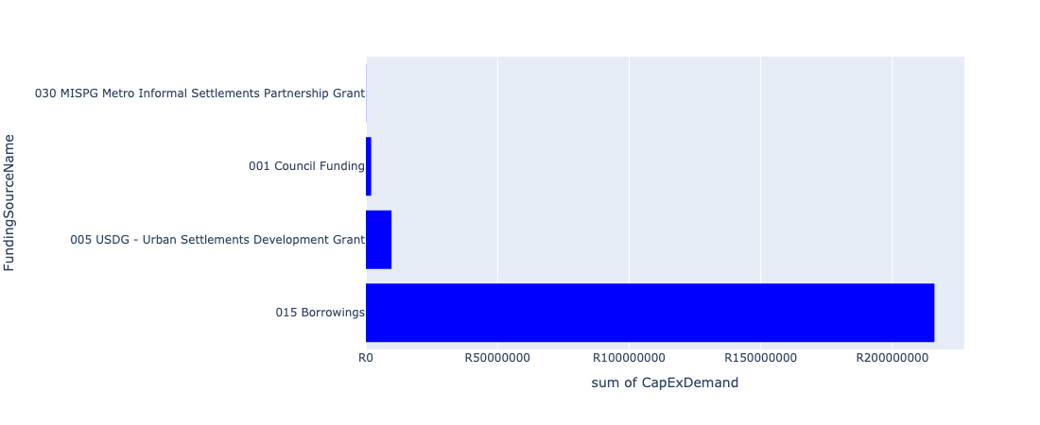

Figure 5.16: Ward 8 Departmental Requests

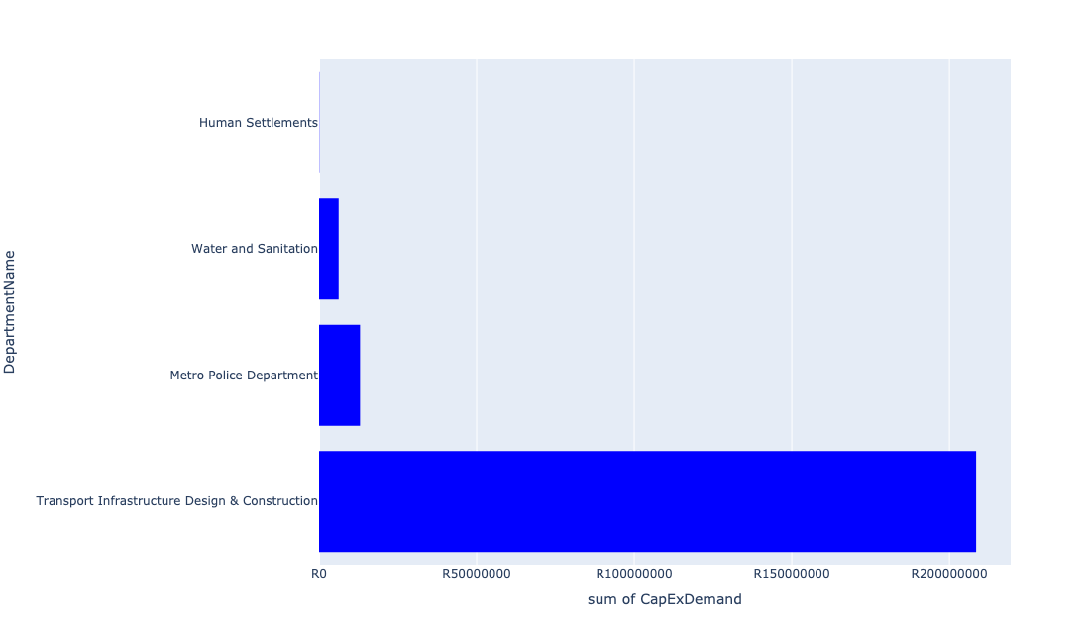

Table 5.8: Summary - Ward 8

|  |  |
| --- | --- |
| Item | Description |
| Total Capital Demand for Ward 8 - All Years | R227,777,951 Rank: 56 (1 = Highest) |
| Total Capital Demand for Ward 8 - MTREF | R82,275,293 Rank: 65 (1 = Highest) |
| Financial Years in which capital requirements are listed for Ward 8 | 2022, 2023, 2024, 2025, 2026, 2027, 2028, 2029 and 2030 |
| Financial Year with highest capital demand for Ward 8 | 2023 |
| Ward 8 intersecting feature used | Works Location |
| Total number of projects intersecting with Ward 8 | 10 Rank: 61 (1 = Highest) |

Table 5.9: All projects asking for budget in Ward 8

|  |  |  |  |
| --- | --- | --- | --- |
| Project ID | Project Name | Department | Project Budget |
| 712971915 | Revitalisation of the City-Development of Non-Motorised Transport Masterplan | Transport Infrastructure Design & Construction | R45,673 (0.02%) Budget spread across: 2027 |
| 712974528 | Kudube Unit 5,7,8 and D : Flood Attenuation Structure | Transport Infrastructure Design & Construction | R15,469,427 (6.79%) Budget spread across: 2025, 2026 and 2027 |
| 967 | (712507) Flooding backlog: Network 2H, Kudube Unit 7 | Transport Infrastructure Design & Construction | R94,743,872 (41.59%) Budget spread across: 2022, 2023, 2024, 2025, 2026, 2027, 2028, 2029 and 2030 |
| 961 | (712503) Flooding backlog: Network 3, Kudube Unit 11 | Transport Infrastructure Design & Construction | R98,227,467 (43.12%) Budget spread across: 2022, 2023, 2024, 2025, 2026, 2027, 2028, 2029 and 2030 |
| 712967840 | (712534H) Replacement and upgrading of bulk pipeline: Union Building - Jumbo Rally to Schoeman Street | Water and Sanitation | R6,213,254 (2.73%) Budget spread across: 2022, 2023 and 2024 |
| 712972933 | (710863) Water provision - Hammanskraal West X10 (Bulk water line) | Human Settlements | R78,257 (0.03%) Budget spread across: 2022 |
| 712975339 | Sub-Project: TMPD Station - Suurman | Metro Police Department | R13,000,000 (5.71%) Budget spread across: 2022 and 2023 |

## Ward 9

Figure 5.17: Ward 9 Funding Requests

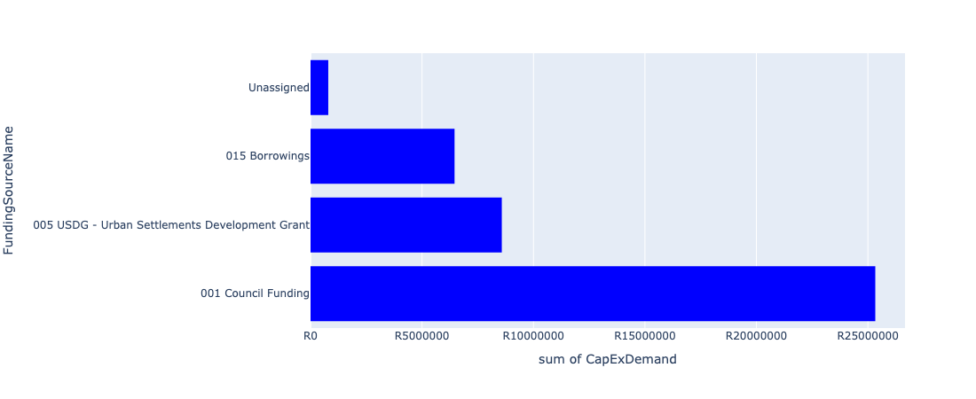

Figure 5.18: Ward 9 Departmental Requests

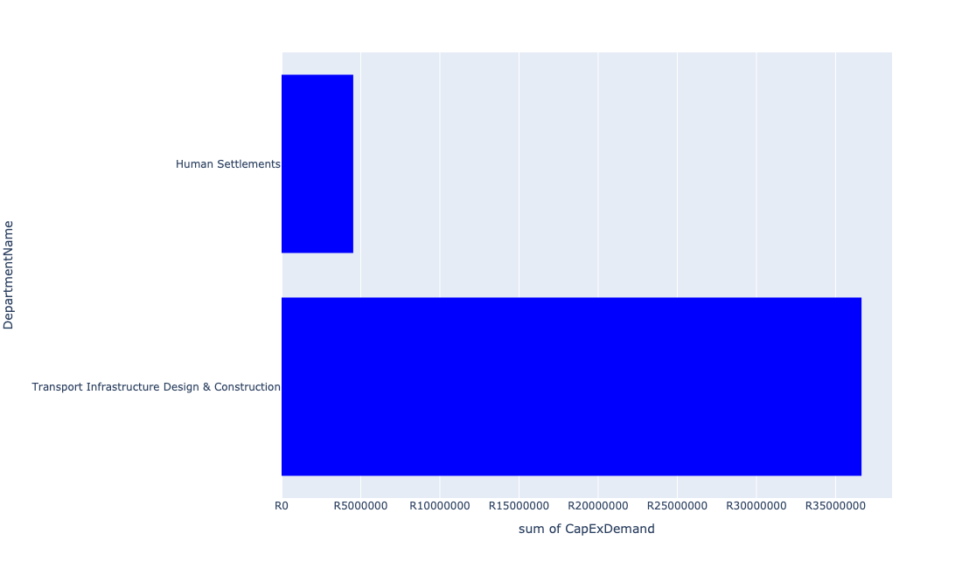

Table 5.9: Summary - Ward 9

|  |  |
| --- | --- |
| Item | Description |
| Total Capital Demand for Ward 9 - All Years | R41,165,436 Rank: 100 (1 = Highest) |
| Total Capital Demand for Ward 9 - MTREF | R22,190,326 Rank: 92 (1 = Highest) |
| Financial Years in which capital requirements are listed for Ward 9 | 2022, 2023, 2024, 2025, 2026, 2027, 2029 and 2030 |
| Financial Year with highest capital demand for Ward 9 | 2022 |
| Ward 9 intersecting feature used | Works Location |
| Total number of projects intersecting with Ward 9 | 4 Rank: 101 (1 = Highest) |

Table 5.10: All projects asking for budget in Ward 9

|  |  |  |  |
| --- | --- | --- | --- |
| Project ID | Project Name | Department | Project Budget |
| 712971915 | Revitalisation of the City-Development of Non-Motorised Transport Masterplan | Transport Infrastructure Design & Construction | R17,084 (0.04%) Budget spread across: 2027 |
| 712974177 | (712611) Upgrading of Mabopane Block A | Transport Infrastructure Design & Construction | R29,385,380 (71.38%) Budget spread across: 2022, 2023, 2024, 2025 and 2026 |
| 712967434 | (710863) Water provision - Winterveldt Water Reticulation | Human Settlements | R4,525,468 (10.99%) Budget spread across: 2022 and 2023 |
| 517 | (710609S) Shova Kalula Bicycle Project | Transport Infrastructure Design & Construction | R7,237,505 (17.58%) Budget spread across: 2022, 2023, 2024, 2025, 2026, 2027, 2029 and 2030 |

## Ward 10

Figure 5.19: Ward 10 Funding Requests

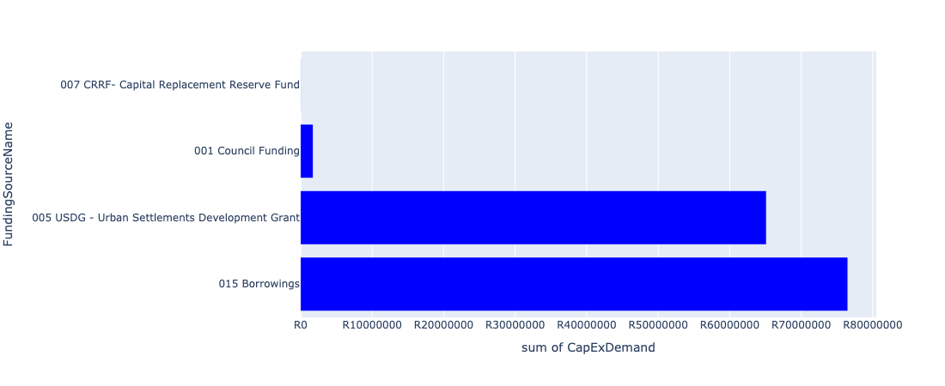

Figure 5.20: Ward 10 Departmental Requests

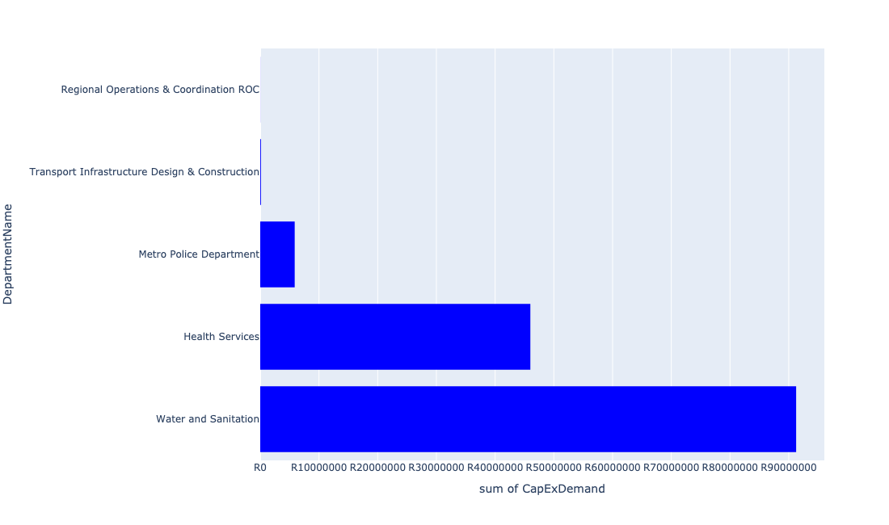

Table 5.10: Summary - Ward 10

|  |  |
| --- | --- |
| Item | Description |
| Total Capital Demand for Ward 10 - All Years | R143,269,333 Rank: 80 (1 = Highest) |
| Total Capital Demand for Ward 10 - MTREF | R99,825,576 Rank: 56 (1 = Highest) |
| Financial Years in which capital requirements are listed for Ward 10 | 2022, 2023, 2024, 2025, 2026 and 2027 |
| Financial Year with highest capital demand for Ward 10 | 2022 |
| Ward 10 intersecting feature used | Works Location |
| Total number of projects intersecting with Ward 10 | 12 Rank: 47 (1 = Highest) |

Table 5.11: All projects asking for budget in Ward 10

|  |  |  |  |
| --- | --- | --- | --- |
| Project ID | Project Name | Department | Project Budget |
| 712971915 | Revitalisation of the City-Development of Non-Motorised Transport Masterplan | Transport Infrastructure Design & Construction | R14,607 (0.01%) Budget spread across: 2027 |
| 712970748 | R6 Machinery and Equipment to ensure basic infrastructure reliability | Regional Operations & Coordination ROC | R15,094 (0.01%) Budget spread across: 2022 and 2023 |
| 712975437 | Sub-Project: TMPD Station - Mamelodi (Extension 10) | Metro Police Department | R5,869,889 (4.10%) Budget spread across: 2022, 2023 and 2024 |
| 712967295 | (711335ML) Mamelodi R5 feeder main relocation | Water and Sanitation | R24,477,882 (17.09%) Budget spread across: 2023, 2024, 2025 and 2026 |
| 992 | (712518) Flooding backlog: Drainage canals along Hans Strydom Dr, Mamelodi x 4 and 5 | Transport Infrastructure Design & Construction | R108,697 (0.08%) Budget spread across: 2022, 2023 and 2024 |
| 712967766 | 712969116_17_(712970T) Mamelodi Ext 11 - Sewerage network line | Water and Sanitation | R63,000,000 (43.97%) Budget spread across: 2023, 2024 and 2025 |
| 712967192 | (713049) New Clinic Lusaka | Health Services | R46,000,000 (32.11%) Budget spread across: 2022 and 2023 |
| 712970801 | (712970) Mahube Valley Ext 15 - Water Provision | Water and Sanitation | R3,783,163 (2.64%) Budget spread across: 2022, 2023, 2024, 2025 and 2026 |

## Ward 11

Figure 5.21: Ward 11 Funding Requests

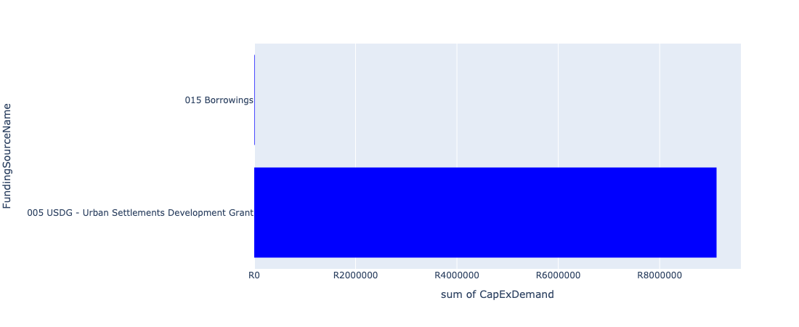

Figure 5.22: Ward 11 Departmental Requests

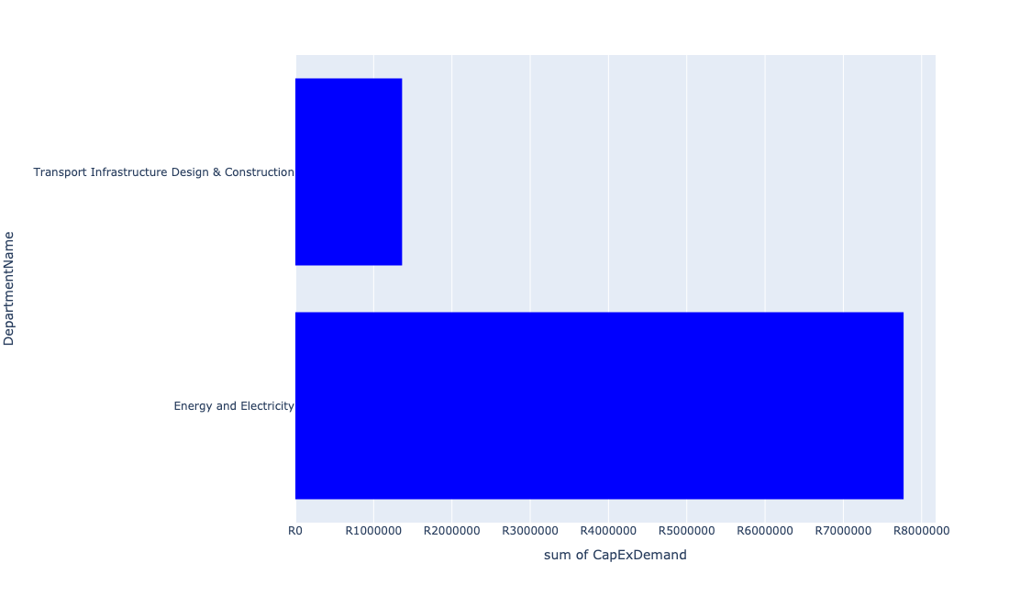

Table 5.11: Summary - Ward 11

|  |  |
| --- | --- |
| Item | Description |
| Total Capital Demand for Ward 11 - All Years | R9,133,039 Rank: 103 (1 = Highest) |
| Total Capital Demand for Ward 11 - MTREF | R9,122,838 Rank: 96 (1 = Highest) |
| Financial Years in which capital requirements are listed for Ward 11 | 2022, 2023, 2024 and 2027 |
| Financial Year with highest capital demand for Ward 11 | 2022 |
| Ward 11 intersecting feature used | Works Location |
| Total number of projects intersecting with Ward 11 | 3 Rank: 105 (1 = Highest) |

Table 5.12: All projects asking for budget in Ward 11

|  |  |  |  |
| --- | --- | --- | --- |
| Project ID | Project Name | Department | Project Budget |
| 712971915 | Revitalisation of the City-Development of Non-Motorised Transport Masterplan | Transport Infrastructure Design & Construction | R10,201 (0.11%) Budget spread across: 2027 |
| 712969084 | (712279) Soshanguve - JJ 132KV Power Line | Energy and Electricity | R7,769,556 (85.07%) Budget spread across: 2022, 2023 and 2024 |
| 295 | (710128) Concrete Canal: Sam Malema Road, Winterveldt | Transport Infrastructure Design & Construction | R1,353,282 (14.82%) Budget spread across: 2022 and 2023 |

## Ward 12

Figure 5.23: Ward 12 Funding Requests

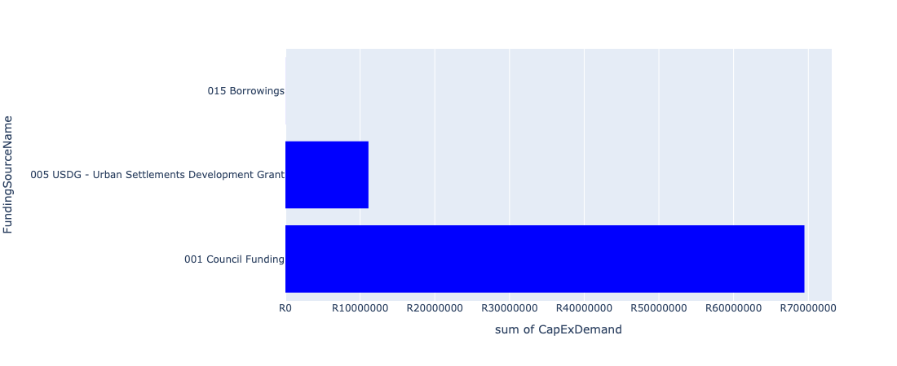

Figure 5.24: Ward 12 Departmental Requests

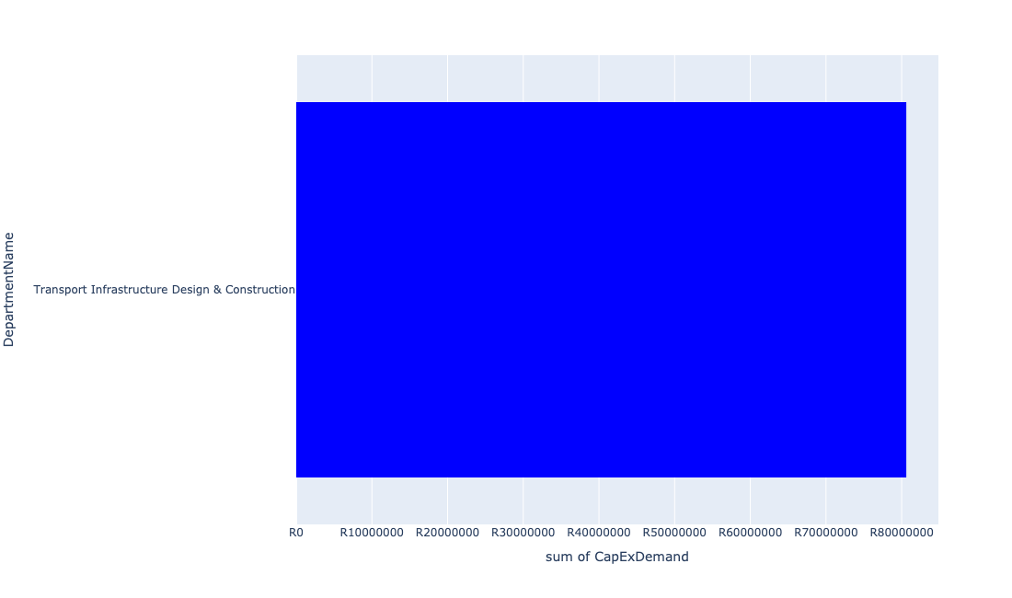

Table 5.12: Summary - Ward 12

|  |  |
| --- | --- |
| Item | Description |
| Total Capital Demand for Ward 12 - All Years | R80,608,530 Rank: 88 (1 = Highest) |
| Total Capital Demand for Ward 12 - MTREF | R41,688,444 Rank: 83 (1 = Highest) |
| Financial Years in which capital requirements are listed for Ward 12 | 2022, 2023, 2024, 2025, 2026 and 2027 |
| Financial Year with highest capital demand for Ward 12 | 2026 |
| Ward 12 intersecting feature used | Works Location |
| Total number of projects intersecting with Ward 12 | 3 Rank: 105 (1 = Highest) |

Table 5.13: All projects asking for budget in Ward 12

|  |  |  |  |
| --- | --- | --- | --- |
| Project ID | Project Name | Department | Project Budget |
| 712971915 | Revitalisation of the City-Development of Non-Motorised Transport Masterplan | Transport Infrastructure Design & Construction | R10,872 (0.01%) Budget spread across: 2027 |
| 712970771 | (710864) Mabopane X11 | Human Settlements | R0 (0.00%) Budget spread across: 2022 |
| 712974177 | (712611) Upgrading of Mabopane Block A | Transport Infrastructure Design & Construction | R80,597,659 (99.99%) Budget spread across: 2022, 2023, 2024, 2025 and 2026 |

## Ward 13

Figure 5.25: Ward 13 Funding Requests

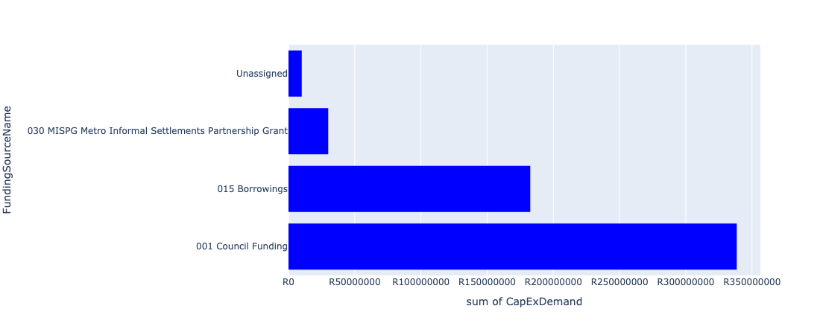

Figure 5.26: Ward 13 Departmental Requests

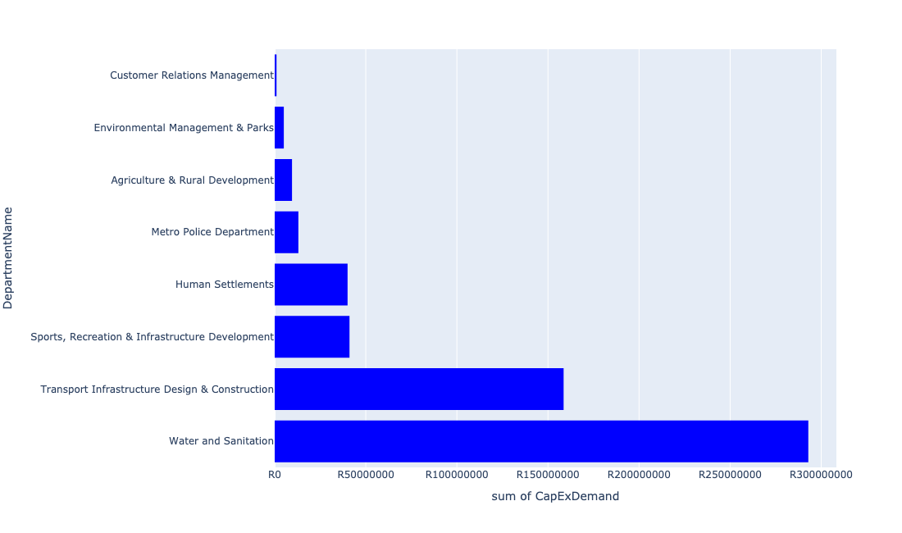

Table 5.13: Summary - Ward 13

|  |  |
| --- | --- |
| Item | Description |
| Total Capital Demand for Ward 13 - All Years | R561,058,336 Rank: 25 (1 = Highest) |
| Total Capital Demand for Ward 13 - MTREF | R155,765,992 Rank: 45 (1 = Highest) |
| Financial Years in which capital requirements are listed for Ward 13 | 2022, 2023, 2024, 2025, 2026, 2027, 2028, 2029 and 2030 |
| Financial Year with highest capital demand for Ward 13 | 2026 |
| Ward 13 intersecting feature used | Works Location |
| Total number of projects intersecting with Ward 13 | 17 Rank: 20 (1 = Highest) |

Table 5.14: All projects asking for budget in Ward 13

|  |  |  |  |
| --- | --- | --- | --- |
| Project ID | Project Name | Department | Project Budget |
| 712971915 | Revitalisation of the City-Development of Non-Motorised Transport Masterplan | Transport Infrastructure Design & Construction | R129,574 (0.02%) Budget spread across: 2027 |
| 712975536 | Refurbishment of Bodibeng customer care centre ( Soshanguve BB) | Customer Relations Management | R1,000,000 (0.18%) Budget spread across: 2023 |
| 712975340 | Sub-Project: TMPD Station - Tswaing | Metro Police Department | R13,000,000 (2.32%) Budget spread across: 2025 and 2026 |
| 712975245 | Erf 4557 -Upgrade of Stink water Park | Environmental Management & Parks | R5,000,000 (0.89%) Budget spread across: 2022 |
| 712975144 | (712121NS) New Stinkwater X03 Outfall Sewer | Water and Sanitation | R2,500,000 (0.45%) Budget spread across: 2023, 2024 and 2025 |
| 712975113 | (710411IA) Temba WWTW Commission of Module 3 | Water and Sanitation | R290,000,000 (51.69%) Budget spread across: 2025, 2026, 2027 and 2028 |
| 712967161 | Development of Stinkwater Agricultural Park | Agriculture & Rural Development | R9,500,000 (1.69%) Budget spread across: 2022, 2023, 2024 and 2025 |
| 712967139 | (712911) New Eersterust library | Sports, Recreation & Infrastructure Development | R1,061,147 (0.19%) Budget spread across: 2023 and 2024 |
| 963 | (712506) Flooding backlog: Networks in Matenteng and Stinkwater Area | Transport Infrastructure Design & Construction | R95,000,000 (16.93%) Budget spread across: 2022, 2023, 2024, 2025 and 2026 |
| 876 | (712219) Flooding Backlogs: Stinkwater & New Eersterust Area | Transport Infrastructure Design & Construction | R8,457,832 (1.51%) Budget spread across: 2022, 2023, 2024, 2025, 2026, 2027, 2028, 2029 and 2030 |
| 582 | (710878N) Sewer reticulation Stinkwater Ext 2 to 8 | Water and Sanitation | R409,783 (0.07%) Budget spread across: 2023, 2024, 2025 and 2027 |
| 508 | (710597M) Mateteng Main Transport Route, Stinkwater | Transport Infrastructure Design & Construction | R55,000,000 (9.80%) Budget spread across: 2022, 2023, 2024 and 2025 |
| 712973862 | Stinkwater Library to have a dedicated building | Sports, Recreation & Infrastructure Development | R40,000,000 (7.13%) Budget spread across: 2029 and 2030 |
| 712970903 | (710864) Sewer provision - New Eersterust X8 (Tswaing) (Pump Stations ) | Human Settlements | R40,000,000 (7.13%) Budget spread across: 2022, 2023 and 2024 |

## Ward 14

Figure 5.27: Ward 14 Funding Requests

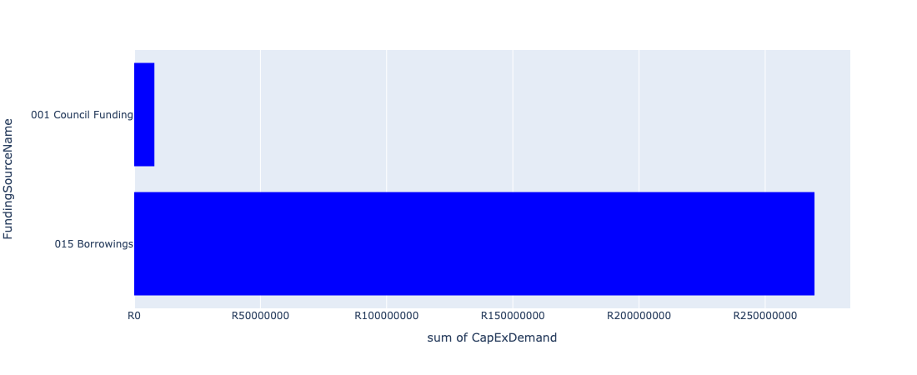

Figure 5.28: Ward 14 Departmental Requests

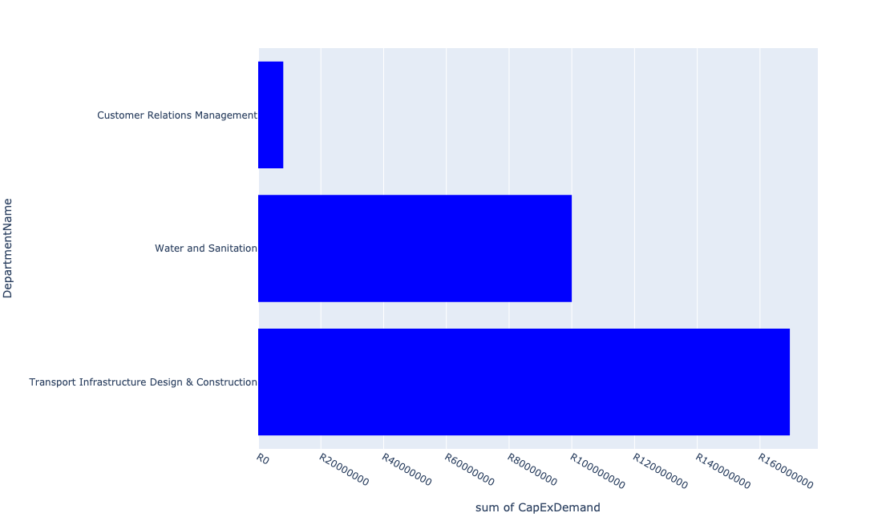

Table 5.14: Summary - Ward 14

|  |  |
| --- | --- |
| Item | Description |
| Total Capital Demand for Ward 14 - All Years | R277,518,702 Rank: 50 (1 = Highest) |
| Total Capital Demand for Ward 14 - MTREF | R62,222,111 Rank: 77 (1 = Highest) |
| Financial Years in which capital requirements are listed for Ward 14 | 2022, 2023, 2024, 2025, 2026, 2027, 2028, 2029 and 2030 |
| Financial Year with highest capital demand for Ward 14 | 2027 |
| Ward 14 intersecting feature used | Works Location |
| Total number of projects intersecting with Ward 14 | 6 Rank: 89 (1 = Highest) |

Table 5.15: All projects asking for budget in Ward 14

|  |  |  |  |
| --- | --- | --- | --- |
| Project ID | Project Name | Department | Project Budget |
| 712971915 | Revitalisation of the City-Development of Non-Motorised Transport Masterplan | Transport Infrastructure Design & Construction | R19,004 (0.01%) Budget spread across: 2027 |
| 876 | (712219) Flooding Backlogs: Stinkwater & New Eersterust Area | Transport Infrastructure Design & Construction | R73,499,699 (26.48%) Budget spread across: 2022, 2023, 2024, 2025, 2026, 2027, 2028, 2029 and 2030 |
| 712967252 | (710878P) Sewer reticulation New Eersterust Ext 4 to 7 | Water and Sanitation | R50,000,000 (18.02%) Budget spread across: 2025, 2026 and 2027 |
| 988 | (712516) Flooding backlog: Network 2D, New Eersterust x 2 | Transport Infrastructure Design & Construction | R96,000,000 (34.59%) Budget spread across: 2022, 2023, 2024, 2025, 2026, 2027, 2028, 2029 and 2030 |
| 574 | (710878) Sewer reticulation New Eersterust Ext 1,2,3 | Water and Sanitation | R50,000,000 (18.02%) Budget spread across: 2025, 2026 and 2027 |
| 712973947 | Refurbishment of New Eersterust customer care centre | Customer Relations Management | R8,000,000 (2.88%) Budget spread across: 2026 |

## Ward 15

Figure 5.29: Ward 15 Funding Requests

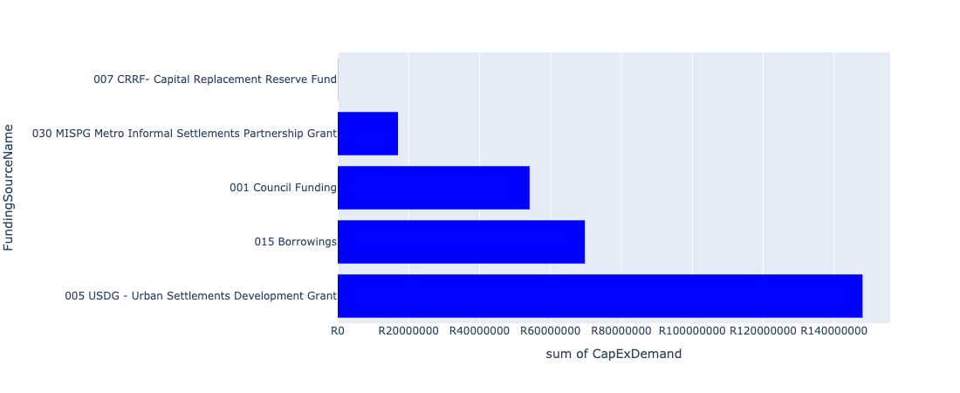

Figure 5.30: Ward 15 Departmental Requests

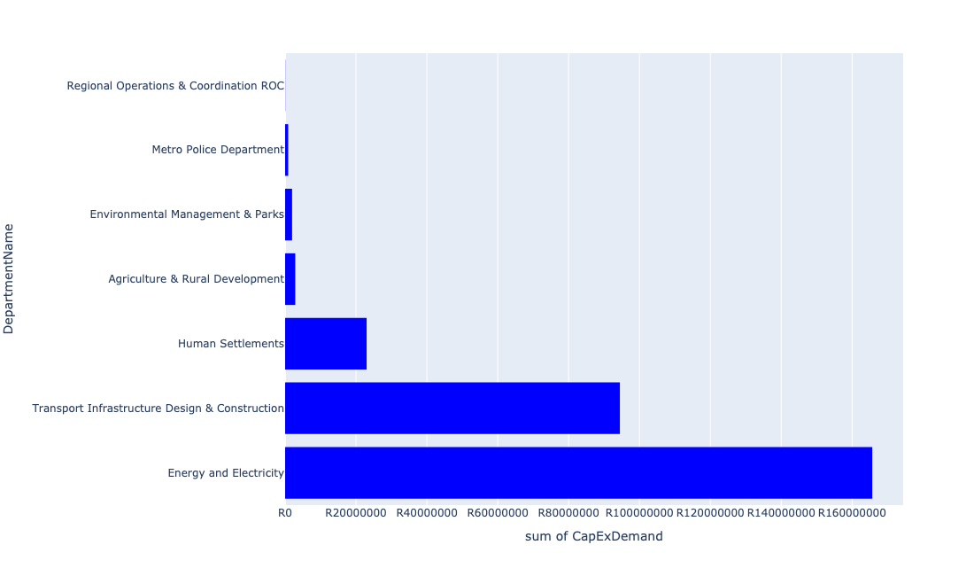

Table 5.15: Summary - Ward 15

|  |  |
| --- | --- |
| Item | Description |
| Total Capital Demand for Ward 15 - All Years | R288,904,938 Rank: 48 (1 = Highest) |
| Total Capital Demand for Ward 15 - MTREF | R210,257,975 Rank: 34 (1 = Highest) |
| Financial Years in which capital requirements are listed for Ward 15 | 2022, 2023, 2024, 2025, 2026, 2027, 2028, 2029 and 2030 |
| Financial Year with highest capital demand for Ward 15 | 2024 |
| Ward 15 intersecting feature used | Works Location |
| Total number of projects intersecting with Ward 15 | 14 Rank: 37 (1 = Highest) |

Table 5.16: All projects asking for budget in Ward 15

|  |  |  |  |
| --- | --- | --- | --- |
| Project ID | Project Name | Department | Project Budget |
| 712971915 | Revitalisation of the City-Development of Non-Motorised Transport Masterplan | Transport Infrastructure Design & Construction | R45,907 (0.02%) Budget spread across: 2027 |
| 712970748 | R6 Machinery and Equipment to ensure basic infrastructure reliability | Regional Operations & Coordination ROC | R53,694 (0.02%) Budget spread across: 2022 and 2023 |
| 712975437 | Sub-Project: TMPD Station - Mamelodi (Extension 10) | Metro Police Department | R866,388 (0.30%) Budget spread across: 2022, 2023 and 2024 |
| 712975391 | (712279) Mamelodi II 132/11kV Substation | Energy and Electricity | R691,852 (0.24%) Budget spread across: 2026 |
| 712973721 | Upgrade of Nelson Mandela Park Tsamaya avenue | Agriculture & Rural Development | R2,859,913 (0.99%) Budget spread across: 2022 |
| 712974187 | Providing new Inter modal Public Transport Facility at Green View (including access to the facility) | Transport Infrastructure Design & Construction | R29,110,579 (10.08%) Budget spread across: 2022, 2023, 2024, 2025, 2026, 2027, 2028, 2029 and 2030 |
| 992 | (712518) Flooding backlog: Drainage canals along Hans Strydom Dr, Mamelodi x 4 and 5 | Transport Infrastructure Design & Construction | R1,979,778 (0.69%) Budget spread across: 2022, 2023 and 2024 |
| 712969619 | (713044) Hatherley Cemetery | Environmental Management & Parks | R1,963,224 (0.68%) Budget spread across: 2022, 2023 and 2025 |
| 891 | (712223) Mamelodi Extension 2: Area 3 | Transport Infrastructure Design & Construction | R63,333,602 (21.92%) Budget spread across: 2023, 2024, 2025, 2026, 2027, 2028, 2029 and 2030 |
| 712974153 | (712279) Wildebees 400/132kV, 315MVA Infeed station | Energy and Electricity | R165,000,000 (57.11%) Budget spread across: 2022, 2023 and 2024 |
| 712974109 | (710864) Sewer provision - Nellmapius X22 -stand 12223 & 12224 | Human Settlements | R23,000,000 (7.96%) Budget spread across: 2022 and 2023 |

## Ward 16

Figure 5.31: Ward 16 Funding Requests

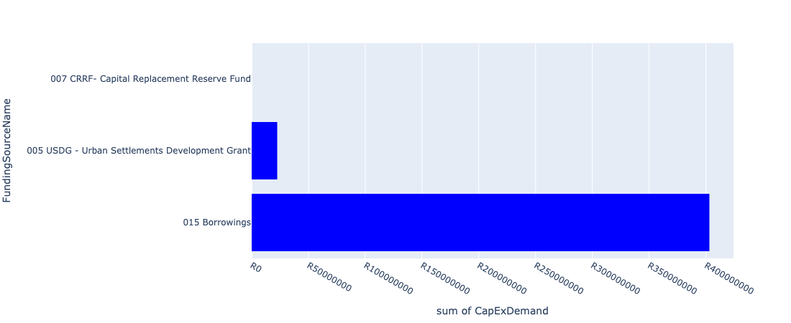

Figure 5.32: Ward 16 Departmental Requests

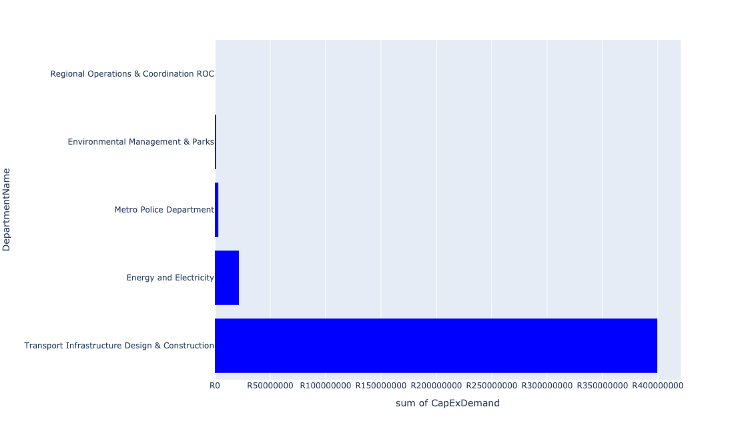

Table 5.16: Summary - Ward 16

|  |  |
| --- | --- |
| Item | Description |
| Total Capital Demand for Ward 16 - All Years | R419,029,761 Rank: 37 (1 = Highest) |
| Total Capital Demand for Ward 16 - MTREF | R134,869,300 Rank: 53 (1 = Highest) |
| Financial Years in which capital requirements are listed for Ward 16 | 2022, 2023, 2024, 2025, 2026, 2027, 2028, 2029 and 2030 |
| Financial Year with highest capital demand for Ward 16 | 2024 |
| Ward 16 intersecting feature used | Works Location |
| Total number of projects intersecting with Ward 16 | 11 Rank: 54 (1 = Highest) |

Table 5.17: All projects asking for budget in Ward 16

|  |  |  |  |
| --- | --- | --- | --- |
| Project ID | Project Name | Department | Project Budget |
| 712971915 | Revitalisation of the City-Development of Non-Motorised Transport Masterplan | Transport Infrastructure Design & Construction | R7,572 (0.00%) Budget spread across: 2027 |
| 712970748 | R6 Machinery and Equipment to ensure basic infrastructure reliability | Regional Operations & Coordination ROC | R8,856 (0.00%) Budget spread across: 2022 and 2023 |
| 712975437 | Sub-Project: TMPD Station - Mamelodi (Extension 10) | Metro Police Department | R3,134,334 (0.75%) Budget spread across: 2022, 2023 and 2024 |
| 712975391 | (712279) Mamelodi II 132/11kV Substation | Energy and Electricity | R5,391,948 (1.29%) Budget spread across: 2026 |
| 712974121 | (712279) Wildebees - Elland 132kV Power line | Energy and Electricity | R16,323,352 (3.90%) Budget spread across: 2023 and 2024 |
| 992 | (712518) Flooding backlog: Drainage canals along Hans Strydom Dr, Mamelodi x 4 and 5 | Transport Infrastructure Design & Construction | R4,869,498 (1.16%) Budget spread across: 2022, 2023 and 2024 |
| 712969619 | (713044) Hatherley Cemetery | Environmental Management & Parks | R1,157,143 (0.28%) Budget spread across: 2022, 2023 and 2025 |
| 891 | (712223) Mamelodi Extension 2: Area 3 | Transport Infrastructure Design & Construction | R64,666,398 (15.43%) Budget spread across: 2023, 2024, 2025, 2026, 2027, 2028, 2029 and 2030 |
| 712969548 | (712223) Mamelodi Extension 2: Area 2 | Transport Infrastructure Design & Construction | R25,000,000 (5.97%) Budget spread across: 2022 and 2023 |
| 712969547 | (712223) Mamelodi Extension 4: Area 1 | Transport Infrastructure Design & Construction | R135,000,000 (32.22%) Budget spread across: 2022, 2023, 2024, 2025, 2026, 2027, 2028 and 2030 |
| 712969546 | (712223) Mamelodi Extension 5: Area 1 | Transport Infrastructure Design & Construction | R170,000,000 (40.57%) Budget spread across: 2023, 2024, 2025, 2026, 2027, 2028, 2029 and 2030 |

## Ward 17

Figure 5.33: Ward 17 Funding Requests

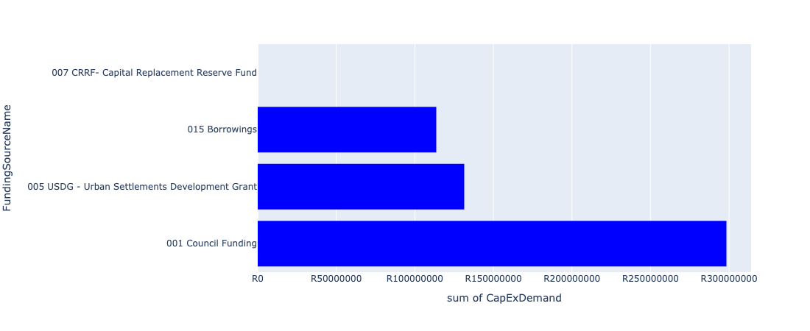

Figure 5.34: Ward 17 Departmental Requests

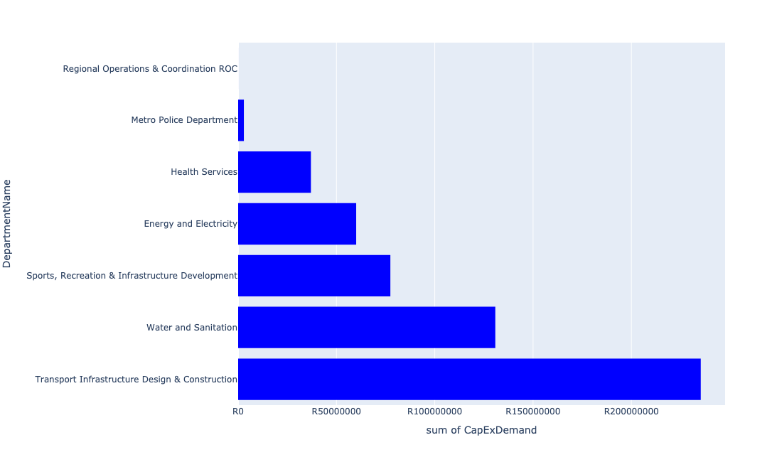

Table 5.17: Summary - Ward 17

|  |  |
| --- | --- |
| Item | Description |
| Total Capital Demand for Ward 17 - All Years | R543,422,993 Rank: 26 (1 = Highest) |
| Total Capital Demand for Ward 17 - MTREF | R309,044,642 Rank: 21 (1 = Highest) |
| Financial Years in which capital requirements are listed for Ward 17 | 2022, 2023, 2024, 2025, 2026, 2027, 2028, 2029 and 2030 |
| Financial Year with highest capital demand for Ward 17 | 2023 |
| Ward 17 intersecting feature used | Works Location |
| Total number of projects intersecting with Ward 17 | 16 Rank: 26 (1 = Highest) |

Table 5.18: All projects asking for budget in Ward 17

|  |  |  |  |
| --- | --- | --- | --- |
| Project ID | Project Name | Department | Project Budget |
| 712971915 | Revitalisation of the City-Development of Non-Motorised Transport Masterplan | Transport Infrastructure Design & Construction | R7,026 (0.00%) Budget spread across: 2027 |
| 712970748 | R6 Machinery and Equipment to ensure basic infrastructure reliability | Regional Operations & Coordination ROC | R5,712 (0.00%) Budget spread across: 2022 and 2023 |
| 712975437 | Sub-Project: TMPD Station - Mamelodi (Extension 10) | Metro Police Department | R2,908,325 (0.54%) Budget spread across: 2022, 2023 and 2024 |
| 712975391 | (712279) Mamelodi II 132/11kV Substation | Energy and Electricity | R30,761 (0.01%) Budget spread across: 2026 |
| 712967295 | (711335ML) Mamelodi R5 feeder main relocation | Water and Sanitation | R1,061,546 (0.20%) Budget spread across: 2023, 2024, 2025 and 2026 |
| 992 | (712518) Flooding backlog: Drainage canals along Hans Strydom Dr, Mamelodi x 4 and 5 | Transport Infrastructure Design & Construction | R8,258,986 (1.52%) Budget spread across: 2022, 2023 and 2024 |
| 712970801 | (712970) Mahube Valley Ext 15 - Water Provision | Water and Sanitation | R129,716,837 (23.87%) Budget spread across: 2022, 2023, 2024, 2025 and 2026 |
| 712967831 | (713069) Lusaka multi-purpose sport facility | Sports, Recreation & Infrastructure Development | R50,000,000 (9.20%) Budget spread across: 2022 and 2023 |
| 712967141 | (714011) Lusaka Library | Sports, Recreation & Infrastructure Development | R27,413,800 (5.04%) Budget spread across: 2022 and 2023 |
| 619 | (711213) Stormwater Drainage Mahube Valley | Transport Infrastructure Design & Construction | R150,000,000 (27.60%) Budget spread across: 2022, 2023, 2024, 2025, 2026, 2027, 2028, 2029 and 2030 |
| 315 | (710164) 11kV Panel Extension In Substations | Energy and Electricity | R60,000,000 (11.04%) Budget spread across: 2022, 2023 and 2024 |
| 298 | (710129M) Major Stormwater System, Mamelodi X 8 | Transport Infrastructure Design & Construction | R77,020,000 (14.17%) Budget spread across: 2022, 2023, 2024, 2025, 2026, 2027, 2028, 2029 and 2030 |
| 712969238 | (713051) Health Posts | Health Services | R37,000,000 (6.81%) Budget spread across: 2024, 2025 and 2026 |

## Ward 18

Figure 5.35: Ward 18 Funding Requests

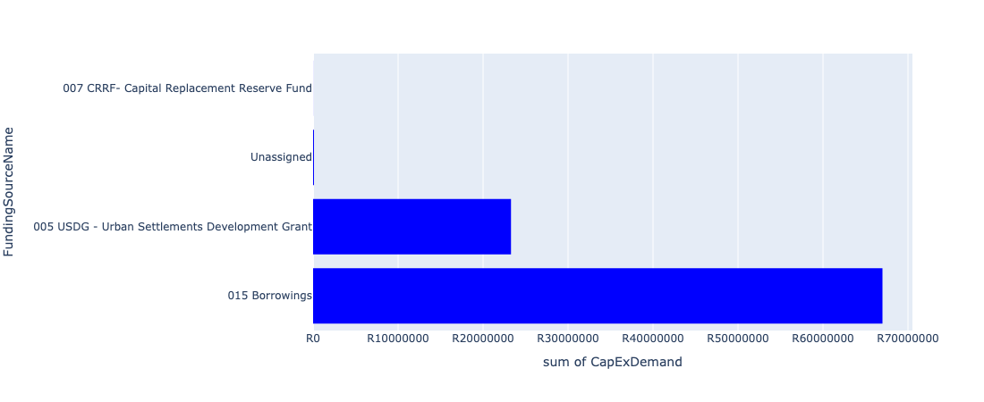

Figure 5.36: Ward 18 Departmental Requests

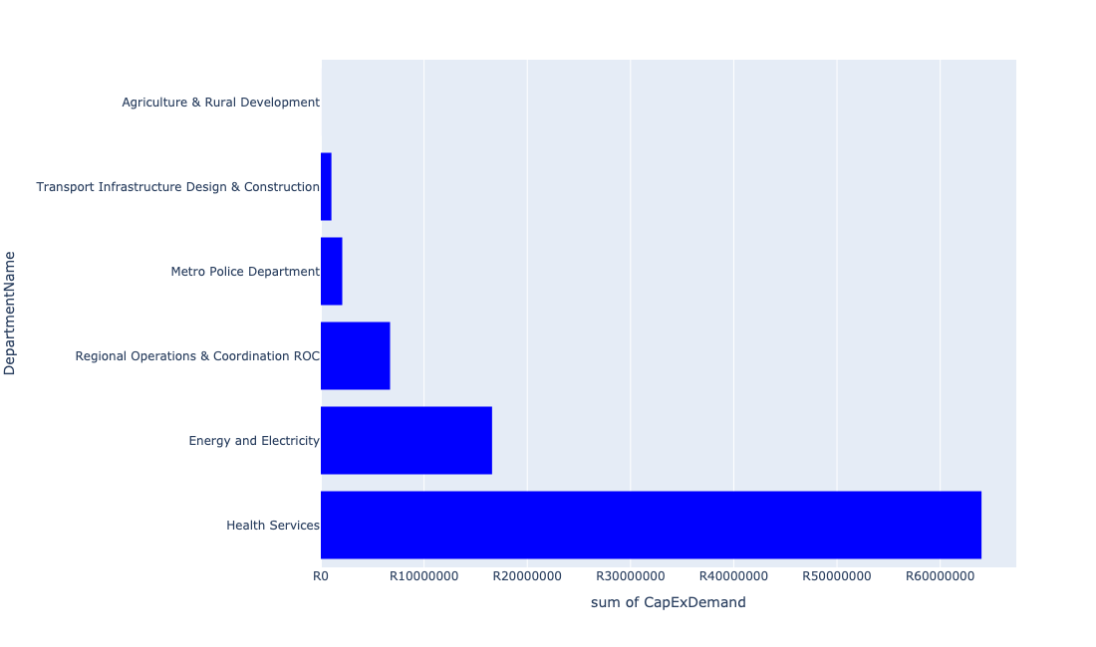

Table 5.18: Summary - Ward 18

|  |  |
| --- | --- |
| Item | Description |
| Total Capital Demand for Ward 18 - All Years | R85,585,842 Rank: 86 (1 = Highest) |
| Total Capital Demand for Ward 18 - MTREF | R80,352,090 Rank: 68 (1 = Highest) |
| Financial Years in which capital requirements are listed for Ward 18 | 2022, 2023, 2024, 2025, 2026, 2027, 2028, 2029 and 2030 |
| Financial Year with highest capital demand for Ward 18 | 2024 |
| Ward 18 intersecting feature used | Works Location |
| Total number of projects intersecting with Ward 18 | 15 Rank: 31 (1 = Highest) |

Table 5.19: All projects asking for budget in Ward 18

|  |  |  |  |
| --- | --- | --- | --- |
| Project ID | Project Name | Department | Project Budget |
| 712971915 | Revitalisation of the City-Development of Non-Motorised Transport Masterplan | Transport Infrastructure Design & Construction | R6,819 (0.01%) Budget spread across: 2027 |
| 712970748 | R6 Machinery and Equipment to ensure basic infrastructure reliability | Regional Operations & Coordination ROC | R7,976 (0.01%) Budget spread across: 2022 and 2023 |
| 712975437 | Sub-Project: TMPD Station - Mamelodi (Extension 10) | Metro Police Department | R2,076,478 (2.43%) Budget spread across: 2022, 2023 and 2024 |
| 712975391 | (712279) Mamelodi II 132/11kV Substation | Energy and Electricity | R4,555,058 (5.32%) Budget spread across: 2026 |
| 712975114 | Phahameng Clinic 2nd phase | Health Services | R64,000,000 (74.78%) Budget spread across: 2022, 2023 and 2024 |
| 1074 | (712612) Upgrading of Sibande Street, Mamelodi | Transport Infrastructure Design & Construction | R1,018,202 (1.19%) Budget spread across: 2022, 2023, 2024, 2025, 2026, 2027, 2028, 2029 and 2030 |
| 712974121 | (712279) Wildebees - Elland 132kV Power line | Energy and Electricity | R12,032,887 (14.06%) Budget spread across: 2023 and 2024 |
| 712973721 | Upgrade of Nelson Mandela Park Tsamaya avenue | Agriculture & Rural Development | R1,576 (0.00%) Budget spread across: 2022 |
| 712967967 | R6 Installation of bio metrics systems at SRAC and Parks Offices | Regional Operations & Coordination ROC | R6,700,000 (7.83%) Budget spread across: 2022 |

## Ward 19

Figure 5.37: Ward 19 Funding Requests

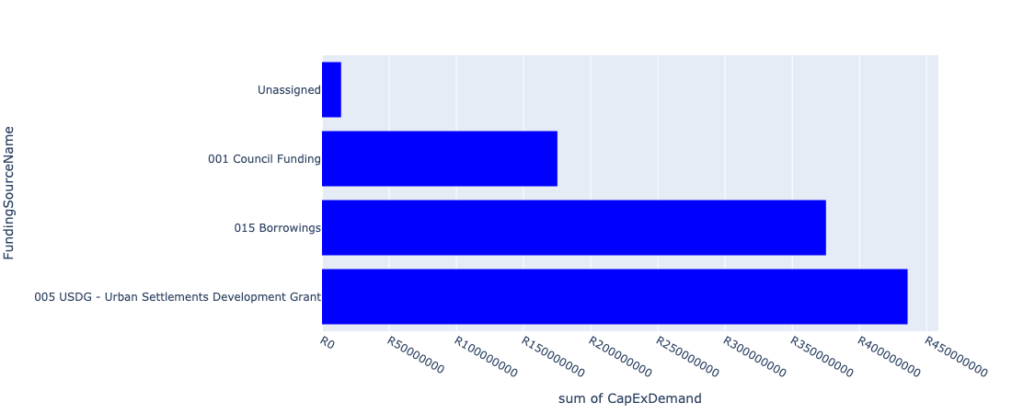

Figure 5.38: Ward 19 Departmental Requests

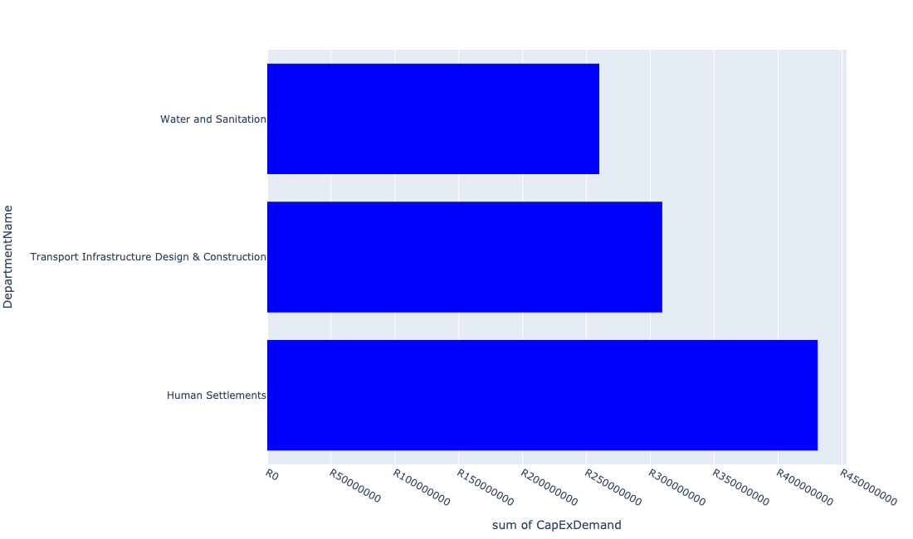

Table 5.19: Summary - Ward 19

|  |  |
| --- | --- |
| Item | Description |
| Total Capital Demand for Ward 19 - All Years | R835,276,765 Rank: 15 (1 = Highest) |
| Total Capital Demand for Ward 19 - MTREF | R663,121,236 Rank: 5 (1 = Highest) |
| Financial Years in which capital requirements are listed for Ward 19 | 2022, 2023, 2024, 2025, 2026, 2027, 2029 and 2030 |
| Financial Year with highest capital demand for Ward 19 | 2023 |
| Ward 19 intersecting feature used | Works Location |
| Total number of projects intersecting with Ward 19 | 12 Rank: 47 (1 = Highest) |

Table 5.20: All projects asking for budget in Ward 19

|  |  |  |  |
| --- | --- | --- | --- |
| Project ID | Project Name | Department | Project Budget |
| 712971915 | Revitalisation of the City-Development of Non-Motorised Transport Masterplan | Transport Infrastructure Design & Construction | R22,759 (0.00%) Budget spread across: 2027 |
| 712974394 | (710863) Water provision - Winterveldt 20ML Reservoir | Human Settlements | R55,500,000 (6.64%) Budget spread across: 2022, 2023 and 2024 |
| 712974378 | (710863) Water Provision - Winterveldt Bulk water line | Human Settlements | R65,000,000 (7.78%) Budget spread across: 2022 and 2023 |
| 712974360 | (712221) Upgrading of roads and stormwater: Winterveldt Area and Mabopane Area | Transport Infrastructure Design & Construction | R145,000,000 (17.36%) Budget spread across: 2022, 2023, 2024, 2025 and 2026 |
| 712974177 | (712611) Upgrading of Mabopane Block A | Transport Infrastructure Design & Construction | R35,016,972 (4.19%) Budget spread across: 2022, 2023, 2024, 2025 and 2026 |
| 712967437 | (710864) Winterveldt (Bulk sewer) | Human Settlements | R65,000,000 (7.78%) Budget spread across: 2022 and 2023 |
| 712967435 | (710865) Construction of roads & stormwater - Winterveldt | Human Settlements | R145,000,000 (17.36%) Budget spread across: 2022, 2023 and 2024 |
| 712967434 | (710863) Water provision - Winterveldt Water Reticulation | Human Settlements | R35,474,530 (4.25%) Budget spread across: 2022 and 2023 |
| 517 | (710609S) Shova Kalula Bicycle Project | Transport Infrastructure Design & Construction | R129,262,504 (15.48%) Budget spread across: 2022, 2023, 2024, 2025, 2026, 2027, 2029 and 2030 |
| 448 | (710411G) Rietgat WWTW: Sludge facility, 7Ml/day BNR re-commission, New 20Ml/day BNR Module | Water and Sanitation | R260,000,000 (31.13%) Budget spread across: 2022, 2023, 2024 and 2025 |
| 712969634 | (710864) Sewer reticulation - Winterveldt | Human Settlements | R65,000,000 (7.78%) Budget spread across: 2022 |

## Ward 20

Figure 5.39: Ward 20 Funding Requests

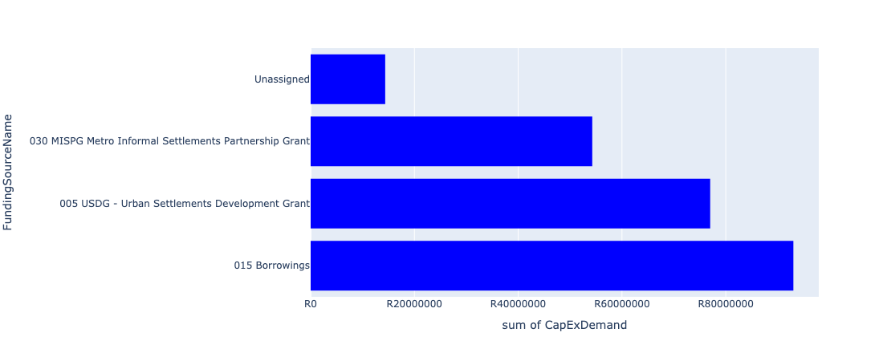

Figure 5.40: Ward 20 Departmental Requests

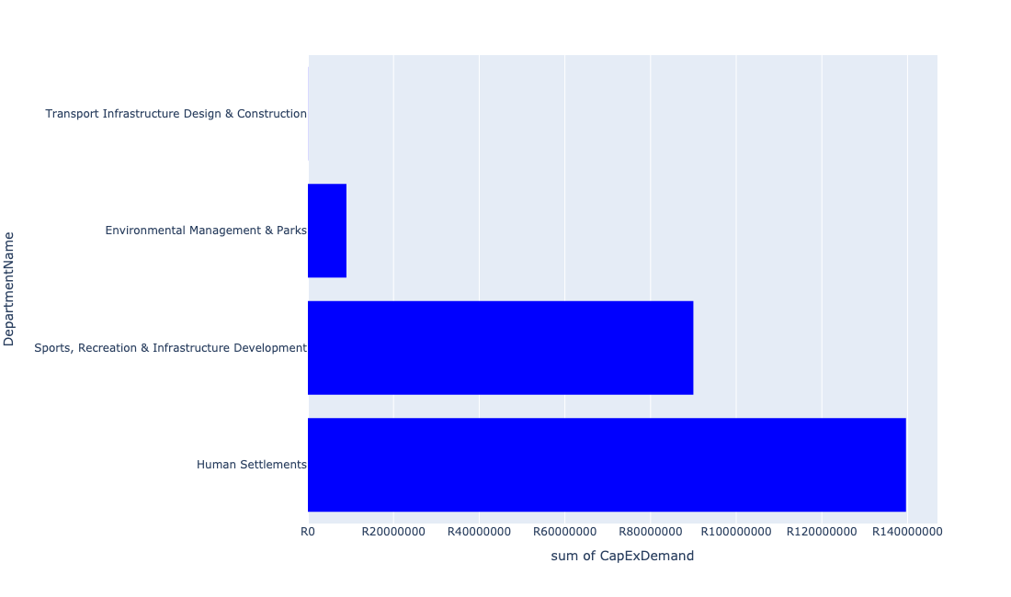

Table 5.20: Summary - Ward 20

|  |  |
| --- | --- |
| Item | Description |
| Total Capital Demand for Ward 20 - All Years | R238,667,487 Rank: 55 (1 = Highest) |
| Total Capital Demand for Ward 20 - MTREF | R148,635,423 Rank: 48 (1 = Highest) |
| Financial Years in which capital requirements are listed for Ward 20 | 2022, 2023, 2024, 2025, 2026 and 2027 |
| Financial Year with highest capital demand for Ward 20 | 2022 |
| Ward 20 intersecting feature used | Works Location |
| Total number of projects intersecting with Ward 20 | 7 Rank: 81 (1 = Highest) |

Table 5.21: All projects asking for budget in Ward 20

|  |  |  |  |
| --- | --- | --- | --- |
| Project ID | Project Name | Department | Project Budget |
| 712971915 | Revitalisation of the City-Development of Non-Motorised Transport Masterplan | Transport Infrastructure Design & Construction | R32,064 (0.01%) Budget spread across: 2027 |
| 712975481 | Rehabilitation of Wetlands - Mabopane | Environmental Management & Parks | R8,995,805 (3.77%) Budget spread across: 2022, 2023 and 2024 |
| 712967621 | (710863) Water provision - Kopanong X1 Phase 2 | Human Settlements | R31,239,481 (13.09%) Budget spread across: 2022, 2023 and 2024 |
| 712967615 | (710864) Sewer provision - Kopanong X1 Phase 2 | Human Settlements | R43,012,647 (18.02%) Budget spread across: 2022, 2023 and 2024 |
| 712967165 | Odi Stadium | Sports, Recreation & Infrastructure Development | R90,000,000 (37.71%) Budget spread across: 2025 and 2026 |
| 712970771 | (710864) Mabopane X11 | Human Settlements | R0 (0.00%) Budget spread across: 2022 |
| 712969230 | (710865) Construction of roads & stormwater - Mabopane X1 | Human Settlements | R65,387,490 (27.40%) Budget spread across: 2022 |

## Ward 21

Figure 5.41: Ward 21 Funding Requests

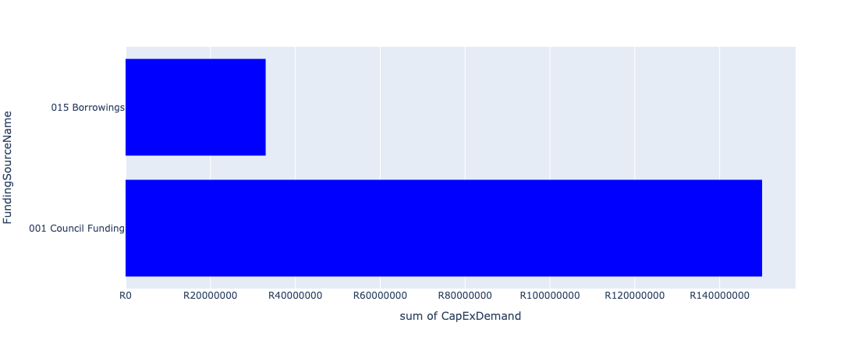

Figure 5.42: Ward 21 Departmental Requests

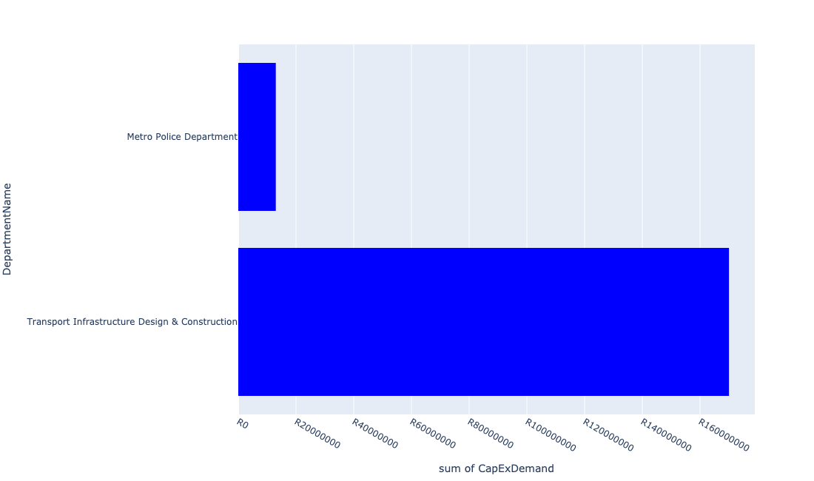

Table 5.21: Summary - Ward 21

|  |  |
| --- | --- |
| Item | Description |
| Total Capital Demand for Ward 21 - All Years | R183,012,305 Rank: 68 (1 = Highest) |
| Total Capital Demand for Ward 21 - MTREF | R91,000,000 Rank: 62 (1 = Highest) |
| Financial Years in which capital requirements are listed for Ward 21 | 2022, 2023, 2024, 2025, 2026 and 2027 |
| Financial Year with highest capital demand for Ward 21 | 2025 |
| Ward 21 intersecting feature used | Works Location |
| Total number of projects intersecting with Ward 21 | 6 Rank: 89 (1 = Highest) |

Table 5.22: All projects asking for budget in Ward 21

|  |  |  |  |
| --- | --- | --- | --- |
| Project ID | Project Name | Department | Project Budget |
| 712971915 | Revitalisation of the City-Development of Non-Motorised Transport Masterplan | Transport Infrastructure Design & Construction | R12,305 (0.01%) Budget spread across: 2027 |
| 712970771 | (710864) Mabopane X11 | Human Settlements | R0 (0.00%) Budget spread across: 2022 |
| 712975337 | Sub-Project: TMPD Station - Mabopane E | Metro Police Department | R13,000,000 (7.10%) Budget spread across: 2024 and 2025 |
| 712974180 | (712611) Upgrading of Mabopane Block B | Transport Infrastructure Design & Construction | R170,000,000 (92.89%) Budget spread across: 2022, 2023, 2024, 2025 and 2026 |

## Ward 22

Figure 5.43: Ward 22 Funding Requests

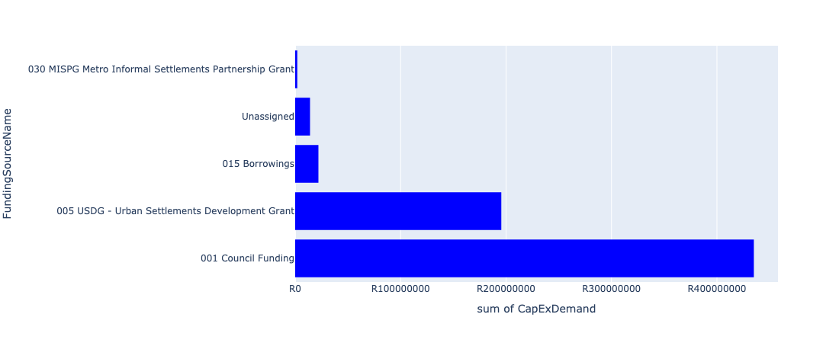

Figure 5.44: Ward 22 Departmental Requests

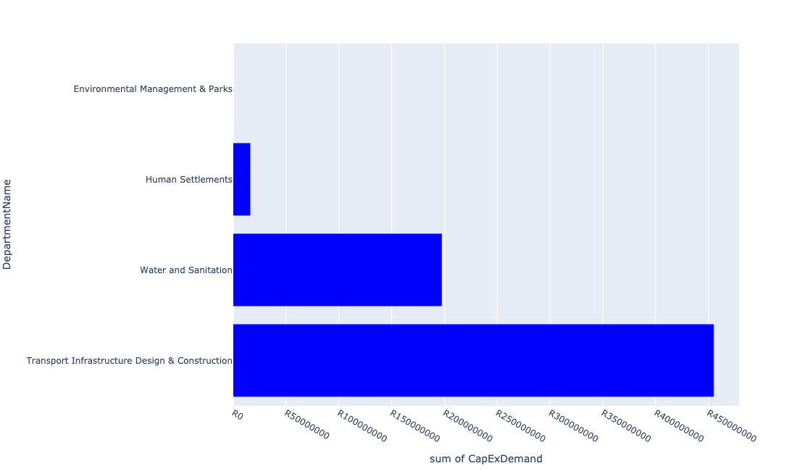

Table 5.22: Summary - Ward 22

|  |  |
| --- | --- |
| Item | Description |
| Total Capital Demand for Ward 22 - All Years | R665,619,906 Rank: 21 (1 = Highest) |
| Total Capital Demand for Ward 22 - MTREF | R495,582,231 Rank: 12 (1 = Highest) |
| Financial Years in which capital requirements are listed for Ward 22 | 2022, 2023, 2024, 2025, 2026, 2027, 2028, 2029 and 2030 |
| Financial Year with highest capital demand for Ward 22 | 2022 |
| Ward 22 intersecting feature used | Works Location |
| Total number of projects intersecting with Ward 22 | 15 Rank: 31 (1 = Highest) |

Table 5.23: All projects asking for budget in Ward 22

|  |  |  |  |
| --- | --- | --- | --- |
| Project ID | Project Name | Department | Project Budget |
| 712971915 | Revitalisation of the City-Development of Non-Motorised Transport Masterplan | Transport Infrastructure Design & Construction | R37,675 (0.01%) Budget spread across: 2027 |
| 712975481 | Rehabilitation of Wetlands - Mabopane | Environmental Management & Parks | R4,195 (0.00%) Budget spread across: 2022, 2023 and 2024 |
| 712970771 | (710864) Mabopane X11 | Human Settlements | R0 (0.00%) Budget spread across: 2022 |
| 712975196 | (711863)Internal Roads Mabopane Block R (Phase 2) | Transport Infrastructure Design & Construction | R160,000,000 (24.04%) Budget spread across: 2022, 2023, 2024, 2025, 2026, 2027, 2028, 2029 and 2030 |
| 712974183 | (712221) Upgrading of Roads: Mabopane Block U | Transport Infrastructure Design & Construction | R140,000,000 (21.03%) Budget spread across: 2022, 2023, 2024, 2025 and 2026 |
| 1022 | (712534) New Klipgat Reservoir | Water and Sanitation | R2,000,000 (0.30%) Budget spread across: 2022 |
| 444 | (710411C) Klipgat WWTW: Upgrading of existing infrastructure to 40Ml/d | Water and Sanitation | R195,500,000 (29.37%) Budget spread across: 2022 and 2023 |
| 712973891 | (711863) Internal Roads Mabopane Block R (Phase 1) | Transport Infrastructure Design & Construction | R155,000,000 (23.29%) Budget spread across: 2022, 2023, 2024, 2025, 2026, 2027, 2028, 2029 and 2030 |
| 712970772 | (710864) Sewer provision - Mabopane X12 | Human Settlements | R11,078,036 (1.66%) Budget spread across: 2022 |
| 712970760 | (710863) Water provision- Mabopane X12 | Human Settlements | R5,000,000 (0.75%) Budget spread across: 2022 |

## Ward 23

Figure 5.45: Ward 23 Funding Requests

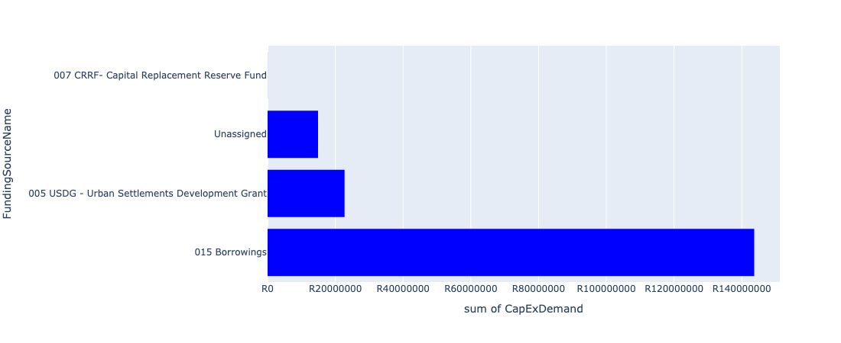

Figure 5.46: Ward 23 Departmental Requests

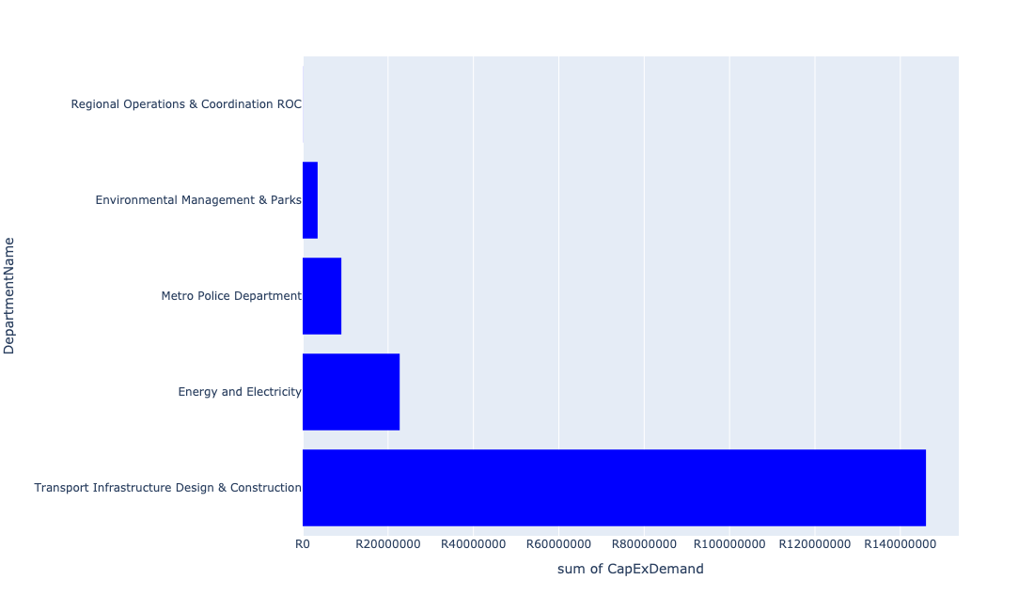

Table 5.23: Summary - Ward 23

|  |  |
| --- | --- |
| Item | Description |
| Total Capital Demand for Ward 23 - All Years | R173,665,600 Rank: 71 (1 = Highest) |
| Total Capital Demand for Ward 23 - MTREF | R73,717,782 Rank: 71 (1 = Highest) |
| Financial Years in which capital requirements are listed for Ward 23 | 2022, 2023, 2024, 2025, 2026, 2027, 2028, 2029 and 2030 |
| Financial Year with highest capital demand for Ward 23 | 2024 |
| Ward 23 intersecting feature used | Works Location |
| Total number of projects intersecting with Ward 23 | 7 Rank: 81 (1 = Highest) |

Table 5.24: All projects asking for budget in Ward 23

|  |  |  |  |
| --- | --- | --- | --- |
| Project ID | Project Name | Department | Project Budget |
| 712971915 | Revitalisation of the City-Development of Non-Motorised Transport Masterplan | Transport Infrastructure Design & Construction | R22,177 (0.01%) Budget spread across: 2027 |
| 712970748 | R6 Machinery and Equipment to ensure basic infrastructure reliability | Regional Operations & Coordination ROC | R25,938 (0.01%) Budget spread across: 2022 and 2023 |
| 712975437 | Sub-Project: TMPD Station - Mamelodi (Extension 10) | Metro Police Department | R9,061,211 (5.22%) Budget spread across: 2022, 2023 and 2024 |
| 712975391 | (712279) Mamelodi II 132/11kV Substation | Energy and Electricity | R3,597,516 (2.07%) Budget spread across: 2026 |
| 1074 | (712612) Upgrading of Sibande Street, Mamelodi | Transport Infrastructure Design & Construction | R145,981,798 (84.06%) Budget spread across: 2022, 2023, 2024, 2025, 2026, 2027, 2028, 2029 and 2030 |
| 712974121 | (712279) Wildebees - Elland 132kV Power line | Energy and Electricity | R19,128,267 (11.01%) Budget spread across: 2023 and 2024 |
| 712975304 | Upgrade of Security and visitor infrastructure in Moretele resort | Environmental Management & Parks | R3,500,000 (2.02%) Budget spread across: 2022 and 2023 |

## Ward 24

Figure 5.47: Ward 24 Funding Requests

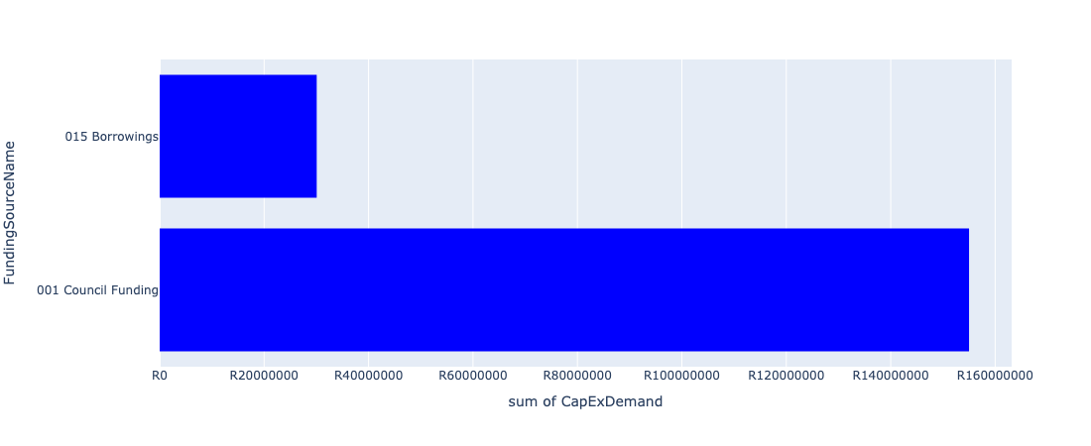

Figure 5.48: Ward 24 Departmental Requests

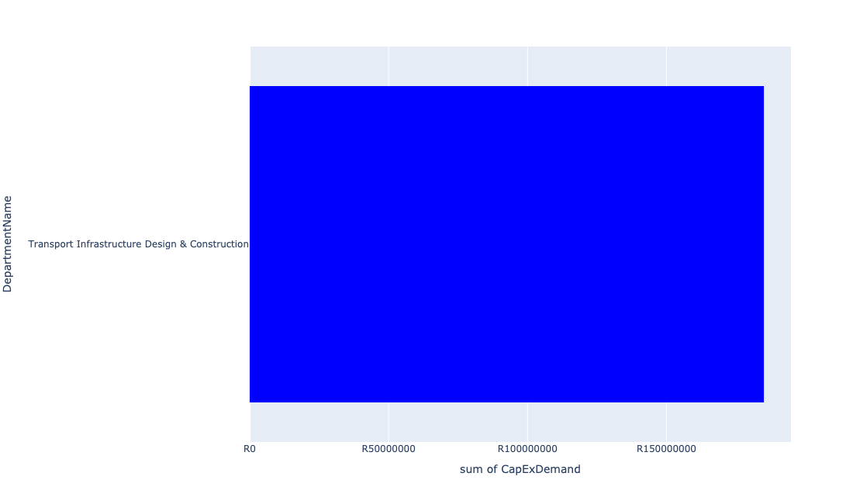

Table 5.24: Summary - Ward 24

|  |  |
| --- | --- |
| Item | Description |
| Total Capital Demand for Ward 24 - All Years | R155,070,511 Rank: 76 (1 = Highest) |
| Total Capital Demand for Ward 24 - MTREF | R65,000,000 Rank: 74 (1 = Highest) |
| Financial Years in which capital requirements are listed for Ward 24 | 2022, 2023, 2024, 2025, 2026, 2027, 2028, 2029 and 2030 |
| Financial Year with highest capital demand for Ward 24 | 2022 |
| Ward 24 intersecting feature used | Works Location |
| Total number of projects intersecting with Ward 24 | 3 Rank: 105 (1 = Highest) |

Table 5.25: All projects asking for budget in Ward 24

|  |  |  |  |
| --- | --- | --- | --- |
| Project ID | Project Name | Department | Project Budget |
| 712971915 | Revitalisation of the City-Development of Non-Motorised Transport Masterplan | Transport Infrastructure Design & Construction | R70,511 (0.05%) Budget spread across: 2027 |
| 712975712 | The paving of 4th Road (Jackie Road), north of Klip Avenue in Winterveld | Transport Infrastructure Design & Construction | R30,000,000 (19.35%) Budget spread across: 2027, 2028 and 2029 |
| 768 | (711863) Internal Roads: Northern Areas: Mandela Village (South) | Transport Infrastructure Design & Construction | R155,000,000 (99.95%) Budget spread across: 2022, 2023, 2024, 2025, 2026, 2027, 2028, 2029 and 2030 |

## Ward 25

Figure 5.49: Ward 25 Funding Requests

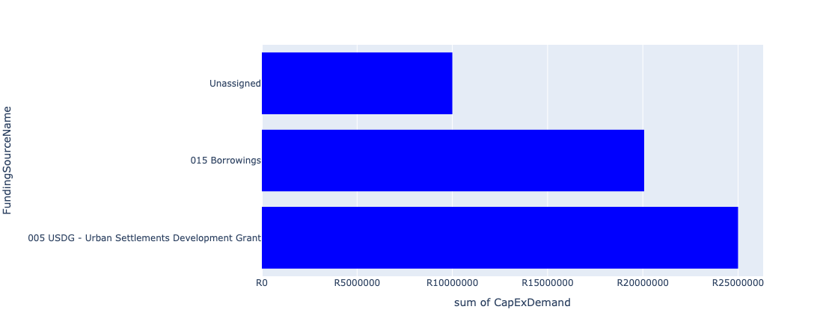

Figure 5.50: Ward 25 Departmental Requests

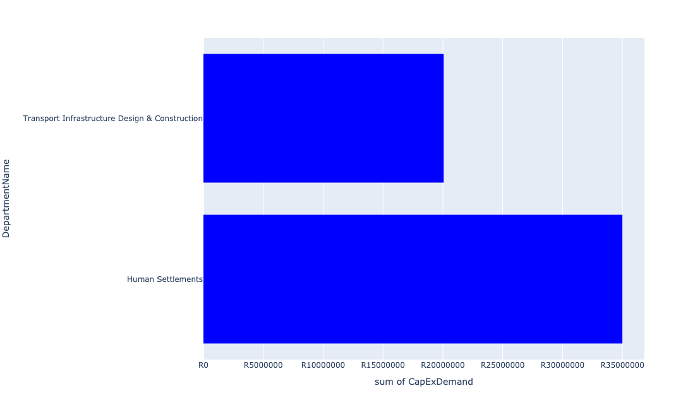

Table 5.25: Summary - Ward 25

|  |  |
| --- | --- |
| Item | Description |
| Total Capital Demand for Ward 25 - All Years | R55,068,649 Rank: 94 (1 = Highest) |
| Total Capital Demand for Ward 25 - MTREF | R35,000,000 Rank: 87 (1 = Highest) |
| Financial Years in which capital requirements are listed for Ward 25 | 2022, 2023, 2024, 2025, 2026 and 2027 |
| Financial Year with highest capital demand for Ward 25 | 2023 |
| Ward 25 intersecting feature used | Works Location |
| Total number of projects intersecting with Ward 25 | 4 Rank: 101 (1 = Highest) |

Table 5.26: All projects asking for budget in Ward 25

|  |  |  |  |
| --- | --- | --- | --- |
| Project ID | Project Name | Department | Project Budget |
| 712971915 | Revitalisation of the City-Development of Non-Motorised Transport Masterplan | Transport Infrastructure Design & Construction | R14,725 (0.03%) Budget spread across: 2027 |
| 712974160 | (711164) Upgrading of roads and stormwater systems in Soshanguve Block W: North | Transport Infrastructure Design & Construction | R20,053,924 (36.42%) Budget spread across: 2022, 2023, 2024, 2025, 2026 and 2027 |
| 712972936 | (710864) Bulk Sewer Line - Winterveldt | Human Settlements | R35,000,000 (63.56%) Budget spread across: 2022, 2023 and 2024 |

## Ward 26

Figure 5.51: Ward 26 Funding Requests

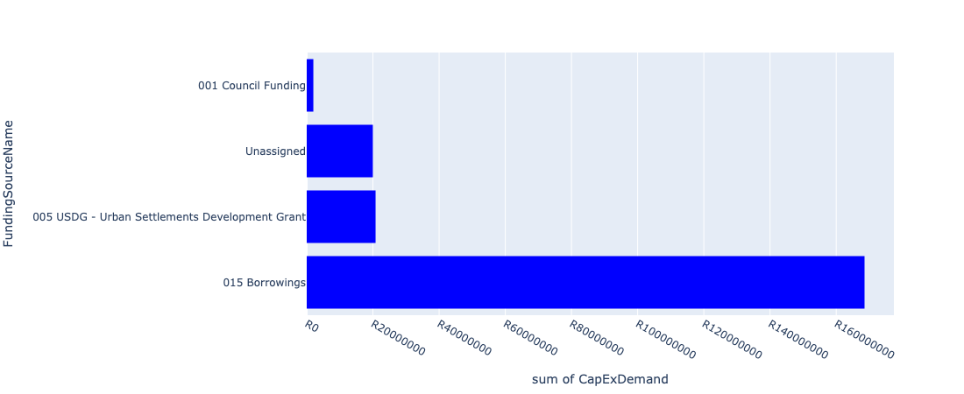

Figure 5.52: Ward 26 Departmental Requests

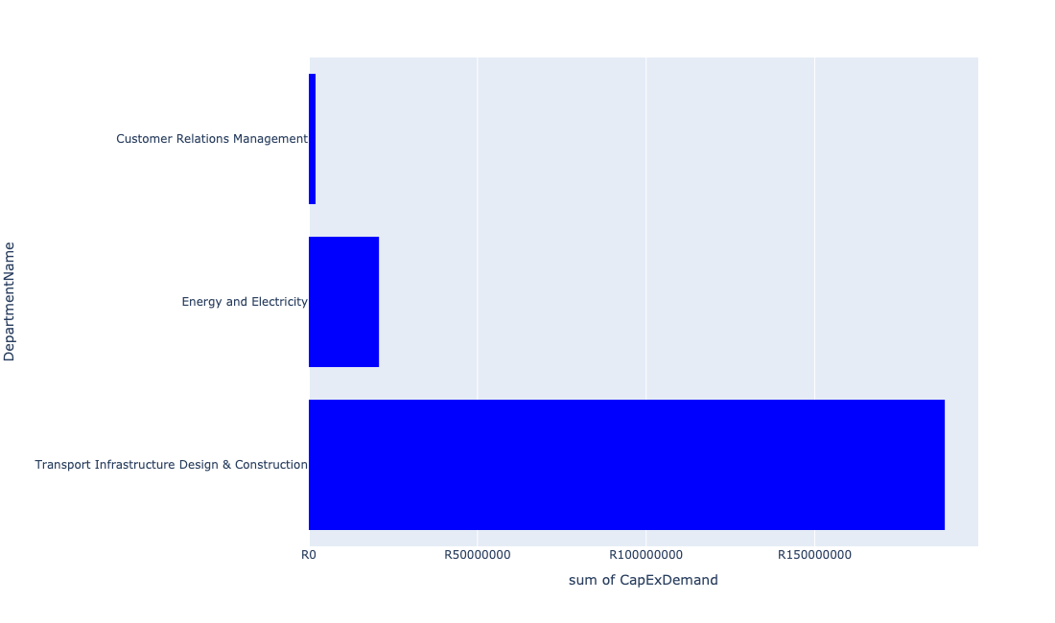

Table 5.26: Summary - Ward 26

|  |  |
| --- | --- |
| Item | Description |
| Total Capital Demand for Ward 26 - All Years | R211,338,363 Rank: 62 (1 = Highest) |
| Total Capital Demand for Ward 26 - MTREF | R82,492,612 Rank: 64 (1 = Highest) |
| Financial Years in which capital requirements are listed for Ward 26 | 2022, 2023, 2024, 2025, 2026, 2027, 2028, 2029 and 2030 |
| Financial Year with highest capital demand for Ward 26 | 2024 |
| Ward 26 intersecting feature used | Works Location |
| Total number of projects intersecting with Ward 26 | 8 Rank: 74 (1 = Highest) |

Table 5.27: All projects asking for budget in Ward 26

|  |  |  |  |
| --- | --- | --- | --- |
| Project ID | Project Name | Department | Project Budget |
| 712971915 | Revitalisation of the City-Development of Non-Motorised Transport Masterplan | Transport Infrastructure Design & Construction | R15,612 (0.01%) Budget spread across: 2027 |
| 712974542 | (712220) Soshanguve Block FF East Area 4 | Transport Infrastructure Design & Construction | R54,602,750 (25.84%) Budget spread across: 2022, 2023, 2024 and 2025 |
| 712969084 | (712279) Soshanguve - JJ 132KV Power Line | Energy and Electricity | R20,800,577 (9.84%) Budget spread across: 2022, 2023 and 2024 |
| 712975539 | Refurbishment of Soshanguve block KK customer care centre | Customer Relations Management | R2,000,000 (0.95%) Budget spread across: 2027 |
| 712974357 | (712220) Upgrading of Culverts | Transport Infrastructure Design & Construction | R131,885,665 (62.40%) Budget spread across: 2023, 2024, 2025, 2026, 2027, 2028, 2029 and 2030 |
| 712974163 | (711164) Upgrading of roads and stormwater systems in Soshanguve Block W: South West | Transport Infrastructure Design & Construction | R280,172 (0.13%) Budget spread across: 2022, 2023, 2024, 2025, 2026 and 2027 |
| 712974160 | (711164) Upgrading of roads and stormwater systems in Soshanguve Block W: North | Transport Infrastructure Design & Construction | R1,753,587 (0.83%) Budget spread across: 2022, 2023, 2024, 2025, 2026 and 2027 |

## Ward 27

Figure 5.53: Ward 27 Funding Requests

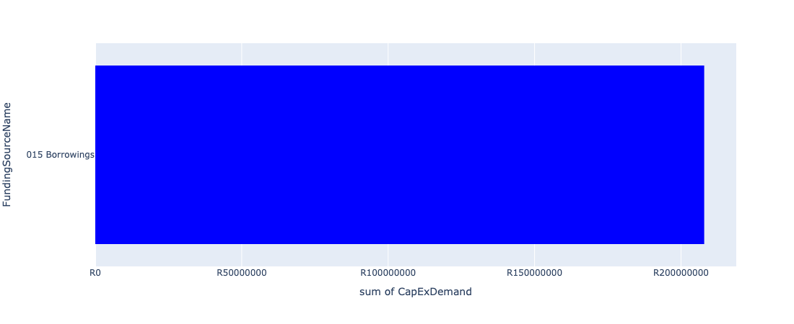

Figure 5.54: Ward 27 Departmental Requests

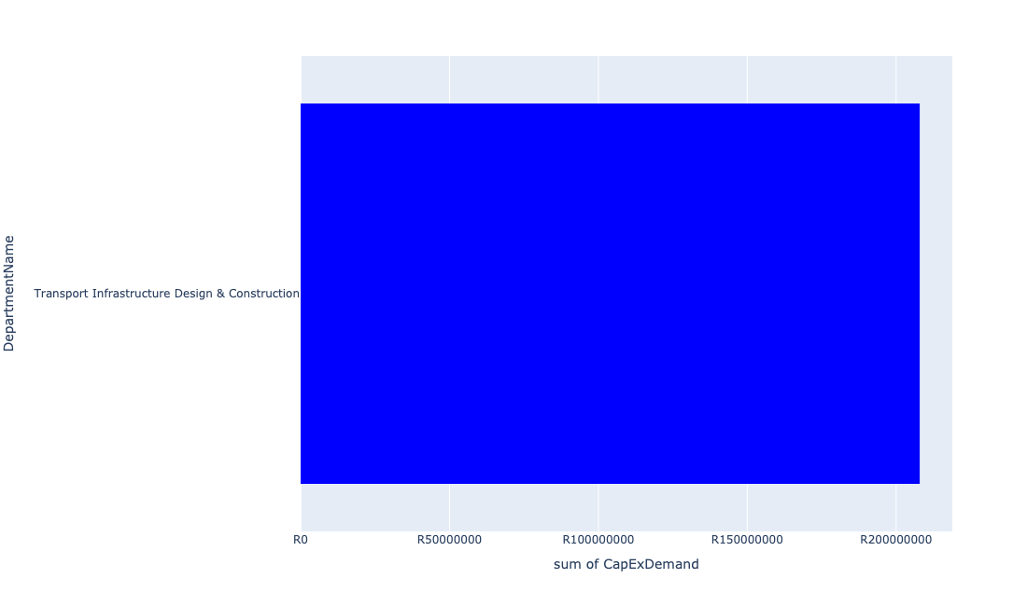

Table 5.27: Summary - Ward 27

|  |  |
| --- | --- |
| Item | Description |
| Total Capital Demand for Ward 27 - All Years | R207,923,699 Rank: 64 (1 = Highest) |
| Total Capital Demand for Ward 27 - MTREF | R0 Rank: 106 (1 = Highest) |
| Financial Years in which capital requirements are listed for Ward 27 | 2025, 2026 and 2027 |
| Financial Year with highest capital demand for Ward 27 | 2026 |
| Ward 27 intersecting feature used | Works Location |
| Total number of projects intersecting with Ward 27 | 6 Rank: 89 (1 = Highest) |

Table 5.28: All projects asking for budget in Ward 27

|  |  |  |  |
| --- | --- | --- | --- |
| Project ID | Project Name | Department | Project Budget |
| 712971915 | Revitalisation of the City-Development of Non-Motorised Transport Masterplan | Transport Infrastructure Design & Construction | R11,382 (0.01%) Budget spread across: 2027 |
| 712974163 | (711164) Upgrading of roads and stormwater systems in Soshanguve Block W: South West | Transport Infrastructure Design & Construction | R45,719,828 (21.99%) Budget spread across: 2022, 2023, 2024, 2025, 2026 and 2027 |
| 712974160 | (711164) Upgrading of roads and stormwater systems in Soshanguve Block W: North | Transport Infrastructure Design & Construction | R24,192,489 (11.64%) Budget spread across: 2022, 2023, 2024, 2025, 2026 and 2027 |
| 712974161 | (711164) Upgrading of roads and stormwater systems in Soshanguve Block W: Central West | Transport Infrastructure Design & Construction | R46,000,000 (22.12%) Budget spread across: 2022, 2023, 2024, 2025, 2026 and 2027 |
| 712969545 | (711164) Upgrading of roads and stormwater systems in Soshanguve Block W: South East | Transport Infrastructure Design & Construction | R46,000,000 (22.12%) Budget spread across: 2022, 2023, 2024, 2025, 2026 and 2027 |
| 712969544 | (711164) Upgrading of roads and stormwater systems in Soshanguve Block W: North East | Transport Infrastructure Design & Construction | R46,000,000 (22.12%) Budget spread across: 2022, 2023, 2024, 2025, 2026 and 2027 |

## Ward 28

Figure 5.55: Ward 28 Funding Requests

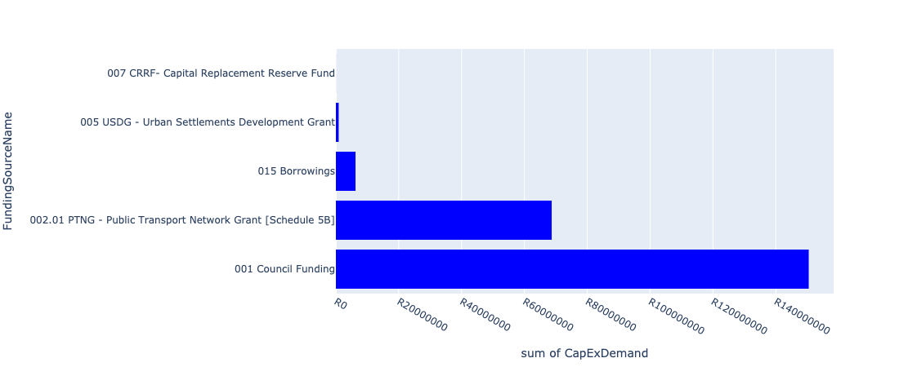

Figure 5.56: Ward 28 Departmental Requests

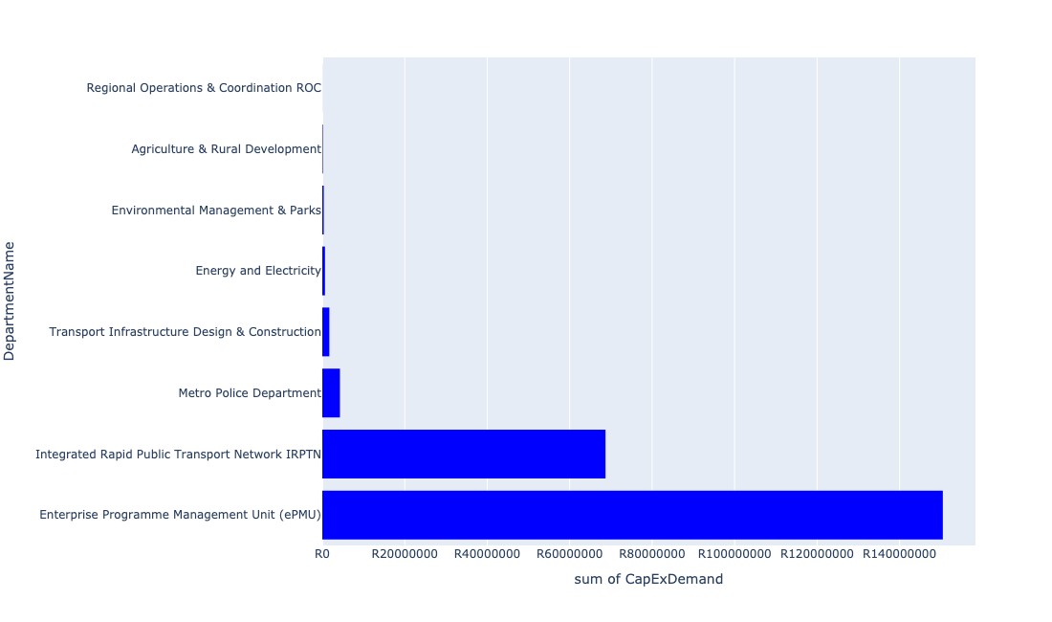

Table 5.28: Summary - Ward 28

|  |  |
| --- | --- |
| Item | Description |
| Total Capital Demand for Ward 28 - All Years | R226,065,232 Rank: 57 (1 = Highest) |
| Total Capital Demand for Ward 28 - MTREF | R225,322,559 Rank: 32 (1 = Highest) |
| Financial Years in which capital requirements are listed for Ward 28 | 2022, 2023, 2024, 2025, 2026 and 2027 |
| Financial Year with highest capital demand for Ward 28 | 2022 |
| Ward 28 intersecting feature used | Works Location |
| Total number of projects intersecting with Ward 28 | 13 Rank: 42 (1 = Highest) |

Table 5.29: All projects asking for budget in Ward 28

|  |  |  |  |
| --- | --- | --- | --- |
| Project ID | Project Name | Department | Project Budget |
| 712971915 | Revitalisation of the City-Development of Non-Motorised Transport Masterplan | Transport Infrastructure Design & Construction | R13,316 (0.01%) Budget spread across: 2027 |
| 712970748 | R6 Machinery and Equipment to ensure basic infrastructure reliability | Regional Operations & Coordination ROC | R15,575 (0.01%) Budget spread across: 2022 and 2023 |
| 712975437 | Sub-Project: TMPD Station - Mamelodi (Extension 10) | Metro Police Department | R1,382,861 (0.61%) Budget spread across: 2022, 2023 and 2024 |
| 712975391 | (712279) Mamelodi II 132/11kV Substation | Energy and Electricity | R12,652 (0.01%) Budget spread across: 2026 |
| 712974121 | (712279) Wildebees - Elland 132kV Power line | Energy and Electricity | R638,686 (0.28%) Budget spread across: 2023 and 2024 |
| 712973721 | Upgrade of Nelson Mandela Park Tsamaya avenue | Agriculture & Rural Development | R138,511 (0.06%) Budget spread across: 2022 |
| 712969053 | (712591) Denneboom Depot | Integrated Rapid Public Transport Network IRPTN | R28,681,369 (12.69%) Budget spread across: 2022 and 2023 |
| 712969619 | (713044) Hatherley Cemetery | Environmental Management & Parks | R351,062 (0.16%) Budget spread across: 2022, 2023 and 2025 |
| 712975435 | Sub-Project: TMPD Station - Nellmapius (Extension 3) | Metro Police Department | R2,897,351 (1.28%) Budget spread across: 2023 and 2024 |
| 712974846 | (714048) Tshwane Automotive SEZ Phase 1 Bulk Infrastructure Roll out | Enterprise Programme Management Unit (ePMU) | R150,489,324 (66.57%) Budget spread across: 2022 |
| 1003 | (712521) Collector Road Backlogs: Mamelodi | Transport Infrastructure Design & Construction | R1,700,000 (0.75%) Budget spread across: 2022, 2023, 2024 and 2025 |
| 712969047 | (712591) Denneboom Intermodal facility | Integrated Rapid Public Transport Network IRPTN | R40,000,000 (17.69%) Budget spread across: 2022 |

## Ward 29

Figure 5.57: Ward 29 Funding Requests

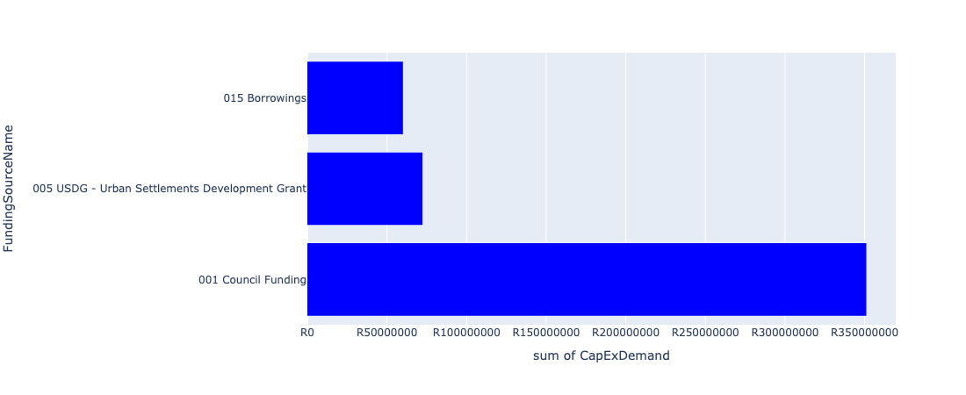

Figure 5.58: Ward 29 Departmental Requests

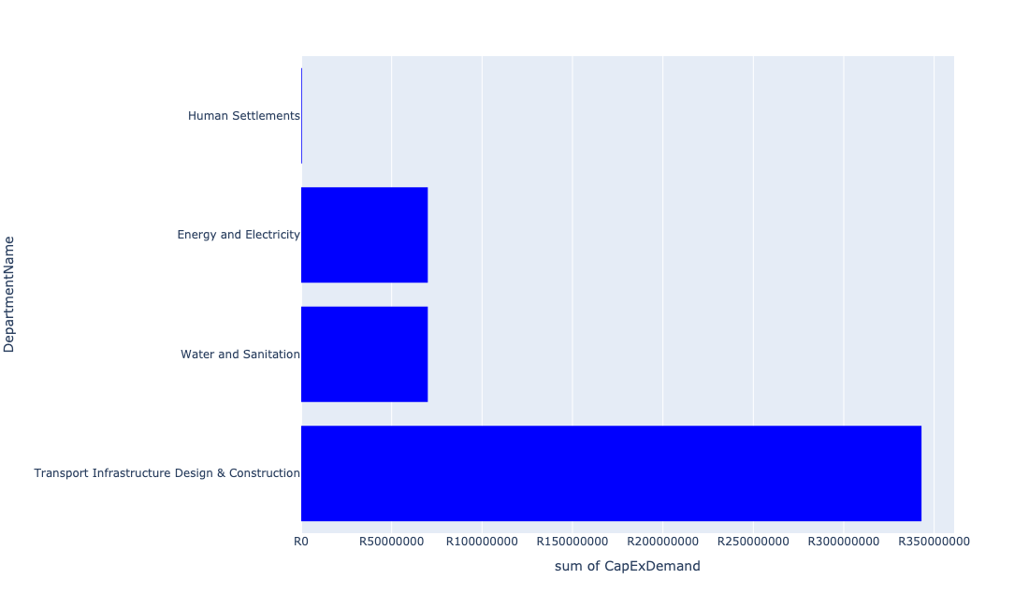

Table 5.29: Summary - Ward 29

|  |  |
| --- | --- |
| Item | Description |
| Total Capital Demand for Ward 29 - All Years | R483,391,072 Rank: 34 (1 = Highest) |
| Total Capital Demand for Ward 29 - MTREF | R265,907,713 Rank: 24 (1 = Highest) |
| Financial Years in which capital requirements are listed for Ward 29 | 2022, 2023, 2024, 2025, 2026, 2027, 2028, 2029, 2030 and 2031 |
| Financial Year with highest capital demand for Ward 29 | 2022 |
| Ward 29 intersecting feature used | Works Location |
| Total number of projects intersecting with Ward 29 | 13 Rank: 42 (1 = Highest) |

Table 5.30: All projects asking for budget in Ward 29

|  |  |  |  |
| --- | --- | --- | --- |
| Project ID | Project Name | Department | Project Budget |
| 712971915 | Revitalisation of the City-Development of Non-Motorised Transport Masterplan | Transport Infrastructure Design & Construction | R19,142 (0.00%) Budget spread across: 2027 |
| 522 | (710657) Mabopane Station Modal Interchange | Transport Infrastructure Design & Construction | R49,669,294 (10.28%) Budget spread across: 2022, 2023, 2024, 2025, 2026, 2027, 2028, 2029 and 2030 |
| 712975466 | Upgrading of Existing rank to cater for the southern west side ( road, traders, pedestrian paths linking townships, malls Infrastructure ) into interchange | Transport Infrastructure Design & Construction | R64,000,000 (13.24%) Budget spread across: 2022, 2023, 2024, 2025, 2026, 2027, 2028, 2029 and 2031 |
| 712967398 | Mabopane EW ( Ext 2) - roads and storm water | Human Settlements | R200,000 (0.04%) Budget spread across: 2022 |
| 712967397 | Mabopane EW (Ext 2) - sewer | Human Settlements | R200,000 (0.04%) Budget spread across: 2022 |
| 1036 | (712545) Upgrading of Buitekant Street | Transport Infrastructure Design & Construction | R216,655,918 (44.82%) Budget spread across: 2022, 2023, 2024, 2025 and 2026 |
| 828 | (71212R) Rietgat Outfall Sewer Upgrade | Water and Sanitation | R70,000,000 (14.48%) Budget spread across: 2022, 2023, 2024, 2025 and 2026 |
| 295 | (710128) Concrete Canal: Sam Malema Road, Winterveldt | Transport Infrastructure Design & Construction | R12,646,718 (2.62%) Budget spread across: 2022 and 2023 |
| 712974103 | (714008) Electricity Distribution Loss | Energy and Electricity | R70,000,000 (14.48%) Budget spread across: 2022 and 2024 |

## Ward 30

Figure 5.59: Ward 30 Funding Requests

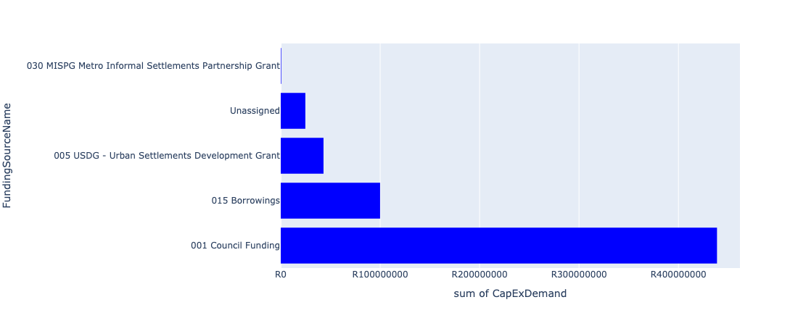

Figure 5.60: Ward 30 Departmental Requests

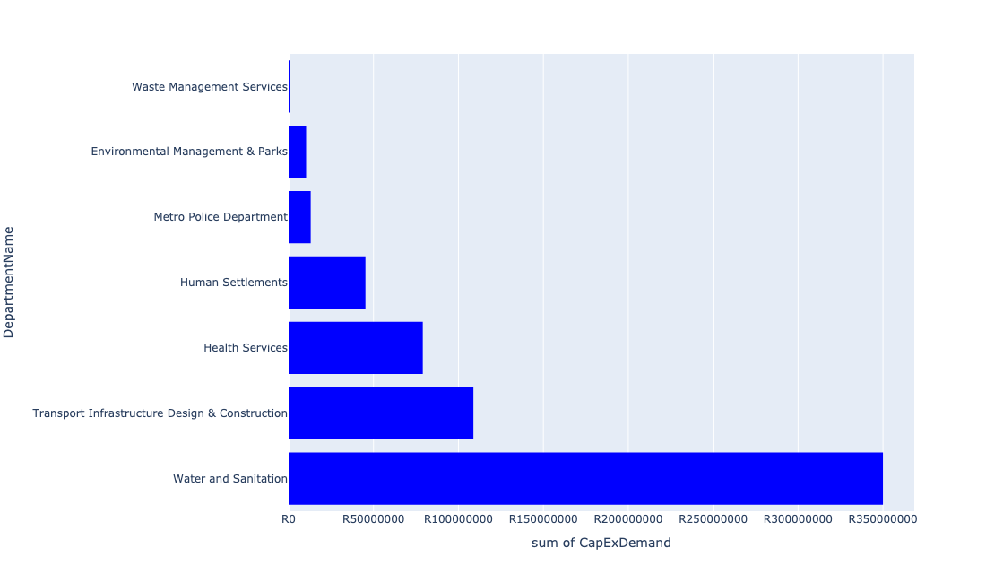

Table 5.30: Summary - Ward 30

|  |  |
| --- | --- |
| Item | Description |
| Total Capital Demand for Ward 30 - All Years | R603,848,405 Rank: 23 (1 = Highest) |
| Total Capital Demand for Ward 30 - MTREF | R174,207,236 Rank: 43 (1 = Highest) |
| Financial Years in which capital requirements are listed for Ward 30 | 2022, 2023, 2024, 2025, 2026, 2027, 2028, 2029 and 2030 |
| Financial Year with highest capital demand for Ward 30 | 2026 |
| Ward 30 intersecting feature used | Works Location |
| Total number of projects intersecting with Ward 30 | 16 Rank: 26 (1 = Highest) |

Table 5.31: All projects asking for budget in Ward 30

|  |  |  |  |
| --- | --- | --- | --- |
| Project ID | Project Name | Department | Project Budget |
| 712971915 | Revitalisation of the City-Development of Non-Motorised Transport Masterplan | Transport Infrastructure Design & Construction | R10,872 (0.00%) Budget spread across: 2027 |
| 712975336 | Sub-Project: TMPD Station - Ga-Rankuwa | Metro Police Department | R13,000,000 (2.15%) Budget spread across: 2023 and 2024 |
| 712974883 | (710864) Sewer reticulation - Garankuwa X10 | Human Settlements | R499,644 (0.08%) Budget spread across: 2022 |
| 712974545 | (710411C2) Klipgat WWTW Phase3: Upgrading of existing infrastructure and extensions of treatment capacity to 106 Ml/d | Water and Sanitation | R350,000,000 (57.96%) Budget spread across: 2024, 2025, 2026, 2027 and 2028 |
| 712974385 | (710865) Construction of roads & stormwater - Garankuwa | Human Settlements | R44,635,972 (7.39%) Budget spread across: 2022 and 2023 |
| 712967836 | New Garankuwa Zone 15 Clinic | Health Services | R79,000,000 (13.08%) Budget spread across: 2022, 2023 and 2024 |
| 712967493 | (712918) Ga-rankuwa Transport Facilities | Transport Infrastructure Design & Construction | R84,000,000 (13.91%) Budget spread across: 2022, 2023, 2024, 2025, 2026, 2027, 2028, 2029 and 2030 |
| 712967184 | (712983) Extension of Ga-Rankuwa Cemetery | Environmental Management & Parks | R10,300,000 (1.71%) Budget spread across: 2023, 2025 and 2026 |
| 712973890 | (711863) Internal Roads Ga-Rankuwa Zone 5 | Transport Infrastructure Design & Construction | R49,323 (0.01%) Budget spread across: 2022, 2023, 2024, 2025, 2026, 2027, 2028, 2029 and 2030 |
| 712973889 | (711863) Internal Roads Ga-Rankuwa Zone 4 | Transport Infrastructure Design & Construction | R24,747,034 (4.10%) Budget spread across: 2022, 2023, 2024, 2025, 2026, 2027, 2028, 2029 and 2030 |
| 712972963 | (710863) Water provision - Garankuwa X10 - Water Connections | Human Settlements | R105,559 (0.02%) Budget spread across: 2022 |
| 712969346 | (713041) New fork lift for Garankuwa Buy Back Centre (Recycling centre) | Waste Management Services | R600,000 (0.10%) Budget spread across: 2022 and 2023 |

## Ward 31

Figure 5.61: Ward 31 Funding Requests

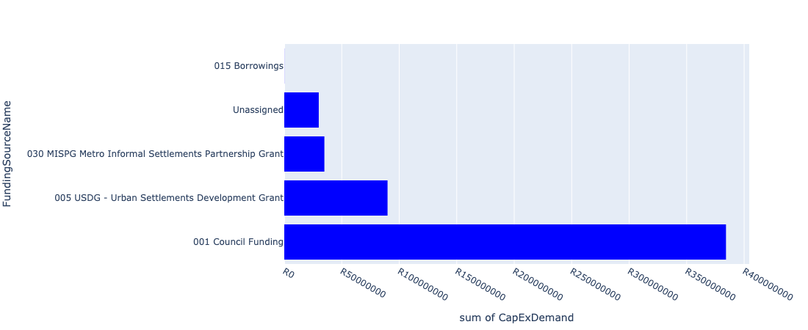

Figure 5.62: Ward 31 Departmental Requests

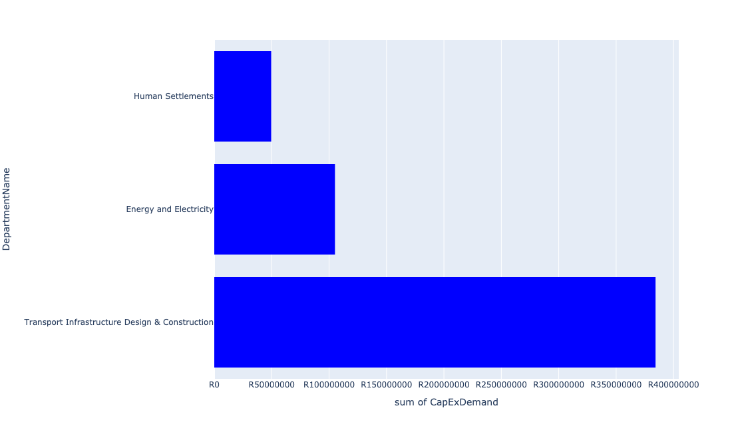

Table 5.31: Summary - Ward 31

|  |  |
| --- | --- |
| Item | Description |
| Total Capital Demand for Ward 31 - All Years | R539,009,260 Rank: 27 (1 = Highest) |
| Total Capital Demand for Ward 31 - MTREF | R271,070,580 Rank: 23 (1 = Highest) |
| Financial Years in which capital requirements are listed for Ward 31 | 2022, 2023, 2024, 2025, 2026, 2027, 2028, 2029 and 2030 |
| Financial Year with highest capital demand for Ward 31 | 2024 |
| Ward 31 intersecting feature used | Works Location |
| Total number of projects intersecting with Ward 31 | 10 Rank: 61 (1 = Highest) |

Table 5.32: All projects asking for budget in Ward 31

|  |  |  |  |
| --- | --- | --- | --- |
| Project ID | Project Name | Department | Project Budget |
| 712971915 | Revitalisation of the City-Development of Non-Motorised Transport Masterplan | Transport Infrastructure Design & Construction | R95,409 (0.02%) Budget spread across: 2027 |
| 712973890 | (711863) Internal Roads Ga-Rankuwa Zone 5 | Transport Infrastructure Design & Construction | R169,950,677 (31.53%) Budget spread across: 2022, 2023, 2024, 2025, 2026, 2027, 2028, 2029 and 2030 |
| 712973889 | (711863) Internal Roads Ga-Rankuwa Zone 4 | Transport Infrastructure Design & Construction | R140,252,990 (26.02%) Budget spread across: 2022, 2023, 2024, 2025, 2026, 2027, 2028, 2029 and 2030 |
| 712975465 | Providing new service and integration of minibus type transfer service in the area around Garankuwa | Transport Infrastructure Design & Construction | R74,000,000 (13.73%) Budget spread across: 2022, 2023, 2024, 2025, 2026, 2027, 2028, 2029 and 2030 |
| 712967648 | (710863) Water provision - Rama City | Human Settlements | R0 (0.00%) Budget spread across: 2022, 2023 and 2024 |
| 712974118 | (712279) Rama City 132kV power line | Energy and Electricity | R15,109,093 (2.80%) Budget spread across: 2023, 2024 and 2025 |
| 712974117 | (712279) Rama City 132/11kV substation | Energy and Electricity | R90,000,000 (16.70%) Budget spread across: 2023, 2024 and 2025 |
| 712972934 | (710863) Water provision - Rama City (20 ML Reservoir) | Human Settlements | R49,601,090 (9.20%) Budget spread across: 2022, 2023 and 2024 |

## Ward 32

Figure 5.63: Ward 32 Funding Requests

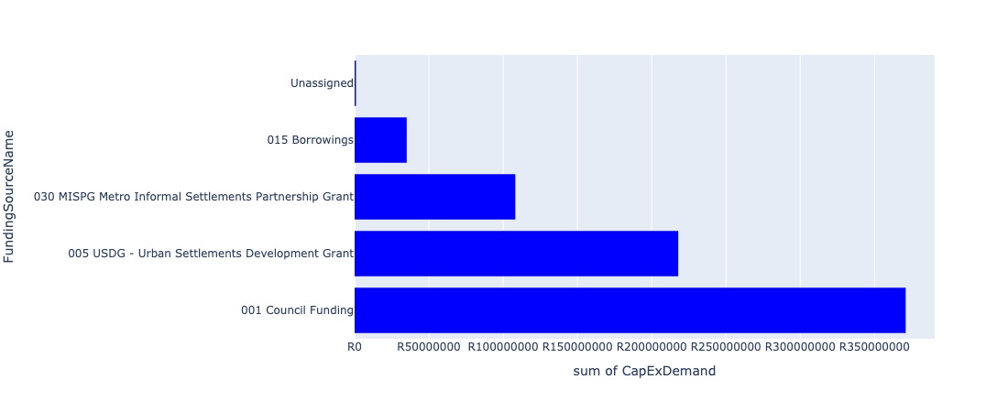

Figure 5.64: Ward 32 Departmental Requests

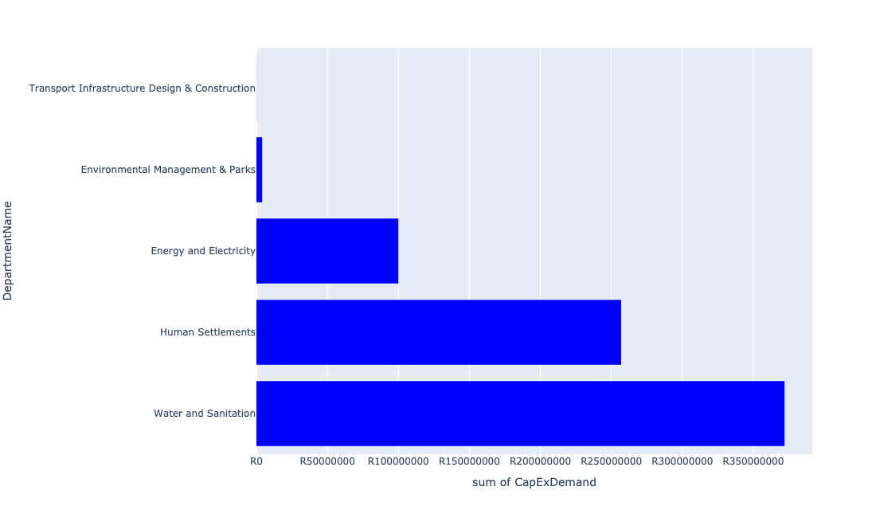

Table 5.32: Summary - Ward 32

|  |  |
| --- | --- |
| Item | Description |
| Total Capital Demand for Ward 32 - All Years | R732,990,107 Rank: 19 (1 = Highest) |
| Total Capital Demand for Ward 32 - MTREF | R380,922,861 Rank: 15 (1 = Highest) |
| Financial Years in which capital requirements are listed for Ward 32 | 2022, 2023, 2024, 2025, 2026, 2027 and 2028 |
| Financial Year with highest capital demand for Ward 32 | 2026 |
| Ward 32 intersecting feature used | Works Location |
| Total number of projects intersecting with Ward 32 | 12 Rank: 47 (1 = Highest) |

Table 5.33: All projects asking for budget in Ward 32

|  |  |  |  |
| --- | --- | --- | --- |
| Project ID | Project Name | Department | Project Budget |
| 712971915 | Revitalisation of the City-Development of Non-Motorised Transport Masterplan | Transport Infrastructure Design & Construction | R67,246 (0.01%) Budget spread across: 2027 |
| 712974883 | (710864) Sewer reticulation - Garankuwa X10 | Human Settlements | R500,356 (0.07%) Budget spread across: 2022 |
| 712972963 | (710863) Water provision - Garankuwa X10 - Water Connections | Human Settlements | R894,441 (0.12%) Budget spread across: 2022 |
| 712967648 | (710863) Water provision - Rama City | Human Settlements | R0 (0.00%) Budget spread across: 2022, 2023 and 2024 |
| 712967605 | (710865) Construction of roads & stormwater - Soshanguve South X13 | Human Settlements | R32,802,361 (4.48%) Budget spread across: 2022 and 2023 |
| 712975514 | Construction of Entrance gate and ablution facilities - Toloane Nature Reserve | Environmental Management & Parks | R2,997,054 (0.41%) Budget spread across: 2022 and 2023 |
| 712975513 | Construction of pedestrian bridge at Toloane Nature Reserve | Environmental Management & Parks | R1,000,000 (0.14%) Budget spread across: 2028 |
| 712974374 | (710411C1) Klipgat WWTW Phse2: Upgrading of existing infrastructure and extensions of treatment capacity to 73Ml/d | Water and Sanitation | R340,000,000 (46.39%) Budget spread across: 2023, 2024, 2025 and 2026 |
| 712967698 | (710178) Electricity for All - Region 1 | Energy and Electricity | R100,000,000 (13.64%) Budget spread across: 2022, 2023, 2024 and 2025 |
| 712967647 | (710864) Sewer provision - Rama City | Human Settlements | R14,396,442 (1.96%) Budget spread across: 2022 and 2024 |
| 712967646 | (710865) Construction of roads & stormwater - Rama City | Human Settlements | R208,332,208 (28.42%) Budget spread across: 2022, 2023 and 2024 |
| 449 | (710411H) Sandspruit WWTW Phase1: Extension of Sludge Handling facility | Water and Sanitation | R32,000,000 (4.37%) Budget spread across: 2022 and 2023 |

## Ward 33

Figure 5.65: Ward 33 Funding Requests

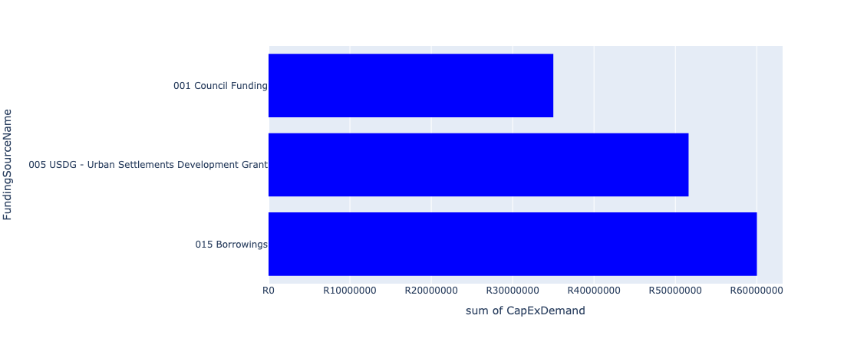

Figure 5.66: Ward 33 Departmental Requests

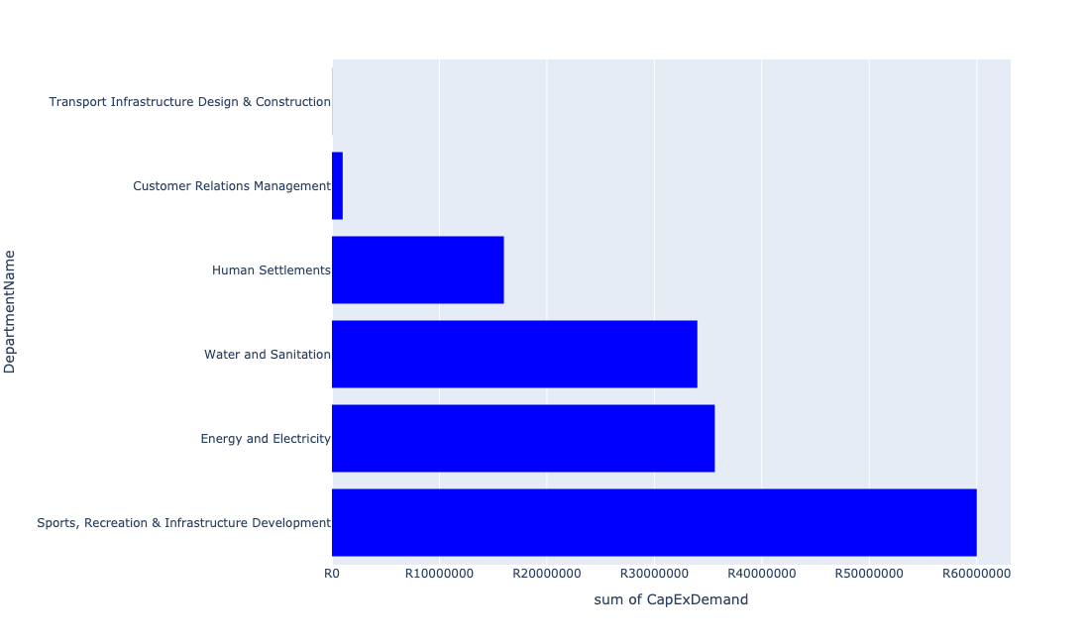

Table 5.33: Summary - Ward 33

|  |  |
| --- | --- |
| Item | Description |
| Total Capital Demand for Ward 33 - All Years | R146,642,593 Rank: 78 (1 = Highest) |
| Total Capital Demand for Ward 33 - MTREF | R72,623,009 Rank: 72 (1 = Highest) |
| Financial Years in which capital requirements are listed for Ward 33 | 2022, 2023, 2024, 2025, 2026, 2027 and 2028 |
| Financial Year with highest capital demand for Ward 33 | 2022 |
| Ward 33 intersecting feature used | Works Location |
| Total number of projects intersecting with Ward 33 | 9 Rank: 68 (1 = Highest) |

Table 5.34: All projects asking for budget in Ward 33

|  |  |  |  |
| --- | --- | --- | --- |
| Project ID | Project Name | Department | Project Budget |
| 712971915 | Revitalisation of the City-Development of Non-Motorised Transport Masterplan | Transport Infrastructure Design & Construction | R19,584 (0.01%) Budget spread across: 2027 |
| 712975536 | Refurbishment of Bodibeng customer care centre ( Soshanguve BB) | Customer Relations Management | R1,000,000 (0.68%) Budget spread across: 2023 |
| 712969084 | (712279) Soshanguve - JJ 132KV Power Line | Energy and Electricity | R10,623,009 (7.24%) Budget spread across: 2022, 2023 and 2024 |
| 712975132 | (71212SDD) Upgrade existing Soshanguve DD Outfall Sewer (2/2) | Water and Sanitation | R34,000,000 (23.19%) Budget spread across: 2023, 2024, 2025 and 2026 |
| 712974390 | (710864) Sewer reticulation - Soshanguve MM | Human Settlements | R6,000,000 (4.09%) Budget spread across: 2022 |
| 712974382 | (710863) Water provision - Soshanguve MM | Human Settlements | R10,000,000 (6.82%) Budget spread across: 2022 |
| 712967685 | (712279) Soshanguve 132/11KV Substation | Energy and Electricity | R25,000,000 (17.05%) Budget spread across: 2022 |
| 712967145 | Soshanguve cultural centre | Sports, Recreation & Infrastructure Development | R60,000,000 (40.92%) Budget spread across: 2027 and 2028 |

## Ward 34

Figure 5.67: Ward 34 Funding Requests

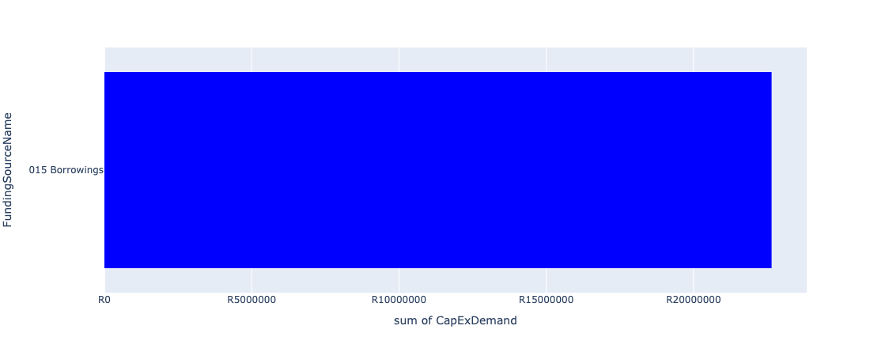

Figure 5.68: Ward 34 Departmental Requests

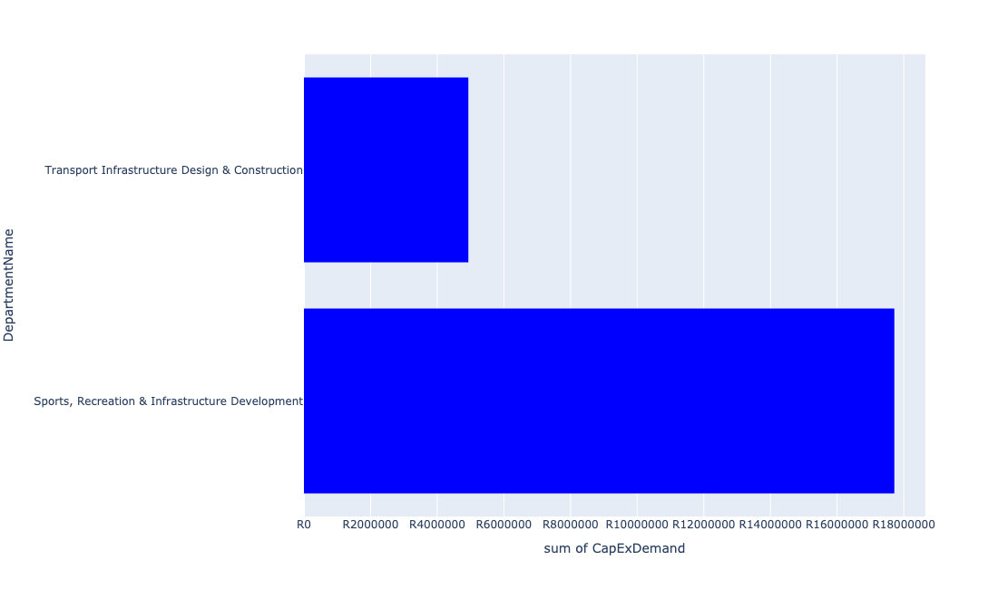

Table 5.34: Summary - Ward 34

|  |  |
| --- | --- |
| Item | Description |
| Total Capital Demand for Ward 34 - All Years | R22,650,514 Rank: 102 (1 = Highest) |
| Total Capital Demand for Ward 34 - MTREF | R8,756,202 Rank: 97 (1 = Highest) |
| Financial Years in which capital requirements are listed for Ward 34 | 2022, 2023, 2024, 2025, 2026, 2027, 2028, 2029, 2030 and 2031 |
| Financial Year with highest capital demand for Ward 34 | 2022 |
| Ward 34 intersecting feature used | Works Location |
| Total number of projects intersecting with Ward 34 | 5 Rank: 96 (1 = Highest) |

Table 5.35: All projects asking for budget in Ward 34

|  |  |  |  |
| --- | --- | --- | --- |
| Project ID | Project Name | Department | Project Budget |
| 712971915 | Revitalisation of the City-Development of Non-Motorised Transport Masterplan | Transport Infrastructure Design & Construction | R8,157 (0.04%) Budget spread across: 2027 |
| 712967124 | (712941) Greening of Sports fields | Sports, Recreation & Infrastructure Development | R17,716,819 (78.22%) Budget spread across: 2022, 2023, 2024, 2025, 2026, 2027, 2028, 2029, 2030 and 2031 |
| 712974356 | (712220) Soshanguve Block L North | Transport Infrastructure Design & Construction | R4,911,578 (21.68%) Budget spread across: 2022 |
| 712970718 | (712220) Soshanguve Block L Area 2 | Transport Infrastructure Design & Construction | R13,960 (0.06%) Budget spread across: 2022 |

## Ward 35

Figure 5.69: Ward 35 Funding Requests

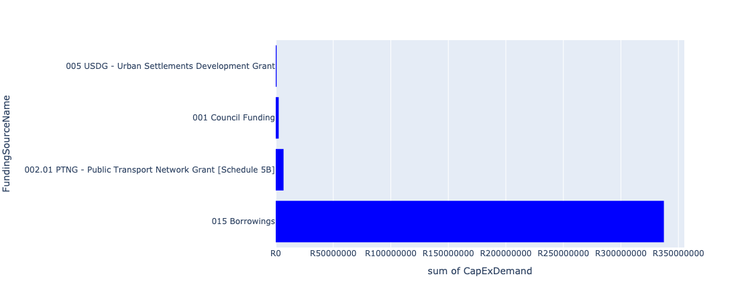

Figure 5.70: Ward 35 Departmental Requests

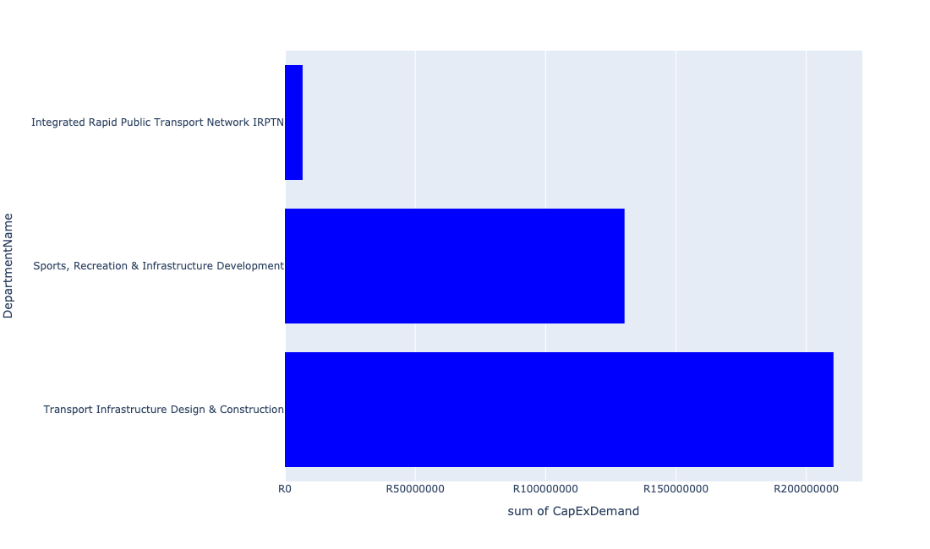

Table 5.35: Summary - Ward 35

|  |  |
| --- | --- |
| Item | Description |
| Total Capital Demand for Ward 35 - All Years | R347,500,820 Rank: 42 (1 = Highest) |
| Total Capital Demand for Ward 35 - MTREF | R92,751,215 Rank: 60 (1 = Highest) |
| Financial Years in which capital requirements are listed for Ward 35 | 2022, 2023, 2024, 2025, 2026, 2027, 2028, 2029, 2030 and 2031 |
| Financial Year with highest capital demand for Ward 35 | 2025 |
| Ward 35 intersecting feature used | Works Location |
| Total number of projects intersecting with Ward 35 | 10 Rank: 61 (1 = Highest) |

Table 5.36: All projects asking for budget in Ward 35

|  |  |  |  |
| --- | --- | --- | --- |
| Project ID | Project Name | Department | Project Budget |
| 712971915 | Revitalisation of the City-Development of Non-Motorised Transport Masterplan | Transport Infrastructure Design & Construction | R15,707 (0.00%) Budget spread across: 2027 |
| 712967745 | (712591) Planning and Design of BRT Projects | Integrated Rapid Public Transport Network IRPTN | R6,783,378 (1.95%) Budget spread across: 2022, 2023, 2024 and 2025 |
| 1036 | (712545) Upgrading of Buitekant Street | Transport Infrastructure Design & Construction | R3,344,081 (0.96%) Budget spread across: 2022, 2023, 2024, 2025 and 2026 |
| 712967124 | (712941) Greening of Sports fields | Sports, Recreation & Infrastructure Development | R130,283,193 (37.49%) Budget spread across: 2022, 2023, 2024, 2025, 2026, 2027, 2028, 2029, 2030 and 2031 |
| 712974356 | (712220) Soshanguve Block L North | Transport Infrastructure Design & Construction | R88,422 (0.03%) Budget spread across: 2022 |
| 712970718 | (712220) Soshanguve Block L Area 2 | Transport Infrastructure Design & Construction | R4,986,040 (1.43%) Budget spread across: 2022 |
| 712970720 | (712220) Soshanguve Block L Area 3 | Transport Infrastructure Design & Construction | R100,000,000 (28.78%) Budget spread across: 2022, 2023, 2025, 2026, 2027 and 2028 |
| 712969200 | (712220) Soshanguve Block L Area 4 | Transport Infrastructure Design & Construction | R102,000,000 (29.35%) Budget spread across: 2023, 2024, 2025, 2026, 2027 and 2028 |

## Ward 36

Figure 5.71: Ward 36 Funding Requests

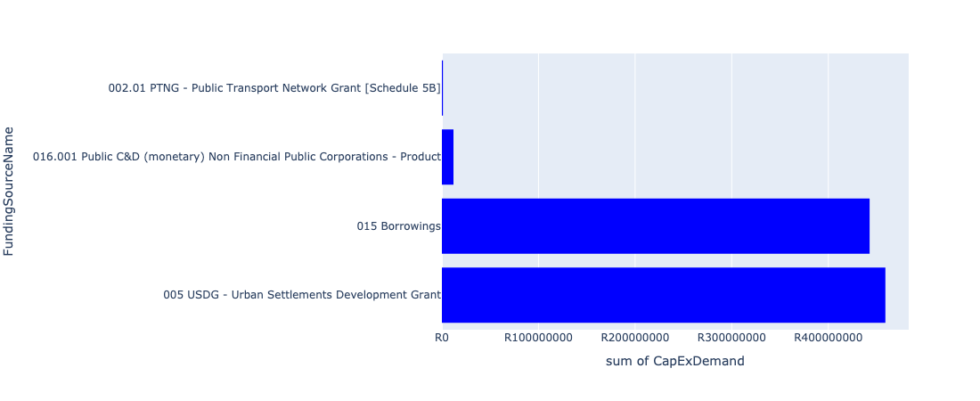

Figure 5.72: Ward 36 Departmental Requests

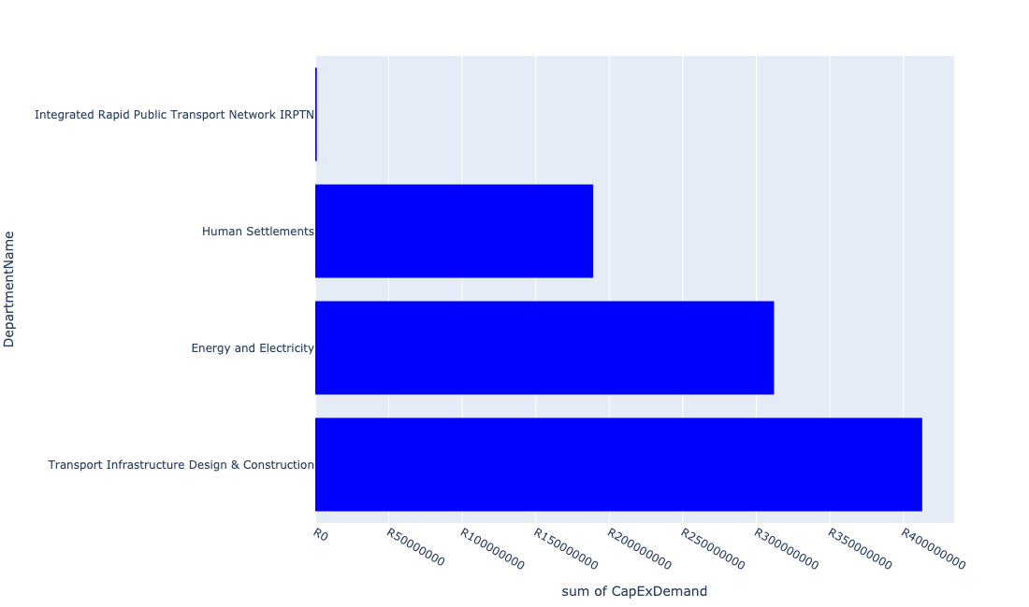

Table 5.36: Summary - Ward 36

|  |  |
| --- | --- |
| Item | Description |
| Total Capital Demand for Ward 36 - All Years | R867,871,436 Rank: 12 (1 = Highest) |
| Total Capital Demand for Ward 36 - MTREF | R572,479,791 Rank: 8 (1 = Highest) |
| Financial Years in which capital requirements are listed for Ward 36 | 2022, 2023, 2024, 2025, 2026, 2027, 2028, 2029 and 2030 |
| Financial Year with highest capital demand for Ward 36 | 2023 |
| Ward 36 intersecting feature used | Works Location |
| Total number of projects intersecting with Ward 36 | 14 Rank: 37 (1 = Highest) |

Table 5.37: All projects asking for budget in Ward 36

|  |  |  |  |
| --- | --- | --- | --- |
| Project ID | Project Name | Department | Project Budget |
| 712971915 | Revitalisation of the City-Development of Non-Motorised Transport Masterplan | Transport Infrastructure Design & Construction | R25,303 (0.00%) Budget spread across: 2027 |
| 712974601 | (712513) Soshanguve Extension 2 | Transport Infrastructure Design & Construction | R231,734 (0.03%) Budget spread across: 2022, 2023, 2024, 2025, 2026, 2027, 2028, 2029 and 2030 |
| 712967745 | (712591) Planning and Design of BRT Projects | Integrated Rapid Public Transport Network IRPTN | R1,068,249 (0.12%) Budget spread across: 2022, 2023, 2024 and 2025 |
| 712975374 | (712279) Buffel Infeed Station | Energy and Electricity | R20,000,000 (2.30%) Budget spread across: 2024 and 2025 |
| 712974481 | 712974355_02_(710143) Soshanguve Block M Extension: Area 3 | Transport Infrastructure Design & Construction | R50,000,000 (5.76%) Budget spread across: 2022 and 2023 |
| 712974477 | 712974355_01_(710143) Soshanguve Block M Extension: Area 2 | Transport Infrastructure Design & Construction | R50,000,000 (5.76%) Budget spread across: 2022 and 2023 |
| 712974203 | 712974355_05_(710143) Soshanguve Block M Extension: Area 6 | Transport Infrastructure Design & Construction | R50,000,000 (5.76%) Budget spread across: 2022 and 2023 |
| 712974202 | 712974355_04_(710143) Soshanguve Block M Extension: Area 5 | Transport Infrastructure Design & Construction | R50,000,000 (5.76%) Budget spread across: 2022 and 2023 |
| 299 | 712974355_03_(710143) Soshanguve Block M Extension: Area 4 | Transport Infrastructure Design & Construction | R75,000,000 (8.64%) Budget spread across: 2022, 2023 and 2024 |
| 712967596 | (710865) Construction of roads & stormwater - Thorntree View | Human Settlements | R189,046,150 (21.78%) Budget spread across: 2022, 2023 and 2024 |
| 712969550 | (712513) Soshanguve Block WW | Transport Infrastructure Design & Construction | R137,500,000 (15.84%) Budget spread across: 2022, 2023, 2024, 2025, 2026, 2028, 2029 and 2030 |
| 712969182 | (710556) Region 1 (Public Lighting) | Energy and Electricity | R292,000,000 (33.65%) Budget spread across: 2022, 2023, 2024, 2025, 2026, 2027, 2028, 2029 and 2030 |

## Ward 37

Figure 5.73: Ward 37 Funding Requests

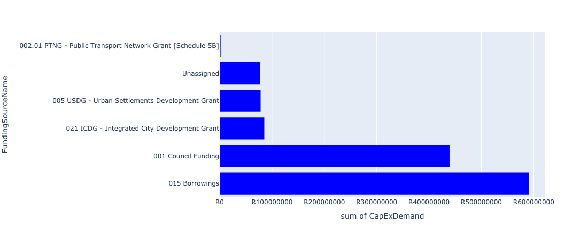

Figure 5.74: Ward 37 Departmental Requests

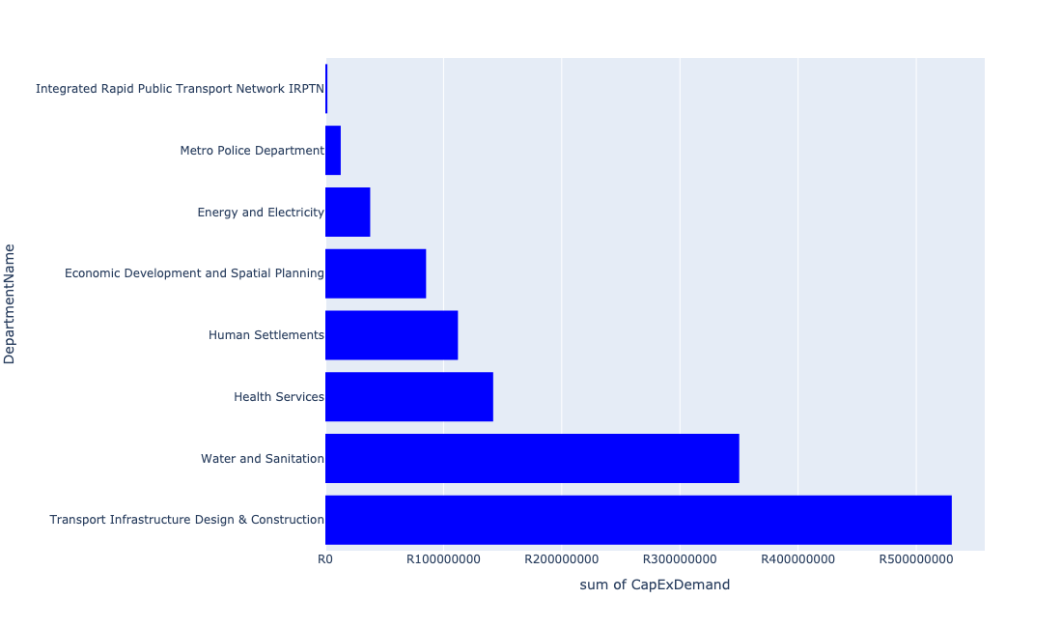

Table 5.37: Summary - Ward 37

|  |  |
| --- | --- |
| Item | Description |
| Total Capital Demand for Ward 37 - All Years | R1,242,308,634 Rank: 7 (1 = Highest) |
| Total Capital Demand for Ward 37 - MTREF | R611,404,297 Rank: 6 (1 = Highest) |
| Financial Years in which capital requirements are listed for Ward 37 | 2022, 2023, 2024, 2025, 2026, 2027, 2028, 2029 and 2030 |
| Financial Year with highest capital demand for Ward 37 | 2023 |
| Ward 37 intersecting feature used | Works Location |
| Total number of projects intersecting with Ward 37 | 28 Rank: 6 (1 = Highest) |

Table 5.38: All projects asking for budget in Ward 37

|  |  |  |  |
| --- | --- | --- | --- |
| Project ID | Project Name | Department | Project Budget |
| 712971915 | Revitalisation of the City-Development of Non-Motorised Transport Masterplan | Transport Infrastructure Design & Construction | R71,673 (0.01%) Budget spread across: 2027 |
| 712974118 | (712279) Rama City 132kV power line | Energy and Electricity | R36,934,799 (2.97%) Budget spread across: 2023, 2024 and 2025 |
| 712975332 | Sub-Project: TMPD Station - Soshanguve South | Metro Police Department | R13,000,000 (1.05%) Budget spread across: 2025 and 2026 |
| 712975231 | Akasia boom Station Public Transport Facility | Transport Infrastructure Design & Construction | R89,000,000 (7.16%) Budget spread across: 2022, 2023, 2024, 2025, 2026, 2027, 2028, 2029 and 2030 |
| 712975076 | (712121Ro) Upgrade existing Rosslyn outfall sewer (2/2) | Water and Sanitation | R2,600,000 (0.21%) Budget spread across: 2025, 2026 and 2027 |
| 712975075 | (712121Ro) Upgrade existing Rosslyn East outfall sewer (1/2) | Water and Sanitation | R600,000 (0.05%) Budget spread across: 2025 and 2026 |
| 712975074 | (712121Sa) Upgrade existing Sandspruit outfall sewer(4/4) | Water and Sanitation | R5,000,000 (0.40%) Budget spread across: 2023 and 2024 |
| 712975073 | (712121Sa) Upgrade existing Sandspruit outfall sewer (1/4) | Water and Sanitation | R70,000,000 (5.63%) Budget spread across: 2023, 2024, 2025, 2026 and 2027 |
| 712974614 | Upgrading of a tributary of the Sand Spruit, Rosslyn x 17 | Transport Infrastructure Design & Construction | R14,150,684 (1.14%) Budget spread across: 2025, 2026 and 2027 |
| 712974603 | (712513) Soshanguve Extensions 3 and 4 | Transport Infrastructure Design & Construction | R85,083,831 (6.85%) Budget spread across: 2022, 2023, 2024, 2025, 2026, 2027, 2028, 2029 and 2030 |
| 712974601 | (712513) Soshanguve Extension 2 | Transport Infrastructure Design & Construction | R22,555,792 (1.82%) Budget spread across: 2022, 2023, 2024, 2025, 2026, 2027, 2028, 2029 and 2030 |
| 712974547 | (710411H1) Sandspruit WWTW Phase2: 10 Ml/d Extension | Water and Sanitation | R272,000,000 (21.89%) Budget spread across: 2024, 2025, 2026, 2027, 2028 and 2029 |
| 712974494 | Construction of a ±2,9km stormwater system in Rosslyn (Rosslyn SMP - Network 6A and 6D) | Transport Infrastructure Design & Construction | R95,500,000 (7.69%) Budget spread across: 2025, 2026, 2027, 2028, 2029 and 2030 |
| 712974191 | Upgrading of the bridge in Longmore Road a Tributary of the sand River, The Orchards | Transport Infrastructure Design & Construction | R7,672,615 (0.62%) Budget spread across: 2026, 2027, 2028, 2029 and 2030 |
| 712967844 | (713048) New Rosslyn Clinic | Health Services | R75,000,000 (6.04%) Budget spread across: 2022 and 2023 |
| 712967745 | (712591) Planning and Design of BRT Projects | Integrated Rapid Public Transport Network IRPTN | R1,712,951 (0.14%) Budget spread across: 2022, 2023, 2024 and 2025 |
| 712967193 | (711326) New Clinic Soshanguve South | Health Services | R67,000,000 (5.39%) Budget spread across: 2022, 2023 and 2024 |
| 712967087 | (712601) Standby Quarters (Revival) | Energy and Electricity | R1,000,000 (0.08%) Budget spread across: 2022 and 2023 |
| 712967605 | (710865) Construction of roads & stormwater - Soshanguve South X13 | Human Settlements | R35,197,639 (2.83%) Budget spread across: 2022 and 2023 |
| 712967604 | (710865) Construction of roads & stormwater - Soshanguve South X12 | Human Settlements | R77,000,000 (6.20%) Budget spread across: 2022 and 2023 |
| 712972924 | Rosslyn Development Centre | Transport Infrastructure Design & Construction | R26,000,000 (2.09%) Budget spread across: 2022, 2023, 2024, 2025 and 2026 |
| 712971921 | Revitalisation of the City-Internal Routes in Rosslyn and Traffic signals | Transport Infrastructure Design & Construction | R190,000,000 (15.29%) Budget spread across: 2022, 2023 and 2024 |
| 712969616 | (700574) Rosslyn Urban Realm Upgrade and Multi Modal Interchange | Economic Development and Spatial Planning | R85,228,650 (6.86%) Budget spread across: 2022 and 2023 |

## Ward 38

Figure 5.75: Ward 38 Funding Requests

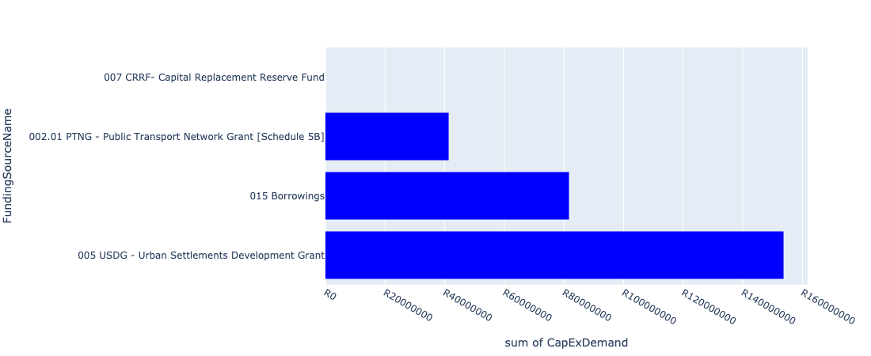

Figure 5.76: Ward 38 Departmental Requests

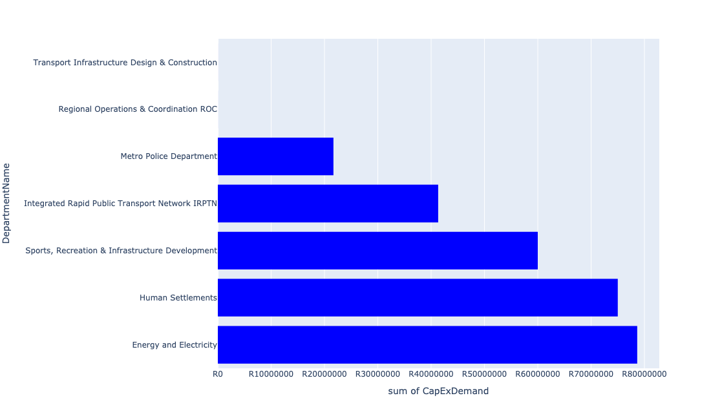

Table 5.38: Summary - Ward 38

|  |  |
| --- | --- |
| Item | Description |
| Total Capital Demand for Ward 38 - All Years | R253,192,733 Rank: 53 (1 = Highest) |
| Total Capital Demand for Ward 38 - MTREF | R178,188,651 Rank: 42 (1 = Highest) |
| Financial Years in which capital requirements are listed for Ward 38 | 2022, 2023, 2024, 2025, 2026 and 2027 |
| Financial Year with highest capital demand for Ward 38 | 2023 |
| Ward 38 intersecting feature used | Works Location |
| Total number of projects intersecting with Ward 38 | 11 Rank: 54 (1 = Highest) |

Table 5.39: All projects asking for budget in Ward 38

|  |  |  |  |
| --- | --- | --- | --- |
| Project ID | Project Name | Department | Project Budget |
| 712971915 | Revitalisation of the City-Development of Non-Motorised Transport Masterplan | Transport Infrastructure Design & Construction | R4,082 (0.00%) Budget spread across: 2027 |
| 712970748 | R6 Machinery and Equipment to ensure basic infrastructure reliability | Regional Operations & Coordination ROC | R4,775 (0.00%) Budget spread across: 2022 and 2023 |
| 712975437 | Sub-Project: TMPD Station - Mamelodi (Extension 10) | Metro Police Department | R1,678,632 (0.66%) Budget spread across: 2022, 2023 and 2024 |
| 712974121 | (712279) Wildebees - Elland 132kV Power line | Energy and Electricity | R8,644,356 (3.41%) Budget spread across: 2023 and 2024 |
| 712975767 | (712900) Upgrading of existing Academic Training facilities (Mamelodi) | Metro Police Department | R20,000,000 (7.90%) Budget spread across: 2022, 2023 and 2024 |
| 712975347 | (712279) Mamelodi Switching Station | Energy and Electricity | R70,000,000 (27.65%) Budget spread across: 2023, 2024 and 2025 |
| 712967641 | (711713) Development of Mamelodi hostels | Human Settlements | R75,000,000 (29.62%) Budget spread across: 2022 and 2023 |
| 712967147 | (711439) Solomon Mahlangu freedom square | Sports, Recreation & Infrastructure Development | R60,000,000 (23.70%) Budget spread across: 2025 and 2026 |
| 712969053 | (712591) Denneboom Depot | Integrated Rapid Public Transport Network IRPTN | R41,318,631 (16.32%) Budget spread across: 2022 and 2023 |

## Ward 39

Figure 5.77: Ward 39 Funding Requests

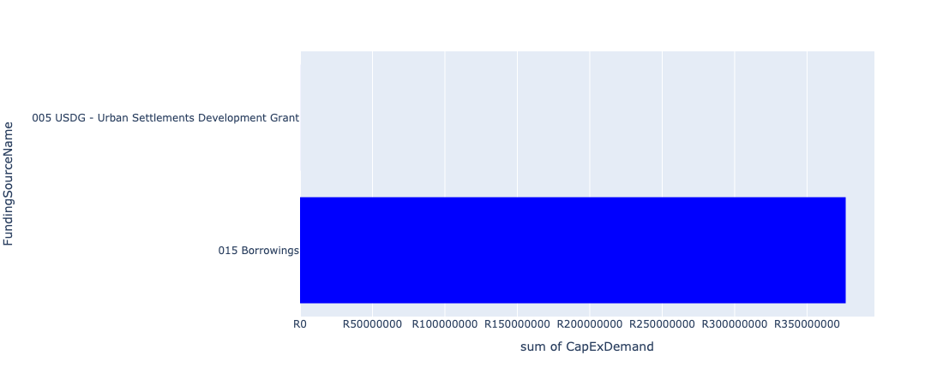

Figure 5.78: Ward 39 Departmental Requests

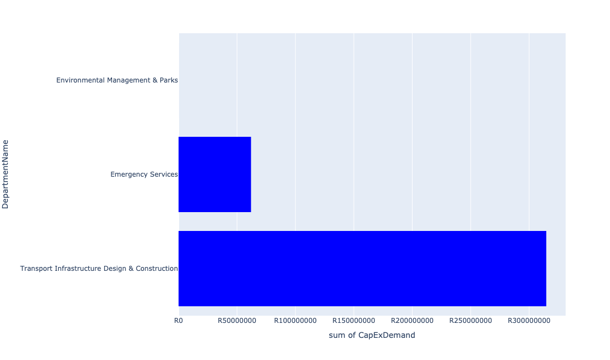

Table 5.39: Summary - Ward 39

|  |  |
| --- | --- |
| Item | Description |
| Total Capital Demand for Ward 39 - All Years | R366,688,449 Rank: 40 (1 = Highest) |
| Total Capital Demand for Ward 39 - MTREF | R111,130,545 Rank: 54 (1 = Highest) |
| Financial Years in which capital requirements are listed for Ward 39 | 2022, 2023, 2024, 2025, 2026, 2027, 2028, 2029 and 2030 |
| Financial Year with highest capital demand for Ward 39 | 2024 |
| Ward 39 intersecting feature used | Works Location |
| Total number of projects intersecting with Ward 39 | 7 Rank: 81 (1 = Highest) |

Table 5.40: All projects asking for budget in Ward 39

|  |  |  |  |
| --- | --- | --- | --- |
| Project ID | Project Name | Department | Project Budget |
| 712971915 | Revitalisation of the City-Development of Non-Motorised Transport Masterplan | Transport Infrastructure Design & Construction | R14,571 (0.00%) Budget spread across: 2027 |
| 712974603 | (712513) Soshanguve Extensions 3 and 4 | Transport Infrastructure Design & Construction | R662,647 (0.18%) Budget spread across: 2022, 2023, 2024, 2025, 2026, 2027, 2028, 2029 and 2030 |
| 712974601 | (712513) Soshanguve Extension 2 | Transport Infrastructure Design & Construction | R8,284 (0.00%) Budget spread across: 2022, 2023, 2024, 2025, 2026, 2027, 2028, 2029 and 2030 |
| 712975514 | Construction of Entrance gate and ablution facilities - Toloane Nature Reserve | Environmental Management & Parks | R2,946 (0.00%) Budget spread across: 2022 and 2023 |
| 712974355 | (710143) Major Stormwater Systems Klip kruisfontein | Transport Infrastructure Design & Construction | R134,000,000 (36.54%) Budget spread across: 2022, 2023, 2024, 2025, 2026, 2027, 2028, 2029 and 2030 |
| 712970708 | (713081) Construction of a new Emergency Services Station in Klip Kruisfontein | Emergency Services | R62,000,000 (16.91%) Budget spread across: 2023, 2024 and 2025 |
| 712969549 | (712513) Soshanguve Extension 1 | Transport Infrastructure Design & Construction | R180,000,000 (49.09%) Budget spread across: 2022, 2023, 2024, 2025, 2026, 2027, 2028, 2029 and 2030 |

## Ward 40

Figure 5.79: Ward 40 Funding Requests

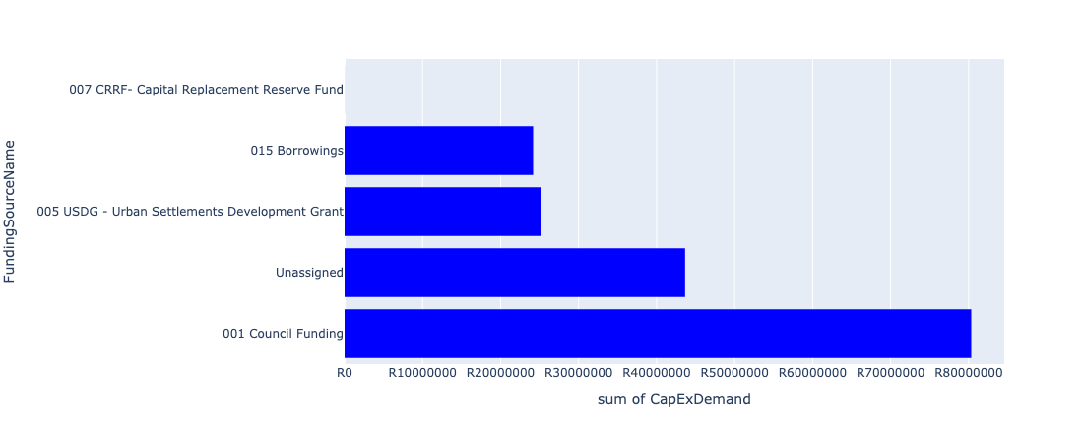

Figure 5.80: Ward 40 Departmental Requests

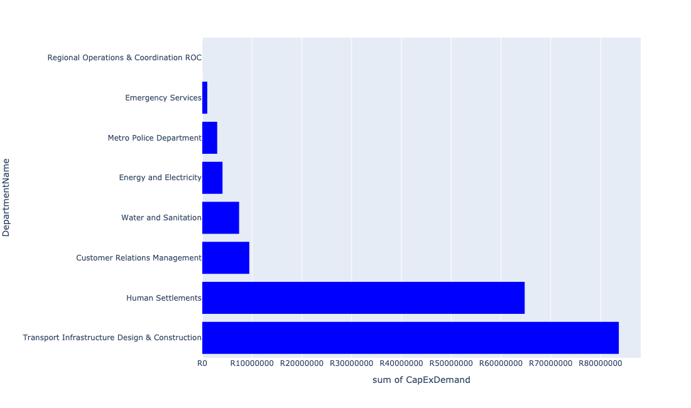

Table 5.40: Summary - Ward 40

|  |  |
| --- | --- |
| Item | Description |
| Total Capital Demand for Ward 40 - All Years | R173,336,554 Rank: 72 (1 = Highest) |
| Total Capital Demand for Ward 40 - MTREF | R95,863,132 Rank: 57 (1 = Highest) |
| Financial Years in which capital requirements are listed for Ward 40 | 2022, 2023, 2024, 2025, 2026, 2027, 2028, 2029 and 2030 |
| Financial Year with highest capital demand for Ward 40 | 2024 |
| Ward 40 intersecting feature used | Works Location |
| Total number of projects intersecting with Ward 40 | 18 Rank: 18 (1 = Highest) |

Table 5.41: All projects asking for budget in Ward 40

|  |  |  |  |
| --- | --- | --- | --- |
| Project ID | Project Name | Department | Project Budget |
| 712971915 | Revitalisation of the City-Development of Non-Motorised Transport Masterplan | Transport Infrastructure Design & Construction | R7,239 (0.00%) Budget spread across: 2027 |
| 712970748 | R6 Machinery and Equipment to ensure basic infrastructure reliability | Regional Operations & Coordination ROC | R8,467 (0.00%) Budget spread across: 2022 and 2023 |
| 712975437 | Sub-Project: TMPD Station - Mamelodi (Extension 10) | Metro Police Department | R2,995,804 (1.73%) Budget spread across: 2022, 2023 and 2024 |
| 712975391 | (712279) Mamelodi II 132/11kV Substation | Energy and Electricity | R4,066,532 (2.35%) Budget spread across: 2026 |
| 712975546 | Construction of new Alaska and Stoffel Park customer care centre | Customer Relations Management | R9,444,378 (5.45%) Budget spread across: 2027 |
| 712974392 | (710864) Sewer reticulation - Mamelodi X6 erf 34041 (Phomolong) | Human Settlements | R35,481,502 (20.47%) Budget spread across: 2022, 2023 and 2024 |
| 712974187 | Providing new Inter modal Public Transport Facility at Green View (including access to the facility) | Transport Infrastructure Design & Construction | R70,889,423 (40.90%) Budget spread across: 2022, 2023, 2024, 2025, 2026, 2027, 2028, 2029 and 2030 |
| 712967793 | (713052) Construction of Emergency Services Station Mamelodi 1 | Emergency Services | R1,000,000 (0.58%) Budget spread across: 2022 |
| 712967295 | (711335ML) Mamelodi R5 feeder main relocation | Water and Sanitation | R7,398,528 (4.27%) Budget spread across: 2023, 2024, 2025 and 2026 |
| 992 | (712518) Flooding backlog: Drainage canals along Hans Strydom Dr, Mamelodi x 4 and 5 | Transport Infrastructure Design & Construction | R12,767,911 (7.37%) Budget spread across: 2022, 2023 and 2024 |
| 712970780 | (710863) Mamelodi X11 | Human Settlements | R0 (0.00%) Budget spread across: 2022 |
| 712970774 | (710864) Mamelodi X11 | Human Settlements | R110,300 (0.06%) Budget spread across: 2022 |
| 712970764 | (710863) Water Provision - Mamelodi X6 erf 34041 (Phomolong) | Human Settlements | R29,166,470 (16.83%) Budget spread across: 2022, 2023 and 2024 |

## Ward 41

Figure 5.81: Ward 41 Funding Requests

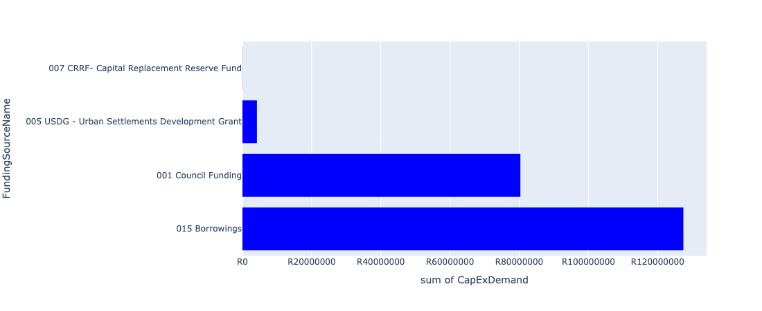

Figure 5.82: Ward 41 Departmental Requests

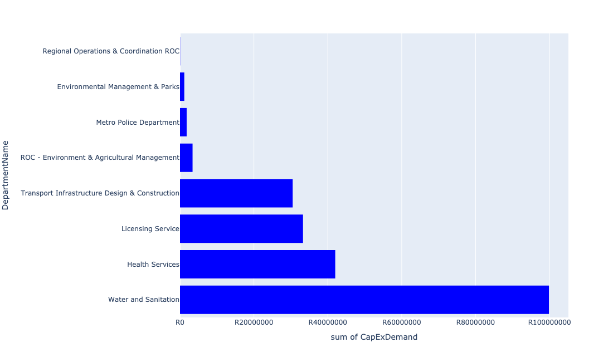

Table 5.41: Summary - Ward 41

|  |  |
| --- | --- |
| Item | Description |
| Total Capital Demand for Ward 41 - All Years | R212,010,251 Rank: 61 (1 = Highest) |
| Total Capital Demand for Ward 41 - MTREF | R144,588,304 Rank: 51 (1 = Highest) |
| Financial Years in which capital requirements are listed for Ward 41 | 2022, 2023, 2024, 2025, 2026, 2027, 2028 and 2031 |
| Financial Year with highest capital demand for Ward 41 | 2024 |
| Ward 41 intersecting feature used | Works Location |
| Total number of projects intersecting with Ward 41 | 15 Rank: 31 (1 = Highest) |

Table 5.42: All projects asking for budget in Ward 41

|  |  |  |  |
| --- | --- | --- | --- |
| Project ID | Project Name | Department | Project Budget |
| 712971915 | Revitalisation of the City-Development of Non-Motorised Transport Masterplan | Transport Infrastructure Design & Construction | R37,814 (0.02%) Budget spread across: 2027 |
| 712970748 | R6 Machinery and Equipment to ensure basic infrastructure reliability | Regional Operations & Coordination ROC | R44,228 (0.02%) Budget spread across: 2022 and 2023 |
| 712969439 | (712121D) Moreletaspruit: Outfall sewer | Water and Sanitation | R20,840,809 (9.83%) Budget spread across: 2022, 2023, 2024, 2025 and 2026 |
| 712971920 | Revitalisation of the City-Doubling of Petroleum Street | Transport Infrastructure Design & Construction | R30,446,390 (14.36%) Budget spread across: 2023 and 2024 |
| 712969619 | (713044) Hatherley Cemetery | Environmental Management & Parks | R1,157,143 (0.55%) Budget spread across: 2022, 2023 and 2025 |
| 712975435 | Sub-Project: TMPD Station - Nellmapius (Extension 3) | Metro Police Department | R1,801,867 (0.85%) Budget spread across: 2023 and 2024 |
| 712975378 | Upgrading of Waltloo Testing Centre | Licensing Service | R26,000,000 (12.26%) Budget spread across: 2022, 2023, 2024, 2028 and 2031 |
| 712975119 | (712534) New 20ML La-Montagne Reservoir | Water and Sanitation | R79,000,000 (37.26%) Budget spread across: 2023, 2024, 2025, 2026 and 2027 |
| 712974564 | Upgrading of pits and VTS at Licensing centres | Licensing Service | R7,282,000 (3.43%) Budget spread across: 2022, 2024 and 2025 |
| 712967645 | New Silverton Clinic | Health Services | R42,000,000 (19.81%) Budget spread across: 2022, 2023 and 2024 |
| 712967951 | Waste Management Block Office Block | ROC - Environment & Agricultural Management | R3,400,000 (1.60%) Budget spread across: 2022 |

## Ward 42

Figure 5.83: Ward 42 Funding Requests

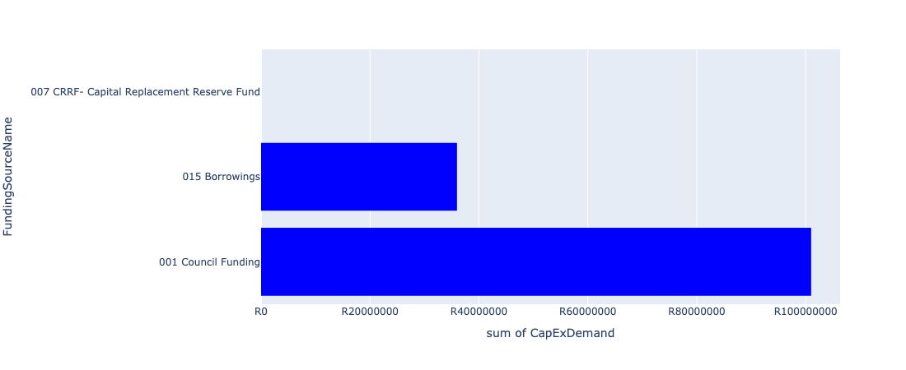

Figure 5.84: Ward 42 Departmental Requests

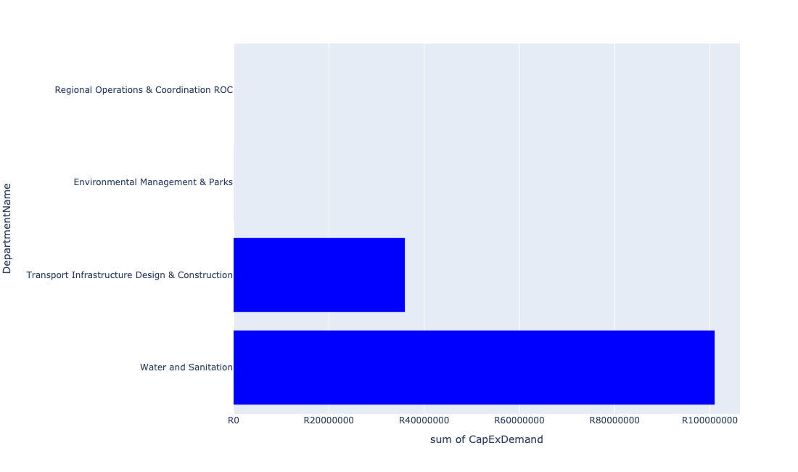

Table 5.42: Summary - Ward 42

|  |  |
| --- | --- |
| Item | Description |
| Total Capital Demand for Ward 42 - All Years | R136,974,013 Rank: 81 (1 = Highest) |
| Total Capital Demand for Ward 42 - MTREF | R48,926,362 Rank: 80 (1 = Highest) |
| Financial Years in which capital requirements are listed for Ward 42 | 2022, 2023, 2024, 2025, 2026, 2027, 2028 and 2029 |
| Financial Year with highest capital demand for Ward 42 | 2026 |
| Ward 42 intersecting feature used | Works Location |
| Total number of projects intersecting with Ward 42 | 6 Rank: 89 (1 = Highest) |

Table 5.43: All projects asking for budget in Ward 42

|  |  |  |  |
| --- | --- | --- | --- |
| Project ID | Project Name | Department | Project Budget |
| 712971915 | Revitalisation of the City-Development of Non-Motorised Transport Masterplan | Transport Infrastructure Design & Construction | R36,080 (0.03%) Budget spread across: 2027 |
| 712970748 | R6 Machinery and Equipment to ensure basic infrastructure reliability | Regional Operations & Coordination ROC | R0 (0.00%) Budget spread across: 2022 and 2023 |
| 712975526 | Upgrade of Roads in Groenkloof Nature reserve | Environmental Management & Parks | R11,572 (0.01%) Budget spread across: 2022, 2023, 2024, 2025, 2026, 2027, 2028 and 2029 |
| 712974522 | Upgrading of Solomon Mahlangu Drive | Transport Infrastructure Design & Construction | R35,926,362 (26.23%) Budget spread across: 2022 |
| 712975099 | (711335WK) Waterkloof 2 feeder main | Water and Sanitation | R19,500,000 (14.24%) Budget spread across: 2023, 2024 and 2025 |
| 712975094 | (710411Y_C) Upgrading of Carina Street Pump station | Water and Sanitation | R81,500,000 (59.50%) Budget spread across: 2025, 2026, 2027 and 2028 |

## Ward 43

Figure 5.85: Ward 43 Funding Requests

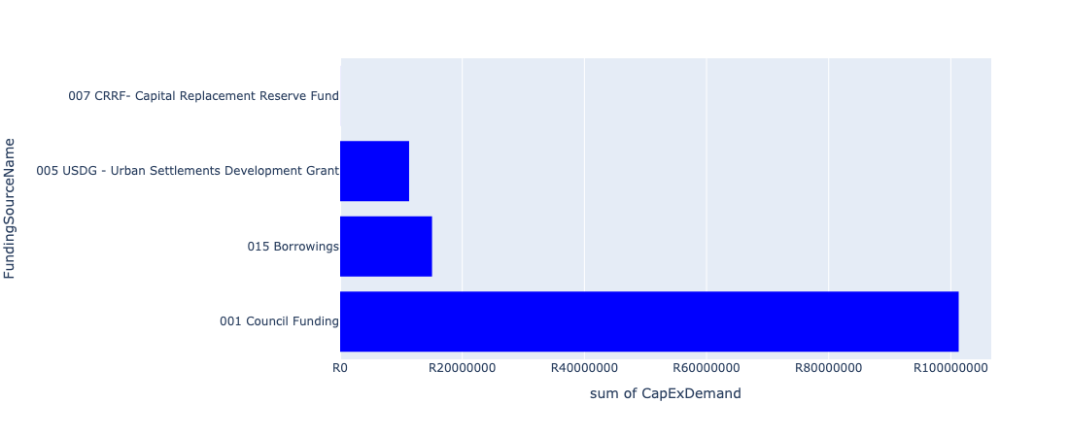

Figure 5.86: Ward 43 Departmental Requests

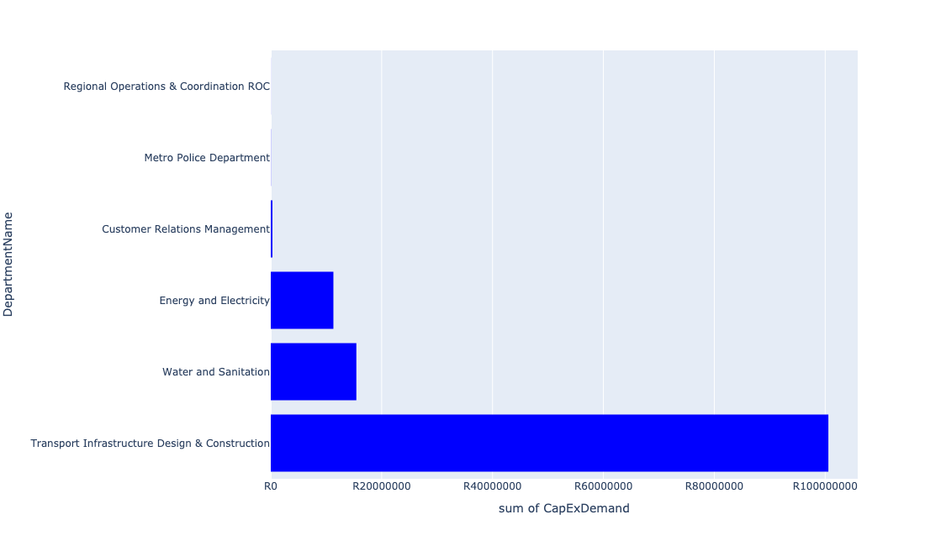

Table 5.43: Summary - Ward 43

|  |  |
| --- | --- |
| Item | Description |
| Total Capital Demand for Ward 43 - All Years | R108,128,228 Rank: 83 (1 = Highest) |
| Total Capital Demand for Ward 43 - MTREF | R24,840,269 Rank: 90 (1 = Highest) |
| Financial Years in which capital requirements are listed for Ward 43 | 2022, 2023, 2024, 2025, 2026, 2027, 2028, 2029 and 2030 |
| Financial Year with highest capital demand for Ward 43 | 2025 |
| Ward 43 intersecting feature used | Works Location |
| Total number of projects intersecting with Ward 43 | 11 Rank: 54 (1 = Highest) |

Table 5.44: All projects asking for budget in Ward 43

|  |  |  |  |
| --- | --- | --- | --- |
| Project ID | Project Name | Department | Project Budget |
| 712971915 | Revitalisation of the City-Development of Non-Motorised Transport Masterplan | Transport Infrastructure Design & Construction | R19,365 (0.02%) Budget spread across: 2027 |
| 712970748 | R6 Machinery and Equipment to ensure basic infrastructure reliability | Regional Operations & Coordination ROC | R12,747 (0.01%) Budget spread across: 2022 and 2023 |
| 712969439 | (712121D) Moreletaspruit: Outfall sewer | Water and Sanitation | R15,436,685 (14.28%) Budget spread across: 2022, 2023, 2024, 2025 and 2026 |
| 712975437 | Sub-Project: TMPD Station - Mamelodi (Extension 10) | Metro Police Department | R28,520 (0.03%) Budget spread across: 2022, 2023 and 2024 |
| 712974121 | (712279) Wildebees - Elland 132kV Power line | Energy and Electricity | R11,295,500 (10.45%) Budget spread across: 2023 and 2024 |
| 712975592 | Refurbishment of Eersterust customer care centre | Customer Relations Management | R300,000 (0.28%) Budget spread across: 2025 |
| 712974192 | Provisioning of New ranking facility at Eersterus Taxi rank | Transport Infrastructure Design & Construction | R100,000,000 (92.48%) Budget spread across: 2022, 2024, 2025, 2026, 2027, 2028, 2029 and 2030 |
| 712971920 | Revitalisation of the City-Doubling of Petroleum Street | Transport Infrastructure Design & Construction | R553,610 (0.51%) Budget spread across: 2023 and 2024 |

## Ward 44

Figure 5.87: Ward 44 Funding Requests

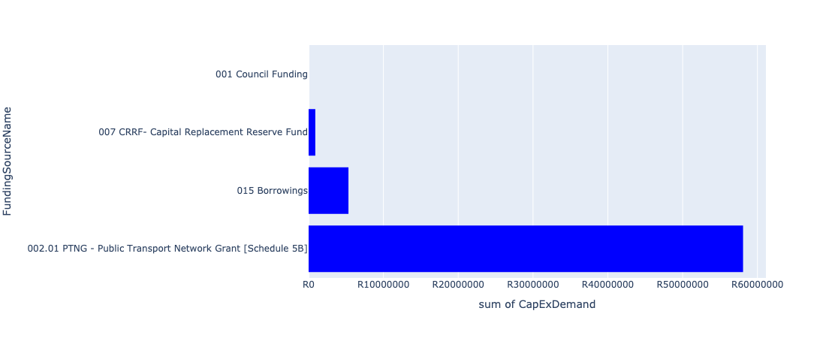

Figure 5.88: Ward 44 Departmental Requests

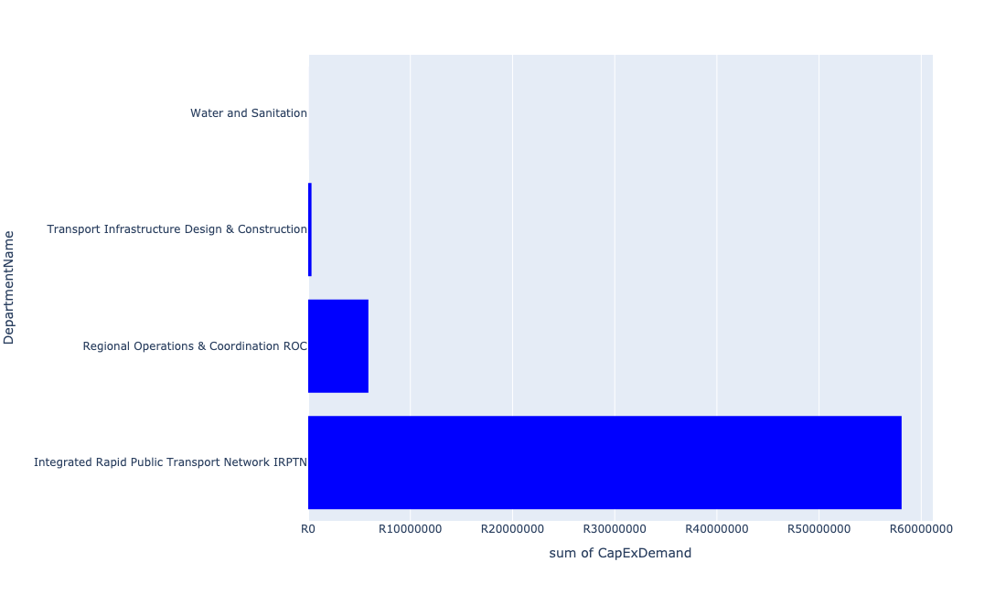

Table 5.44: Summary - Ward 44

|  |  |
| --- | --- |
| Item | Description |
| Total Capital Demand for Ward 44 - All Years | R64,293,351 Rank: 90 (1 = Highest) |
| Total Capital Demand for Ward 44 - MTREF | R64,271,833 Rank: 75 (1 = Highest) |
| Financial Years in which capital requirements are listed for Ward 44 | 2022, 2023, 2024, 2025, 2026 and 2027 |
| Financial Year with highest capital demand for Ward 44 | 2023 |
| Ward 44 intersecting feature used | Works Location |
| Total number of projects intersecting with Ward 44 | 11 Rank: 54 (1 = Highest) |

Table 5.45: All projects asking for budget in Ward 44

|  |  |  |  |
| --- | --- | --- | --- |
| Project ID | Project Name | Department | Project Budget |
| 712971915 | Revitalisation of the City-Development of Non-Motorised Transport Masterplan | Transport Infrastructure Design & Construction | R20,940 (0.03%) Budget spread across: 2027 |
| 712970748 | R6 Machinery and Equipment to ensure basic infrastructure reliability | Regional Operations & Coordination ROC | R24,491 (0.04%) Budget spread across: 2022 and 2023 |
| 712967734 | (712591) BRT Line 2C-Lynnwood Rd (btw January Masilela & Simon Vermooten) | Integrated Rapid Public Transport Network IRPTN | R18,075,924 (28.11%) Budget spread across: 2022 and 2023 |
| 712973845 | R6 Regional Building Electrical Equipment / Aircon, Fire detection/systems installation (energy efficient) | Regional Operations & Coordination ROC | R867,120 (1.35%) Budget spread across: 2022 and 2023 |
| 712969439 | (712121D) Moreletaspruit: Outfall sewer | Water and Sanitation | R3,009 (0.00%) Budget spread across: 2022, 2023, 2024, 2025 and 2026 |
| 712974525 | Upgrading of Lynnwood Road | Transport Infrastructure Design & Construction | R301,868 (0.47%) Budget spread across: 2023 and 2024 |
| 712974888 | (712591) Line 2C Stations | Integrated Rapid Public Transport Network IRPTN | R26,000,000 (40.44%) Budget spread across: 2022 and 2023 |
| 712974887 | (712591) Line 2B Stations | Integrated Rapid Public Transport Network IRPTN | R14,000,000 (21.78%) Budget spread across: 2022 and 2023 |
| 712973842 | (714028) R6 Security Cameras / Alarms Systems at Regional Facilities | Regional Operations & Coordination ROC | R5,000,000 (7.78%) Budget spread across: 2022 and 2023 |

## Ward 45

Figure 5.89: Ward 45 Funding Requests

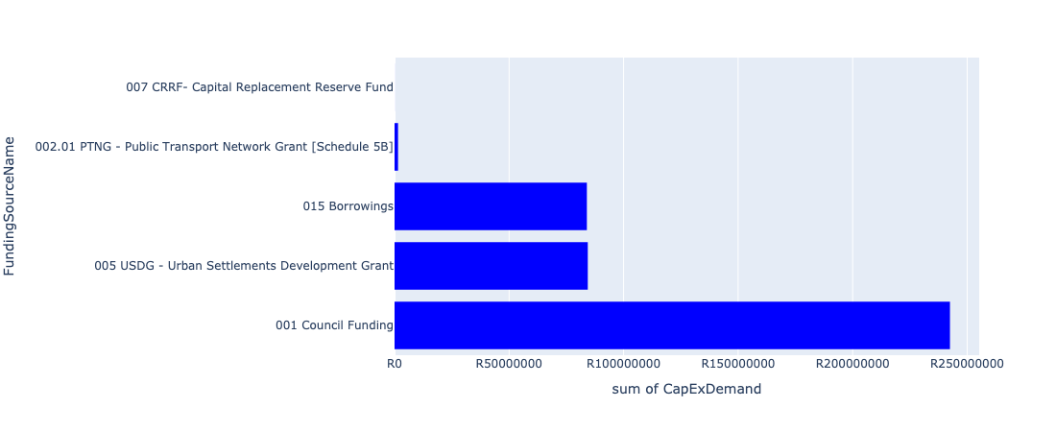

Figure 5.90: Ward 45 Departmental Requests

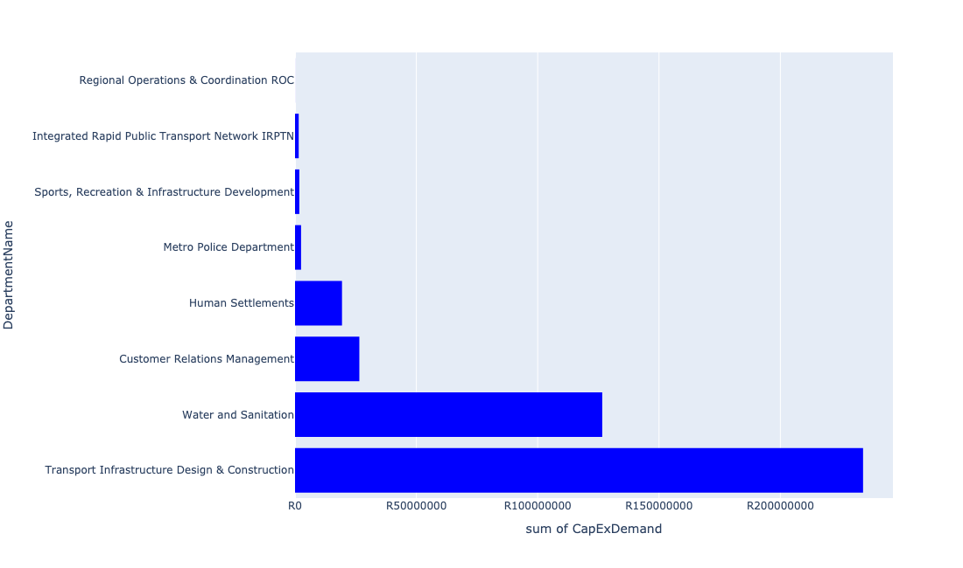

Table 5.45: Summary - Ward 45

|  |  |
| --- | --- |
| Item | Description |
| Total Capital Demand for Ward 45 - All Years | R408,878,418 Rank: 38 (1 = Highest) |
| Total Capital Demand for Ward 45 - MTREF | R261,767,609 Rank: 25 (1 = Highest) |
| Financial Years in which capital requirements are listed for Ward 45 | 2022, 2023, 2024, 2025, 2026, 2027, 2029, 2030 and 2031 |
| Financial Year with highest capital demand for Ward 45 | 2023 |
| Ward 45 intersecting feature used | Works Location |
| Total number of projects intersecting with Ward 45 | 19 Rank: 15 (1 = Highest) |

Table 5.46: All projects asking for budget in Ward 45

|  |  |  |  |
| --- | --- | --- | --- |
| Project ID | Project Name | Department | Project Budget |
| 712967744 | (712591) Design, Supply, Installation, Commissioning and Operational Support Of Advanced Public Transport Management System (APTMS) | Integrated Rapid Public Transport Network IRPTN | R14,786 (0.00%) Budget spread across: 2022 |
| 712971915 | Revitalisation of the City-Development of Non-Motorised Transport Masterplan | Transport Infrastructure Design & Construction | R19,275 (0.00%) Budget spread across: 2027 |
| 712970748 | R6 Machinery and Equipment to ensure basic infrastructure reliability | Regional Operations & Coordination ROC | R22,544 (0.01%) Budget spread across: 2022 and 2023 |
| 712967743 | (712591) The Design, Supply, Installation, Operation and Maintenance of an automated fare Collection (AFC) System | Integrated Rapid Public Transport Network IRPTN | R217,180 (0.05%) Budget spread across: 2022, 2023, 2024 and 2025 |
| 712967733 | (712591) BRT Line 2C-January Masilela (btw Atterbury & Lynnwood Rd) | Integrated Rapid Public Transport Network IRPTN | R1,287,049 (0.31%) Budget spread across: 2022 and 2023 |
| 712973830 | Build additional study hall at Glenstantia Library | Sports, Recreation & Infrastructure Development | R1,764,071 (0.43%) Budget spread across: 2029 |
| 712969439 | (712121D) Moreletaspruit: Outfall sewer | Water and Sanitation | R11,598,223 (2.84%) Budget spread across: 2022, 2023, 2024, 2025 and 2026 |
| 712975779 | (710865) Construction of roads & stormwater at Pretorius Park X20 | Human Settlements | R19,354,845 (4.73%) Budget spread across: 2022 and 2023 |
| 712975440 | Sub-Project: TMPD Station - Pretorius Park | Metro Police Department | R2,487,589 (0.61%) Budget spread across: 2024 and 2025 |
| 1472 | (712956) Upgrading of Garsfontein road | Transport Infrastructure Design & Construction | R234,062,421 (57.24%) Budget spread across: 2022, 2023, 2024, 2025 and 2026 |
| 712975542 | Construction of Pretorius park customer care centre | Customer Relations Management | R6,502,857 (1.59%) Budget spread across: 2030 |
| 712975541 | construction of Garsfontein customer care centre | Customer Relations Management | R20,000,000 (4.89%) Budget spread across: 2031 |
| 712967293 | (711335GL) Replace feeder main from Garsfontein to Parkmore HL Reservoir | Water and Sanitation | R50,000,000 (12.23%) Budget spread across: 2023, 2024, 2025 and 2026 |
| 712967269 | (712534) New Parkmore LL Reservoir and HL Reservoir | Water and Sanitation | R65,000,000 (15.90%) Budget spread across: 2022 and 2023 |

## Ward 46

Figure 5.91: Ward 46 Funding Requests

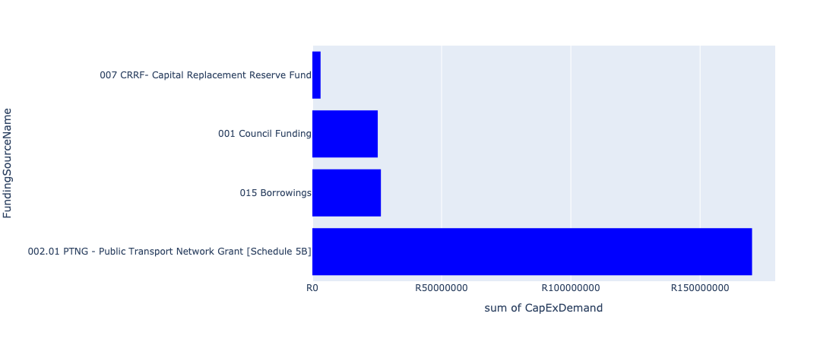

Figure 5.92: Ward 46 Departmental Requests

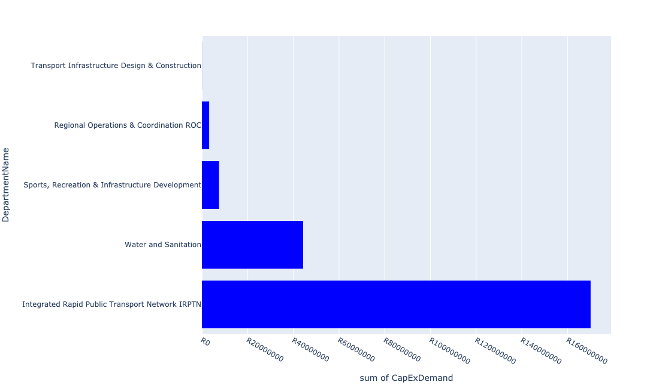

Table 5.46: Summary - Ward 46

|  |  |
| --- | --- |
| Item | Description |
| Total Capital Demand for Ward 46 - All Years | R225,090,948 Rank: 58 (1 = Highest) |
| Total Capital Demand for Ward 46 - MTREF | R182,478,086 Rank: 41 (1 = Highest) |
| Financial Years in which capital requirements are listed for Ward 46 | 2022, 2023, 2024, 2025, 2026, 2027, 2028, 2029 and 2030 |
| Financial Year with highest capital demand for Ward 46 | 2023 |
| Ward 46 intersecting feature used | Works Location |
| Total number of projects intersecting with Ward 46 | 16 Rank: 26 (1 = Highest) |

Table 5.47: All projects asking for budget in Ward 46

|  |  |  |  |
| --- | --- | --- | --- |
| Project ID | Project Name | Department | Project Budget |
| 712967744 | (712591) Design, Supply, Installation, Commissioning and Operational Support Of Advanced Public Transport Management System (APTMS) | Integrated Rapid Public Transport Network IRPTN | R703,089 (0.31%) Budget spread across: 2022 |
| 712971915 | Revitalisation of the City-Development of Non-Motorised Transport Masterplan | Transport Infrastructure Design & Construction | R39,838 (0.02%) Budget spread across: 2027 |
| 712970748 | R6 Machinery and Equipment to ensure basic infrastructure reliability | Regional Operations & Coordination ROC | R41,819 (0.02%) Budget spread across: 2022 and 2023 |
| 712975138 | (712121NAB2) New Arbeidsgenot 1 (Northern) Outfall Sewer (2/2) | Water and Sanitation | R18,000,000 (8.00%) Budget spread across: 2027, 2028, 2029 and 2030 |
| 712975137 | (712121NAB1) New Arbeidsgenot 1 (Northern) Outfall Sewer (1/2) | Water and Sanitation | R6,000,000 (2.67%) Budget spread across: 2028, 2029 and 2030 |
| 712967743 | (712591) The Design, Supply, Installation, Operation and Maintenance of an automated fare Collection (AFC) System | Integrated Rapid Public Transport Network IRPTN | R5,908,479 (2.62%) Budget spread across: 2022, 2023, 2024 and 2025 |
| 712967734 | (712591) BRT Line 2C-Lynnwood Rd (btw January Masilela & Simon Vermooten) | Integrated Rapid Public Transport Network IRPTN | R52,174,302 (23.18%) Budget spread across: 2022 and 2023 |
| 712967733 | (712591) BRT Line 2C-January Masilela (btw Atterbury & Lynnwood Rd) | Integrated Rapid Public Transport Network IRPTN | R87,905,163 (39.05%) Budget spread across: 2022 and 2023 |
| 712967731 | (712591) Line 2B: Atterbury Rd (btw Lynnwood Rd to Lois Avenue) | Integrated Rapid Public Transport Network IRPTN | R23,410,832 (10.40%) Budget spread across: 2022, 2023, 2024 and 2025 |
| 712973845 | R6 Regional Building Electrical Equipment / Aircon, Fire detection/systems installation (energy efficient) | Regional Operations & Coordination ROC | R3,132,880 (1.39%) Budget spread across: 2022 and 2023 |
| 712973830 | Build additional study hall at Glenstantia Library | Sports, Recreation & Infrastructure Development | R7,499,998 (3.33%) Budget spread across: 2029 |
| 712969439 | (712121D) Moreletaspruit: Outfall sewer | Water and Sanitation | R20,274,547 (9.01%) Budget spread across: 2022, 2023, 2024, 2025 and 2026 |

## Ward 47

Figure 5.93: Ward 47 Funding Requests

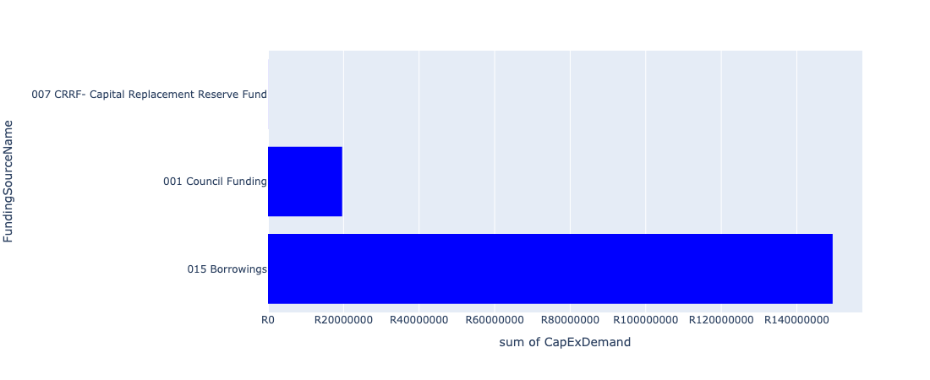

Figure 5.94: Ward 47 Departmental Requests

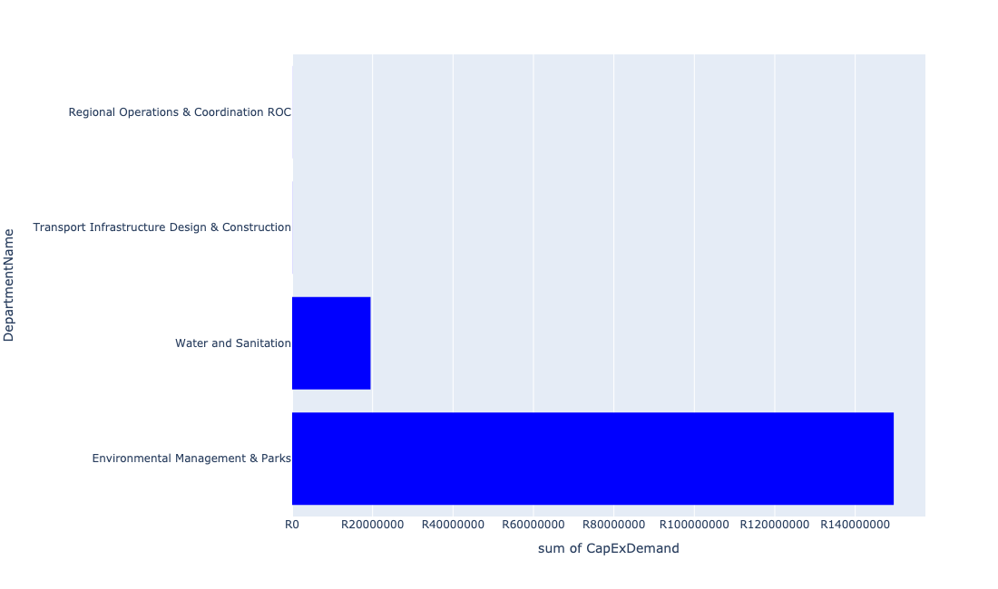

Table 5.47: Summary - Ward 47

|  |  |
| --- | --- |
| Item | Description |
| Total Capital Demand for Ward 47 - All Years | R169,131,916 Rank: 73 (1 = Highest) |
| Total Capital Demand for Ward 47 - MTREF | R103,769,542 Rank: 55 (1 = Highest) |
| Financial Years in which capital requirements are listed for Ward 47 | 2022, 2023, 2024, 2025, 2026, 2027 and 2028 |
| Financial Year with highest capital demand for Ward 47 | 2025 |
| Ward 47 intersecting feature used | Works Location |
| Total number of projects intersecting with Ward 47 | 6 Rank: 89 (1 = Highest) |

Table 5.48: All projects asking for budget in Ward 47

|  |  |  |  |
| --- | --- | --- | --- |
| Project ID | Project Name | Department | Project Budget |
| 712971915 | Revitalisation of the City-Development of Non-Motorised Transport Masterplan | Transport Infrastructure Design & Construction | R31,843 (0.02%) Budget spread across: 2027 |
| 712970748 | R6 Machinery and Equipment to ensure basic infrastructure reliability | Regional Operations & Coordination ROC | R21,874 (0.01%) Budget spread across: 2022 and 2023 |
| 712975233 | Development of Rietvlei conference Facility and Office park | Environmental Management & Parks | R149,447,384 (88.36%) Budget spread across: 2022, 2023, 2024 and 2025 |
| 712975455 | Upgrade infrastructure at Moreletakloof Nature Reserve | Environmental Management & Parks | R130,816 (0.08%) Budget spread across: 2023 and 2024 |
| 712975098 | (711335Gar) Replace and upgrade Garsfontein bulk pipe in Lynwood road | Water and Sanitation | R8,000,000 (4.73%) Budget spread across: 2026, 2027 and 2028 |
| 712975096 | (710411Y_EP) Additional Pump for Elardus Park (Large) booster PS | Water and Sanitation | R11,500,000 (6.80%) Budget spread across: 2025, 2026 and 2027 |

## Ward 48

Figure 5.95: Ward 48 Funding Requests

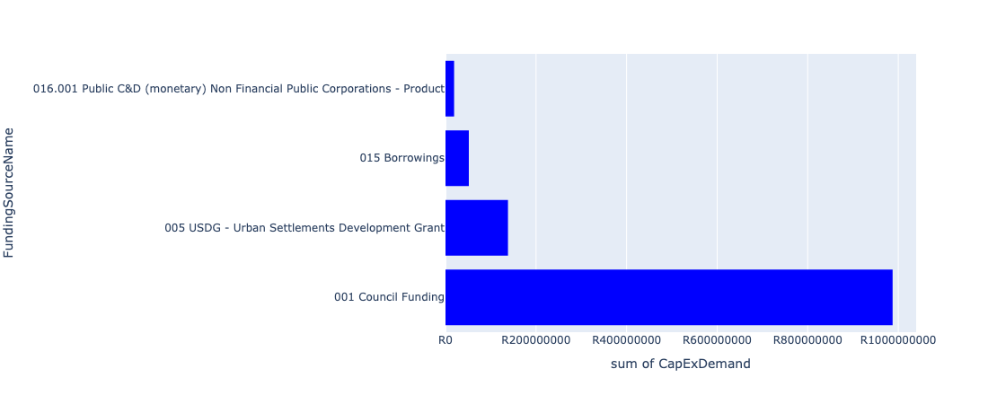

Figure 5.96: Ward 48 Departmental Requests

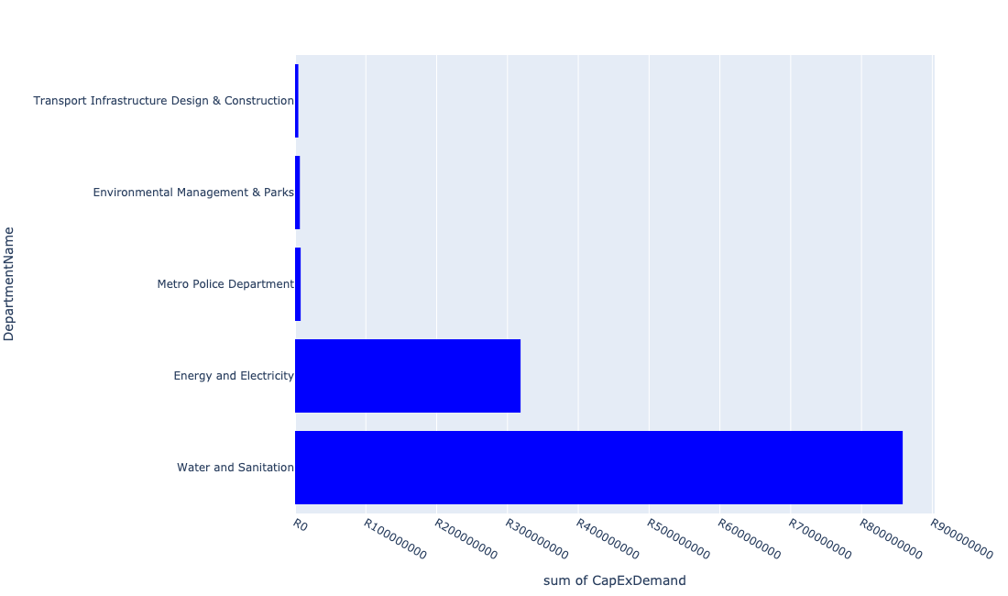

Table 5.48: Summary - Ward 48

|  |  |
| --- | --- |
| Item | Description |
| Total Capital Demand for Ward 48 - All Years | R1,166,031,796 Rank: 10 (1 = Highest) |
| Total Capital Demand for Ward 48 - MTREF | R443,187,237 Rank: 13 (1 = Highest) |
| Financial Years in which capital requirements are listed for Ward 48 | 2022, 2023, 2024, 2025, 2026, 2027 and 2028 |
| Financial Year with highest capital demand for Ward 48 | 2026 |
| Ward 48 intersecting feature used | Works Location |
| Total number of projects intersecting with Ward 48 | 14 Rank: 37 (1 = Highest) |

Table 5.49: All projects asking for budget in Ward 48

|  |  |  |  |
| --- | --- | --- | --- |
| Project ID | Project Name | Department | Project Budget |
| 712971915 | Revitalisation of the City-Development of Non-Motorised Transport Masterplan | Transport Infrastructure Design & Construction | R150,525 (0.01%) Budget spread across: 2027 |
| 712975171 | Upgrading of Hendrik Verwoerd Drive between John Vorster Drive and Rooihuiskraal Road in Centurion | Transport Infrastructure Design & Construction | R380,092 (0.03%) Budget spread across: 2026, 2027 and 2028 |
| 712974523 | Upgrading of Rooihuiskraal Road | Transport Infrastructure Design & Construction | R4,076,942 (0.35%) Budget spread across: 2022, 2023 and 2024 |
| 826 | (712121E) Rietspruit outfall sewer upgrade | Water and Sanitation | R10,200,800 (0.87%) Budget spread across: 2023 and 2024 |
| 712975402 | Sub-Project: TMPD Station: Raslouw AH | Metro Police Department | R7,923,437 (0.68%) Budget spread across: 2024 and 2025 |
| 712975346 | (712279) Centurion Switching Station | Energy and Electricity | R50,000,000 (4.29%) Budget spread across: 2025 and 2026 |
| 712974819 | 713044 Olievenhoutbosch Cemetery | Environmental Management & Parks | R800,000 (0.07%) Budget spread across: 2022 |
| 712974535 | (710411A5) Sunderland Ridge WWTW Phase 3: 25 Ml/d Extension on new adjacent site | Water and Sanitation | R693,000,000 (59.43%) Budget spread across: 2023, 2024, 2025, 2026, 2027 and 2028 |
| 712974534 | (710411A4) Sunderland Ridge WWTW: land aquisition of new adjacent site | Water and Sanitation | R155,000,000 (13.29%) Budget spread across: 2023 |
| 712967696 | (710178) Electricity for All - Region 4 | Energy and Electricity | R94,500,000 (8.10%) Budget spread across: 2022, 2023, 2024 and 2025 |
| 712967690 | (712279) Monavoni 132/11KV Substation | Energy and Electricity | R60,000,000 (5.15%) Budget spread across: 2022, 2023 and 2024 |
| 712967169 | New Electricity Depot -Region 4 (New) | Energy and Electricity | R114,000,000 (9.78%) Budget spread across: 2022, 2023 and 2024 |
| 712967120 | (713089) Rehabilitation of wetlands | Environmental Management & Parks | R6,000,000 (0.51%) Budget spread across: 2022 and 2023 |

## Ward 49

Figure 5.97: Ward 49 Funding Requests

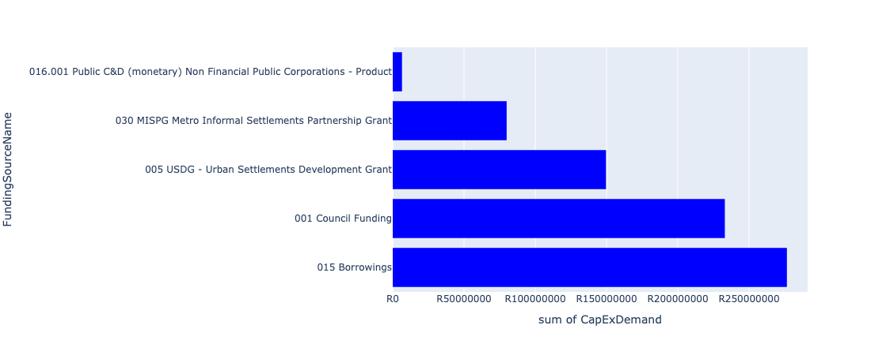

Figure 5.98: Ward 49 Departmental Requests

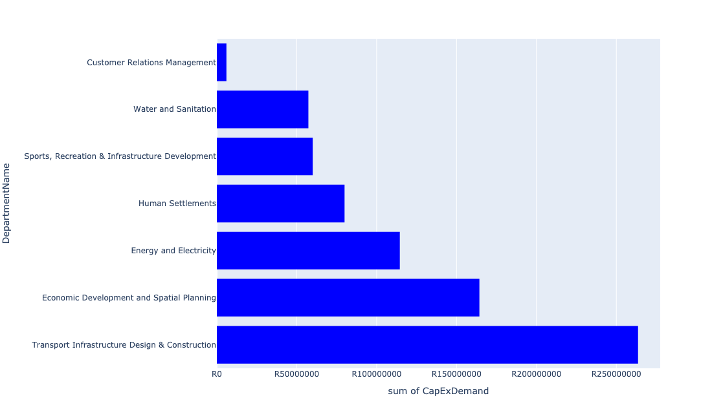

Table 5.49: Summary - Ward 49

|  |  |
| --- | --- |
| Item | Description |
| Total Capital Demand for Ward 49 - All Years | R739,085,684 Rank: 18 (1 = Highest) |
| Total Capital Demand for Ward 49 - MTREF | R378,521,517 Rank: 16 (1 = Highest) |
| Financial Years in which capital requirements are listed for Ward 49 | 2022, 2023, 2024, 2025, 2026, 2027, 2028, 2029 and 2030 |
| Financial Year with highest capital demand for Ward 49 | 2022 |
| Ward 49 intersecting feature used | Works Location |
| Total number of projects intersecting with Ward 49 | 22 Rank: 11 (1 = Highest) |

Table 5.50: All projects asking for budget in Ward 49

|  |  |  |  |
| --- | --- | --- | --- |
| Project ID | Project Name | Department | Project Budget |
| 712971915 | Revitalisation of the City-Development of Non-Motorised Transport Masterplan | Transport Infrastructure Design & Construction | R243,224 (0.03%) Budget spread across: 2027 |
| 712967840 | (712534H) Replacement and upgrading of bulk pipeline: Union Building - Jumbo Rally to Schoeman Street | Water and Sanitation | R9,286,745 (1.26%) Budget spread across: 2022, 2023 and 2024 |
| 712975468 | Upgrading of Existing ranking facility at Hammanskraal - Kopanong | Transport Infrastructure Design & Construction | R56,000,000 (7.58%) Budget spread across: 2022, 2023, 2024, 2025, 2026, 2027, 2028, 2029 and 2030 |
| 712975092 | (710411Y_NT) New Temba PS and Rising mains (Phase 2/2) | Water and Sanitation | R48,000,000 (6.49%) Budget spread across: 2028, 2029 and 2030 |
| 712967846 | (710178) Electricity for All - Region 2 | Energy and Electricity | R56,000,000 (7.58%) Budget spread across: 2024 and 2025 |
| 712967331 | (712977) Business Process Outsourcing (BPO) Park Construction | Economic Development and Spatial Planning | R164,300,000 (22.23%) Budget spread across: 2022 and 2023 |
| 622 | (711262) Magriet Monamodi Stormwater System | Transport Infrastructure Design & Construction | R67,333,971 (9.11%) Budget spread across: 2022, 2023, 2024, 2025, 2026, 2027, 2028, 2029 and 2030 |
| 712973963 | Refurbishment of Hammanskraal customer care centre | Customer Relations Management | R6,000,000 (0.81%) Budget spread across: 2024 |
| 712973888 | (711863) Internal Roads Mandela Village (North) | Transport Infrastructure Design & Construction | R140,000,000 (18.94%) Budget spread across: 2022, 2023, 2024, 2025, 2026, 2027, 2028, 2029 and 2030 |
| 712972933 | (710863) Water provision - Hammanskraal West X10 (Bulk water line) | Human Settlements | R19,921,743 (2.70%) Budget spread across: 2022 |
| 712969612 | (710863) Water provision - Hammanskraal West X10 (15ML Reservoir) | Human Settlements | R50,000,000 (6.77%) Budget spread across: 2022 and 2023 |
| 712969609 | (710864) Bulk Sewer - Hammanskraal West X10 | Human Settlements | R10,000,000 (1.35%) Budget spread across: 2023 |
| 712969350 | Hammanskraal Multi-purpose Sport Facility | Sports, Recreation & Infrastructure Development | R60,000,000 (8.12%) Budget spread across: 2026 and 2027 |
| 712969197 | (710556) Region 2 (Public Lighting) | Energy and Electricity | R58,500,000 (7.92%) Budget spread across: 2022, 2023, 2024, 2025, 2026, 2027, 2028, 2029 and 2030 |

## Ward 50

Figure 5.99: Ward 50 Funding Requests

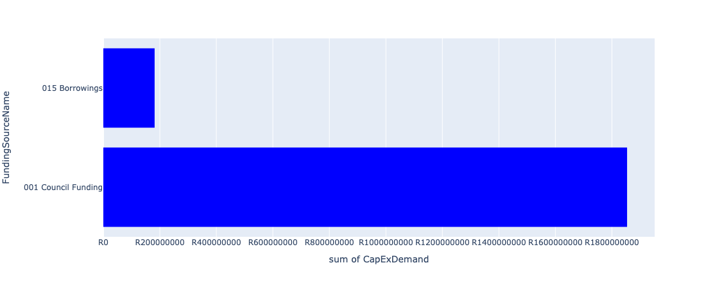

Figure 5.100: Ward 50 Departmental Requests

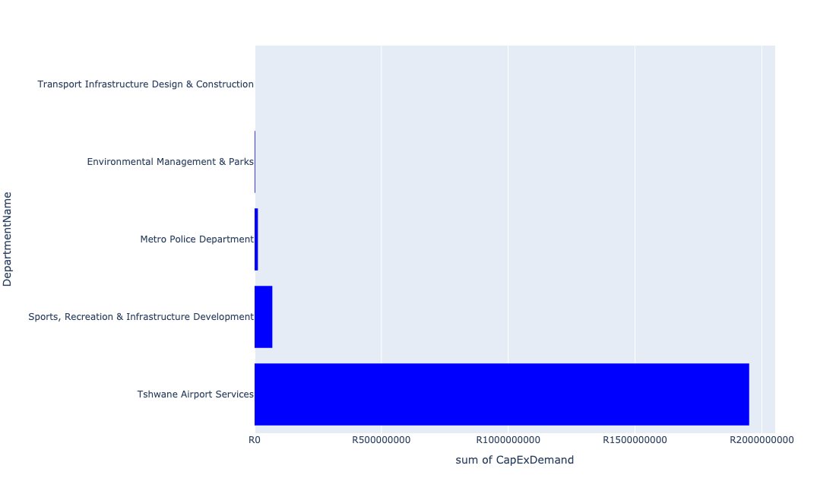

Table 5.50: Summary - Ward 50

|  |  |
| --- | --- |
| Item | Description |
| Total Capital Demand for Ward 50 - All Years | R1,735,247,624 Rank: 5 (1 = Highest) |
| Total Capital Demand for Ward 50 - MTREF | R328,935,661 Rank: 20 (1 = Highest) |
| Financial Years in which capital requirements are listed for Ward 50 | 2022, 2023, 2024, 2025, 2026, 2027, 2028, 2029, 2030 and 2031 |
| Financial Year with highest capital demand for Ward 50 | 2028 |
| Ward 50 intersecting feature used | Works Location |
| Total number of projects intersecting with Ward 50 | 63 Rank: 2 (1 = Highest) |

Table 5.51: All projects asking for budget in Ward 50

|  |  |  |  |
| --- | --- | --- | --- |
| Project ID | Project Name | Department | Project Budget |
| 712971915 | Revitalisation of the City-Development of Non-Motorised Transport Masterplan | Transport Infrastructure Design & Construction | R34,772 (0.00%) Budget spread across: 2027 |
| 712975456 | Upgrade of infrastructure of Magalies mountain | Environmental Management & Parks | R1,807,190 (0.10%) Budget spread across: 2022, 2023, 2024, 2025, 2026, 2027, 2028, 2029, 2030 and 2031 |
| 712975531 | Construction of 90 meters safety overshoot | Tshwane Airport Services | R29,435,661 (1.70%) Budget spread across: 2022, 2023 and 2024 |
| 712975771 | Upgrade and replacement of the faulty booster pump | Tshwane Airport Services | R5,300,000 (0.31%) Budget spread across: 2022 and 2023 |
| 712975769 | Information/advertising board at airport entrance | Tshwane Airport Services | R2,000,000 (0.12%) Budget spread across: 2022 and 2023 |
| 712975768 | Scrap aircraft preservation/storage parking bay | Tshwane Airport Services | R1,000,000 (0.06%) Budget spread across: 2023 and 2024 |
| 712975751 | Construction of a roof over the main terminal building | Tshwane Airport Services | R9,500,000 (0.55%) Budget spread across: 2022, 2023, 2024 and 2026 |
| 712975748 | Electronic billing system for Wonderboom Airport revenue streams (aeronautical and non-aeronautical) | Tshwane Airport Services | R7,500,000 (0.43%) Budget spread across: 2022 and 2023 |
| 712975746 | Purchase 4x4 vehicle for the Airport Aviation Safety Officer | Tshwane Airport Services | R850,000 (0.05%) Budget spread across: 2022 |
| 712975532 | Upgrade/replacement of emergency generator | Tshwane Airport Services | R6,800,000 (0.39%) Budget spread across: 2022, 2024 and 2025 |
| 712975454 | Upgrade of infrastructure at Wonderboom Nature Reserve | Environmental Management & Parks | R500,000 (0.03%) Budget spread across: 2022, 2023 and 2024 |
| 712975338 | Sub-Project: TMPD Station - Annlin West | Metro Police Department | R13,000,000 (0.75%) Budget spread across: 2023 and 2024 |
| 712967249 | CoT owned hangars and structure upgrade/replacement | Tshwane Airport Services | R43,000,000 (2.48%) Budget spread across: 2022, 2023, 2024, 2025, 2026, 2027, 2028, 2029 and 2030 |
| 712967248 | Construct of Golf Taxiway 2nd phase | Tshwane Airport Services | R45,000,000 (2.59%) Budget spread across: 2027, 2028 and 2029 |
| 712967247 | Construct additional helistops | Tshwane Airport Services | R12,500,000 (0.72%) Budget spread across: 2025, 2026, 2027 and 2030 |
| 712967245 | (712884) Upgrade and replacement of all runway and taxiway lights, Threshold light, Papi lights, apron lights, security and lighting system | Tshwane Airport Services | R43,000,000 (2.48%) Budget spread across: 2022, 2023 and 2024 |
| 712967244 | Resurface taxiways | Tshwane Airport Services | R19,000,000 (1.09%) Budget spread across: 2022, 2023, 2028 and 2029 |
| 712967243 | Resurface secondary runway | Tshwane Airport Services | R36,000,000 (2.07%) Budget spread across: 2022, 2023, 2029 and 2030 |
| 712967242 | Resurface main runway | Tshwane Airport Services | R22,000,000 (1.27%) Budget spread across: 2022 and 2028 |
| 712967237 | Purchase ground handling equipment | Tshwane Airport Services | R7,000,000 (0.40%) Budget spread across: 2023, 2024, 2025, 2027 and 2029 |
| 712967231 | Construction of Holding Bays | Tshwane Airport Services | R14,500,000 (0.84%) Budget spread across: 2027, 2028 and 2029 |
| 712967226 | (711953) Airside/Landside: Legislative compliance and related requirements | Tshwane Airport Services | R135,000,000 (7.78%) Budget spread across: 2022, 2023, 2024, 2025, 2026, 2027, 2028, 2029 and 2030 |
| 73 | Construction of a parkade | Tshwane Airport Services | R83,500,000 (4.81%) Budget spread across: 2027, 2028 and 2029 |
| 69 | Construction of offices, maintenance depot, boardroom, training facilities and conference facility on Airport Property | Tshwane Airport Services | R23,000,000 (1.33%) Budget spread across: 2027, 2028, 2029 and 2030 |
| 68 | Airport vehicles replacement, equipment and new vehicles (i.e. slasher, tipper truck, tractors with cabins, perimeter control inspection vehicles, mini-passenger busses, truck with crane, disabled transporting vehicles, etc.) | Tshwane Airport Services | R15,000,000 (0.86%) Budget spread across: 2023, 2024, 2025, 2026, 2027, 2028, 2029 and 2030 |
| 67 | Construction of a new control tower | Tshwane Airport Services | R55,000,000 (3.17%) Budget spread across: 2026, 2027 and 2028 |
| 66 | Provision of additional water, sewage, service road and taxiways, stormwater, security systems, electricity for airport expansion | Tshwane Airport Services | R43,000,000 (2.48%) Budget spread across: 2022, 2023, 2024, 2025, 2026, 2027, 2028, 2029 and 2030 |
| 65 | (713029) Additional carports and electronic parking payment equipment | Tshwane Airport Services | R3,000,000 (0.17%) Budget spread across: 2024 |
| 64 | Upgrade of Alpha apron | Tshwane Airport Services | R38,500,000 (2.22%) Budget spread across: 2026, 2027 and 2028 |
| 63 | Completion of Bravo apron | Tshwane Airport Services | R30,000,000 (1.73%) Budget spread across: 2025 and 2026 |
| 62 | Main runway and taxiway upgrade and/or extension, including all security, ground lighting and related systems and services. | Tshwane Airport Services | R1,155,000,000 (66.56%) Budget spread across: 2025, 2026, 2027, 2028, 2029 and 2030 |
| 58 | (714059) Construction of labour change room and related facilities | Tshwane Airport Services | R2,000,000 (0.12%) Budget spread across: 2022 and 2023 |
| 54 | (713057) Replacement and upgrade of fire hydrants and equipment | Tshwane Airport Services | R6,300,000 (0.36%) Budget spread across: 2022, 2023, 2024, 2025, 2026, 2027, 2028, 2029 and 2030 |
| 53 | (713000) Elevator/escalator for main terminal building | Tshwane Airport Services | R500,000 (0.03%) Budget spread across: 2024 |
| 20 | Overkruin Library and office space | Sports, Recreation & Infrastructure Development | R40,000,000 (2.31%) Budget spread across: 2022 and 2023 |
| 712973959 | Sinoville Spinning Club add ablutions store room and Kitchen unit | Sports, Recreation & Infrastructure Development | R10,000,000 (0.58%) Budget spread across: 2029 |
| 712973831 | Deon Malherbe Swimming pool Construction of a 25m indoor outdoor heated pool. | Sports, Recreation & Infrastructure Development | R20,000,000 (1.15%) Budget spread across: 2028 and 2029 |
| 712972920 | Golf Cart Shuttle for airport management inspection | Tshwane Airport Services | R70,000 (0.00%) Budget spread across: 2026 |
| 712972917 | Establishment and Renovation of Airport Maintenance Depot (compliance issue) | Tshwane Airport Services | R1,000,000 (0.06%) Budget spread across: 2022 |
| 712972912 | Capital Movables | Tshwane Airport Services | R4,500,000 (0.26%) Budget spread across: 2022, 2023, 2024, 2025, 2026, 2027, 2028, 2029 and 2030 |
| 712969641 | (713054) Construction of a separate entrance for General Aviation passengers | Tshwane Airport Services | R21,000,000 (1.21%) Budget spread across: 2023 and 2024 |
| 712969228 | (714065) Runway, Taxiway and road sweeper | Tshwane Airport Services | R4,000,000 (0.23%) Budget spread across: 2022 |
| 712969227 | (713031) Firearm safe for airport Visitors | Tshwane Airport Services | R200,000 (0.01%) Budget spread across: 2023 |
| 712969223 | 1 Tonner LDV for maintenance | Tshwane Airport Services | R500,000 (0.03%) Budget spread across: 2022 |
| 712969221 | Upgrade and fully equipping of airport medical clinic | Tshwane Airport Services | R5,150,000 (0.30%) Budget spread across: 2023, 2024, 2027 and 2029 |
| 712969218 | Airport minibus | Tshwane Airport Services | R2,500,000 (0.14%) Budget spread across: 2022 and 2024 |
| 712969217 | (714064) Tractors with slashers | Tshwane Airport Services | R7,300,000 (0.42%) Budget spread across: 2022, 2023 and 2030 |
| 712969209 | (714016) Development of a Joint Operating Centre | Tshwane Airport Services | R4,500,000 (0.26%) Budget spread across: 2022, 2023 and 2024 |
| 712969208 | (714049) Construction of rescue and fire fighting training facility as per SACARS requirements | Tshwane Airport Services | R3,000,000 (0.17%) Budget spread across: 2023 |
| 712969207 | Replacement of Tipper Truck | Tshwane Airport Services | R2,000,000 (0.12%) Budget spread across: 2022 |

## Ward 51

Figure 5.101: Ward 51 Funding Requests

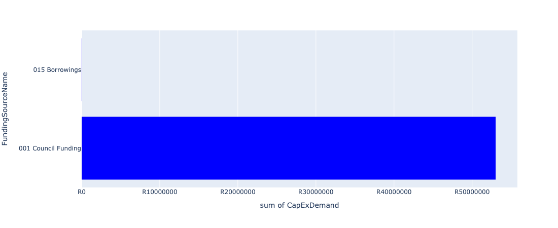

Figure 5.102: Ward 51 Departmental Requests

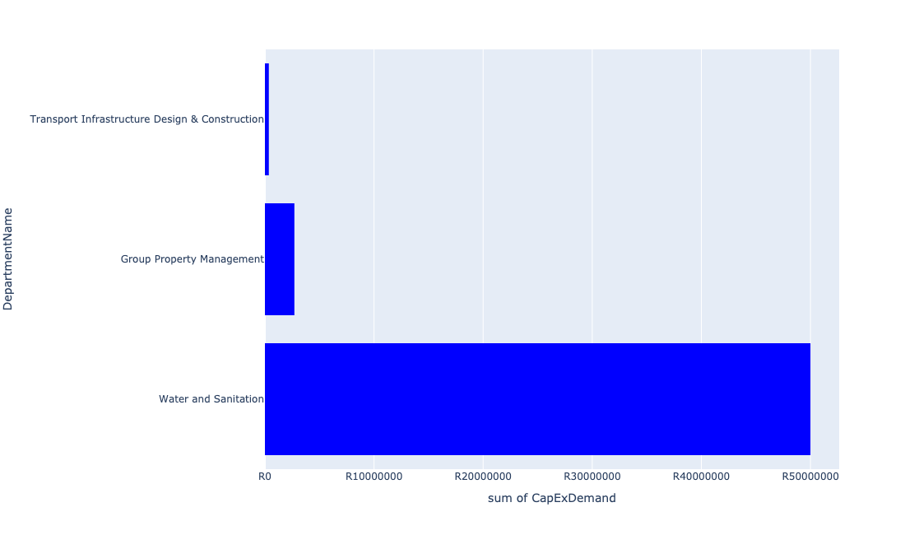

Table 5.51: Summary - Ward 51

|  |  |
| --- | --- |
| Item | Description |
| Total Capital Demand for Ward 51 - All Years | R53,059,102 Rank: 95 (1 = Highest) |
| Total Capital Demand for Ward 51 - MTREF | R27,724,049 Rank: 89 (1 = Highest) |
| Financial Years in which capital requirements are listed for Ward 51 | 2022, 2023, 2024, 2025, 2026, 2027, 2028, 2029 and 2030 |
| Financial Year with highest capital demand for Ward 51 | 2025 |
| Ward 51 intersecting feature used | Works Location |
| Total number of projects intersecting with Ward 51 | 6 Rank: 89 (1 = Highest) |

Table 5.52: All projects asking for budget in Ward 51

|  |  |  |  |
| --- | --- | --- | --- |
| Project ID | Project Name | Department | Project Budget |
| 712975019 | Decongestion of the inner city- Provisioning of New off street holding facilities within the inner city – CBD as per the 04 identified sites | Transport Infrastructure Design & Construction | R312,641 (0.59%) Budget spread across: 2022, 2023, 2024, 2025, 2026, 2027, 2028, 2029 and 2030 |
| 712971915 | Revitalisation of the City-Development of Non-Motorised Transport Masterplan | Transport Infrastructure Design & Construction | R46,461 (0.09%) Budget spread across: 2027 |
| 712975048 | Upgrade elevators Pretoria West power station | Group Property Management | R2,700,000 (5.09%) Budget spread across: 2022 |
| 712967862 | (711335L) Louwlardia to Samrand Bulk Pipeline | Water and Sanitation | R50,000,000 (94.23%) Budget spread across: 2023, 2024, 2025 and 2026 |

## Ward 52

Figure 5.103: Ward 52 Funding Requests

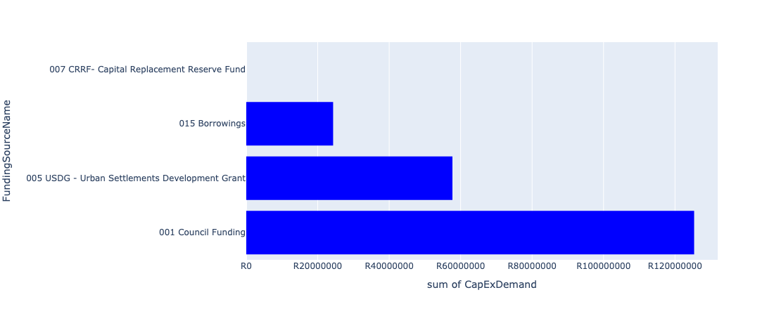

Figure 5.104: Ward 52 Departmental Requests

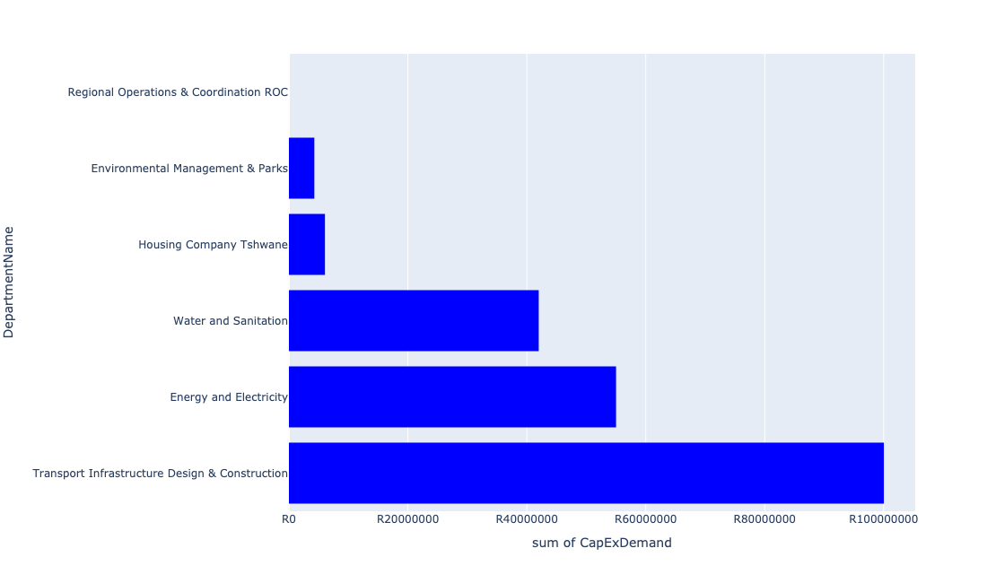

Table 5.52: Summary - Ward 52

|  |  |
| --- | --- |
| Item | Description |
| Total Capital Demand for Ward 52 - All Years | R204,664,118 Rank: 65 (1 = Highest) |
| Total Capital Demand for Ward 52 - MTREF | R94,355,000 Rank: 58 (1 = Highest) |
| Financial Years in which capital requirements are listed for Ward 52 | 2022, 2023, 2024, 2025, 2026, 2027, 2028, 2029, 2030 and 2031 |
| Financial Year with highest capital demand for Ward 52 | 2024 |
| Ward 52 intersecting feature used | Works Location |
| Total number of projects intersecting with Ward 52 | 13 Rank: 42 (1 = Highest) |

Table 5.53: All projects asking for budget in Ward 52

|  |  |  |  |
| --- | --- | --- | --- |
| Project ID | Project Name | Department | Project Budget |
| 712971915 | Revitalisation of the City-Development of Non-Motorised Transport Masterplan | Transport Infrastructure Design & Construction | R35,271 (0.02%) Budget spread across: 2027 |
| 712970748 | R6 Machinery and Equipment to ensure basic infrastructure reliability | Regional Operations & Coordination ROC | R0 (0.00%) Budget spread across: 2022 and 2023 |
| 712975456 | Upgrade of infrastructure of Magalies mountain | Environmental Management & Parks | R4,273,847 (2.09%) Budget spread across: 2022, 2023, 2024, 2025, 2026, 2027, 2028, 2029, 2030 and 2031 |
| 712975345 | (712279) Elland Switching Station | Energy and Electricity | R55,000,000 (26.87%) Budget spread across: 2023, 2024 and 2025 |
| 712975122 | (712534Mo) Mooiwater Reservoir (Phase 2) | Water and Sanitation | R31,000,000 (15.15%) Budget spread across: 2026, 2027 and 2028 |
| 712975120 | (712534) New Additional Waverly LL Reservoir | Water and Sanitation | R11,000,000 (5.37%) Budget spread across: 2023, 2024 and 2025 |
| 712967488 | (710671) East Lynne bus and taxi facilities | Transport Infrastructure Design & Construction | R100,000,000 (48.86%) Budget spread across: 2022, 2023, 2024, 2025, 2026, 2027, 2028, 2029 and 2030 |
| 712973991 | Oosmoot (Villeria) SSE (60 Units) | Housing Company Tshwane | R6,058,398 (2.96%) Budget spread across: 2024 |

## Ward 53

Figure 5.105: Ward 53 Funding Requests

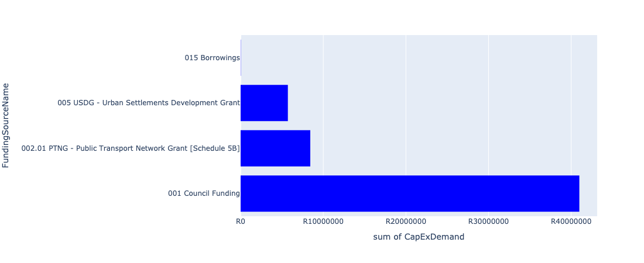

Figure 5.106: Ward 53 Departmental Requests

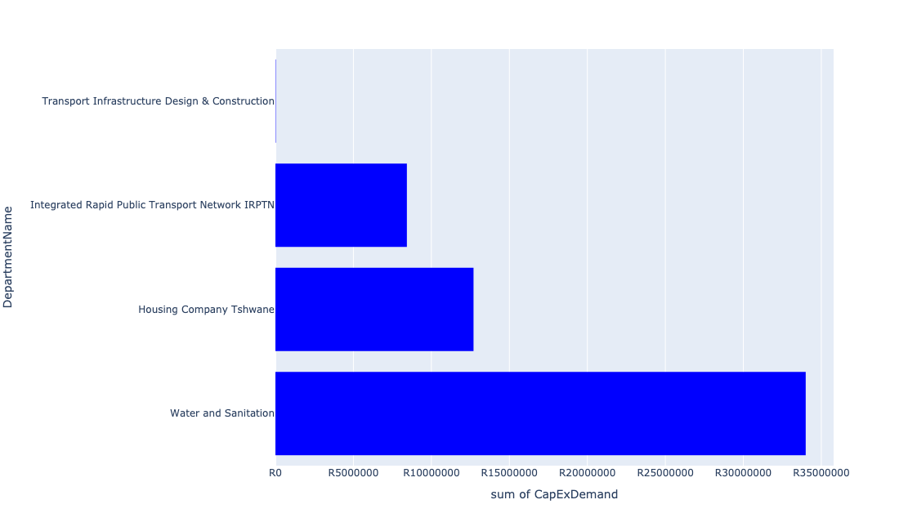

Table 5.53: Summary - Ward 53

|  |  |
| --- | --- |
| Item | Description |
| Total Capital Demand for Ward 53 - All Years | R49,438,077 Rank: 98 (1 = Highest) |
| Total Capital Demand for Ward 53 - MTREF | R39,414,120 Rank: 86 (1 = Highest) |
| Financial Years in which capital requirements are listed for Ward 53 | 2022, 2023, 2024, 2026 and 2027 |
| Financial Year with highest capital demand for Ward 53 | 2024 |
| Ward 53 intersecting feature used | Works Location |
| Total number of projects intersecting with Ward 53 | 9 Rank: 68 (1 = Highest) |

Table 5.54: All projects asking for budget in Ward 53

|  |  |  |  |
| --- | --- | --- | --- |
| Project ID | Project Name | Department | Project Budget |
| 712967744 | (712591) Design, Supply, Installation, Commissioning and Operational Support Of Advanced Public Transport Management System (APTMS) | Integrated Rapid Public Transport Network IRPTN | R1,562,508 (3.16%) Budget spread across: 2022 |
| 712971915 | Revitalisation of the City-Development of Non-Motorised Transport Masterplan | Transport Infrastructure Design & Construction | R23,957 (0.05%) Budget spread across: 2027 |
| 712967498 | (712591) BRT Rationalization Infrastructure (Mixed Traffic Operations) | Integrated Rapid Public Transport Network IRPTN | R6,170,304 (12.48%) Budget spread across: 2022 |
| 712969042 | (712591) Capital Park Railway Bridges (Line 1A - WP6) | Integrated Rapid Public Transport Network IRPTN | R696,309 (1.41%) Budget spread across: 2022 |
| 712975030 | (712534) Rietfontein Res (Phase1) | Water and Sanitation | R34,000,000 (68.77%) Budget spread across: 2023, 2024 and 2026 |
| 712973994 | Silwerkroon SSE (121 Units) | Housing Company Tshwane | R12,702,022 (25.69%) Budget spread across: 2024 |

## Ward 54

Figure 5.107: Ward 54 Funding Requests

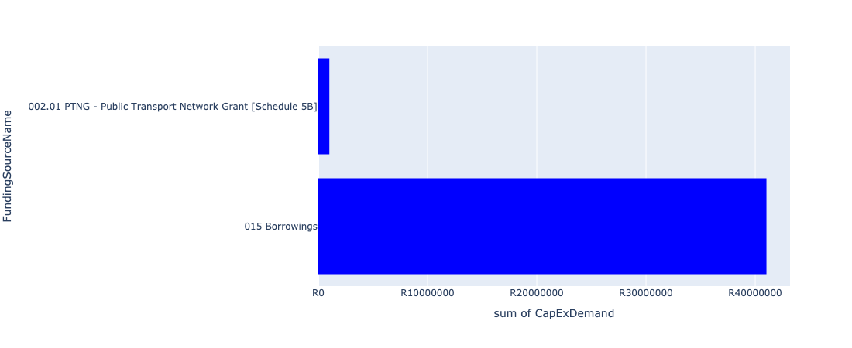

Figure 5.108: Ward 54 Departmental Requests

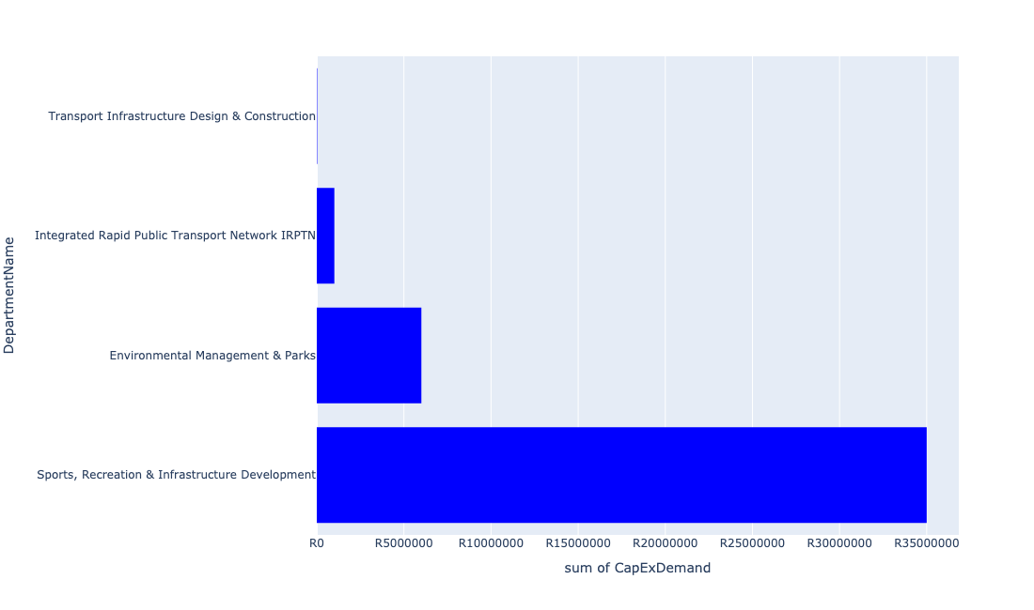

Table 5.54: Summary - Ward 54

|  |  |
| --- | --- |
| Item | Description |
| Total Capital Demand for Ward 54 - All Years | R42,035,567 Rank: 99 (1 = Highest) |
| Total Capital Demand for Ward 54 - MTREF | R3,008,184 Rank: 99 (1 = Highest) |
| Financial Years in which capital requirements are listed for Ward 54 | 2022, 2023, 2025, 2026, 2027, 2028, 2029, 2030 and 2031 |
| Financial Year with highest capital demand for Ward 54 | 2026 |
| Ward 54 intersecting feature used | Works Location |
| Total number of projects intersecting with Ward 54 | 7 Rank: 81 (1 = Highest) |

Table 5.55: All projects asking for budget in Ward 54

|  |  |  |  |
| --- | --- | --- | --- |
| Project ID | Project Name | Department | Project Budget |
| 712967744 | (712591) Design, Supply, Installation, Commissioning and Operational Support Of Advanced Public Transport Management System (APTMS) | Integrated Rapid Public Transport Network IRPTN | R1,008,184 (2.40%) Budget spread across: 2022 |
| 712971915 | Revitalisation of the City-Development of Non-Motorised Transport Masterplan | Transport Infrastructure Design & Construction | R25,365 (0.06%) Budget spread across: 2027 |
| 712975456 | Upgrade of infrastructure of Magalies mountain | Environmental Management & Parks | R4,002,018 (9.52%) Budget spread across: 2022, 2023, 2024, 2025, 2026, 2027, 2028, 2029, 2030 and 2031 |
| 712967133 | (712736) Fencing off Nature areas City Wide (Ecological Sensitive Purposes) | Environmental Management & Parks | R2,000,000 (4.76%) Budget spread across: 2022 and 2023 |
| 18 | (713070) New Mayville Library | Sports, Recreation & Infrastructure Development | R35,000,000 (83.26%) Budget spread across: 2026 and 2027 |

## Ward 55

Figure 5.109: Ward 55 Funding Requests

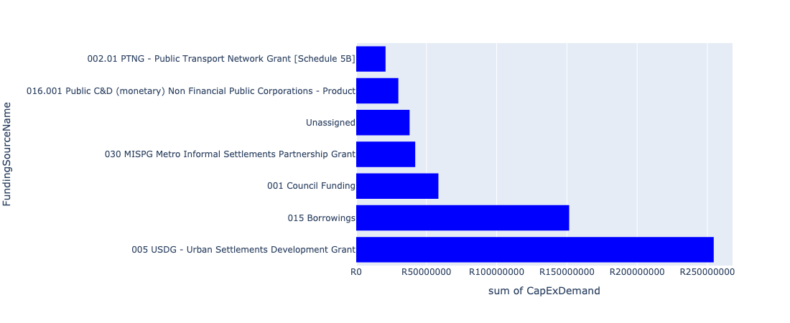

Figure 5.110: Ward 55 Departmental Requests

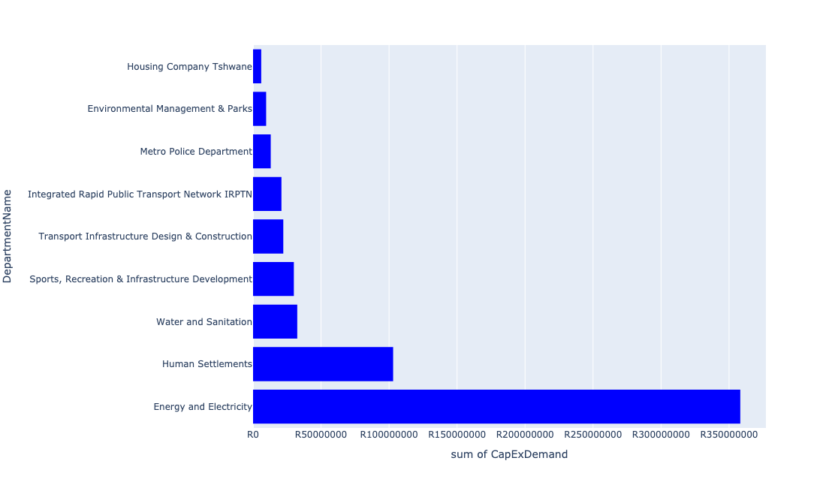

Table 5.55: Summary - Ward 55

|  |  |
| --- | --- |
| Item | Description |
| Total Capital Demand for Ward 55 - All Years | R531,475,451 Rank: 29 (1 = Highest) |
| Total Capital Demand for Ward 55 - MTREF | R246,738,477 Rank: 26 (1 = Highest) |
| Financial Years in which capital requirements are listed for Ward 55 | 2022, 2023, 2024, 2025, 2026, 2027, 2028, 2029, 2030 and 2031 |
| Financial Year with highest capital demand for Ward 55 | 2022 |
| Ward 55 intersecting feature used | Works Location |
| Total number of projects intersecting with Ward 55 | 27 Rank: 7 (1 = Highest) |

Table 5.56: All projects asking for budget in Ward 55

|  |  |  |  |
| --- | --- | --- | --- |
| Project ID | Project Name | Department | Project Budget |
| 712971915 | Revitalisation of the City-Development of Non-Motorised Transport Masterplan | Transport Infrastructure Design & Construction | R226,325 (0.04%) Budget spread across: 2027 |
| 712967745 | (712591) Planning and Design of BRT Projects | Integrated Rapid Public Transport Network IRPTN | R20,873,343 (3.93%) Budget spread across: 2022, 2023, 2024 and 2025 |
| 712975456 | Upgrade of infrastructure of Magalies mountain | Environmental Management & Parks | R2,125,783 (0.40%) Budget spread across: 2022, 2023, 2024, 2025, 2026, 2027, 2028, 2029, 2030 and 2031 |
| 712975533 | The Upgrading of Malie Street in Andeon and Booysens | Transport Infrastructure Design & Construction | R22,000,000 (4.14%) Budget spread across: 2025, 2026 and 2027 |
| 712975409 | Sub-Project: TMPD Station - Lady Selbourne/Suiderberg | Metro Police Department | R13,000,000 (2.45%) Budget spread across: 2024 and 2025 |
| 712975134 | (712121NSW2) New Swartspruit (A) Outfall Sewer (2/2) | Water and Sanitation | R22,000,000 (4.14%) Budget spread across: 2028 and 2029 |
| 712975133 | (712121NSW1) New Swartspruit (A) Outfall Sewer (1/2) | Water and Sanitation | R10,500,000 (1.98%) Budget spread across: 2028, 2029 and 2030 |
| 712967697 | (710178) Electricity for All - Region 3 | Energy and Electricity | R96,750,000 (18.20%) Budget spread across: 2022, 2023, 2024 and 2025 |
| 22 | Mountain View Library | Sports, Recreation & Infrastructure Development | R30,000,000 (5.64%) Budget spread across: 2026 and 2027 |
| 712974065 | (712279) Ifafi 88/11kV Substation | Energy and Electricity | R80,000,000 (15.05%) Budget spread across: 2024, 2025 and 2026 |
| 712973995 | Claremont 50 (BeterWag) SSE - 50 Units | Housing Company Tshwane | R6,000,000 (1.13%) Budget spread across: 2022 |
| 712972951 | (712826) Upgrade of infrastructure at Booysens Nursery | Environmental Management & Parks | R7,500,000 (1.41%) Budget spread across: 2022, 2023 and 2026 |
| 712972931 | (710863) Booysens X4 (30ML Reservoir) | Human Settlements | R60,000,000 (11.29%) Budget spread across: 2022, 2023 and 2024 |
| 712970768 | (710864) Sewer reticulation - Andeon X37 | Human Settlements | R0 (0.00%) Budget spread across: 2022 and 2023 |
| 712970767 | (710864) Sewer reticulation - Booysens X4 | Human Settlements | R5,000,000 (0.94%) Budget spread across: 2022 |
| 712970763 | (710863) Water reticulation - Booysens X4 | Human Settlements | R3,000,000 (0.56%) Budget spread across: 2022 |
| 712970762 | (710863) Water reticulation - Andeon X37 | Human Settlements | R0 (0.00%) Budget spread across: 2022 |
| 712969610 | (710863) Bulk water pipeline - Booysens X4 | Human Settlements | R35,000,000 (6.59%) Budget spread across: 2022, 2023 and 2024 |
| 712969192 | (710556) Region 3 (Public Lighting) | Energy and Electricity | R181,500,000 (34.15%) Budget spread across: 2022, 2023, 2024, 2025, 2026, 2027, 2028, 2029 and 2030 |

## Ward 56

Figure 5.111: Ward 56 Funding Requests

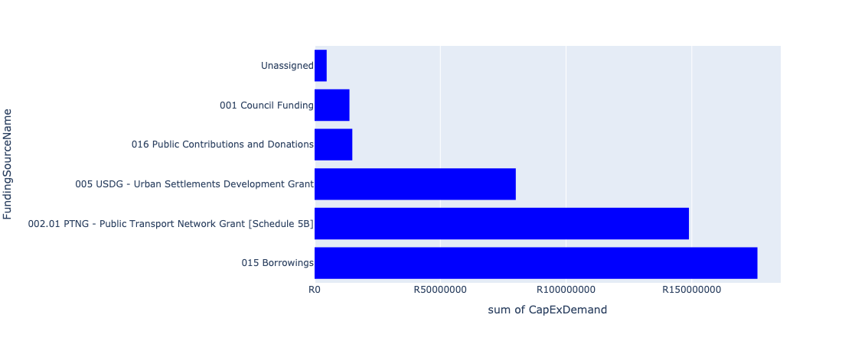

Figure 5.112: Ward 56 Departmental Requests

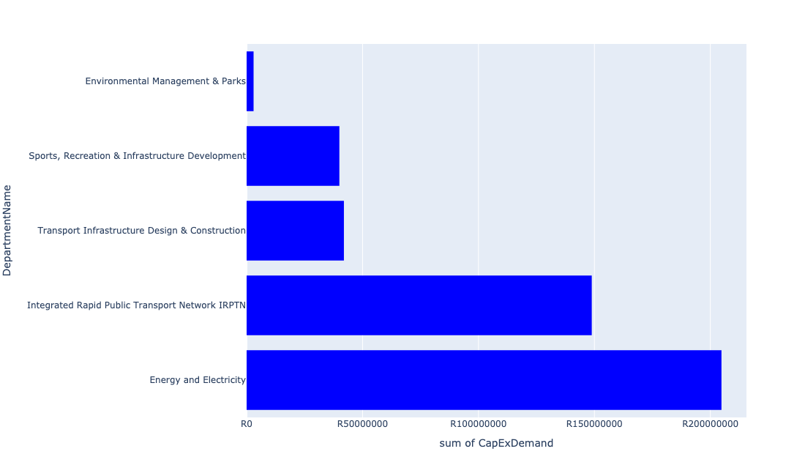

Table 5.56: Summary - Ward 56

|  |  |
| --- | --- |
| Item | Description |
| Total Capital Demand for Ward 56 - All Years | R378,616,202 Rank: 39 (1 = Highest) |
| Total Capital Demand for Ward 56 - MTREF | R206,963,062 Rank: 35 (1 = Highest) |
| Financial Years in which capital requirements are listed for Ward 56 | 2022, 2023, 2024, 2025, 2026, 2027, 2028, 2029, 2030 and 2031 |
| Financial Year with highest capital demand for Ward 56 | 2023 |
| Ward 56 intersecting feature used | Works Location |
| Total number of projects intersecting with Ward 56 | 14 Rank: 37 (1 = Highest) |

Table 5.57: All projects asking for budget in Ward 56

|  |  |  |  |
| --- | --- | --- | --- |
| Project ID | Project Name | Department | Project Budget |
| 712975019 | Decongestion of the inner city- Provisioning of New off street holding facilities within the inner city – CBD as per the 04 identified sites | Transport Infrastructure Design & Construction | R12,590,660 (3.33%) Budget spread across: 2022, 2023, 2024, 2025, 2026, 2027, 2028, 2029 and 2030 |
| 712967744 | (712591) Design, Supply, Installation, Commissioning and Operational Support Of Advanced Public Transport Management System (APTMS) | Integrated Rapid Public Transport Network IRPTN | R1,835,690 (0.48%) Budget spread across: 2022 |
| 712971915 | Revitalisation of the City-Development of Non-Motorised Transport Masterplan | Transport Infrastructure Design & Construction | R16,811 (0.00%) Budget spread across: 2027 |
| 712967743 | (712591) The Design, Supply, Installation, Operation and Maintenance of an automated fare Collection (AFC) System | Integrated Rapid Public Transport Network IRPTN | R15,549,936 (4.11%) Budget spread across: 2022, 2023, 2024 and 2025 |
| 712975494 | Construction of Litter Traps at Austin Roberts Nature Reserve | Environmental Management & Parks | R3,000,000 (0.79%) Budget spread across: 2022, 2023, 2024, 2025 and 2026 |
| 712974816 | Upgrading of Justice Mahomed Drive between Dely/Brooklyn Road and Jan Shoba Street | Transport Infrastructure Design & Construction | R25,027,912 (6.61%) Budget spread across: 2022 and 2023 |
| 712974188 | Hillcrest swimming pool upgrade to international standard facility | Sports, Recreation & Infrastructure Development | R40,000,000 (10.56%) Budget spread across: 2028 and 2029 |
| 712974164 | Major Stormwater network 4G along Boundary Road, Hatfield | Transport Infrastructure Design & Construction | R4,323,859 (1.14%) Budget spread across: 2026, 2027 and 2028 |
| 712967730 | (712591) Line 2B: Lynnwood Rd (btw University Rd to Atterbury) | Integrated Rapid Public Transport Network IRPTN | R126,124,815 (33.31%) Budget spread across: 2022, 2023 and 2024 |
| 485 | (710484) Secondary Substations | Energy and Electricity | R204,800,000 (54.09%) Budget spread across: 2022, 2023, 2024, 2025, 2026, 2027, 2028, 2029, 2030 and 2031 |
| 712969046 | (712591) NMT Line 2B (Hatfield to Menlyn) | Integrated Rapid Public Transport Network IRPTN | R5,346,519 (1.41%) Budget spread across: 2022 |

## Ward 57

Figure 5.113: Ward 57 Funding Requests

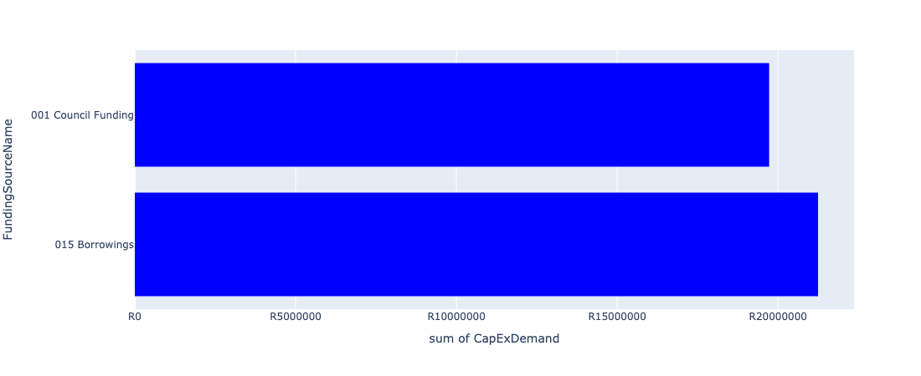

Figure 5.114: Ward 57 Departmental Requests

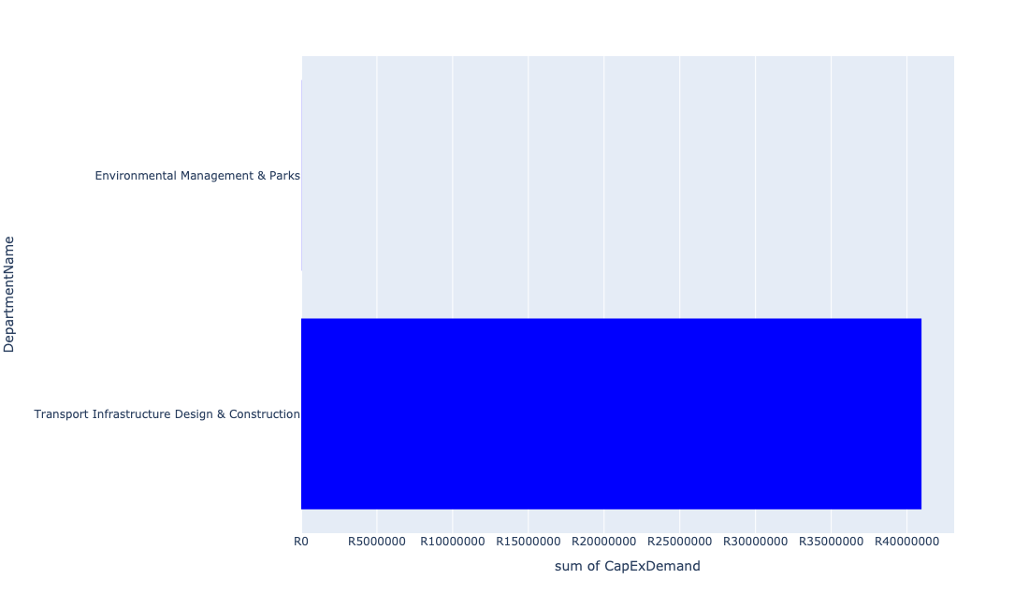

Table 5.57: Summary - Ward 57

|  |  |
| --- | --- |
| Item | Description |
| Total Capital Demand for Ward 57 - All Years | R37,101,853 Rank: 101 (1 = Highest) |
| Total Capital Demand for Ward 57 - MTREF | R2,524,760 Rank: 101 (1 = Highest) |
| Financial Years in which capital requirements are listed for Ward 57 | 2022, 2023, 2024, 2025, 2026, 2027, 2028, 2029 and 2030 |
| Financial Year with highest capital demand for Ward 57 | 2027 |
| Ward 57 intersecting feature used | Works Location |
| Total number of projects intersecting with Ward 57 | 8 Rank: 74 (1 = Highest) |

Table 5.58: All projects asking for budget in Ward 57

|  |  |  |  |
| --- | --- | --- | --- |
| Project ID | Project Name | Department | Project Budget |
| 712971915 | Revitalisation of the City-Development of Non-Motorised Transport Masterplan | Transport Infrastructure Design & Construction | R20,504 (0.06%) Budget spread across: 2027 |
| 712975442 | Upgrade of infrastructure at DLS Nature Reserve | Environmental Management & Parks | R10,907 (0.03%) Budget spread across: 2022 and 2023 |
| 712974159 | Major Stormwater Network 6C, along Gropius Avenue, Die Hoewes | Transport Infrastructure Design & Construction | R2,000,000 (5.39%) Budget spread across: 2026 and 2027 |
| 712974158 | Upgrading of major stormwater Network 3A along Rabie Street, Lyttleton | Transport Infrastructure Design & Construction | R19,020,460 (51.27%) Budget spread across: 2025, 2026 and 2027 |
| 712967490 | (712368) Upgrading of facility ( Shelters and bus terminals ) at Centurion CBD | Transport Infrastructure Design & Construction | R19,917,446 (53.68%) Budget spread across: 2022, 2023, 2024, 2025, 2026, 2027, 2028, 2029 and 2030 |

## Ward 58

Figure 5.115: Ward 58 Funding Requests

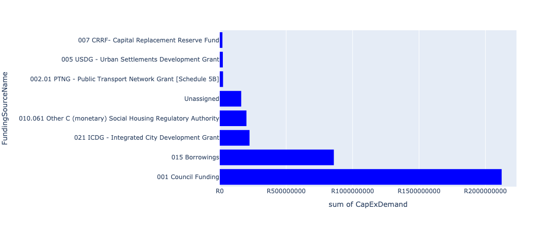

Figure 5.116: Ward 58 Departmental Requests

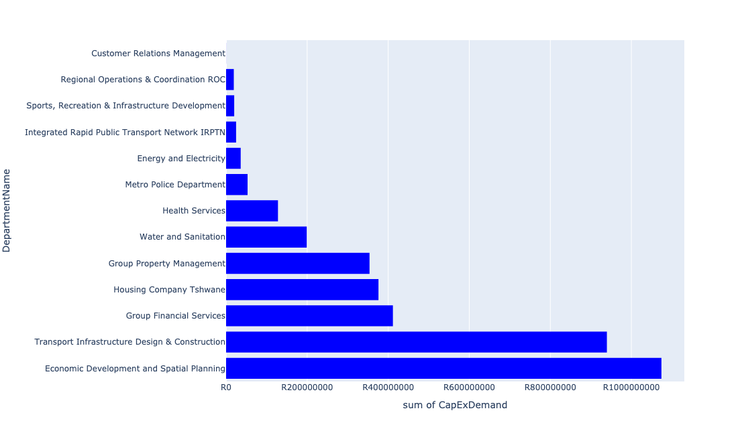

Table 5.58: Summary - Ward 58

|  |  |
| --- | --- |
| Item | Description |
| Total Capital Demand for Ward 58 - All Years | R3,401,056,429 Rank: 2 (1 = Highest) |
| Total Capital Demand for Ward 58 - MTREF | R1,612,749,354 Rank: 1 (1 = Highest) |
| Financial Years in which capital requirements are listed for Ward 58 | 2022, 2023, 2024, 2025, 2026, 2027, 2028, 2029, 2030, 2031 and 2032 |
| Financial Year with highest capital demand for Ward 58 | 2022 |
| Ward 58 intersecting feature used | Works Location |
| Total number of projects intersecting with Ward 58 | 83 Rank: 1 (1 = Highest) |

Table 5.59: All projects asking for budget in Ward 58

|  |  |  |  |
| --- | --- | --- | --- |
| Project ID | Project Name | Department | Project Budget |
| 712975797 | Acquisition Old-Mercedes Benz Building | Group Property Management | R120,888,656 (3.55%) Budget spread across: 2022, 2023, 2024, 2025, 2026, 2027, 2028, 2029, 2030 and 2031 |
| 712975590 | Refurbishment of Mamelodi customer care centre | Customer Relations Management | R166,667 (0.00%) Budget spread across: 2025 |
| 712975578 | Refurbishment of the Old Fire Station | Group Property Management | R20,000,000 (0.59%) Budget spread across: 2023 |
| 712975556 | Refurbishment of Pretoria City Hall | Group Property Management | R50,000,000 (1.47%) Budget spread across: 2022 and 2023 |
| 712975525 | Upgrading and extension of cold storage Facilities | Economic Development and Spatial Planning | R444,160,000 (13.06%) Budget spread across: 2022, 2023, 2024, 2025, 2026, 2027, 2028, 2029, 2030, 2031 and 2032 |
| 712975520 | Upgrading of ripening center | Economic Development and Spatial Planning | R17,242,432 (0.51%) Budget spread across: 2022, 2023, 2024, 2025, 2026, 2027, 2028, 2029, 2030, 2031 and 2032 |
| 712975479 | Upgrade elevator Christiaan De Wet administration building | Group Property Management | R1,200,000 (0.04%) Budget spread across: 2024 |
| 712975474 | Upgrade elevators Pretoria City Hall | Group Property Management | R5,000,000 (0.15%) Budget spread across: 2023 |
| 712975453 | Upgrading of Dr Savage tranking facility and holding facility | Transport Infrastructure Design & Construction | R182,000,000 (5.35%) Budget spread across: 2022, 2023, 2024, 2025, 2026, 2027, 2028, 2029 and 2030 |
| 712975443 | Supply and installation of generators for Tshwane Market | Economic Development and Spatial Planning | R5,949,998 (0.17%) Budget spread across: 2022, 2023, 2024, 2025, 2026, 2027, 2028, 2029, 2030, 2031 and 2032 |
| 712975438 | Creative Arts Spaces (Region 3) | Sports, Recreation & Infrastructure Development | R10,000,000 (0.29%) Budget spread across: 2025 |
| 712975406 | Sub-Project: TMPD Station - CBD (Madiba Street 1) | Metro Police Department | R42,000,000 (1.23%) Budget spread across: 2022, 2023 and 2024 |
| 712975385 | Upgrading and extension of Access control office on the eastern gate | Economic Development and Spatial Planning | R20,300,000 (0.60%) Budget spread across: 2022, 2023, 2024, 2025, 2026, 2027, 2028, 2029, 2030, 2031 and 2032 |
| 712975293 | Upgrade elevator Old Council Chamber | Group Property Management | R1,400,000 (0.04%) Budget spread across: 2027 |
| 712975292 | Upgrading of Dairy Mall to one stop intermodal facility ( Rail,Bus,Taxi) | Transport Infrastructure Design & Construction | R110,000,000 (3.23%) Budget spread across: 2022, 2023, 2024, 2025, 2026, 2027, 2028, 2029 and 2030 |
| 712975251 | 712967311_02 Upgrade passenger elevators at Blesbok and Bosbok flats | Group Property Management | R3,999,349 (0.12%) Budget spread across: 2022 |
| 712975197 | Upgrade elevator PE5905 Sammy Marks Library | Group Property Management | R1,400,000 (0.04%) Budget spread across: 2022 |
| 712975019 | Decongestion of the inner city- Provisioning of New off street holding facilities within the inner city – CBD as per the 04 identified sites | Transport Infrastructure Design & Construction | R14,883,472 (0.44%) Budget spread across: 2022, 2023, 2024, 2025, 2026, 2027, 2028, 2029 and 2030 |
| 712974602 | Upgrading of the Steenhoven Spruit near Asiatic Bazaar, Pretoria west | Transport Infrastructure Design & Construction | R45,000,000 (1.32%) Budget spread across: 2026, 2027, 2028, 2029 and 2030 |
| 712974479 | RIMM: BELLE OMBRE: SOIL & ASPHALT LAB REFURBISHMENT | Regional Operations & Coordination ROC | R1,000,000 (0.03%) Budget spread across: 2022 |
| 712974478 | RIMM: BELLE OMBRE: BIOMETRICAL TIME AND ATTENDANCE SYSTEM | Regional Operations & Coordination ROC | R1,000,000 (0.03%) Budget spread across: 2022 |
| 712974354 | (712591) Belle Ombre - Phase 2 (Overflow car park, Electric Fencing etc) | Integrated Rapid Public Transport Network IRPTN | R1,000,000 (0.03%) Budget spread across: 2022 |
| 712974352 | (712591) Line 3: CBD to Atteridgeville - Section 1 (CBD - Pretoria West) | Integrated Rapid Public Transport Network IRPTN | R3,774,599 (0.11%) Budget spread across: 2022 |
| 712974181 | Provisioning of new taxi ranking facility at Marabastad  Bazaar | Transport Infrastructure Design & Construction | R79,000,000 (2.32%) Budget spread across: 2022, 2023, 2024, 2025, 2026, 2027, 2028, 2029 and 2030 |
| 712967835 | New Folang Clinic | Health Services | R64,000,000 (1.88%) Budget spread across: 2022, 2023 and 2024 |
| 712967812 | (712900) Upgrading of Departmental Armory & Ammunition Depot | Metro Police Department | R11,000,000 (0.32%) Budget spread across: 2022, 2023 and 2024 |
| 712967744 | (712591) Design, Supply, Installation, Commissioning and Operational Support Of Advanced Public Transport Management System (APTMS) | Integrated Rapid Public Transport Network IRPTN | R2,553,499 (0.08%) Budget spread across: 2022 |
| 712967144 | (711442) Upgrading of museums/historical buildings | Sports, Recreation & Infrastructure Development | R6 (0.00%) Budget spread across: 2025 |
| 1286 | (712868) Upgrading of the market trading system | Economic Development and Spatial Planning | R106,100,000 (3.12%) Budget spread across: 2022, 2023, 2025, 2026, 2027, 2028, 2029, 2031 and 2032 |
| 1124 | (712751) Capital Funded from Operating (City Planning & Development) | Economic Development and Spatial Planning | R5,500,000 (0.16%) Budget spread across: 2022, 2023, 2024, 2025, 2026, 2027, 2028, 2029 and 2030 |
| 1028 | (712534) Relining/upgrading reservoirs | Water and Sanitation | R190,000,000 (5.59%) Budget spread across: 2022, 2023, 2024, 2025, 2026, 2027, 2028, 2029 and 2030 |
| 460 | Reparation To & Resurfacing Of Roads (Fresh Produce Market) | Economic Development and Spatial Planning | R17,500,000 (0.51%) Budget spread across: 2022, 2023, 2024 and 2025 |
| 391 | (710276) Upgrading And Extension Of Market Facilities | Economic Development and Spatial Planning | R228,700,000 (6.72%) Budget spread across: 2022, 2023, 2024 and 2025 |
| 15 | Capital Theatre (Feasibility Study) | Sports, Recreation & Infrastructure Development | R10,000,000 (0.29%) Budget spread across: 2025 |
| 712974096 | 712972939_04_Replacement of oils cables (City Centre) ( Electricity Distribution Loss) | Energy and Electricity | R36,000,000 (1.06%) Budget spread across: 2022, 2023, 2024 and 2025 |
| 712973993 | Capital Park SSE (69 Units) | Housing Company Tshwane | R6,852,942 (0.20%) Budget spread across: 2024 |
| 712973992 | Eloff Gebou (95 Units) Affordable rental | Housing Company Tshwane | R10,450,000 (0.31%) Budget spread across: 2023 and 2024 |
| 712973975 | Replacement of FF Ribeiro Clinic | Health Services | R64,000,000 (1.88%) Budget spread across: 2024, 2025 and 2026 |
| 712973957 | Timberlands Construction Of 607 Social Housing Units | Housing Company Tshwane | R91,497,677 (2.69%) Budget spread across: 2022, 2023 and 2024 |
| 712973869 | RIMM: BELLE OMBRE DEPOT: Upgrade Security fence | Regional Operations & Coordination ROC | R2,000,000 (0.06%) Budget spread across: 2022 |
| 712973856 | (714029) RIMM: Belle Ombre: Concrete Plant | Regional Operations & Coordination ROC | R1,500,000 (0.04%) Budget spread across: 2022 |
| 712973851 | (714030 RIMM: Belle Ombre: Concrete Plant: Pneumatic Cylinders | Regional Operations & Coordination ROC | R1,000,000 (0.03%) Budget spread across: 2022 |
| 712972966 | Townlands Project - Construction of 1,200 social housing units | Housing Company Tshwane | R267,180,300 (7.86%) Budget spread across: 2022, 2023 and 2024 |
| 712972958 | (712827) Specialised Vehicles | Economic Development and Spatial Planning | R4,626,773 (0.14%) Budget spread across: 2022, 2023, 2024, 2025, 2026, 2027, 2029, 2030, 2031 and 2032 |
| 712972946 | (712591) Wonderboom Intermodal Facility (Building Works) | Integrated Rapid Public Transport Network IRPTN | R17,343,397 (0.51%) Budget spread across: 2022 |
| 712971919 | Revitalisation of the City-Taxi Holding areas within the Pretoria CBD | Transport Infrastructure Design & Construction | R276,000,000 (8.12%) Budget spread across: 2022, 2023, 2024, 2025, 2026, 2027, 2028, 2029 and 2030 |
| 712971918 | Revitalisation of the City-Upgrade of Pretoria Station Taxi Rank- Dairy Mall Taxi Rank | Transport Infrastructure Design & Construction | R232,647,652 (6.84%) Budget spread across: 2022, 2023, 2024, 2025, 2026, 2027, 2028, 2029 and 2030 |
| 712971915 | Revitalisation of the City-Development of Non-Motorised Transport Masterplan | Transport Infrastructure Design & Construction | R22,609 (0.00%) Budget spread across: 2027 |
| 712970745 | (713093) Upgrade HB Philips Building | Group Property Management | R150,000,000 (4.41%) Budget spread across: 2022 |
| 712970712 | (713084) Lalela Monument | Economic Development and Spatial Planning | R24,000,000 (0.71%) Budget spread across: 2022 and 2023 |
| 712969694 | (712762) Capital Moveables | Water and Sanitation | R9,000,000 (0.26%) Budget spread across: 2022, 2023, 2024, 2025, 2026, 2027, 2028, 2029 and 2030 |
| 712969692 | (712926) Capital Moveables | Regional Operations & Coordination ROC | R12,500,000 (0.37%) Budget spread across: 2022, 2023, 2024, 2025 and 2026 |
| 712969687 | (713063) Turnaround of Municipal Water Service - Reduction of Water losses | Group Financial Services | R411,592,208 (12.10%) Budget spread across: 2022, 2023, 2024, 2026 and 2027 |
| 712969243 | (713023) Inner City Regeneration: Civic and Northern Gateway Precincts | Economic Development and Spatial Planning | R200,000,000 (5.88%) Budget spread across: 2022, 2023, 2024, 2025, 2026, 2027, 2028, 2029 and 2030 |

## Ward 59

Figure 5.117: Ward 59 Funding Requests

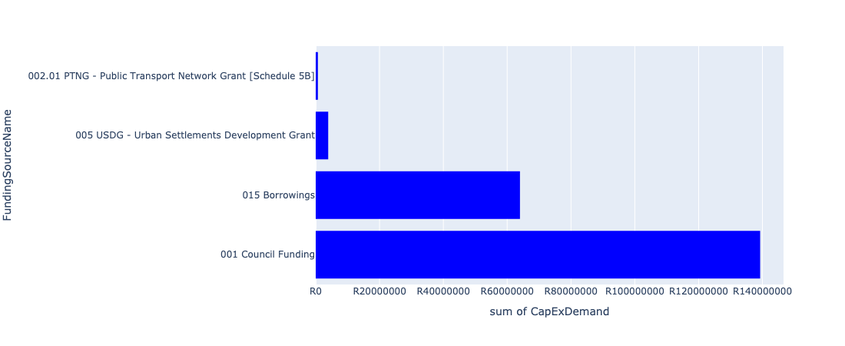

Figure 5.118: Ward 59 Departmental Requests

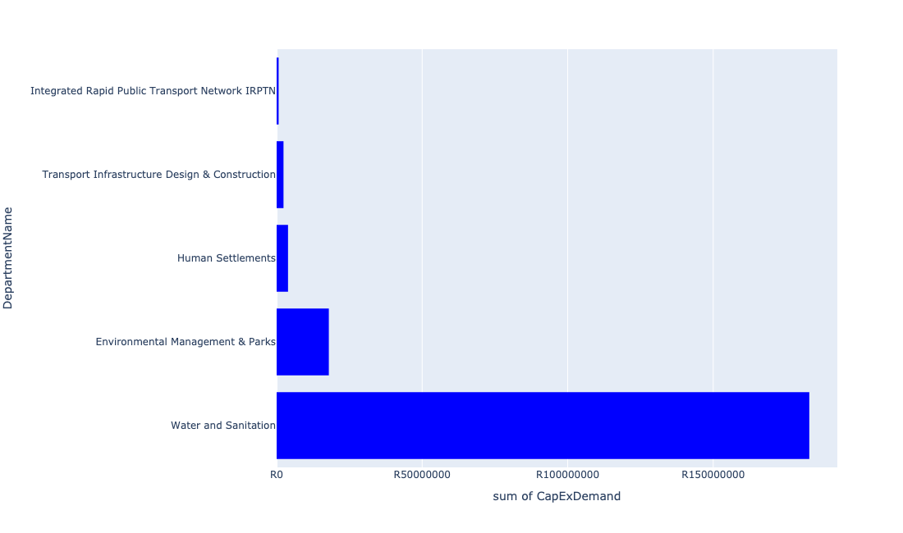

Table 5.59: Summary - Ward 59

|  |  |
| --- | --- |
| Item | Description |
| Total Capital Demand for Ward 59 - All Years | R187,887,027 Rank: 67 (1 = Highest) |
| Total Capital Demand for Ward 59 - MTREF | R40,763,567 Rank: 84 (1 = Highest) |
| Financial Years in which capital requirements are listed for Ward 59 | 2022, 2023, 2024, 2025, 2026, 2027, 2028, 2029 and 2030 |
| Financial Year with highest capital demand for Ward 59 | 2026 |
| Ward 59 intersecting feature used | Works Location |
| Total number of projects intersecting with Ward 59 | 16 Rank: 26 (1 = Highest) |

Table 5.60: All projects asking for budget in Ward 59

|  |  |  |  |
| --- | --- | --- | --- |
| Project ID | Project Name | Department | Project Budget |
| 712975019 | Decongestion of the inner city- Provisioning of New off street holding facilities within the inner city – CBD as per the 04 identified sites | Transport Infrastructure Design & Construction | R2,280,800 (1.21%) Budget spread across: 2022, 2023, 2024, 2025, 2026, 2027, 2028, 2029 and 2030 |
| 712967744 | (712591) Design, Supply, Installation, Commissioning and Operational Support Of Advanced Public Transport Management System (APTMS) | Integrated Rapid Public Transport Network IRPTN | R685,936 (0.37%) Budget spread across: 2022 |
| 712971915 | Revitalisation of the City-Development of Non-Motorised Transport Masterplan | Transport Infrastructure Design & Construction | R75,945 (0.04%) Budget spread across: 2027 |
| 712975442 | Upgrade of infrastructure at DLS Nature Reserve | Environmental Management & Parks | R1,989,093 (1.06%) Budget spread across: 2022 and 2023 |
| 712975526 | Upgrade of Roads in Groenkloof Nature reserve | Environmental Management & Parks | R3,942,182 (2.10%) Budget spread across: 2022, 2023, 2024, 2025, 2026, 2027, 2028 and 2029 |
| 712975523 | Upgrade of Visitors Facilities - Groenkloof Nature Reserve | Environmental Management & Parks | R3,999,979 (2.13%) Budget spread across: 2022, 2023, 2024, 2025, 2026 and 2027 |
| 712975516 | Construction of Entrance gates - Klapperkop | Environmental Management & Parks | R3,000,000 (1.60%) Budget spread across: 2022, 2023 and 2024 |
| 712975512 | Upgrade of worker ablution facilities - Groenkloof Nature Reserve | Environmental Management & Parks | R1,000,000 (0.53%) Budget spread across: 2022 |
| 712975448 | Upgrade of infrastructure of Voortrekker Monument Nature Reserve | Environmental Management & Parks | R2,000,000 (1.06%) Budget spread across: 2022 and 2023 |
| 712975324 | Furniture and equipment for visitor facilities at Groenkloof Nature Reserve | Environmental Management & Parks | R2,000,000 (1.06%) Budget spread across: 2028 |
| 712975097 | (711335Mck) Replace feeder mains to Muckleneuck Reservoir with new route from Klapperkop | Water and Sanitation | R75,000,000 (39.92%) Budget spread across: 2025, 2026, 2027 and 2028 |
| 712974377 | (710863) Water provision - Bridgeway Communial Stand pipes | Human Settlements | R3,913,092 (2.08%) Budget spread across: 2022 |
| 712967294 | (711335) Cathodic protection to all Steel pipes (City wide) | Water and Sanitation | R108,000,000 (57.48%) Budget spread across: 2022, 2023, 2024, 2025, 2026, 2027, 2028, 2029 and 2030 |

## Ward 60

Figure 5.119: Ward 60 Funding Requests

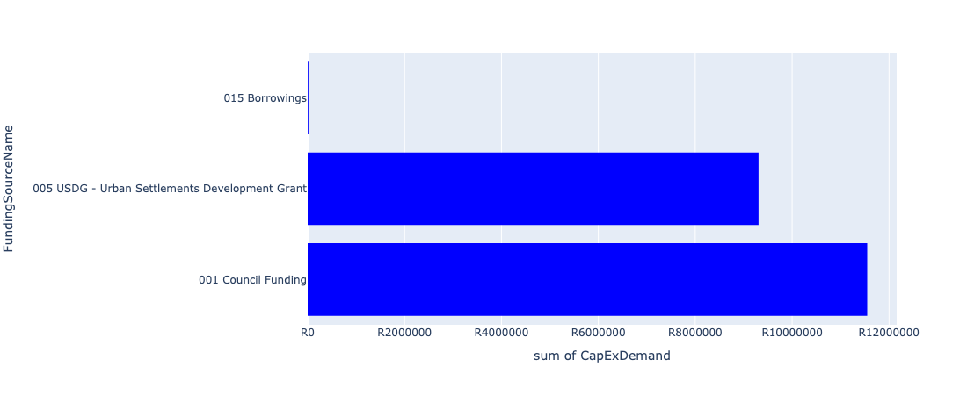

Figure 5.120: Ward 60 Departmental Requests

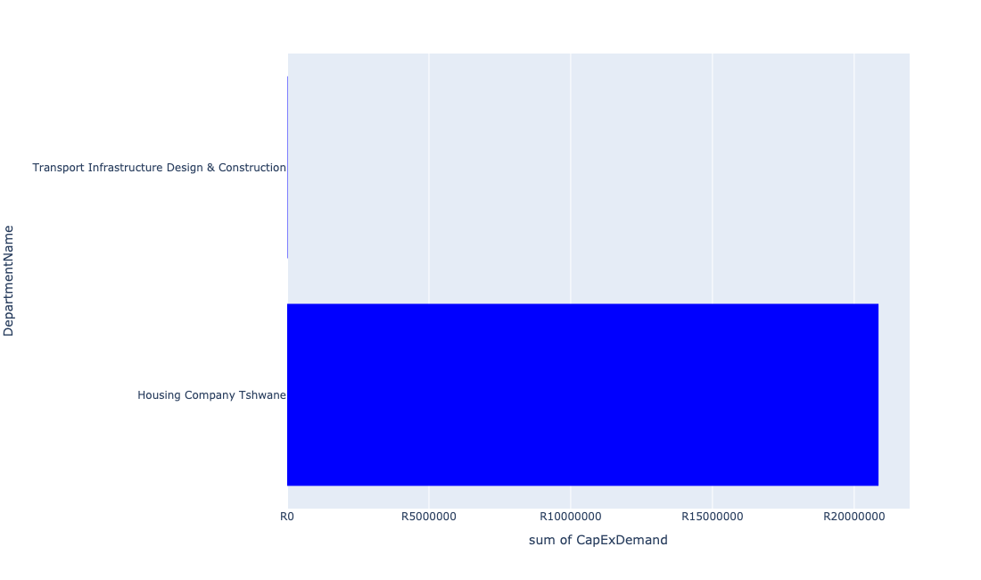

Table 5.60: Summary - Ward 60

|  |  |
| --- | --- |
| Item | Description |
| Total Capital Demand for Ward 60 - All Years | R5,790,862 Rank: 104 (1 = Highest) |
| Total Capital Demand for Ward 60 - MTREF | R5,775,000 Rank: 98 (1 = Highest) |
| Financial Years in which capital requirements are listed for Ward 60 | 2023 and 2027 |
| Financial Year with highest capital demand for Ward 60 | 2023 |
| Ward 60 intersecting feature used | Works Location |
| Total number of projects intersecting with Ward 60 | 4 Rank: 101 (1 = Highest) |

Table 5.61: All projects asking for budget in Ward 60

|  |  |  |  |
| --- | --- | --- | --- |
| Project ID | Project Name | Department | Project Budget |
| 712971915 | Revitalisation of the City-Development of Non-Motorised Transport Masterplan | Transport Infrastructure Design & Construction | R15,862 (0.27%) Budget spread across: 2027 |
| 712973990 | Danville SSE (105 Units) | Housing Company Tshwane | R20,856,780 (360.17%) Budget spread across: 2023 |

## Ward 61

Figure 5.121: Ward 61 Funding Requests

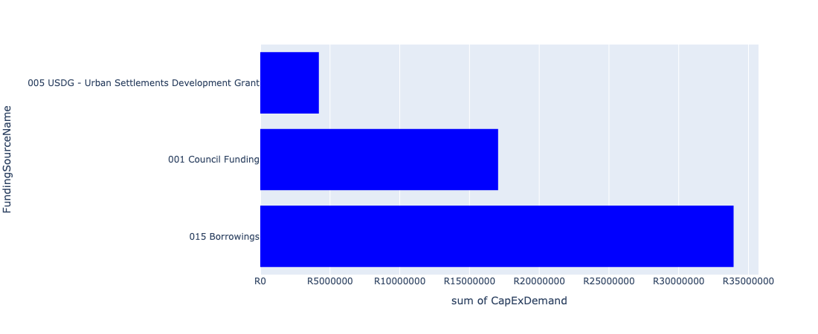

Figure 5.122: Ward 61 Departmental Requests

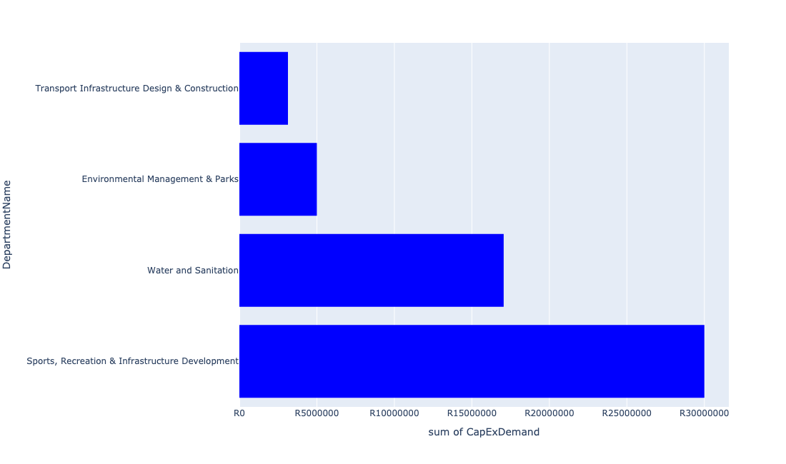

Table 5.61: Summary - Ward 61

|  |  |
| --- | --- |
| Item | Description |
| Total Capital Demand for Ward 61 - All Years | R55,186,212 Rank: 93 (1 = Highest) |
| Total Capital Demand for Ward 61 - MTREF | R17,219,321 Rank: 94 (1 = Highest) |
| Financial Years in which capital requirements are listed for Ward 61 | 2022, 2023, 2024, 2025, 2026, 2027 and 2028 |
| Financial Year with highest capital demand for Ward 61 | 2028 |
| Ward 61 intersecting feature used | Works Location |
| Total number of projects intersecting with Ward 61 | 11 Rank: 54 (1 = Highest) |

Table 5.62: All projects asking for budget in Ward 61

|  |  |  |  |
| --- | --- | --- | --- |
| Project ID | Project Name | Department | Project Budget |
| 712971915 | Revitalisation of the City-Development of Non-Motorised Transport Masterplan | Transport Infrastructure Design & Construction | R134,646 (0.24%) Budget spread across: 2027 |
| 712975170 | Construction of stormwater relief networks to alleviate flooding from the regional low-point discharging unto the township, Erasmia | Transport Infrastructure Design & Construction | R2,100,000 (3.81%) Budget spread across: 2027 and 2028 |
| 712975169 | Construction of stormwater relief networks to alleviate flooding pertaining to Fourth Avenue and surrounding areas in Laudium | Transport Infrastructure Design & Construction | R900,000 (1.63%) Budget spread across: 2026 and 2027 |
| 712975142 | (712121NA3) New Atteridgeville P3 Outfall Sewer (3/3) | Water and Sanitation | R5,500,000 (9.97%) Budget spread across: 2023, 2024 and 2025 |
| 712975072 | (712121NA1) New Atteridgeville P3 Outfall Sewer (1/3) | Water and Sanitation | R3,051,566 (5.53%) Budget spread across: 2023, 2024 and 2025 |
| 712975033 | (712121NA2) New Atteridgeville P3 Outfall Sewer (2/3) | Water and Sanitation | R8,500,000 (15.40%) Budget spread across: 2023, 2024 and 2025 |
| 21 | Erasmia Library | Sports, Recreation & Infrastructure Development | R30,000,000 (54.36%) Budget spread across: 2027 and 2028 |
| 712973728 | (713044) Laudium Cemetery | Environmental Management & Parks | R5,000,000 (9.06%) Budget spread across: 2022 and 2023 |

## Ward 62

Figure 5.123: Ward 62 Funding Requests

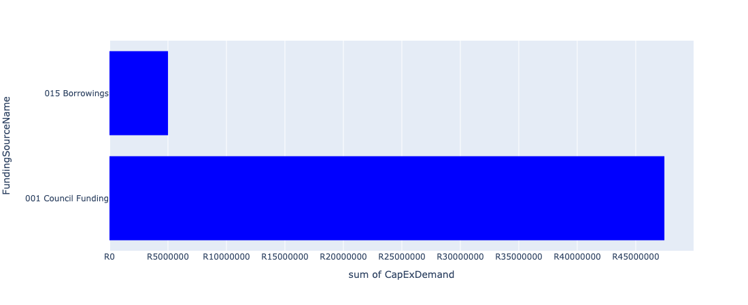

Figure 5.124: Ward 62 Departmental Requests

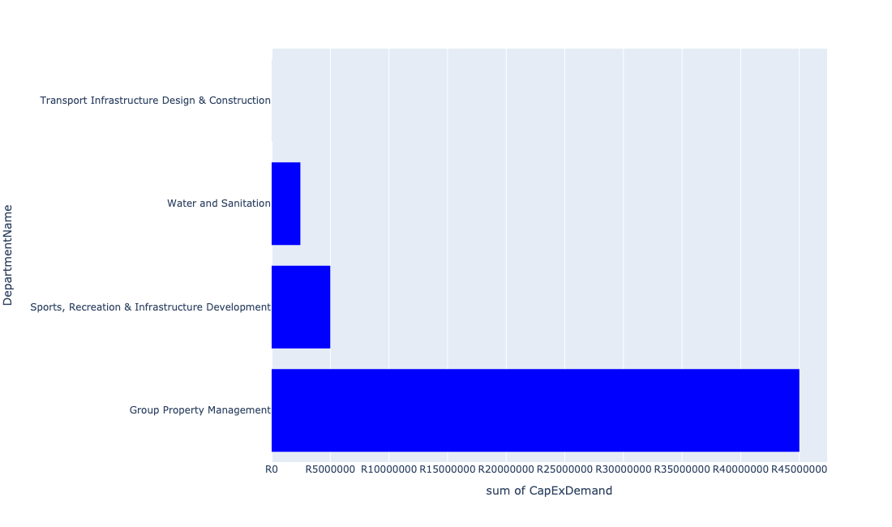

Table 5.62: Summary - Ward 62

|  |  |
| --- | --- |
| Item | Description |
| Total Capital Demand for Ward 62 - All Years | R52,454,487 Rank: 96 (1 = Highest) |
| Total Capital Demand for Ward 62 - MTREF | R46,780,679 Rank: 81 (1 = Highest) |
| Financial Years in which capital requirements are listed for Ward 62 | 2022, 2023, 2024, 2025, 2027 and 2029 |
| Financial Year with highest capital demand for Ward 62 | 2022 |
| Ward 62 intersecting feature used | Works Location |
| Total number of projects intersecting with Ward 62 | 8 Rank: 74 (1 = Highest) |

Table 5.63: All projects asking for budget in Ward 62

|  |  |  |  |
| --- | --- | --- | --- |
| Project ID | Project Name | Department | Project Budget |
| 712971915 | Revitalisation of the City-Development of Non-Motorised Transport Masterplan | Transport Infrastructure Design & Construction | R6,053 (0.01%) Budget spread across: 2027 |
| 712975072 | (712121NA1) New Atteridgeville P3 Outfall Sewer (1/3) | Water and Sanitation | R2,448,434 (4.67%) Budget spread across: 2023, 2024 and 2025 |
| 712975571 | Construction/Refurbishment of Atteridgeville Electrical Depot | Group Property Management | R45,000,000 (85.79%) Budget spread across: 2022 and 2023 |
| 712973921 | Mbolekwa Synthetic Soccer pitch | Sports, Recreation & Infrastructure Development | R5,000,000 (9.53%) Budget spread across: 2029 |
| 712969601 | (712591) Atteridgeville Taxi Interchange | Integrated Rapid Public Transport Network IRPTN | R0 (0.00%) Budget spread across: 2022 |

## Ward 63

Figure 5.125: Ward 63 Funding Requests

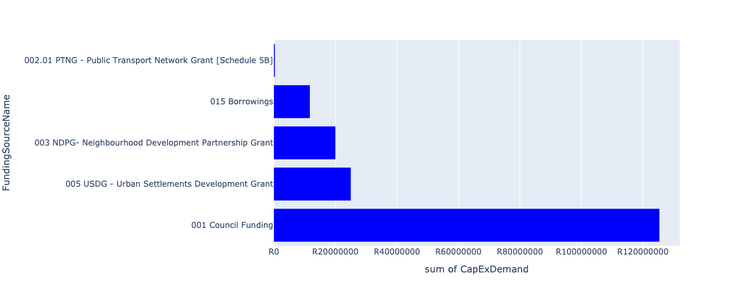

Figure 5.126: Ward 63 Departmental Requests

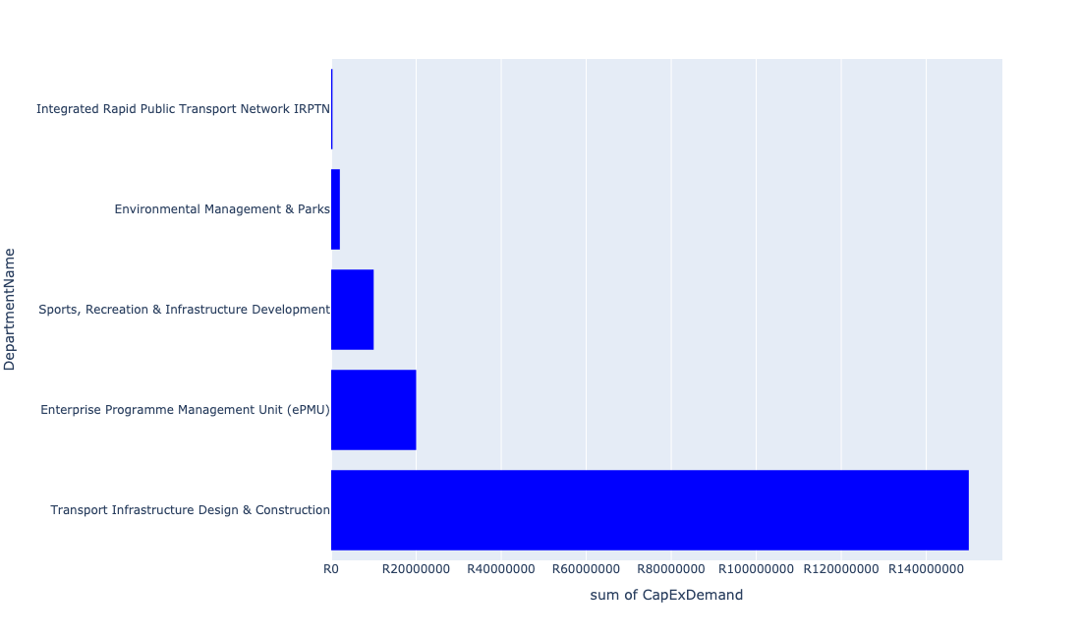

Table 5.63: Summary - Ward 63

|  |  |
| --- | --- |
| Item | Description |
| Total Capital Demand for Ward 63 - All Years | R182,353,461 Rank: 69 (1 = Highest) |
| Total Capital Demand for Ward 63 - MTREF | R77,348,286 Rank: 70 (1 = Highest) |
| Financial Years in which capital requirements are listed for Ward 63 | 2022, 2023, 2024, 2025, 2026, 2027, 2028, 2029 and 2030 |
| Financial Year with highest capital demand for Ward 63 | 2022 |
| Ward 63 intersecting feature used | Works Location |
| Total number of projects intersecting with Ward 63 | 14 Rank: 37 (1 = Highest) |

Table 5.64: All projects asking for budget in Ward 63

|  |  |  |  |
| --- | --- | --- | --- |
| Project ID | Project Name | Department | Project Budget |
| 712971915 | Revitalisation of the City-Development of Non-Motorised Transport Masterplan | Transport Infrastructure Design & Construction | R5,175 (0.00%) Budget spread across: 2027 |
| 712975007 | Security and visitor infrastructure upgrades at GaMothakga Recreational Resort | Environmental Management & Parks | R690,779 (0.38%) Budget spread across: 2022, 2023 and 2024 |
| 712974353 | (712591) Line 3: CBD to Atteridgeville - Section 2 (Pretoria West - Atteridgeville) | Integrated Rapid Public Transport Network IRPTN | R307,507 (0.17%) Budget spread across: 2022 |
| 712967127 | (713040) Furniture and Equipment for offices, overnight accommodation and facilities within resorts | Environmental Management & Parks | R1,350,000 (0.74%) Budget spread across: 2022 and 2024 |
| 712974934 | (712533) Tsosoloso Programme - Upgrading of roads in Saulsville | Enterprise Programme Management Unit (ePMU) | R20,000,000 (10.97%) Budget spread across: 2022 and 2023 |
| 968 | (712511) Flooding backlog: Atteridgeville | Transport Infrastructure Design & Construction | R150,000,000 (82.26%) Budget spread across: 2022, 2023, 2024, 2025, 2026, 2027, 2028, 2029 and 2030 |
| 712973925 | Saulsville Library | Sports, Recreation & Infrastructure Development | R10,000,000 (5.48%) Budget spread across: 2028 |

## Ward 64

Figure 5.127: Ward 64 Funding Requests

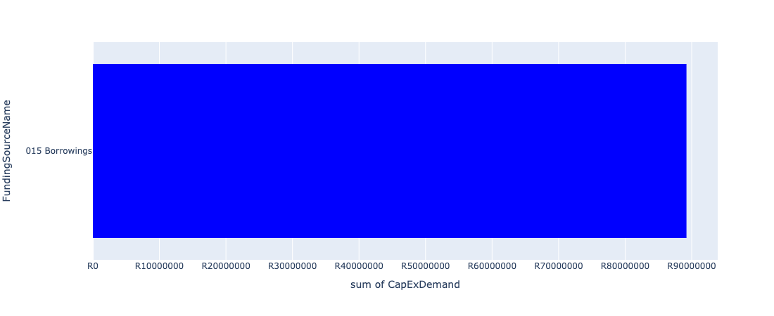

Figure 5.128: Ward 64 Departmental Requests

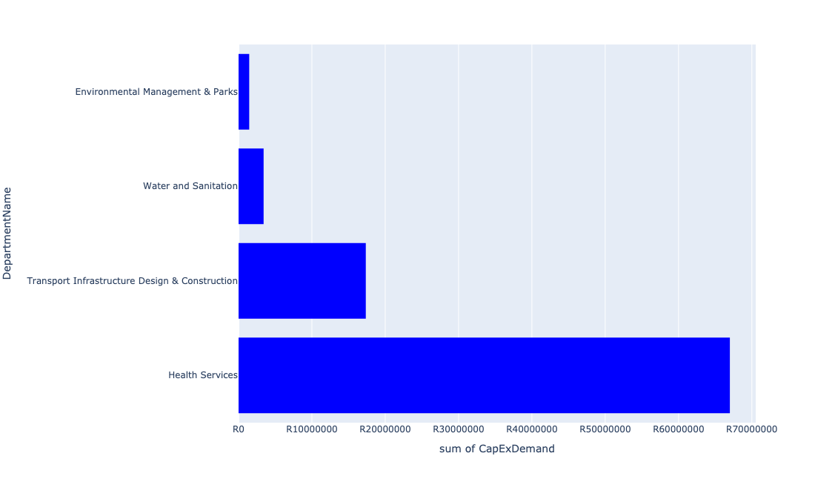

Table 5.64: Summary - Ward 64

|  |  |
| --- | --- |
| Item | Description |
| Total Capital Demand for Ward 64 - All Years | R56,216,777 Rank: 92 (1 = Highest) |
| Total Capital Demand for Ward 64 - MTREF | R24,743,403 Rank: 91 (1 = Highest) |
| Financial Years in which capital requirements are listed for Ward 64 | 2022, 2023, 2024, 2025, 2026 and 2027 |
| Financial Year with highest capital demand for Ward 64 | 2025 |
| Ward 64 intersecting feature used | Works Location |
| Total number of projects intersecting with Ward 64 | 5 Rank: 96 (1 = Highest) |

Table 5.65: All projects asking for budget in Ward 64

|  |  |  |  |
| --- | --- | --- | --- |
| Project ID | Project Name | Department | Project Budget |
| 712971915 | Revitalisation of the City-Development of Non-Motorised Transport Masterplan | Transport Infrastructure Design & Construction | R21,136 (0.04%) Budget spread across: 2027 |
| 712974523 | Upgrading of Rooihuiskraal Road | Transport Infrastructure Design & Construction | R17,329,150 (30.83%) Budget spread across: 2022, 2023 and 2024 |
| 712975493 | Rehabilitation of Wetlands - The Reeds | Environmental Management & Parks | R1,452,238 (2.58%) Budget spread across: 2022, 2023, 2024, 2025 and 2026 |
| 826 | (712121E) Rietspruit outfall sewer upgrade | Water and Sanitation | R3,414,252 (6.07%) Budget spread across: 2023 and 2024 |
| 712969022 | Extension of Rooihuiskraal Clinic to accommodate growing patient numbers | Health Services | R67,000,000 (119.18%) Budget spread across: 2024, 2025 and 2026 |

## Ward 65

Figure 5.129: Ward 65 Funding Requests

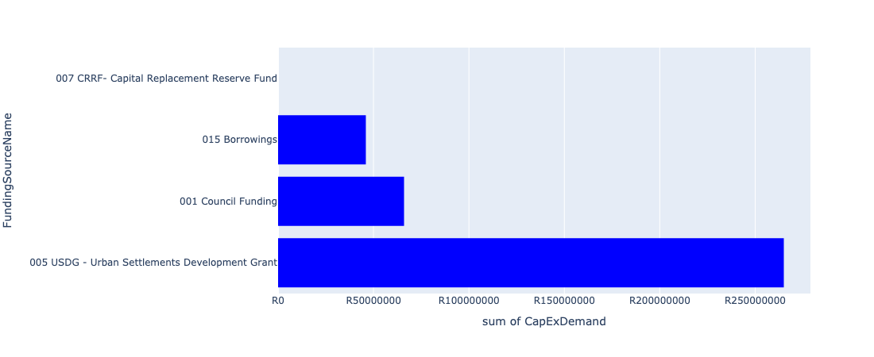

Figure 5.130: Ward 65 Departmental Requests

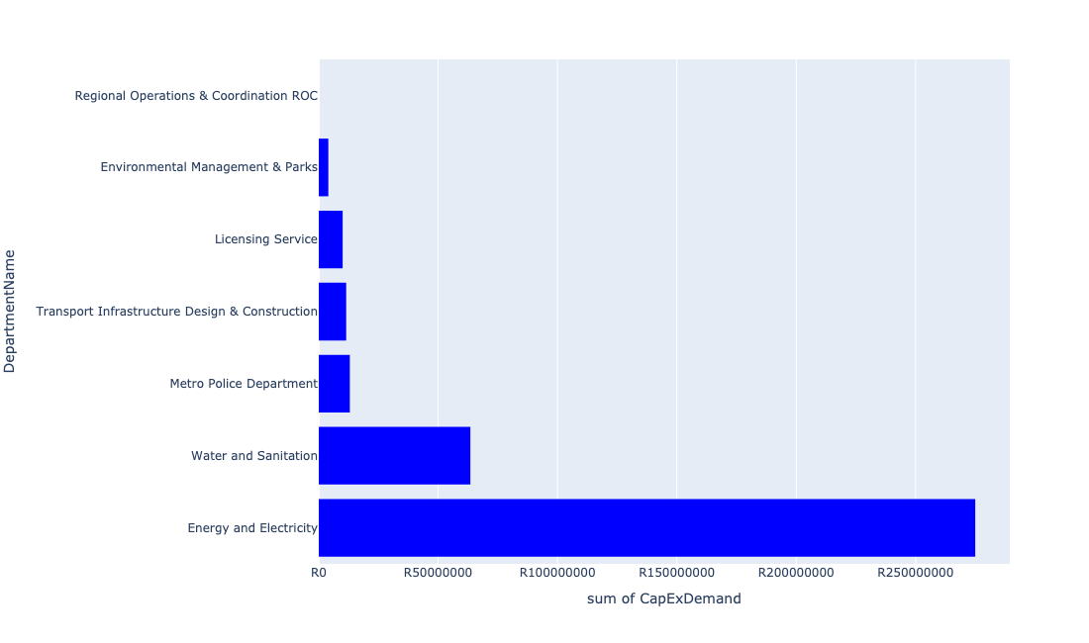

Table 5.65: Summary - Ward 65

|  |  |
| --- | --- |
| Item | Description |
| Total Capital Demand for Ward 65 - All Years | R286,979,615 Rank: 49 (1 = Highest) |
| Total Capital Demand for Ward 65 - MTREF | R187,897,787 Rank: 39 (1 = Highest) |
| Financial Years in which capital requirements are listed for Ward 65 | 2022, 2023, 2024, 2025, 2026 and 2027 |
| Financial Year with highest capital demand for Ward 65 | 2024 |
| Ward 65 intersecting feature used | Works Location |
| Total number of projects intersecting with Ward 65 | 13 Rank: 42 (1 = Highest) |

Table 5.66: All projects asking for budget in Ward 65

|  |  |  |  |
| --- | --- | --- | --- |
| Project ID | Project Name | Department | Project Budget |
| 712971915 | Revitalisation of the City-Development of Non-Motorised Transport Masterplan | Transport Infrastructure Design & Construction | R92,893 (0.03%) Budget spread across: 2027 |
| 712970748 | R6 Machinery and Equipment to ensure basic infrastructure reliability | Regional Operations & Coordination ROC | R0 (0.00%) Budget spread across: 2022 and 2023 |
| 643 | (711325) Olievenhoutbosch Activity Spine | Transport Infrastructure Design & Construction | R11,386,722 (3.97%) Budget spread across: 2023, 2024, 2025 and 2026 |
| 712975483 | Rehabilitation of Wetlands - Technopark | Environmental Management & Parks | R1,500,000 (0.52%) Budget spread across: 2022, 2023, 2024 and 2025 |
| 712975450 | Upgrade of infrastructure development at Luton Valley Nature Area | Environmental Management & Parks | R2,500,000 (0.87%) Budget spread across: 2026 |
| 712975417 | Sub-Project: TMPD Station - Irene | Metro Police Department | R13,000,000 (4.53%) Budget spread across: 2022 and 2023 |
| 712975392 | (712279) Heritage Hill to Kentron T 132kV Power Line | Energy and Electricity | R25,000,000 (8.71%) Budget spread across: 2023 and 2024 |
| 712975349 | (712279) Heritage Hill Substation | Energy and Electricity | R175,000,000 (60.98%) Budget spread across: 2024, 2025 and 2026 |
| 712975149 | (71212Doo)Doornkloof Bulk Sewer Extension | Water and Sanitation | R18,500,000 (6.45%) Budget spread across: 2023, 2024 and 2025 |
| 712974567 | Installation of security at licensing centres | Licensing Service | R10,000,000 (3.48%) Budget spread across: 2022 |
| 712967277 | (712534L) Louwlardia Reservoir/ Heritage Reservoir | Water and Sanitation | R45,000,000 (15.68%) Budget spread across: 2023, 2024 and 2025 |
| 712969077 | (712279) Kentron 132/11kV Substation | Energy and Electricity | R75,000,000 (26.13%) Budget spread across: 2022 and 2023 |

## Ward 66

Figure 5.131: Ward 66 Funding Requests

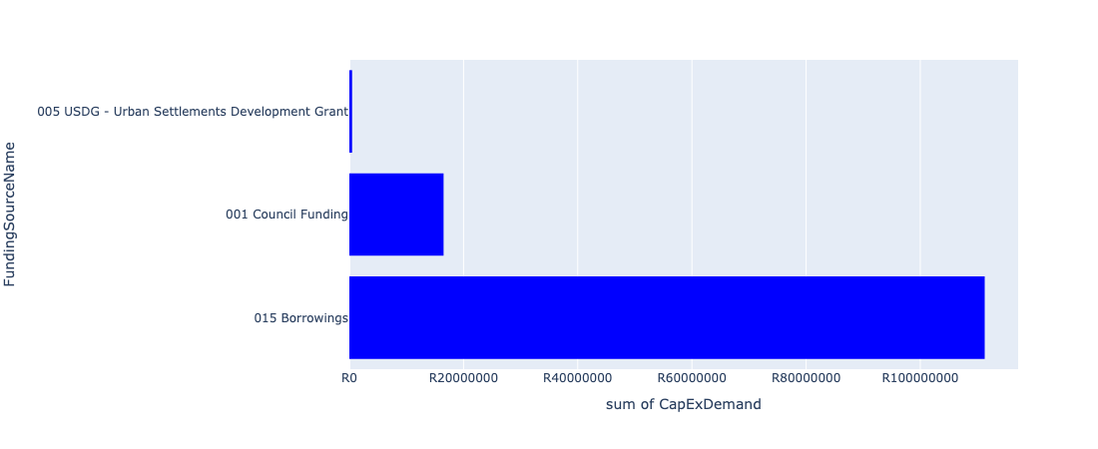

Figure 5.132: Ward 66 Departmental Requests

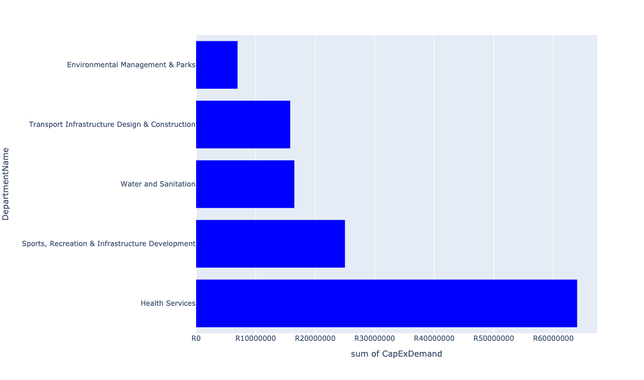

Table 5.66: Summary - Ward 66

|  |  |
| --- | --- |
| Item | Description |
| Total Capital Demand for Ward 66 - All Years | R98,257,770 Rank: 84 (1 = Highest) |
| Total Capital Demand for Ward 66 - MTREF | R11,310,829 Rank: 95 (1 = Highest) |
| Financial Years in which capital requirements are listed for Ward 66 | 2022, 2023, 2024, 2025, 2026, 2027, 2028 and 2029 |
| Financial Year with highest capital demand for Ward 66 | 2025 |
| Ward 66 intersecting feature used | Works Location |
| Total number of projects intersecting with Ward 66 | 12 Rank: 47 (1 = Highest) |

Table 5.67: All projects asking for budget in Ward 66

|  |  |  |  |
| --- | --- | --- | --- |
| Project ID | Project Name | Department | Project Budget |
| 712971915 | Revitalisation of the City-Development of Non-Motorised Transport Masterplan | Transport Infrastructure Design & Construction | R75,353 (0.08%) Budget spread across: 2027 |
| 712974158 | Upgrading of major stormwater Network 3A along Rabie Street, Lyttleton | Transport Infrastructure Design & Construction | R3,834,977 (3.90%) Budget spread across: 2025, 2026 and 2027 |
| 712975171 | Upgrading of Hendrik Verwoerd Drive between John Vorster Drive and Rooihuiskraal Road in Centurion | Transport Infrastructure Design & Construction | R11,058,121 (11.25%) Budget spread across: 2026, 2027 and 2028 |
| 712975070 | 713044 Extension of Centurion Cemetery | Environmental Management & Parks | R581,694 (0.59%) Budget spread across: 2023 and 2025 |
| 712974524 | Upgrading of Lenchen Avenue | Transport Infrastructure Design & Construction | R832,274 (0.85%) Budget spread across: 2022, 2023 and 2024 |
| 712975008 | Upgrades security and building infrastructure at Zwartkops Resort | Environmental Management & Parks | R4,375,351 (4.45%) Budget spread across: 2022, 2023 and 2024 |
| 712975259 | Development of of Monte kneen Park | Environmental Management & Parks | R2,000,000 (2.04%) Budget spread across: 2023 |
| 712975078 | (712121NH1) New Hennops River (Sunderland Ridge) Outfall Sewer (1/6) | Water and Sanitation | R16,500,000 (16.79%) Budget spread across: 2026, 2027 and 2028 |
| 712967195 | New Clinic Mooiplaas | Health Services | R64,000,000 (65.13%) Budget spread across: 2024, 2025 and 2026 |
| 16 | New Valhalla Library | Sports, Recreation & Infrastructure Development | R25,000,000 (25.44%) Budget spread across: 2028 and 2029 |

## Ward 67

Figure 5.133: Ward 67 Funding Requests

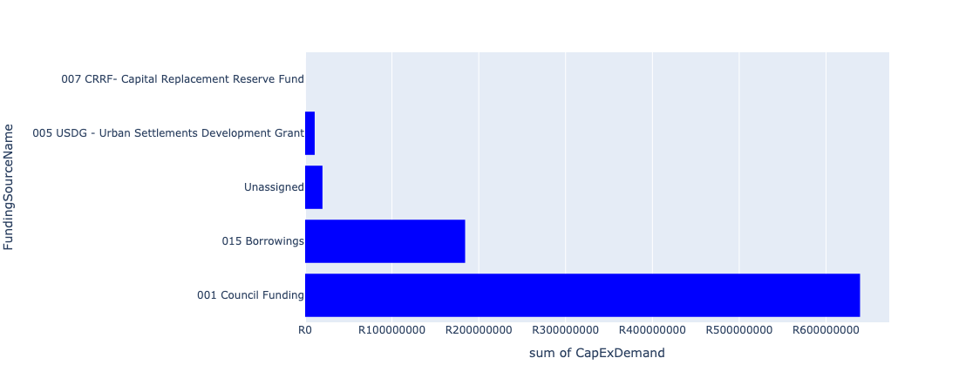

Figure 5.134: Ward 67 Departmental Requests

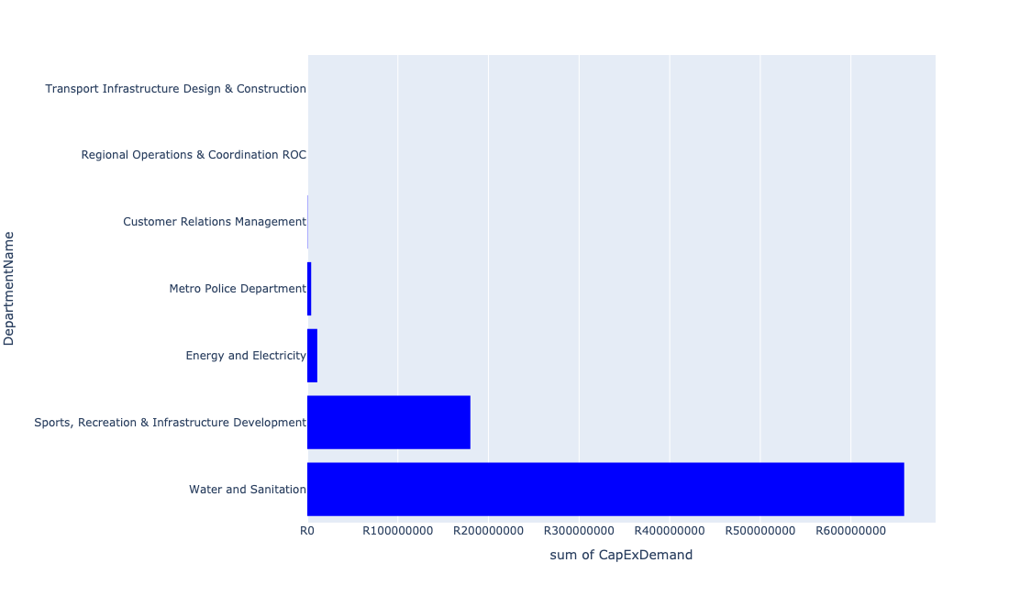

Table 5.67: Summary - Ward 67

|  |  |
| --- | --- |
| Item | Description |
| Total Capital Demand for Ward 67 - All Years | R850,067,061 Rank: 13 (1 = Highest) |
| Total Capital Demand for Ward 67 - MTREF | R30,881,257 Rank: 88 (1 = Highest) |
| Financial Years in which capital requirements are listed for Ward 67 | 2022, 2023, 2024, 2025, 2026, 2027, 2028 and 2029 |
| Financial Year with highest capital demand for Ward 67 | 2027 |
| Ward 67 intersecting feature used | Works Location |
| Total number of projects intersecting with Ward 67 | 7 Rank: 81 (1 = Highest) |

Table 5.68: All projects asking for budget in Ward 67

|  |  |  |  |
| --- | --- | --- | --- |
| Project ID | Project Name | Department | Project Budget |
| 712975590 | Refurbishment of Mamelodi customer care centre | Customer Relations Management | R333,333 (0.04%) Budget spread across: 2025 |
| 712971915 | Revitalisation of the City-Development of Non-Motorised Transport Masterplan | Transport Infrastructure Design & Construction | R10,849 (0.00%) Budget spread across: 2027 |
| 712970748 | R6 Machinery and Equipment to ensure basic infrastructure reliability | Regional Operations & Coordination ROC | R12,689 (0.00%) Budget spread across: 2022 and 2023 |
| 712975437 | Sub-Project: TMPD Station - Mamelodi (Extension 10) | Metro Police Department | R4,293,152 (0.51%) Budget spread across: 2022, 2023 and 2024 |
| 712974121 | (712279) Wildebees - Elland 132kV Power line | Energy and Electricity | R11,019,358 (1.30%) Budget spread across: 2023 and 2024 |
| 712974544 | (710411F2) Baviaanspoort WWTW Phase3: 40Ml/d extension project on new site with link outfall sewer | Water and Sanitation | R658,805,423 (77.50%) Budget spread across: 2024, 2025, 2026, 2027, 2028 and 2029 |
| 712967168 | (710692) Upgrading of HM Pitje Stadium | Sports, Recreation & Infrastructure Development | R180,000,000 (21.17%) Budget spread across: 2025, 2026 and 2027 |

## Ward 68

Figure 5.135: Ward 68 Funding Requests

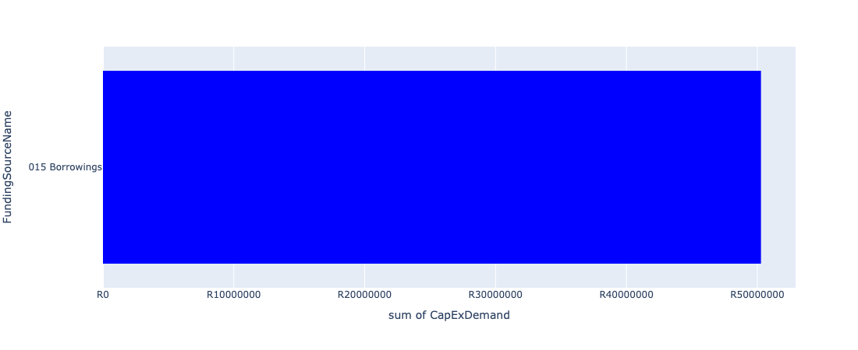

Figure 5.136: Ward 68 Departmental Requests

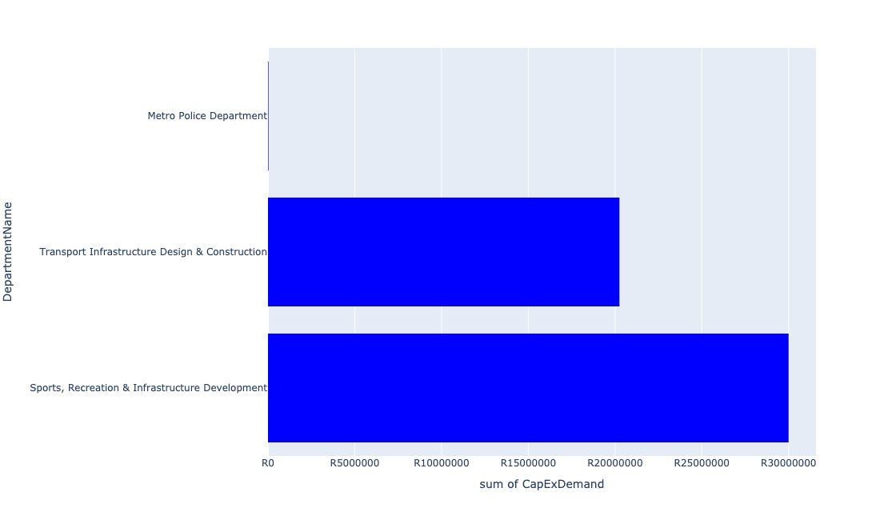

Table 5.68: Summary - Ward 68

|  |  |
| --- | --- |
| Item | Description |
| Total Capital Demand for Ward 68 - All Years | R49,943,725 Rank: 97 (1 = Highest) |
| Total Capital Demand for Ward 68 - MTREF | R2,304 Rank: 103 (1 = Highest) |
| Financial Years in which capital requirements are listed for Ward 68 | 2023, 2025, 2026, 2027, 2028 and 2031 |
| Financial Year with highest capital demand for Ward 68 | 2027 |
| Ward 68 intersecting feature used | Works Location |
| Total number of projects intersecting with Ward 68 | 6 Rank: 89 (1 = Highest) |

Table 5.69: All projects asking for budget in Ward 68

|  |  |  |  |
| --- | --- | --- | --- |
| Project ID | Project Name | Department | Project Budget |
| 712971915 | Revitalisation of the City-Development of Non-Motorised Transport Masterplan | Transport Infrastructure Design & Construction | R5,481 (0.01%) Budget spread across: 2027 |
| 712975413 | Sub-Project: TMPD Station - Kwaggasrand / Atteridgeville | Metro Police Department | R29,947 (0.06%) Budget spread across: 2023 |
| 712974540 | Construction of major storm water Network 2A in the vicinity of Motheberebe Street, AtteridgevilleProject | Transport Infrastructure Design & Construction | R1,247,921 (2.50%) Budget spread across: 2025 and 2026 |
| 712974539 | Construction of major storm water Network 8 throughout Atteridgeville x 7 | Transport Infrastructure Design & Construction | R19,000,000 (38.04%) Budget spread across: 2026, 2027 and 2028 |
| 712967142 | Saulsville arena | Sports, Recreation & Infrastructure Development | R15,000,000 (30.03%) Budget spread across: 2027 |
| 712973923 | Upgrading of Makhaza Sport Facility | Sports, Recreation & Infrastructure Development | R15,000,000 (30.03%) Budget spread across: 2031 |

## Ward 69

Figure 5.137: Ward 69 Funding Requests

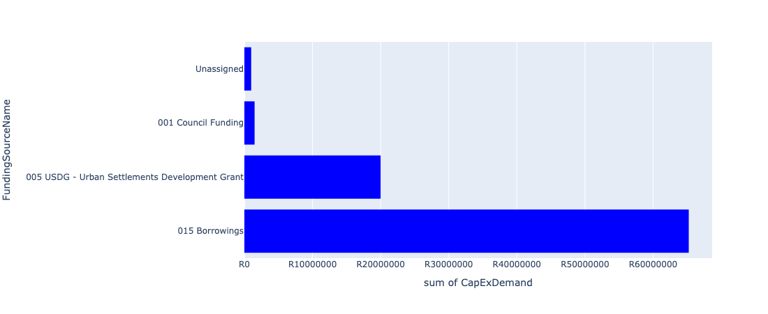

Figure 5.138: Ward 69 Departmental Requests

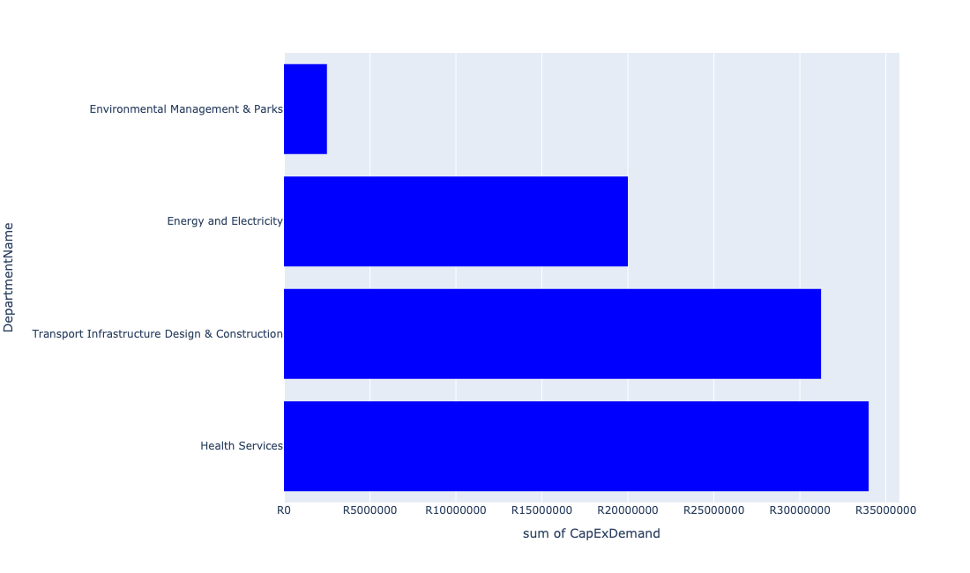

Table 5.69: Summary - Ward 69

|  |  |
| --- | --- |
| Item | Description |
| Total Capital Demand for Ward 69 - All Years | R87,731,910 Rank: 85 (1 = Highest) |
| Total Capital Demand for Ward 69 - MTREF | R39,593,907 Rank: 85 (1 = Highest) |
| Financial Years in which capital requirements are listed for Ward 69 | 2022, 2023, 2024, 2026, 2027 and 2028 |
| Financial Year with highest capital demand for Ward 69 | 2022 |
| Ward 69 intersecting feature used | Works Location |
| Total number of projects intersecting with Ward 69 | 9 Rank: 68 (1 = Highest) |

Table 5.70: All projects asking for budget in Ward 69

|  |  |  |  |
| --- | --- | --- | --- |
| Project ID | Project Name | Department | Project Budget |
| 712971915 | Revitalisation of the City-Development of Non-Motorised Transport Masterplan | Transport Infrastructure Design & Construction | R22,794 (0.03%) Budget spread across: 2027 |
| 712975171 | Upgrading of Hendrik Verwoerd Drive between John Vorster Drive and Rooihuiskraal Road in Centurion | Transport Infrastructure Design & Construction | R25,615,209 (29.20%) Budget spread across: 2026, 2027 and 2028 |
| 712975529 | Upgrade of Rooihuiskraal - Reptile park | Environmental Management & Parks | R1,000,000 (1.14%) Budget spread across: 2022, 2023, 2024, 2025, 2026, 2027 and 2028 |
| 712975458 | Upgrade infrastructure at Bishop Bird Sanctuary | Environmental Management & Parks | R1,500,000 (1.71%) Budget spread across: 2028 |
| 712974523 | Upgrading of Rooihuiskraal Road | Transport Infrastructure Design & Construction | R5,593,907 (6.38%) Budget spread across: 2022, 2023 and 2024 |
| 712967684 | (712279) Eldoraigne 132/11kv Substation | Energy and Electricity | R20,000,000 (22.80%) Budget spread across: 2026 |
| 712973701 | Eldoraigne Clinic Dispensaries | Health Services | R34,000,000 (38.75%) Budget spread across: 2022 and 2023 |

## Ward 70

Figure 5.139: Ward 70 Funding Requests

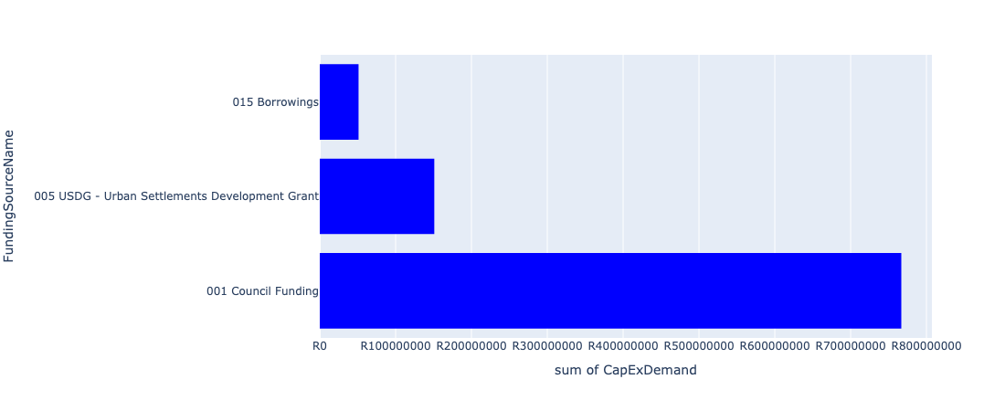

Figure 5.140: Ward 70 Departmental Requests

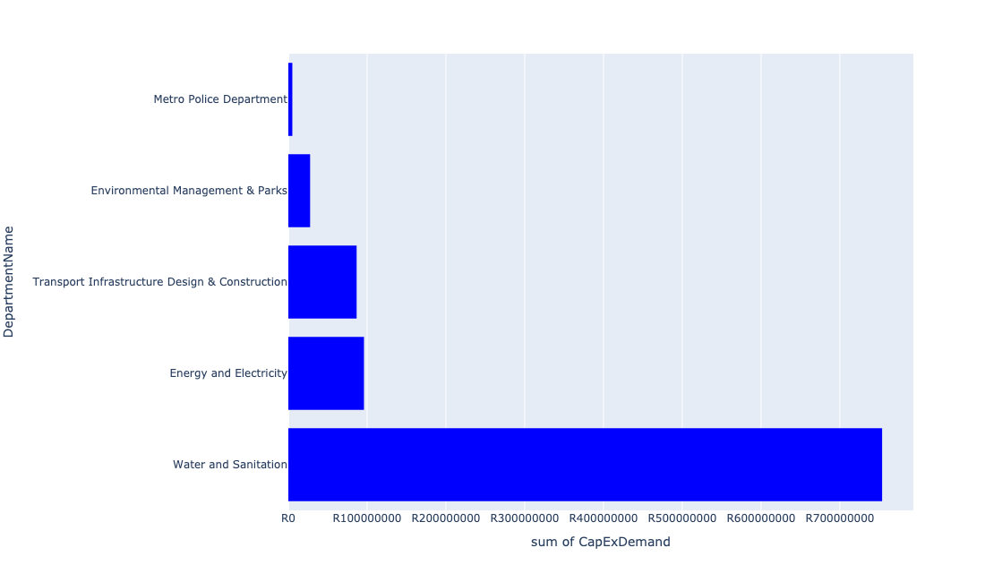

Table 5.70: Summary - Ward 70

|  |  |
| --- | --- |
| Item | Description |
| Total Capital Demand for Ward 70 - All Years | R948,943,945 Rank: 11 (1 = Highest) |
| Total Capital Demand for Ward 70 - MTREF | R523,796,265 Rank: 10 (1 = Highest) |
| Financial Years in which capital requirements are listed for Ward 70 | 2022, 2023, 2024, 2025, 2026, 2027, 2028, 2029 and 2030 |
| Financial Year with highest capital demand for Ward 70 | 2023 |
| Ward 70 intersecting feature used | Works Location |
| Total number of projects intersecting with Ward 70 | 16 Rank: 26 (1 = Highest) |

Table 5.71: All projects asking for budget in Ward 70

|  |  |  |  |
| --- | --- | --- | --- |
| Project ID | Project Name | Department | Project Budget |
| 712971915 | Revitalisation of the City-Development of Non-Motorised Transport Masterplan | Transport Infrastructure Design & Construction | R80,852 (0.01%) Budget spread across: 2027 |
| 712975171 | Upgrading of Hendrik Verwoerd Drive between John Vorster Drive and Rooihuiskraal Road in Centurion | Transport Infrastructure Design & Construction | R11,580,769 (1.22%) Budget spread across: 2026, 2027 and 2028 |
| 826 | (712121E) Rietspruit outfall sewer upgrade | Water and Sanitation | R6,781,112 (0.71%) Budget spread across: 2023 and 2024 |
| 712975402 | Sub-Project: TMPD Station: Raslouw AH | Metro Police Department | R5,076,563 (0.53%) Budget spread across: 2024 and 2025 |
| 712975135 | (712121PT) New Peach Tree 1 Outfall Sewer | Water and Sanitation | R3,500,000 (0.37%) Budget spread across: 2028 and 2029 |
| 712975084 | (712121H) Upgrade existing Hennops River (B) Outfall Sewer (2/4) | Water and Sanitation | R800,000 (0.08%) Budget spread across: 2028 and 2029 |
| 712975083 | (712121NH6) New Hennops River (Sunderland Ridge) Outfall Sewer (6/6) | Water and Sanitation | R106,500,000 (11.22%) Budget spread across: 2027, 2028, 2029 and 2030 |
| 712975082 | (712121NH5) New Hennops River (Sunderland Ridge) Outfall Sewer (5/6) | Water and Sanitation | R18,500,000 (1.95%) Budget spread across: 2027, 2028 and 2029 |
| 712975081 | (712121NH4) New Hennops River (Sunderland Ridge) Outfall Sewer (4/6) | Water and Sanitation | R26,500,000 (2.79%) Budget spread across: 2026, 2027, 2028 and 2029 |
| 712975080 | (712121NH3) New Hennops River (Sunderland Ridge) Outfall Sewer (3/6) | Water and Sanitation | R31,500,000 (3.32%) Budget spread across: 2026, 2027, 2028 and 2029 |
| 712975079 | (712121NH2) New Hennops River (Sunderland Ridge) Outfall Sewer (2/6) | Water and Sanitation | R19,500,000 (2.05%) Budget spread across: 2026, 2027 and 2028 |
| 712975008 | Upgrades security and building infrastructure at Zwartkops Resort | Environmental Management & Parks | R27,624,648 (2.91%) Budget spread across: 2022, 2023 and 2024 |
| 712974533 | (710411A3) Sunderland Ridge WWTW Phase 2: 20 Ml/d Extension project using alternative technologies on existing site | Water and Sanitation | R480,000,000 (50.58%) Budget spread across: 2022, 2023, 2024 and 2025 |
| 712967492 | Wierda Park Transport Facilities | Transport Infrastructure Design & Construction | R75,000,000 (7.90%) Budget spread across: 2022, 2023, 2024, 2025, 2026, 2027, 2028, 2029 and 2030 |
| 439 | (710411A) Sunderland Ridge WWTW Phase1: Upgrade of existing infrastructure | Water and Sanitation | R60,000,000 (6.32%) Budget spread across: 2022 and 2023 |
| 712969196 | (710556) Region 4 (Public Lighting) | Energy and Electricity | R96,000,000 (10.12%) Budget spread across: 2024, 2025, 2026, 2027, 2028, 2029 and 2030 |

## Ward 71

Figure 5.141: Ward 71 Funding Requests

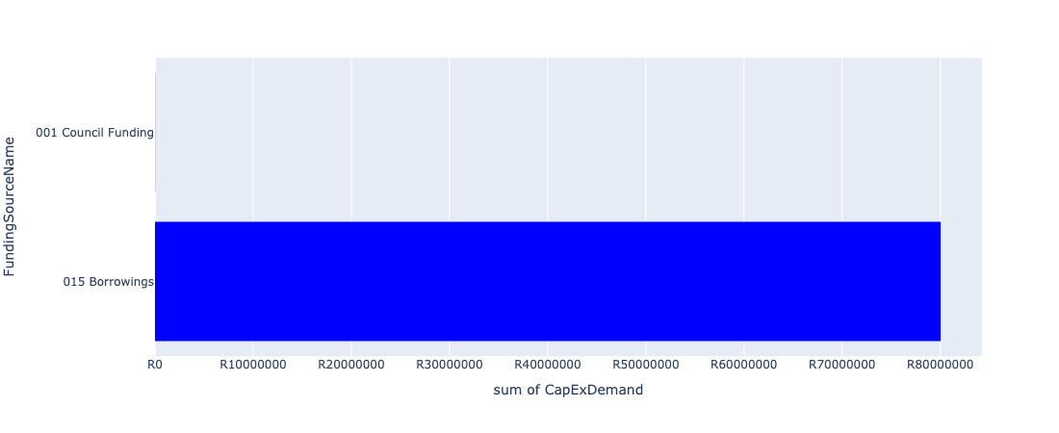

Figure 5.142: Ward 71 Departmental Requests

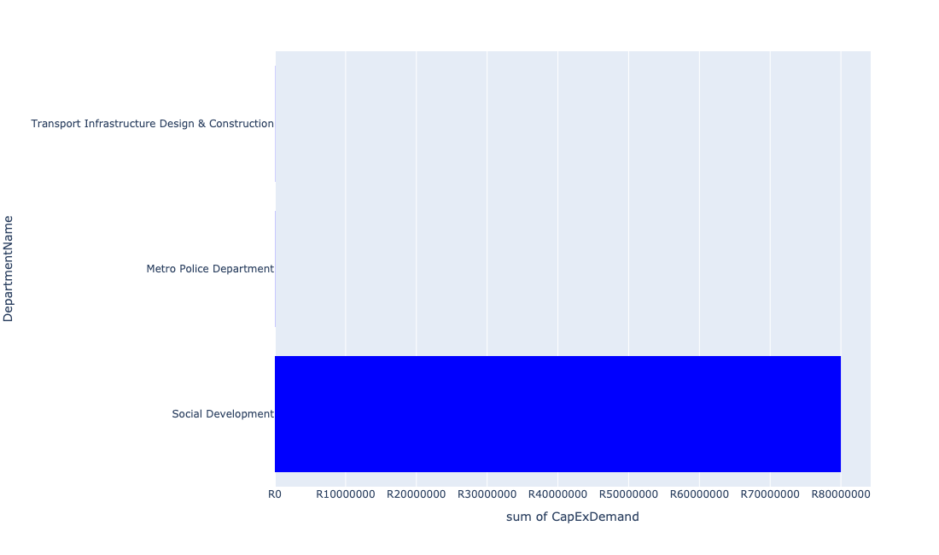

Table 5.71: Summary - Ward 71

|  |  |
| --- | --- |
| Item | Description |
| Total Capital Demand for Ward 71 - All Years | R80,025,010 Rank: 89 (1 = Highest) |
| Total Capital Demand for Ward 71 - MTREF | R5,507 Rank: 102 (1 = Highest) |
| Financial Years in which capital requirements are listed for Ward 71 | 2022, 2023, 2024, 2025, 2026, 2027, 2028, 2029 and 2030 |
| Financial Year with highest capital demand for Ward 71 | 2027 |
| Ward 71 intersecting feature used | Works Location |
| Total number of projects intersecting with Ward 71 | 4 Rank: 101 (1 = Highest) |

Table 5.72: All projects asking for budget in Ward 71

|  |  |  |  |
| --- | --- | --- | --- |
| Project ID | Project Name | Department | Project Budget |
| 712971915 | Revitalisation of the City-Development of Non-Motorised Transport Masterplan | Transport Infrastructure Design & Construction | R3,876 (0.00%) Budget spread across: 2027 |
| 712975413 | Sub-Project: TMPD Station - Kwaggasrand / Atteridgeville | Metro Police Department | R26,447 (0.03%) Budget spread across: 2023 |
| 712975229 | Saulsville Public Transport Facility | Transport Infrastructure Design & Construction | R19,099 (0.02%) Budget spread across: 2022, 2023, 2024, 2025, 2026, 2027, 2028, 2029 and 2030 |
| 1080 | (712681) Multipurpose Development Centre next to Phomolong Clinic | Social Development | R80,000,000 (99.97%) Budget spread across: 2026 and 2027 |

## Ward 72

Figure 5.143: Ward 72 Funding Requests

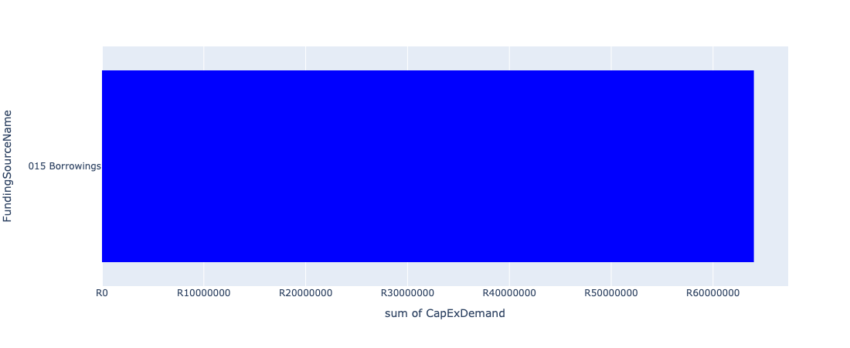

Figure 5.144: Ward 72 Departmental Requests

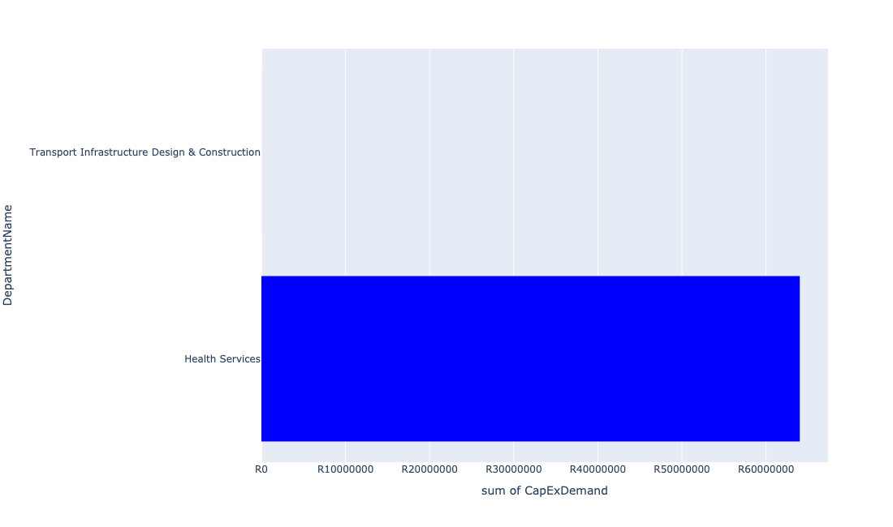

Table 5.72: Summary - Ward 72

|  |  |
| --- | --- |
| Item | Description |
| Total Capital Demand for Ward 72 - All Years | R64,004,952 Rank: 91 (1 = Highest) |
| Total Capital Demand for Ward 72 - MTREF | R0 Rank: 106 (1 = Highest) |
| Financial Years in which capital requirements are listed for Ward 72 | 2027, 2028, 2029 and 2030 |
| Financial Year with highest capital demand for Ward 72 | 2029 |
| Ward 72 intersecting feature used | Works Location |
| Total number of projects intersecting with Ward 72 | 2 Rank: 107 (1 = Highest) |

Table 5.73: All projects asking for budget in Ward 72

|  |  |  |  |
| --- | --- | --- | --- |
| Project ID | Project Name | Department | Project Budget |
| 712971915 | Revitalisation of the City-Development of Non-Motorised Transport Masterplan | Transport Infrastructure Design & Construction | R4,952 (0.01%) Budget spread across: 2027 |
| 712973703 | Extension of Saulsville Clinic | Health Services | R64,000,000 (99.99%) Budget spread across: 2028, 2029 and 2030 |

## Ward 73

Figure 5.145: Ward 73 Funding Requests

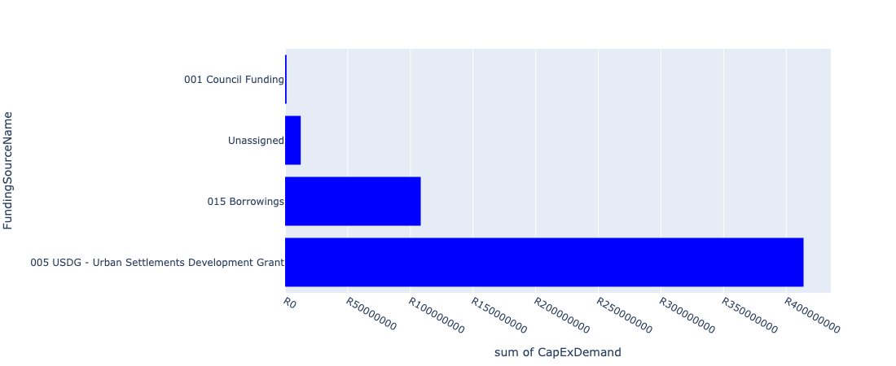

Figure 5.146: Ward 73 Departmental Requests

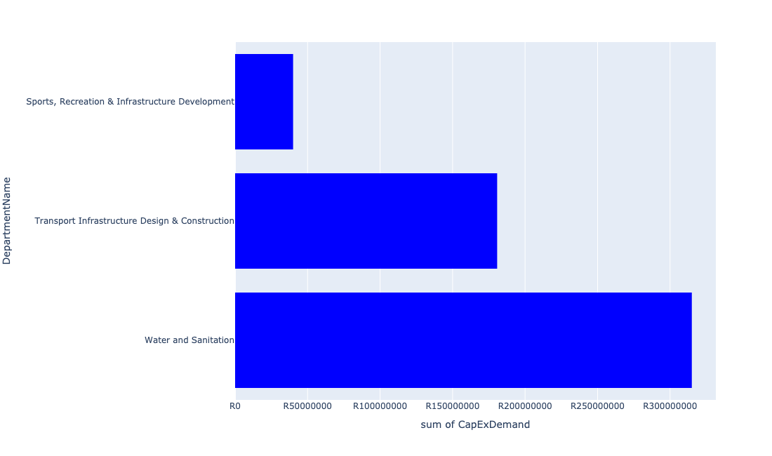

Table 5.73: Summary - Ward 73

|  |  |
| --- | --- |
| Item | Description |
| Total Capital Demand for Ward 73 - All Years | R466,924,248 Rank: 35 (1 = Highest) |
| Total Capital Demand for Ward 73 - MTREF | R93,978,023 Rank: 59 (1 = Highest) |
| Financial Years in which capital requirements are listed for Ward 73 | 2022, 2023, 2024, 2025, 2026, 2027, 2028, 2029 and 2030 |
| Financial Year with highest capital demand for Ward 73 | 2026 |
| Ward 73 intersecting feature used | Works Location |
| Total number of projects intersecting with Ward 73 | 8 Rank: 74 (1 = Highest) |

Table 5.74: All projects asking for budget in Ward 73

|  |  |  |  |
| --- | --- | --- | --- |
| Project ID | Project Name | Department | Project Budget |
| 712971915 | Revitalisation of the City-Development of Non-Motorised Transport Masterplan | Transport Infrastructure Design & Construction | R93,546 (0.02%) Budget spread across: 2027 |
| 712975490 | Steve Bikoville Library | Sports, Recreation & Infrastructure Development | R40,000,000 (8.57%) Budget spread across: 2029 and 2030 |
| 1005 | (712523) Flooding backlog: Network 3A, Kudube Unit 9 | Transport Infrastructure Design & Construction | R16,642,573 (3.56%) Budget spread across: 2022, 2023, 2024, 2025, 2026, 2027, 2028, 2029 and 2030 |
| 1000 | (712520) Flooding backlog: Ramotse (Network 1A, 1C & 1F) | Transport Infrastructure Design & Construction | R75,000,000 (16.06%) Budget spread across: 2022, 2023, 2024, 2025, 2026, 2027, 2028, 2029 and 2030 |
| 987 | (712515) Flooding backlog: Network 2B, Ramotse | Transport Infrastructure Design & Construction | R89,000,000 (19.06%) Budget spread across: 2022, 2023, 2024, 2025, 2026, 2027, 2028, 2029 and 2030 |
| 575 | (710878) Ramotse-Marokolong waterborne sanitation | Water and Sanitation | R315,000,000 (67.46%) Budget spread across: 2022, 2023, 2025, 2026 and 2027 |

## Ward 74

Figure 5.147: Ward 74 Funding Requests

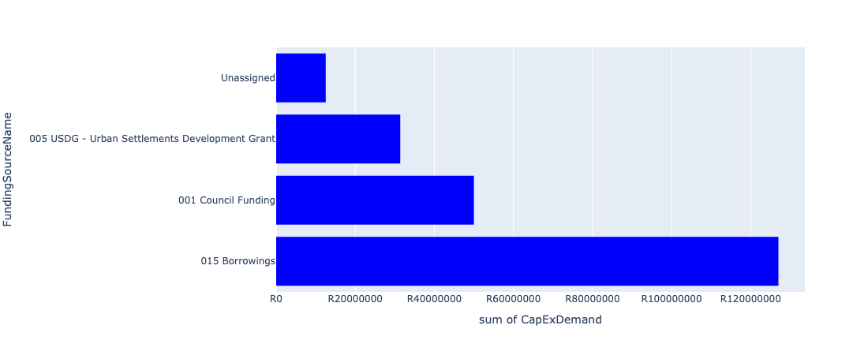

Figure 5.148: Ward 74 Departmental Requests

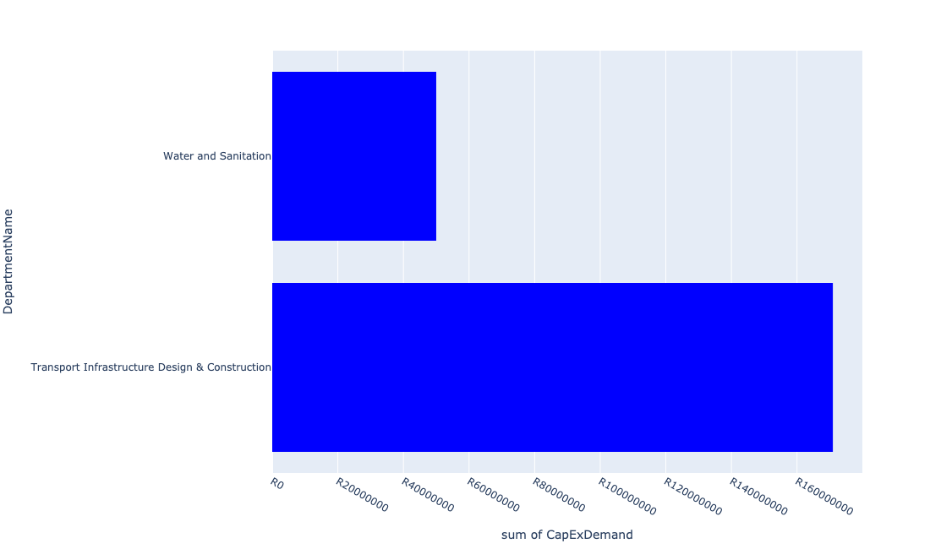

Table 5.74: Summary - Ward 74

|  |  |
| --- | --- |
| Item | Description |
| Total Capital Demand for Ward 74 - All Years | R217,948,265 Rank: 59 (1 = Highest) |
| Total Capital Demand for Ward 74 - MTREF | R81,197,078 Rank: 66 (1 = Highest) |
| Financial Years in which capital requirements are listed for Ward 74 | 2022, 2023, 2024, 2025, 2026, 2027, 2028, 2029 and 2030 |
| Financial Year with highest capital demand for Ward 74 | 2022 |
| Ward 74 intersecting feature used | Works Location |
| Total number of projects intersecting with Ward 74 | 10 Rank: 61 (1 = Highest) |

Table 5.75: All projects asking for budget in Ward 74

|  |  |  |  |
| --- | --- | --- | --- |
| Project ID | Project Name | Department | Project Budget |
| 712971915 | Revitalisation of the City-Development of Non-Motorised Transport Masterplan | Transport Infrastructure Design & Construction | R14,436 (0.01%) Budget spread across: 2027 |
| 712974520 | Mashemong Major Stormwater Network 5A | Transport Infrastructure Design & Construction | R21,144,613 (9.70%) Budget spread across: 2027, 2028, 2029 and 2030 |
| 712974518 | Mashemong Major Stormwater Network 1E | Transport Infrastructure Design & Construction | R28,738,733 (13.19%) Budget spread across: 2026, 2027, 2028 and 2029 |
| 1005 | (712523) Flooding backlog: Network 3A, Kudube Unit 9 | Transport Infrastructure Design & Construction | R84,357,427 (38.71%) Budget spread across: 2022, 2023, 2024, 2025, 2026, 2027, 2028, 2029 and 2030 |
| 622 | (711262) Magriet Monamodi Stormwater System | Transport Infrastructure Design & Construction | R36,666,029 (16.82%) Budget spread across: 2022, 2023, 2024, 2025, 2026, 2027, 2028, 2029 and 2030 |
| 450 | (710411I) Temba and Babelegi WWTW upgrade of existing infrastructure | Water and Sanitation | R50,000,000 (22.94%) Budget spread across: 2022 and 2023 |

## Ward 75

Figure 5.149: Ward 75 Funding Requests

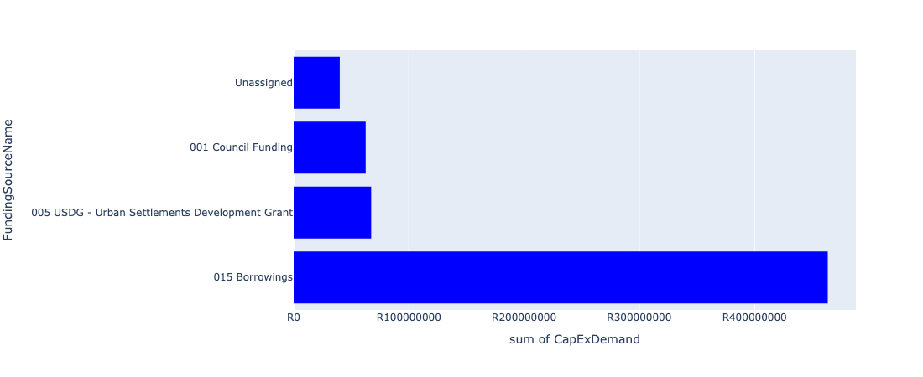

Figure 5.150: Ward 75 Departmental Requests

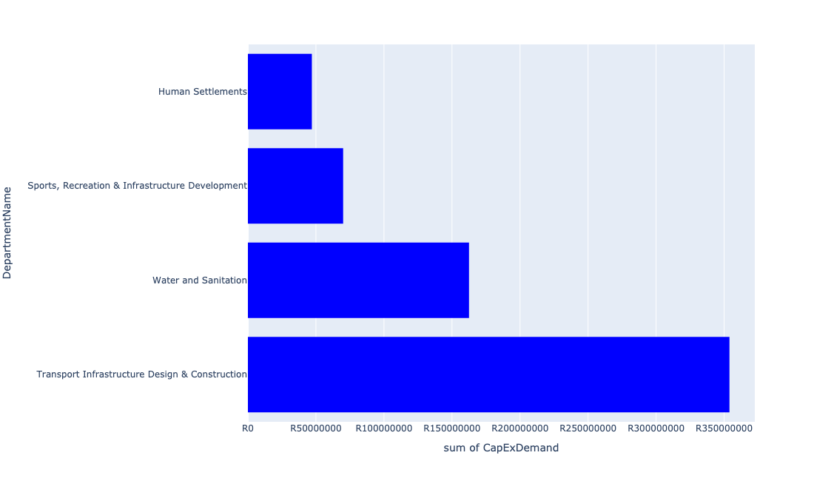

Table 5.75: Summary - Ward 75

|  |  |
| --- | --- |
| Item | Description |
| Total Capital Demand for Ward 75 - All Years | R615,376,423 Rank: 22 (1 = Highest) |
| Total Capital Demand for Ward 75 - MTREF | R225,323,305 Rank: 31 (1 = Highest) |
| Financial Years in which capital requirements are listed for Ward 75 | 2022, 2023, 2024, 2025, 2026, 2027, 2028, 2029 and 2030 |
| Financial Year with highest capital demand for Ward 75 | 2022 |
| Ward 75 intersecting feature used | Works Location |
| Total number of projects intersecting with Ward 75 | 19 Rank: 15 (1 = Highest) |

Table 5.76: All projects asking for budget in Ward 75

|  |  |  |  |
| --- | --- | --- | --- |
| Project ID | Project Name | Department | Project Budget |
| 712971915 | Revitalisation of the City-Development of Non-Motorised Transport Masterplan | Transport Infrastructure Design & Construction | R4,991 (0.00%) Budget spread across: 2027 |
| 712975085 | (712121NS1) New Suurman 1 Outfall Sewer (1/2) | Water and Sanitation | R2,500,000 (0.41%) Budget spread across: 2023 and 2024 |
| 712974528 | Kudube Unit 5,7,8 and D : Flood Attenuation Structure | Transport Infrastructure Design & Construction | R26,530,573 (4.31%) Budget spread across: 2025, 2026 and 2027 |
| 712974520 | Mashemong Major Stormwater Network 5A | Transport Infrastructure Design & Construction | R78,855,387 (12.81%) Budget spread across: 2027, 2028, 2029 and 2030 |
| 712974518 | Mashemong Major Stormwater Network 1E | Transport Infrastructure Design & Construction | R87,261,266 (14.18%) Budget spread across: 2026, 2027, 2028 and 2029 |
| 712974393 | (710864) Sewer provision - Kudube X9 | Human Settlements | R47,000,000 (7.64%) Budget spread across: 2022 and 2023 |
| 712974172 | Flooding backlog: Kudube Unit 3 | Transport Infrastructure Design & Construction | R42,000,000 (6.83%) Budget spread across: 2027, 2028 and 2029 |
| 712967272 | (712534W) Babelegi Reservoir Extension | Water and Sanitation | R60,000,000 (9.75%) Budget spread across: 2022, 2023, 2024 and 2025 |
| 712967146 | Hammanskraal cultural centre | Sports, Recreation & Infrastructure Development | R50,000,000 (8.13%) Budget spread across: 2027 and 2028 |
| 967 | (712507) Flooding backlog: Network 2H, Kudube Unit 7 | Transport Infrastructure Design & Construction | R11,256,128 (1.83%) Budget spread across: 2022, 2023, 2024, 2025, 2026, 2027, 2028, 2029 and 2030 |
| 962 | (712504) Flooding backlog: Network 2F, Kudube Unit 6 | Transport Infrastructure Design & Construction | R91,000,000 (14.79%) Budget spread across: 2022, 2023, 2024, 2025, 2026, 2027, 2028, 2029 and 2030 |
| 961 | (712503) Flooding backlog: Network 3, Kudube Unit 11 | Transport Infrastructure Design & Construction | R2,772,532 (0.45%) Budget spread across: 2022, 2023, 2024, 2025, 2026, 2027, 2028, 2029 and 2030 |
| 632 | (711273) Major Stormwater Drainage System Majaneng | Transport Infrastructure Design & Construction | R14,222,574 (2.31%) Budget spread across: 2022, 2025, 2026, 2027, 2028, 2029 and 2030 |
| 580 | (710878K) Sewer reticulation Kudube 5 | Water and Sanitation | R100,000,000 (16.25%) Budget spread across: 2022 and 2023 |
| 712973846 | Temba Stadium: Roof over the Main and side Pavilions with floodlights at main field (912 Unit D, Temba) | Sports, Recreation & Infrastructure Development | R20,000,000 (3.25%) Budget spread across: 2029 |

## Ward 76

Figure 5.151: Ward 76 Funding Requests

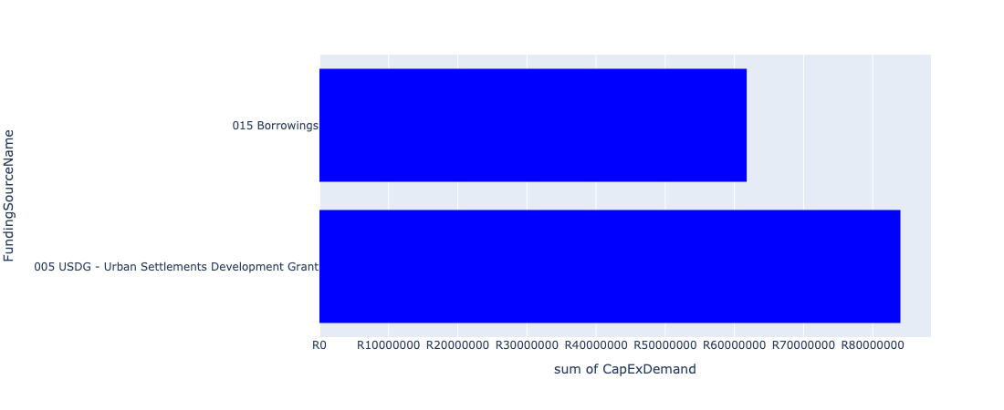

Figure 5.152: Ward 76 Departmental Requests

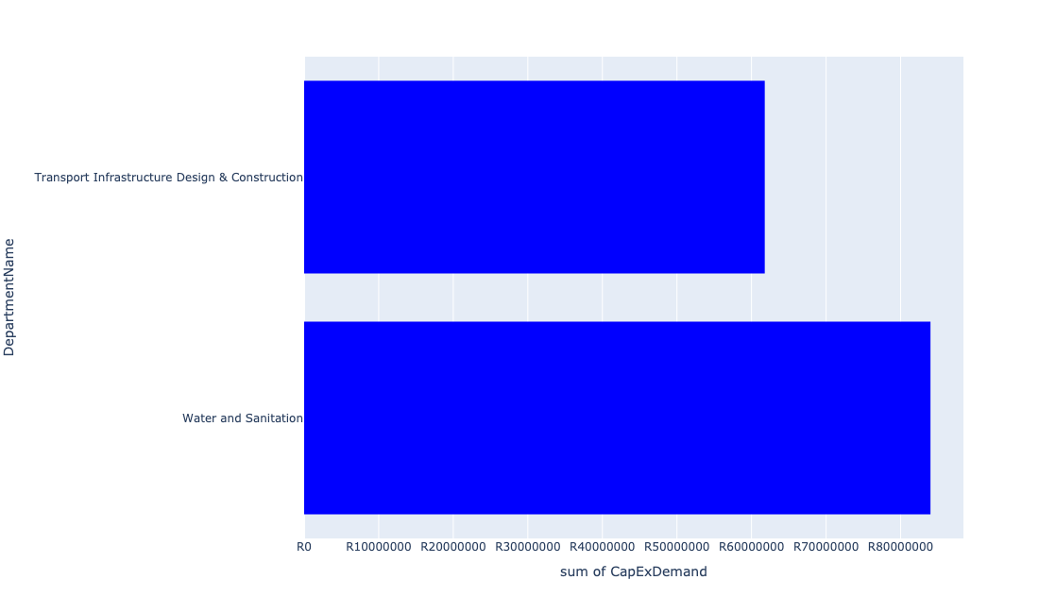

Table 5.76: Summary - Ward 76

|  |  |
| --- | --- |
| Item | Description |
| Total Capital Demand for Ward 76 - All Years | R145,777,426 Rank: 79 (1 = Highest) |
| Total Capital Demand for Ward 76 - MTREF | R56,192,913 Rank: 78 (1 = Highest) |
| Financial Years in which capital requirements are listed for Ward 76 | 2022, 2023, 2024, 2025, 2026, 2027, 2028, 2029 and 2030 |
| Financial Year with highest capital demand for Ward 76 | 2025 |
| Ward 76 intersecting feature used | Works Location |
| Total number of projects intersecting with Ward 76 | 6 Rank: 89 (1 = Highest) |

Table 5.77: All projects asking for budget in Ward 76

|  |  |  |  |
| --- | --- | --- | --- |
| Project ID | Project Name | Department | Project Budget |
| 632 | (711273) Major Stormwater Drainage System Majaneng | Transport Infrastructure Design & Construction | R61,777,426 (42.38%) Budget spread across: 2022, 2025, 2026, 2027, 2028, 2029 and 2030 |
| 712967258 | (710878U) Refurbishment of Water networks and backlog eradication : Greater Temba: Suurman, Mashemong and Majaneng | Water and Sanitation | R42,000,000 (28.81%) Budget spread across: 2023, 2024 and 2025 |
| 712967253 | (710878Q) Refurbishment of Sewer networks and backlog eradication : Greater Temba: Suurman, Mashemong and Majaneng | Water and Sanitation | R42,000,000 (28.81%) Budget spread across: 2023, 2024 and 2025 |

## Ward 77

Figure 5.153: Ward 77 Funding Requests

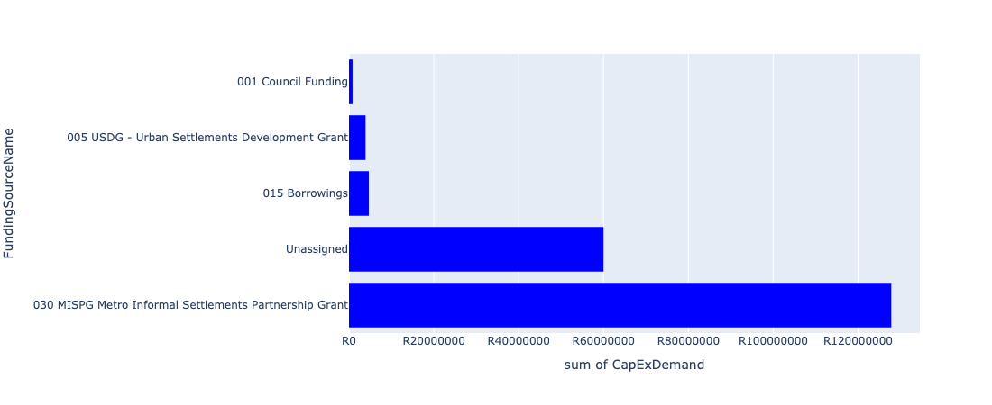

Figure 5.154: Ward 77 Departmental Requests

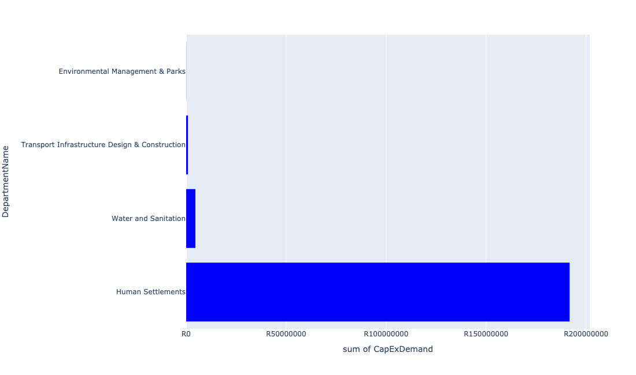

Table 5.77: Summary - Ward 77

|  |  |
| --- | --- |
| Item | Description |
| Total Capital Demand for Ward 77 - All Years | R197,259,675 Rank: 66 (1 = Highest) |
| Total Capital Demand for Ward 77 - MTREF | R196,473,638 Rank: 37 (1 = Highest) |
| Financial Years in which capital requirements are listed for Ward 77 | 2022, 2023, 2024, 2025, 2026, 2027, 2028, 2029 and 2030 |
| Financial Year with highest capital demand for Ward 77 | 2022 |
| Ward 77 intersecting feature used | Works Location |
| Total number of projects intersecting with Ward 77 | 8 Rank: 74 (1 = Highest) |

Table 5.78: All projects asking for budget in Ward 77

|  |  |  |  |
| --- | --- | --- | --- |
| Project ID | Project Name | Department | Project Budget |
| 712971915 | Revitalisation of the City-Development of Non-Motorised Transport Masterplan | Transport Infrastructure Design & Construction | R21,768 (0.01%) Budget spread across: 2027 |
| 712975493 | Rehabilitation of Wetlands - The Reeds | Environmental Management & Parks | R47,762 (0.02%) Budget spread across: 2022, 2023, 2024, 2025 and 2026 |
| 826 | (712121E) Rietspruit outfall sewer upgrade | Water and Sanitation | R4,603,835 (2.33%) Budget spread across: 2023 and 2024 |
| 712975228 | Olivienhoutbosch Public Transport Facility (Provisioning of new taxi ranking facility at Olivienhoutbosch ) | Transport Infrastructure Design & Construction | R841,895 (0.43%) Budget spread across: 2022, 2023, 2024, 2025, 2026, 2027, 2028, 2029 and 2030 |
| 712967627 | (710863) Water provision - Olievenhoutbosch X60 | Human Settlements | R8,000,000 (4.06%) Budget spread across: 2022 |
| 712967614 | (710864) Sewer provision Olievenhoutbosch X60 | Human Settlements | R3,905,440 (1.98%) Budget spread across: 2022 |
| 712967598 | (710865) Construction of roads & stormwater - Olievenhoutbosch X60 | Human Settlements | R179,838,974 (91.17%) Budget spread across: 2022, 2023 and 2024 |

## Ward 78

Figure 5.155: Ward 78 Funding Requests

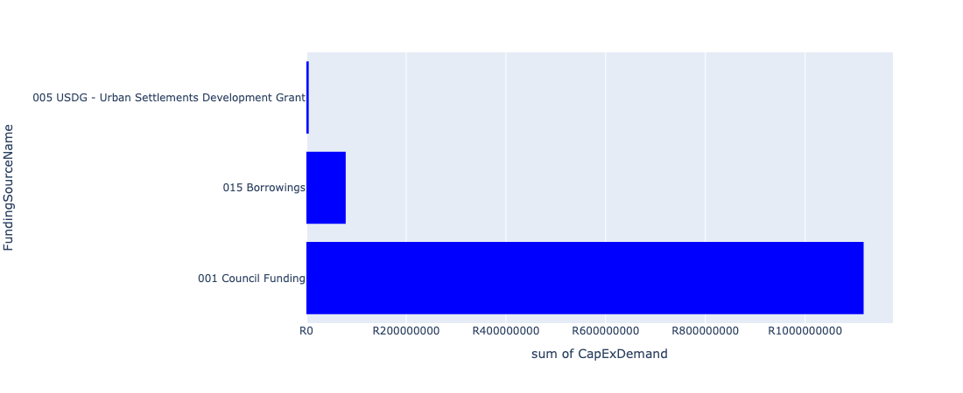

Figure 5.156: Ward 78 Departmental Requests

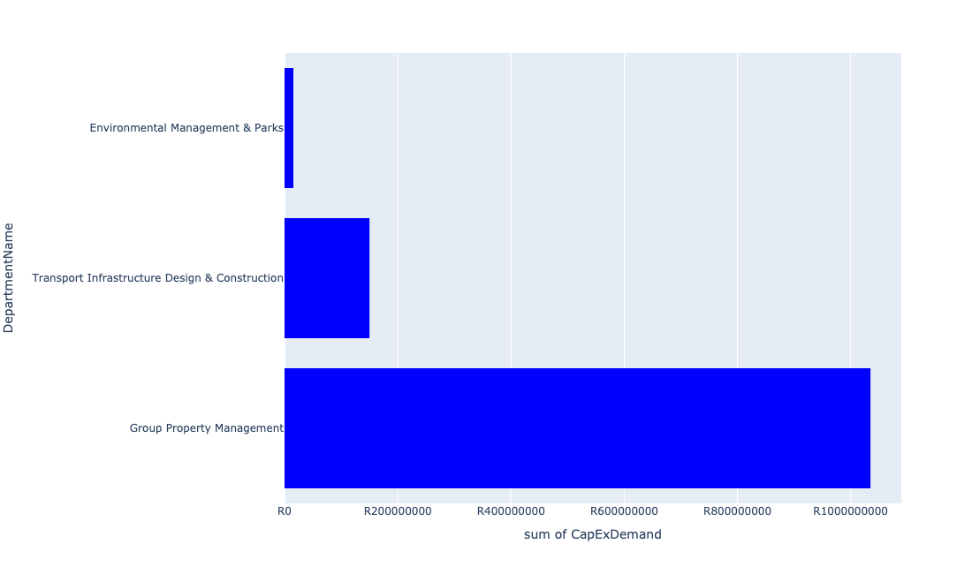

Table 5.78: Summary - Ward 78

|  |  |
| --- | --- |
| Item | Description |
| Total Capital Demand for Ward 78 - All Years | R1,184,565,625 Rank: 8 (1 = Highest) |
| Total Capital Demand for Ward 78 - MTREF | R604,650,670 Rank: 7 (1 = Highest) |
| Financial Years in which capital requirements are listed for Ward 78 | 2022, 2023, 2024, 2025, 2026, 2027, 2028, 2029 and 2030 |
| Financial Year with highest capital demand for Ward 78 | 2024 |
| Ward 78 intersecting feature used | Works Location |
| Total number of projects intersecting with Ward 78 | 12 Rank: 47 (1 = Highest) |

Table 5.79: All projects asking for budget in Ward 78

|  |  |  |  |
| --- | --- | --- | --- |
| Project ID | Project Name | Department | Project Budget |
| 712971915 | Revitalisation of the City-Development of Non-Motorised Transport Masterplan | Transport Infrastructure Design & Construction | R19,202 (0.00%) Budget spread across: 2027 |
| 712974158 | Upgrading of major stormwater Network 3A along Rabie Street, Lyttleton | Transport Infrastructure Design & Construction | R2,444,562 (0.21%) Budget spread across: 2025, 2026 and 2027 |
| 712967490 | (712368) Upgrading of facility ( Shelters and bus terminals ) at Centurion CBD | Transport Infrastructure Design & Construction | R83,082,554 (7.01%) Budget spread across: 2022, 2023, 2024, 2025, 2026, 2027, 2028, 2029 and 2030 |
| 712975580 | Centurion Customer Centre - Masterplan | Group Property Management | R1,035,000,000 (87.37%) Budget spread across: 2022, 2023, 2024 and 2025 |
| 712975171 | Upgrading of Hendrik Verwoerd Drive between John Vorster Drive and Rooihuiskraal Road in Centurion | Transport Infrastructure Design & Construction | R16,365,809 (1.38%) Budget spread across: 2026, 2027 and 2028 |
| 712975070 | 713044 Extension of Centurion Cemetery | Environmental Management & Parks | R5,618,306 (0.47%) Budget spread across: 2023 and 2025 |
| 712974524 | Upgrading of Lenchen Avenue | Transport Infrastructure Design & Construction | R48,167,726 (4.07%) Budget spread across: 2022, 2023 and 2024 |
| 712973727 | 713044 Construction of internal roads and guard house at Centurion Cemetery | Environmental Management & Parks | R10,000,000 (0.84%) Budget spread across: 2022 |

## Ward 79

Figure 5.157: Ward 79 Funding Requests

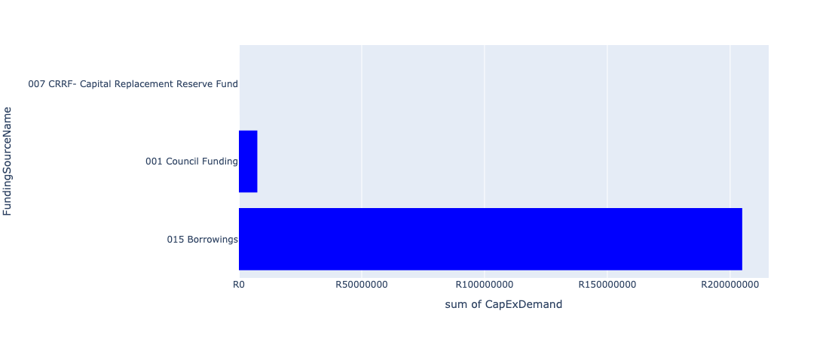

Figure 5.158: Ward 79 Departmental Requests

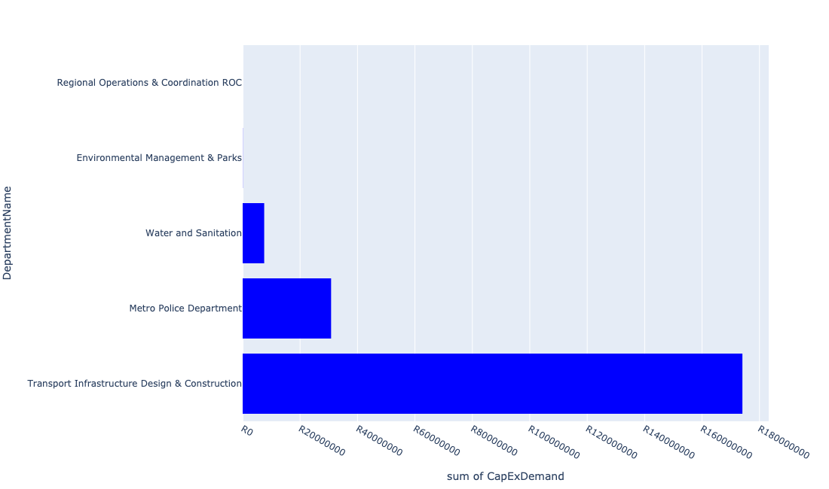

Table 5.79: Summary - Ward 79

|  |  |
| --- | --- |
| Item | Description |
| Total Capital Demand for Ward 79 - All Years | R212,405,810 Rank: 60 (1 = Highest) |
| Total Capital Demand for Ward 79 - MTREF | R70,290,116 Rank: 73 (1 = Highest) |
| Financial Years in which capital requirements are listed for Ward 79 | 2022, 2023, 2024, 2025, 2026, 2027 and 2029 |
| Financial Year with highest capital demand for Ward 79 | 2025 |
| Ward 79 intersecting feature used | Works Location |
| Total number of projects intersecting with Ward 79 | 9 Rank: 68 (1 = Highest) |

Table 5.80: All projects asking for budget in Ward 79

|  |  |  |  |
| --- | --- | --- | --- |
| Project ID | Project Name | Department | Project Budget |
| 712971915 | Revitalisation of the City-Development of Non-Motorised Transport Masterplan | Transport Infrastructure Design & Construction | R58,362 (0.03%) Budget spread across: 2027 |
| 712970748 | R6 Machinery and Equipment to ensure basic infrastructure reliability | Regional Operations & Coordination ROC | R2,934 (0.00%) Budget spread across: 2022 and 2023 |
| 712975772 | (712900) Upgrading of existing Practical Training facilities (Centurion) | Metro Police Department | R30,800,000 (14.50%) Budget spread across: 2022, 2023 and 2024 |
| 712975526 | Upgrade of Roads in Groenkloof Nature reserve | Environmental Management & Parks | R46,246 (0.02%) Budget spread across: 2022, 2023, 2024, 2025, 2026, 2027, 2028 and 2029 |
| 712975523 | Upgrade of Visitors Facilities - Groenkloof Nature Reserve | Environmental Management & Parks | R21 (0.00%) Budget spread across: 2022, 2023, 2024, 2025, 2026 and 2027 |
| 712975087 | (71212PvR) Upgrade existing Pierre van Ryneveld Outfall Sewer | Water and Sanitation | R7,500,000 (3.53%) Budget spread across: 2023, 2024 and 2025 |
| 712974522 | Upgrading of Solomon Mahlangu Drive | Transport Infrastructure Design & Construction | R5,384,968 (2.54%) Budget spread across: 2022 |
| 643 | (711325) Olievenhoutbosch Activity Spine | Transport Infrastructure Design & Construction | R168,613,278 (79.38%) Budget spread across: 2023, 2024, 2025 and 2026 |

## Ward 80

Figure 5.159: Ward 80 Funding Requests

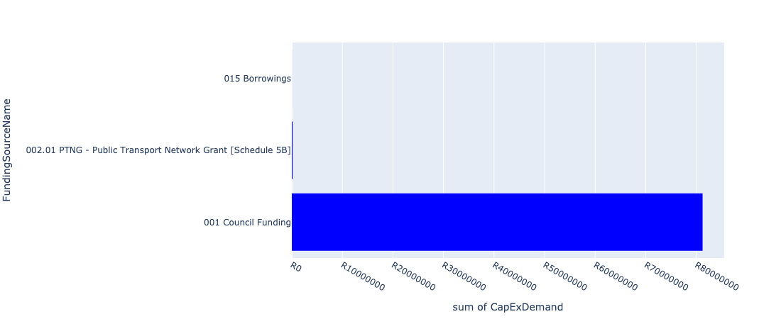

Figure 5.160: Ward 80 Departmental Requests

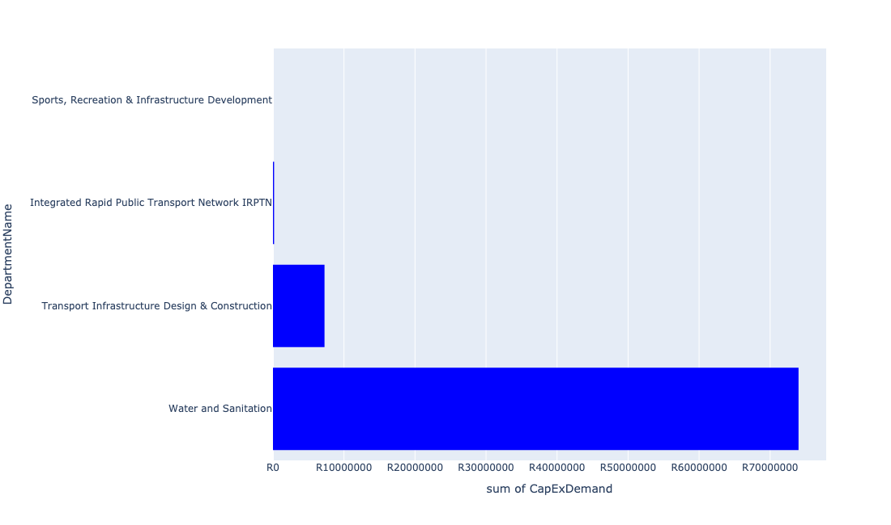

Table 5.80: Summary - Ward 80

|  |  |
| --- | --- |
| Item | Description |
| Total Capital Demand for Ward 80 - All Years | R81,415,840 Rank: 87 (1 = Highest) |
| Total Capital Demand for Ward 80 - MTREF | R49,969,649 Rank: 79 (1 = Highest) |
| Financial Years in which capital requirements are listed for Ward 80 | 2022, 2023, 2024, 2025, 2026, 2027, 2028, 2029 and 2030 |
| Financial Year with highest capital demand for Ward 80 | 2024 |
| Ward 80 intersecting feature used | Works Location |
| Total number of projects intersecting with Ward 80 | 11 Rank: 54 (1 = Highest) |

Table 5.81: All projects asking for budget in Ward 80

|  |  |  |  |
| --- | --- | --- | --- |
| Project ID | Project Name | Department | Project Budget |
| 712975019 | Decongestion of the inner city- Provisioning of New off street holding facilities within the inner city – CBD as per the 04 identified sites | Transport Infrastructure Design & Construction | R3,895,810 (4.79%) Budget spread across: 2022, 2023, 2024, 2025, 2026, 2027, 2028, 2029 and 2030 |
| 712967744 | (712591) Design, Supply, Installation, Commissioning and Operational Support Of Advanced Public Transport Management System (APTMS) | Integrated Rapid Public Transport Network IRPTN | R158,594 (0.19%) Budget spread across: 2022 |
| 712967144 | (711442) Upgrading of museums/historical buildings | Sports, Recreation & Infrastructure Development | R14 (0.00%) Budget spread across: 2025 |
| 712971918 | Revitalisation of the City-Upgrade of Pretoria Station Taxi Rank- Dairy Mall Taxi Rank | Transport Infrastructure Design & Construction | R3,352,365 (4.12%) Budget spread across: 2022, 2023, 2024, 2025, 2026, 2027, 2028, 2029 and 2030 |
| 712971915 | Revitalisation of the City-Development of Non-Motorised Transport Masterplan | Transport Infrastructure Design & Construction | R9,057 (0.01%) Budget spread across: 2027 |
| 712974840 | (714046) Salvokop Reservoir – Conduit Hydropower Plant | Water and Sanitation | R14,000,000 (17.20%) Budget spread across: 2022, 2023 and 2024 |
| 712967276 | (712534SL) Salvokop Reservoir | Water and Sanitation | R60,000,000 (73.70%) Budget spread across: 2023, 2024, 2025 and 2026 |
| 712969048 | (712591) Pretoria Station | Integrated Rapid Public Transport Network IRPTN | R0 (0.00%) Budget spread across: 2022 |

## Ward 81

Figure 5.161: Ward 81 Funding Requests

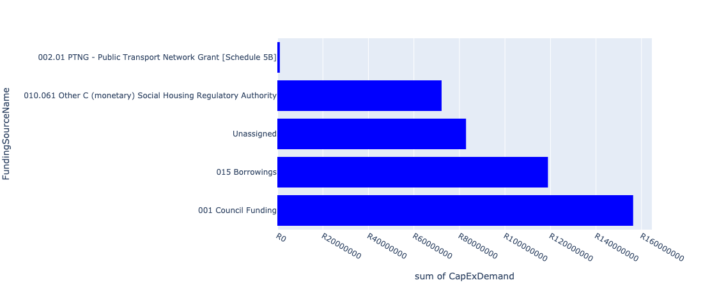

Figure 5.162: Ward 81 Departmental Requests

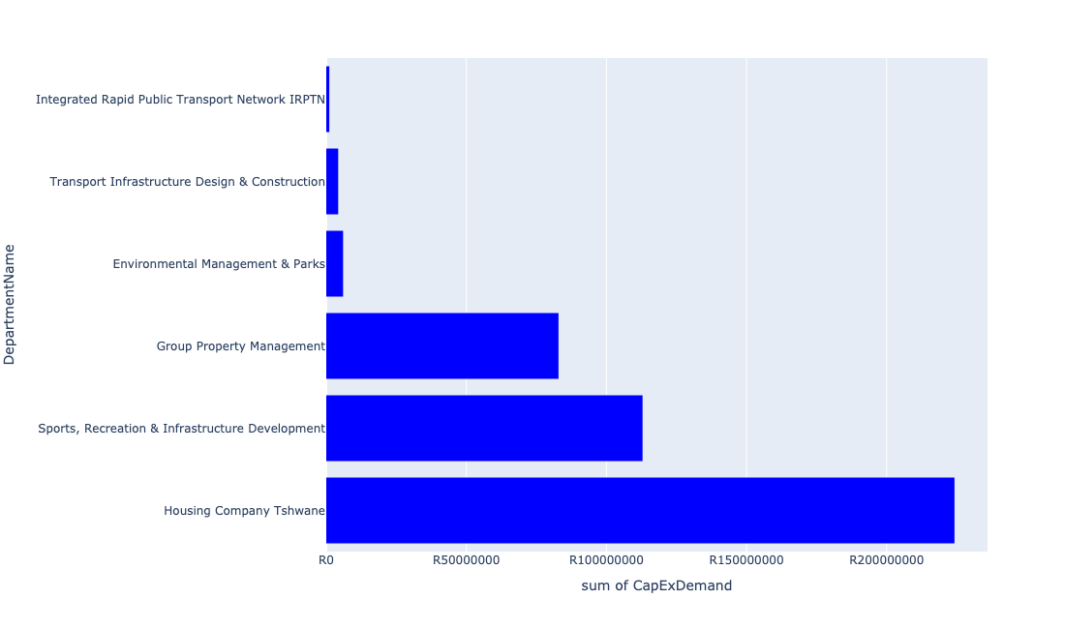

Table 5.81: Summary - Ward 81

|  |  |
| --- | --- |
| Item | Description |
| Total Capital Demand for Ward 81 - All Years | R359,182,333 Rank: 41 (1 = Highest) |
| Total Capital Demand for Ward 81 - MTREF | R336,466,994 Rank: 18 (1 = Highest) |
| Financial Years in which capital requirements are listed for Ward 81 | 2022, 2023, 2024, 2025, 2026, 2027, 2028, 2029, 2030 and 2031 |
| Financial Year with highest capital demand for Ward 81 | 2022 |
| Ward 81 intersecting feature used | Works Location |
| Total number of projects intersecting with Ward 81 | 10 Rank: 61 (1 = Highest) |

Table 5.82: All projects asking for budget in Ward 81

|  |  |  |  |
| --- | --- | --- | --- |
| Project ID | Project Name | Department | Project Budget |
| 712975251 | 712967311_02 Upgrade passenger elevators at Blesbok and Bosbok flats | Group Property Management | R650 (0.00%) Budget spread across: 2022 |
| 712975019 | Decongestion of the inner city- Provisioning of New off street holding facilities within the inner city – CBD as per the 04 identified sites | Transport Infrastructure Design & Construction | R4,251,929 (1.18%) Budget spread across: 2022, 2023, 2024, 2025, 2026, 2027, 2028, 2029 and 2030 |
| 712967744 | (712591) Design, Supply, Installation, Commissioning and Operational Support Of Advanced Public Transport Management System (APTMS) | Integrated Rapid Public Transport Network IRPTN | R1,080,162 (0.30%) Budget spread across: 2022 |
| 712973957 | Timberlands Construction Of 607 Social Housing Units | Housing Company Tshwane | R224,217,161 (62.42%) Budget spread across: 2022, 2023 and 2024 |
| 712971915 | Revitalisation of the City-Development of Non-Motorised Transport Masterplan | Transport Infrastructure Design & Construction | R3,302 (0.00%) Budget spread across: 2027 |
| 712975796 | (714071) Acquisition and refurbishment of Midtown Building | Group Property Management | R82,890,700 (23.08%) Budget spread across: 2022, 2023, 2024, 2025, 2026, 2027, 2028, 2029, 2030 and 2031 |
| 712975244 | Upgrade of Jubilee Park Sunnyside | Environmental Management & Parks | R6,000,000 (1.67%) Budget spread across: 2022 |
| 712967089 | (712915) Upgrading of Caledonian Stadium (Inner City Park) | Sports, Recreation & Infrastructure Development | R112,886,200 (31.43%) Budget spread across: 2022 and 2023 |

## Ward 82

Figure 5.163: Ward 82 Funding Requests

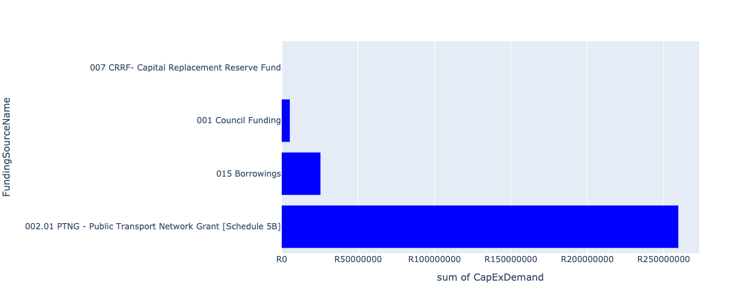

Figure 5.164: Ward 82 Departmental Requests

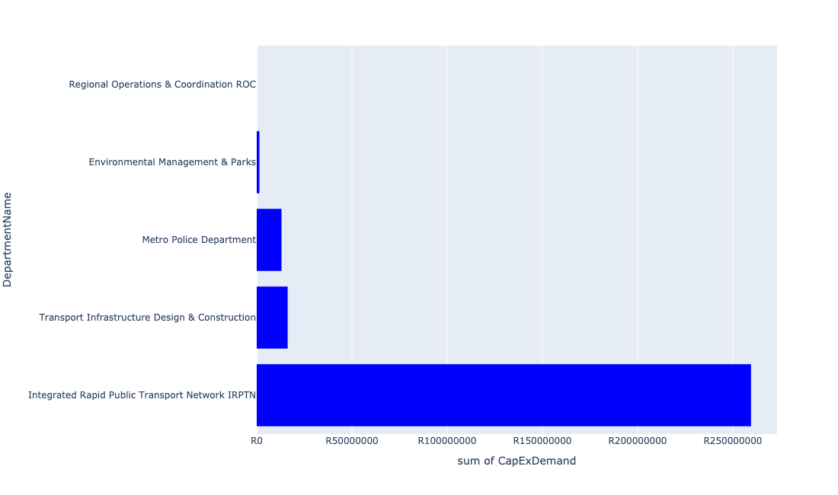

Table 5.82: Summary - Ward 82

|  |  |
| --- | --- |
| Item | Description |
| Total Capital Demand for Ward 82 - All Years | R290,212,564 Rank: 45 (1 = Highest) |
| Total Capital Demand for Ward 82 - MTREF | R230,033,872 Rank: 30 (1 = Highest) |
| Financial Years in which capital requirements are listed for Ward 82 | 2022, 2023, 2024, 2025, 2026, 2027, 2028, 2029 and 2030 |
| Financial Year with highest capital demand for Ward 82 | 2023 |
| Ward 82 intersecting feature used | Works Location |
| Total number of projects intersecting with Ward 82 | 16 Rank: 26 (1 = Highest) |

Table 5.83: All projects asking for budget in Ward 82

|  |  |  |  |
| --- | --- | --- | --- |
| Project ID | Project Name | Department | Project Budget |
| 712975019 | Decongestion of the inner city- Provisioning of New off street holding facilities within the inner city – CBD as per the 04 identified sites | Transport Infrastructure Design & Construction | R1,565,505 (0.54%) Budget spread across: 2022, 2023, 2024, 2025, 2026, 2027, 2028, 2029 and 2030 |
| 712967744 | (712591) Design, Supply, Installation, Commissioning and Operational Support Of Advanced Public Transport Management System (APTMS) | Integrated Rapid Public Transport Network IRPTN | R3,154,768 (1.09%) Budget spread across: 2022 |
| 712971915 | Revitalisation of the City-Development of Non-Motorised Transport Masterplan | Transport Infrastructure Design & Construction | R33,159 (0.01%) Budget spread across: 2027 |
| 712970748 | R6 Machinery and Equipment to ensure basic infrastructure reliability | Regional Operations & Coordination ROC | R0 (0.00%) Budget spread across: 2022 and 2023 |
| 712967743 | (712591) The Design, Supply, Installation, Operation and Maintenance of an automated fare Collection (AFC) System | Integrated Rapid Public Transport Network IRPTN | R26,453,849 (9.12%) Budget spread across: 2022, 2023, 2024 and 2025 |
| 712967731 | (712591) Line 2B: Atterbury Rd (btw Lynnwood Rd to Lois Avenue) | Integrated Rapid Public Transport Network IRPTN | R152,990,841 (52.72%) Budget spread across: 2022, 2023, 2024 and 2025 |
| 712974816 | Upgrading of Justice Mahomed Drive between Dely/Brooklyn Road and Jan Shoba Street | Transport Infrastructure Design & Construction | R1,972,088 (0.68%) Budget spread across: 2022 and 2023 |
| 712974164 | Major Stormwater network 4G along Boundary Road, Hatfield | Transport Infrastructure Design & Construction | R12,676,141 (4.37%) Budget spread across: 2026, 2027 and 2028 |
| 712967730 | (712591) Line 2B: Lynnwood Rd (btw University Rd to Atterbury) | Integrated Rapid Public Transport Network IRPTN | R72,875,184 (25.11%) Budget spread across: 2022, 2023 and 2024 |
| 712969046 | (712591) NMT Line 2B (Hatfield to Menlyn) | Integrated Rapid Public Transport Network IRPTN | R4,089,708 (1.41%) Budget spread across: 2022 |
| 712975491 | Rehabilitation of Wetlands - Colbyn Wetland | Environmental Management & Parks | R1,401,321 (0.48%) Budget spread across: 2022, 2023, 2024, 2025 and 2026 |
| 712975410 | Sub-Project: TMPD Station - Ashlea Garden | Metro Police Department | R13,000,000 (4.48%) Budget spread across: 2022 and 2023 |

## Ward 83

Figure 5.165: Ward 83 Funding Requests

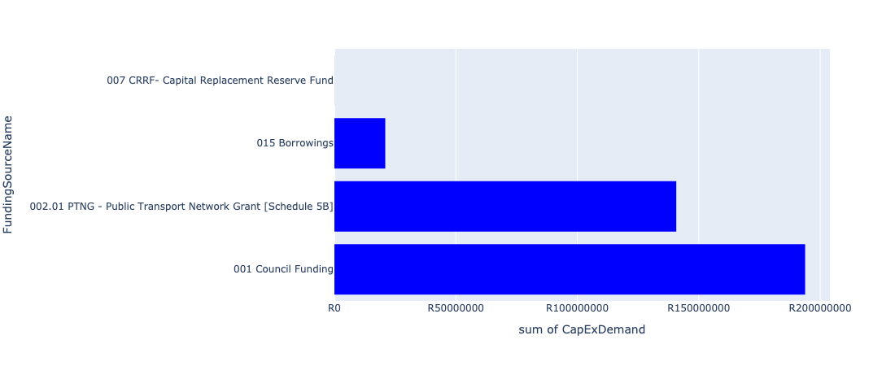

Figure 5.166: Ward 83 Departmental Requests

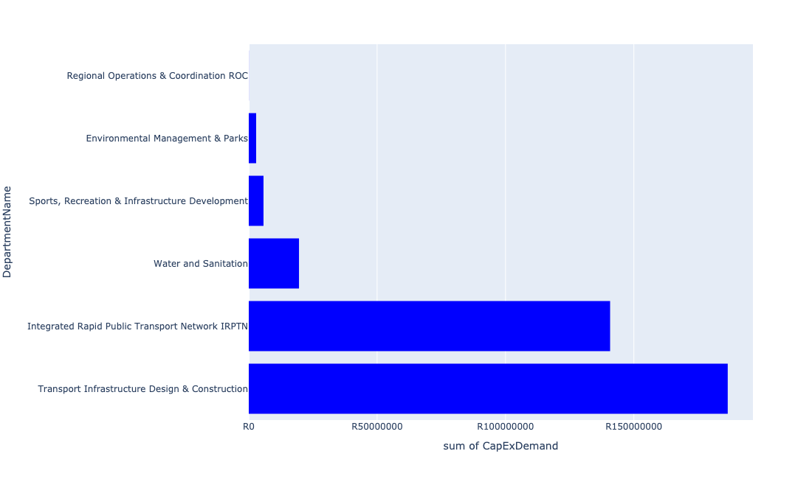

Table 5.83: Summary - Ward 83

|  |  |
| --- | --- |
| Item | Description |
| Total Capital Demand for Ward 83 - All Years | R311,581,780 Rank: 44 (1 = Highest) |
| Total Capital Demand for Ward 83 - MTREF | R141,729,169 Rank: 52 (1 = Highest) |
| Financial Years in which capital requirements are listed for Ward 83 | 2022, 2023, 2024, 2025, 2026, 2027, 2028, 2029, 2030 and 2031 |
| Financial Year with highest capital demand for Ward 83 | 2023 |
| Ward 83 intersecting feature used | Works Location |
| Total number of projects intersecting with Ward 83 | 23 Rank: 10 (1 = Highest) |

Table 5.84: All projects asking for budget in Ward 83

|  |  |  |  |
| --- | --- | --- | --- |
| Project ID | Project Name | Department | Project Budget |
| 712967744 | (712591) Design, Supply, Installation, Commissioning and Operational Support Of Advanced Public Transport Management System (APTMS) | Integrated Rapid Public Transport Network IRPTN | R657,664 (0.21%) Budget spread across: 2022 |
| 712971915 | Revitalisation of the City-Development of Non-Motorised Transport Masterplan | Transport Infrastructure Design & Construction | R29,364 (0.01%) Budget spread across: 2027 |
| 712970748 | R6 Machinery and Equipment to ensure basic infrastructure reliability | Regional Operations & Coordination ROC | R34,344 (0.01%) Budget spread across: 2022 and 2023 |
| 712967743 | (712591) The Design, Supply, Installation, Operation and Maintenance of an automated fare Collection (AFC) System | Integrated Rapid Public Transport Network IRPTN | R5,583,674 (1.79%) Budget spread across: 2022, 2023, 2024 and 2025 |
| 712967733 | (712591) BRT Line 2C-January Masilela (btw Atterbury & Lynnwood Rd) | Integrated Rapid Public Transport Network IRPTN | R807,789 (0.26%) Budget spread across: 2022 and 2023 |
| 712967731 | (712591) Line 2B: Atterbury Rd (btw Lynnwood Rd to Lois Avenue) | Integrated Rapid Public Transport Network IRPTN | R21,129,261 (6.78%) Budget spread across: 2022, 2023, 2024 and 2025 |
| 712973830 | Build additional study hall at Glenstantia Library | Sports, Recreation & Infrastructure Development | R5,735,932 (1.84%) Budget spread across: 2029 |
| 712969439 | (712121D) Moreletaspruit: Outfall sewer | Water and Sanitation | R65,410 (0.02%) Budget spread across: 2022, 2023, 2024, 2025 and 2026 |
| 1472 | (712956) Upgrading of Garsfontein road | Transport Infrastructure Design & Construction | R47,341,300 (15.19%) Budget spread across: 2022, 2023, 2024, 2025 and 2026 |
| 712974522 | Upgrading of Solomon Mahlangu Drive | Transport Infrastructure Design & Construction | R1,188,670 (0.38%) Budget spread across: 2022 |
| 712969046 | (712591) NMT Line 2B (Hatfield to Menlyn) | Integrated Rapid Public Transport Network IRPTN | R563,773 (0.18%) Budget spread across: 2022 |
| 712975473 | Provisioning of new taxi ranking facility at Erasmus | Transport Infrastructure Design & Construction | R64,000,000 (20.54%) Budget spread across: 2022, 2023, 2024, 2025, 2026, 2027, 2028, 2029 and 2030 |
| 712975455 | Upgrade infrastructure at Moreletakloof Nature Reserve | Environmental Management & Parks | R2,869,184 (0.92%) Budget spread across: 2023 and 2024 |
| 712975100 | (711335Co) Feeder main replacement Constantia Reservoir | Water and Sanitation | R19,500,000 (6.26%) Budget spread across: 2028, 2029 and 2030 |
| 712975018 | Provisioning of new taxi holding facility for the Menlyn area | Transport Infrastructure Design & Construction | R74,000,000 (23.75%) Budget spread across: 2022, 2023, 2024, 2025, 2026, 2027, 2028, 2029 and 2031 |
| 712974885 | (712591) Menlyn Taxi Interchange (Gobie) | Integrated Rapid Public Transport Network IRPTN | R43,075,415 (13.82%) Budget spread across: 2022 and 2023 |
| 712974884 | (712591) Menlyn Taxi Interchange (Dallas) | Integrated Rapid Public Transport Network IRPTN | R68,925,200 (22.12%) Budget spread across: 2022 |

## Ward 84

Figure 5.167: Ward 84 Funding Requests

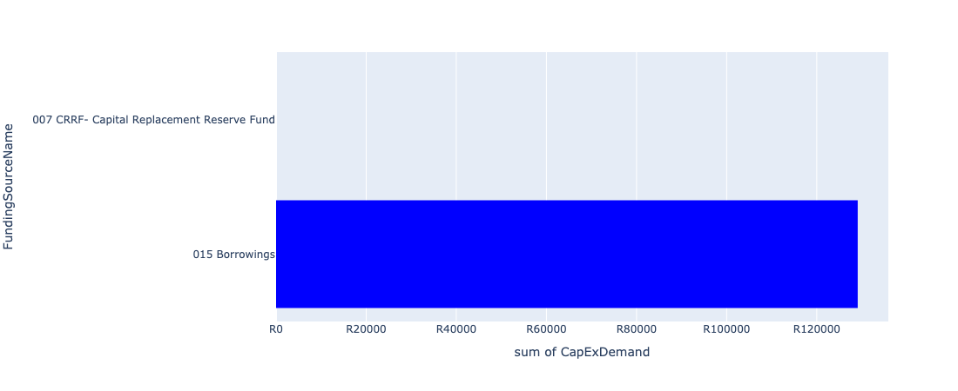

Figure 5.168: Ward 84 Departmental Requests

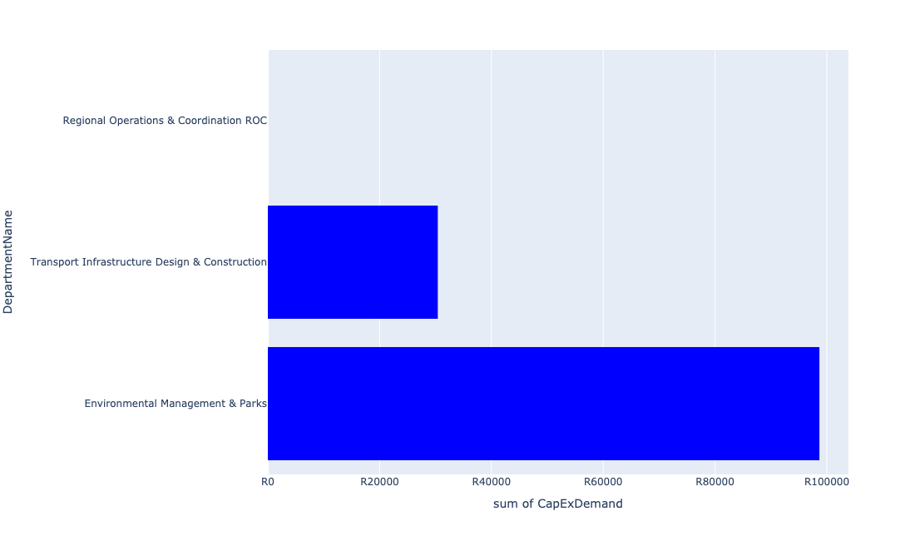

Table 5.84: Summary - Ward 84

|  |  |
| --- | --- |
| Item | Description |
| Total Capital Demand for Ward 84 - All Years | R129,083 Rank: 107 (1 = Highest) |
| Total Capital Demand for Ward 84 - MTREF | R0 Rank: 104 (1 = Highest) |
| Financial Years in which capital requirements are listed for Ward 84 | 2022, 2023, 2026 and 2027 |
| Financial Year with highest capital demand for Ward 84 | 2026 |
| Ward 84 intersecting feature used | Works Location |
| Total number of projects intersecting with Ward 84 | 4 Rank: 101 (1 = Highest) |

Table 5.85: All projects asking for budget in Ward 84

|  |  |  |  |
| --- | --- | --- | --- |
| Project ID | Project Name | Department | Project Budget |
| 712971915 | Revitalisation of the City-Development of Non-Motorised Transport Masterplan | Transport Infrastructure Design & Construction | R30,404 (23.55%) Budget spread across: 2027 |
| 712970748 | R6 Machinery and Equipment to ensure basic infrastructure reliability | Regional Operations & Coordination ROC | R0 (0.00%) Budget spread across: 2022 and 2023 |
| 712975491 | Rehabilitation of Wetlands - Colbyn Wetland | Environmental Management & Parks | R98,679 (76.45%) Budget spread across: 2022, 2023, 2024, 2025 and 2026 |

## Ward 85

Figure 5.169: Ward 85 Funding Requests

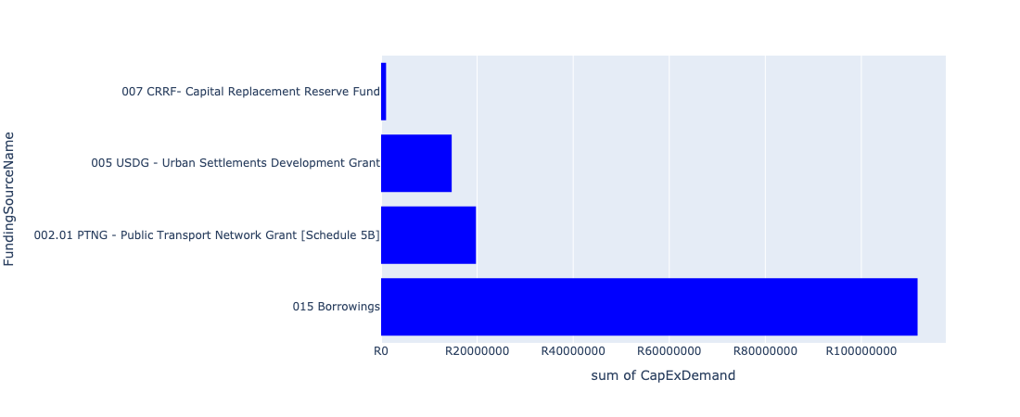

Figure 5.170: Ward 85 Departmental Requests

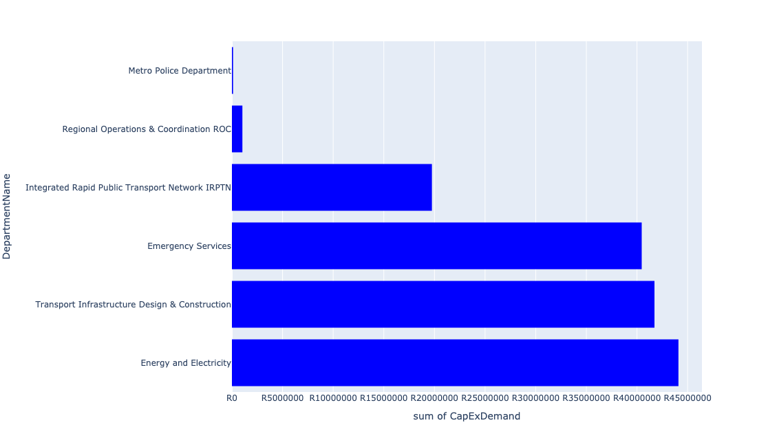

Table 5.85: Summary - Ward 85

|  |  |
| --- | --- |
| Item | Description |
| Total Capital Demand for Ward 85 - All Years | R147,186,618 Rank: 77 (1 = Highest) |
| Total Capital Demand for Ward 85 - MTREF | R62,595,798 Rank: 76 (1 = Highest) |
| Financial Years in which capital requirements are listed for Ward 85 | 2022, 2023, 2024, 2025, 2026, 2027, 2028 and 2029 |
| Financial Year with highest capital demand for Ward 85 | 2023 |
| Ward 85 intersecting feature used | Works Location |
| Total number of projects intersecting with Ward 85 | 9 Rank: 68 (1 = Highest) |

Table 5.86: All projects asking for budget in Ward 85

|  |  |  |  |
| --- | --- | --- | --- |
| Project ID | Project Name | Department | Project Budget |
| 712971915 | Revitalisation of the City-Development of Non-Motorised Transport Masterplan | Transport Infrastructure Design & Construction | R29,199 (0.02%) Budget spread across: 2027 |
| 712970748 | R6 Machinery and Equipment to ensure basic infrastructure reliability | Regional Operations & Coordination ROC | R34,152 (0.02%) Budget spread across: 2022 and 2023 |
| 712967734 | (712591) BRT Line 2C-Lynnwood Rd (btw January Masilela & Simon Vermooten) | Integrated Rapid Public Transport Network IRPTN | R19,749,774 (13.42%) Budget spread across: 2022 and 2023 |
| 712975386 | (712279) Wapadrand 132/11kV Substation | Energy and Electricity | R44,094,579 (29.96%) Budget spread across: 2028 and 2029 |
| 712967794 | Construction of New Emergency Services Station Shere / The Willows | Emergency Services | R40,467,042 (27.49%) Budget spread across: 2025, 2026 and 2027 |
| 712975435 | Sub-Project: TMPD Station - Nellmapius (Extension 3) | Metro Police Department | R113,739 (0.08%) Budget spread across: 2023 and 2024 |
| 712975334 | RIMM: STELLENBERG QUARRY: PERIMETER FENCE | Regional Operations & Coordination ROC | R1,000,000 (0.68%) Budget spread across: 2022 |
| 712974525 | Upgrading of Lynnwood Road | Transport Infrastructure Design & Construction | R41,698,132 (28.33%) Budget spread across: 2023 and 2024 |

## Ward 86

Figure 5.171: Ward 86 Funding Requests

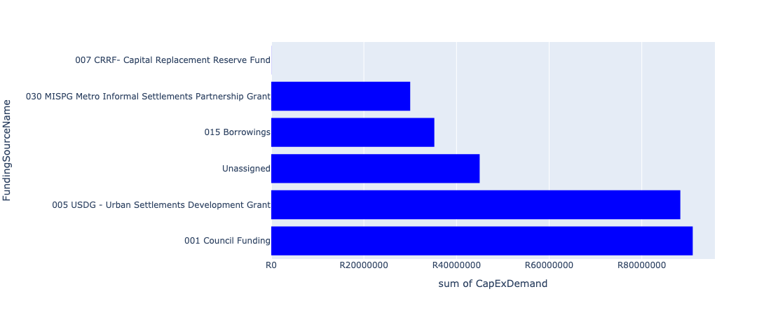

Figure 5.172: Ward 86 Departmental Requests

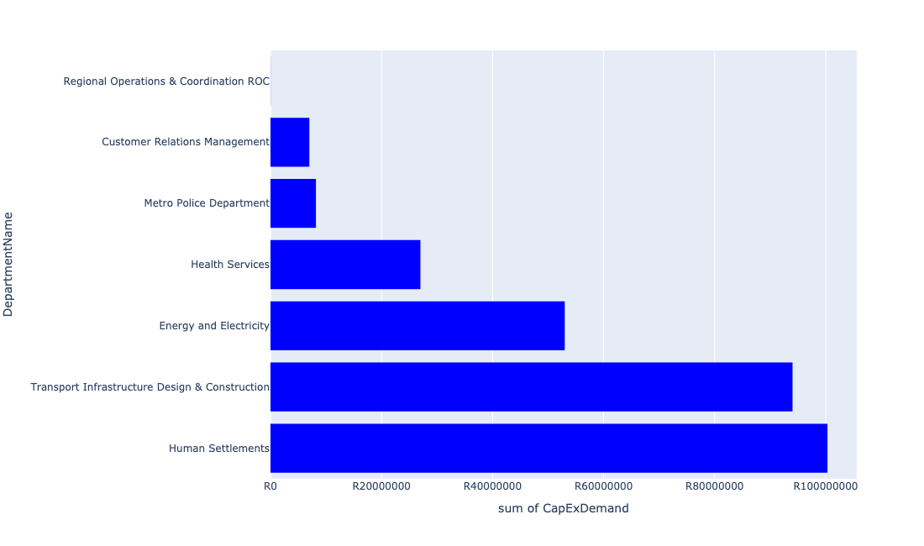

Table 5.86: Summary - Ward 86

|  |  |
| --- | --- |
| Item | Description |
| Total Capital Demand for Ward 86 - All Years | R289,553,926 Rank: 47 (1 = Highest) |
| Total Capital Demand for Ward 86 - MTREF | R183,532,395 Rank: 40 (1 = Highest) |
| Financial Years in which capital requirements are listed for Ward 86 | 2022, 2023, 2024, 2025, 2026, 2027, 2028, 2029 and 2030 |
| Financial Year with highest capital demand for Ward 86 | 2023 |
| Ward 86 intersecting feature used | Works Location |
| Total number of projects intersecting with Ward 86 | 10 Rank: 61 (1 = Highest) |

Table 5.87: All projects asking for budget in Ward 86

|  |  |  |  |
| --- | --- | --- | --- |
| Project ID | Project Name | Department | Project Budget |
| 712971915 | Revitalisation of the City-Development of Non-Motorised Transport Masterplan | Transport Infrastructure Design & Construction | R21,531 (0.01%) Budget spread across: 2027 |
| 712970748 | R6 Machinery and Equipment to ensure basic infrastructure reliability | Regional Operations & Coordination ROC | R25,183 (0.01%) Budget spread across: 2022 and 2023 |
| 712975435 | Sub-Project: TMPD Station - Nellmapius (Extension 3) | Metro Police Department | R8,187,043 (2.83%) Budget spread across: 2023 and 2024 |
| 712975388 | (712279) TASEZ 132/11kV Substation | Energy and Electricity | R53,000,000 (18.30%) Budget spread across: 2023, 2025 and 2026 |
| 712974929 | (710864) Sewer provision - Nellmapius Willows Mega Project | Human Settlements | R50,000,000 (17.27%) Budget spread across: 2022, 2023 and 2024 |
| 712974927 | (710863) Water Provision - Nellmapius Willows Mega Project | Human Settlements | R40,320,169 (13.92%) Budget spread across: 2022, 2023 and 2024 |
| 712974897 | Nellmapius Ext 26 (Covid-19) Acquisition of Land | Human Settlements | R10,000,000 (3.45%) Budget spread across: 2022 |
| 712967494 | (712921) Nellmapius Transport Facilities | Transport Infrastructure Design & Construction | R94,000,000 (32.46%) Budget spread across: 2022, 2023, 2024, 2025, 2026, 2027, 2028, 2029 and 2030 |
| 712973941 | (714026) Revamp of Nellmapius customer care centre | Customer Relations Management | R7,000,000 (2.42%) Budget spread across: 2022 and 2023 |
| 712973702 | Nellmapius Clinic Dispensaries | Health Services | R27,000,000 (9.32%) Budget spread across: 2024, 2025 and 2026 |

## Ward 87

Figure 5.173: Ward 87 Funding Requests

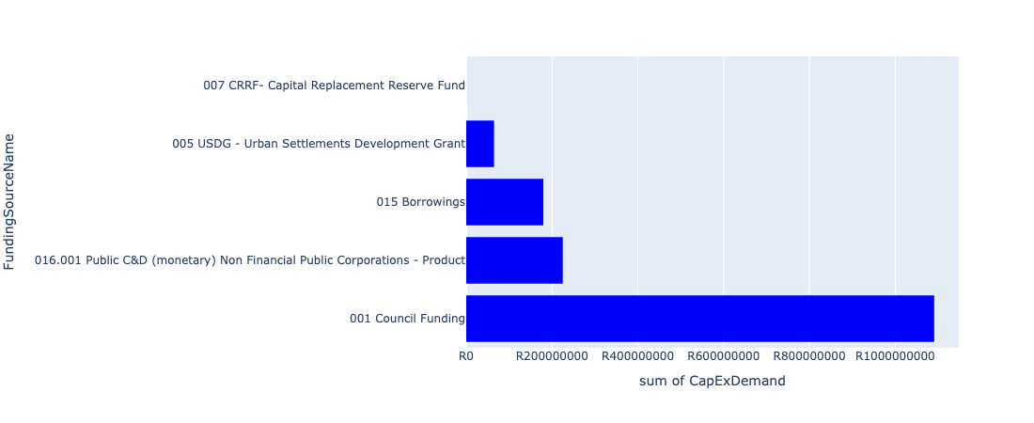

Figure 5.174: Ward 87 Departmental Requests

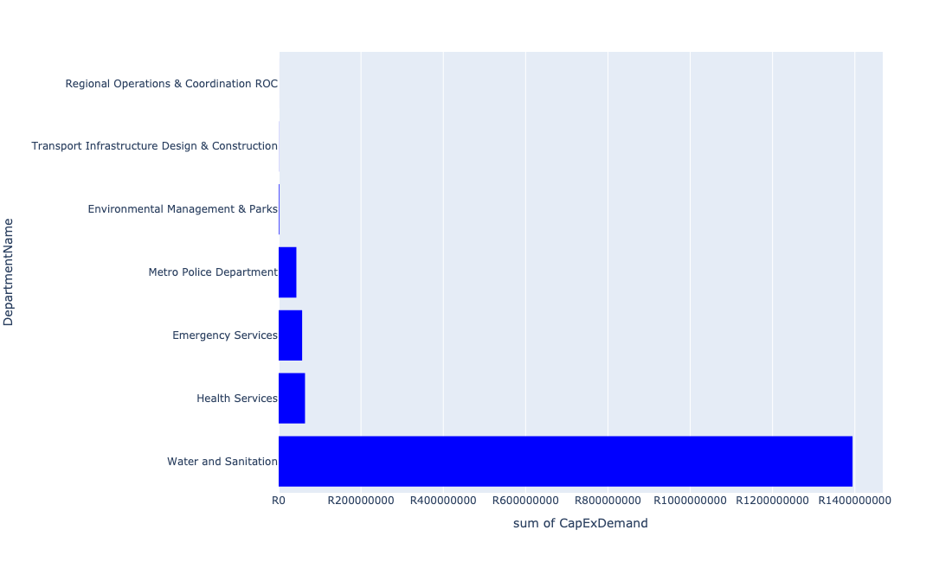

Table 5.87: Summary - Ward 87

|  |  |
| --- | --- |
| Item | Description |
| Total Capital Demand for Ward 87 - All Years | R1,557,480,802 Rank: 6 (1 = Highest) |
| Total Capital Demand for Ward 87 - MTREF | R439,319,831 Rank: 14 (1 = Highest) |
| Financial Years in which capital requirements are listed for Ward 87 | 2022, 2023, 2024, 2025, 2026, 2027, 2028, 2029, 2030 and 2031 |
| Financial Year with highest capital demand for Ward 87 | 2025 |
| Ward 87 intersecting feature used | Works Location |
| Total number of projects intersecting with Ward 87 | 21 Rank: 12 (1 = Highest) |

Table 5.88: All projects asking for budget in Ward 87

|  |  |  |  |
| --- | --- | --- | --- |
| Project ID | Project Name | Department | Project Budget |
| 712971915 | Revitalisation of the City-Development of Non-Motorised Transport Masterplan | Transport Infrastructure Design & Construction | R321,714 (0.02%) Budget spread across: 2027 |
| 712970748 | R6 Machinery and Equipment to ensure basic infrastructure reliability | Regional Operations & Coordination ROC | R35,162 (0.00%) Budget spread across: 2022 and 2023 |
| 712975456 | Upgrade of infrastructure of Magalies mountain | Environmental Management & Parks | R299,750 (0.02%) Budget spread across: 2022, 2023, 2024, 2025, 2026, 2027, 2028, 2029, 2030 and 2031 |
| 712969439 | (712121D) Moreletaspruit: Outfall sewer | Water and Sanitation | R9,781,315 (0.63%) Budget spread across: 2022, 2023, 2024, 2025 and 2026 |
| 712975437 | Sub-Project: TMPD Station - Mamelodi (Extension 10) | Metro Police Department | R25,219 (0.00%) Budget spread across: 2022, 2023 and 2024 |
| 712967285 | (711335DP) Roodeplaat WTP to Montana Reservoir bulk pipe line | Water and Sanitation | R30,096,550 (1.93%) Budget spread across: 2023, 2024 and 2025 |
| 712975418 | Establishment of Metro Police Office - Region 5 | Metro Police Department | R43,000,000 (2.76%) Budget spread across: 2022, 2023 and 2024 |
| 712975032 | (712121FZ) Future Zeekoegat bulk Outfall sewer (2/6) | Water and Sanitation | R22,500,000 (1.44%) Budget spread across: 2025, 2026 and 2027 |
| 712974546 | (710411B1) Zeekoegat WWTW: Phase2: De-bottlenecking & tertiary treatment | Water and Sanitation | R363,000,000 (23.31%) Budget spread across: 2023, 2024, 2025 and 2028 |
| 440 | (710411B) Zeekoegat WWTW Phase 1: Upgrading of existing infrastructure (mechanical) | Water and Sanitation | R62,000,000 (3.98%) Budget spread across: 2022, 2023, 2024 and 2025 |
| 239 | (710022) Township Water and Sanitation Services Development: Tshwane Contributions (City Wide) | Water and Sanitation | R525,000,000 (33.71%) Budget spread across: 2022, 2023, 2024, 2025, 2026, 2027, 2028, 2029 and 2030 |
| 179 | Construction of New Emergency Services Station in Derdepoort | Emergency Services | R57,000,000 (3.66%) Budget spread across: 2028, 2029 and 2030 |
| 712973981 | Extension of East Lynne Clinic | Health Services | R64,000,000 (4.11%) Budget spread across: 2025, 2026 and 2027 |
| 712973744 | (711921H) Upgrading of Sable Hills Portable WTP | Water and Sanitation | R6,000,000 (0.39%) Budget spread across: 2023 and 2024 |
| 712973743 | (711921Ro) Roodeplaat WTP: Refurbishment and Upgrade of existing plant | Water and Sanitation | R312,000,000 (20.03%) Budget spread across: 2023, 2024, 2025, 2026 and 2027 |
| 712969619 | (713044) Hatherley Cemetery | Environmental Management & Parks | R1,157,142 (0.07%) Budget spread across: 2022, 2023 and 2025 |
| 712969099 | 712969116_05_(712970) Kameeldrift 174 & 175 - Bulk Supply Pipeline to 1000 Housing Units - Water Provision | Water and Sanitation | R64,000,000 (4.11%) Budget spread across: 2022, 2023, 2024 and 2025 |

## Ward 88

Figure 5.175: Ward 88 Funding Requests

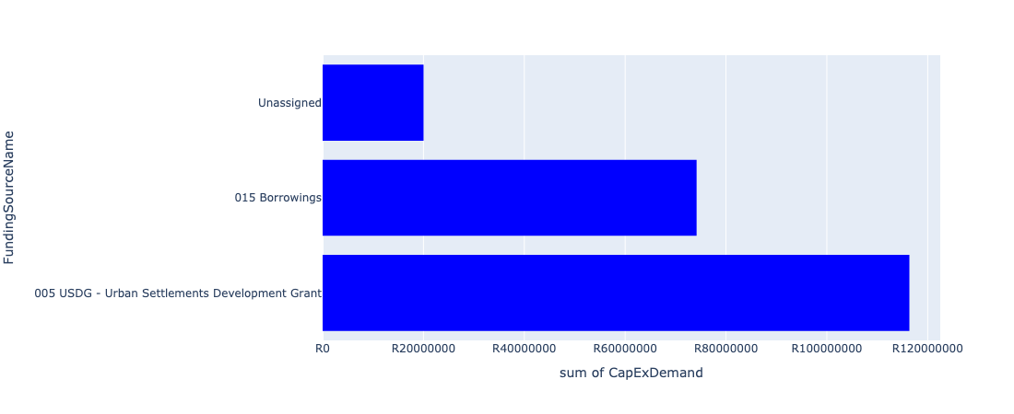

Figure 5.176: Ward 88 Departmental Requests

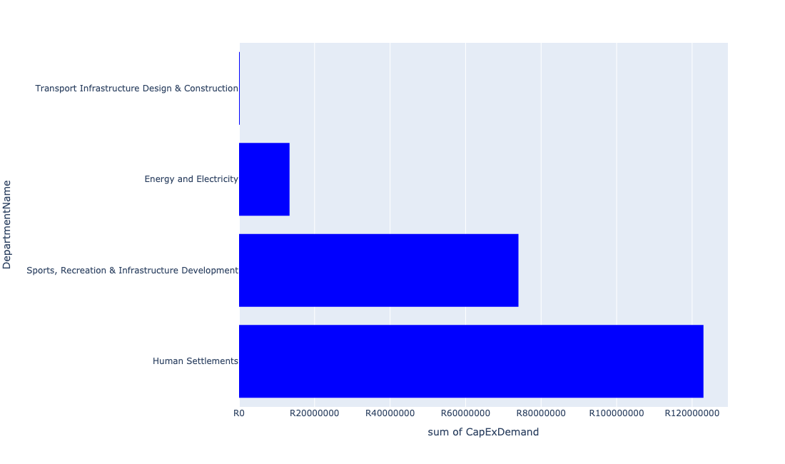

Table 5.88: Summary - Ward 88

|  |  |
| --- | --- |
| Item | Description |
| Total Capital Demand for Ward 88 - All Years | R210,556,269 Rank: 63 (1 = Highest) |
| Total Capital Demand for Ward 88 - MTREF | R152,431,479 Rank: 47 (1 = Highest) |
| Financial Years in which capital requirements are listed for Ward 88 | 2022, 2023, 2024, 2025, 2026, 2027, 2028, 2029, 2030 and 2031 |
| Financial Year with highest capital demand for Ward 88 | 2023 |
| Ward 88 intersecting feature used | Works Location |
| Total number of projects intersecting with Ward 88 | 6 Rank: 89 (1 = Highest) |

Table 5.89: All projects asking for budget in Ward 88

|  |  |  |  |
| --- | --- | --- | --- |
| Project ID | Project Name | Department | Project Budget |
| 712971915 | Revitalisation of the City-Development of Non-Motorised Transport Masterplan | Transport Infrastructure Design & Construction | R13,357 (0.01%) Budget spread across: 2027 |
| 712974542 | (712220) Soshanguve Block FF East Area 4 | Transport Infrastructure Design & Construction | R59,199 (0.03%) Budget spread across: 2022, 2023, 2024 and 2025 |
| 712969084 | (712279) Soshanguve - JJ 132KV Power Line | Energy and Electricity | R13,369,367 (6.35%) Budget spread across: 2022, 2023 and 2024 |
| 712974357 | (712220) Upgrading of Culverts | Transport Infrastructure Design & Construction | R114,344 (0.05%) Budget spread across: 2023, 2024, 2025, 2026, 2027, 2028, 2029 and 2030 |
| 712967124 | (712941) Greening of Sports fields | Sports, Recreation & Infrastructure Development | R74,000,001 (35.15%) Budget spread across: 2022, 2023, 2024, 2025, 2026, 2027, 2028, 2029, 2030 and 2031 |
| 712974386 | (710865) Construction of roads & stormwater - Soshanguve ext19 | Human Settlements | R123,000,000 (58.42%) Budget spread across: 2022, 2023 and 2024 |

## Ward 89

Figure 5.177: Ward 89 Funding Requests

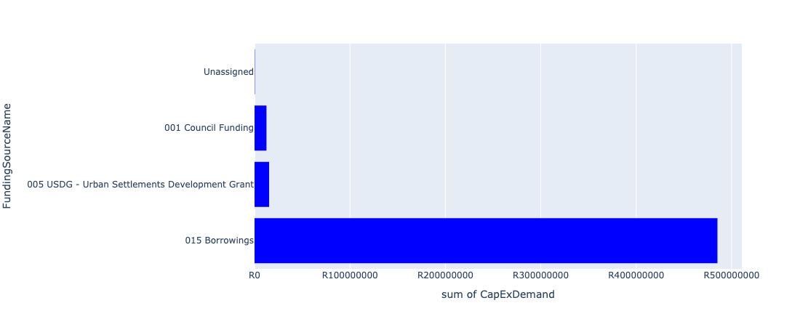

Figure 5.178: Ward 89 Departmental Requests

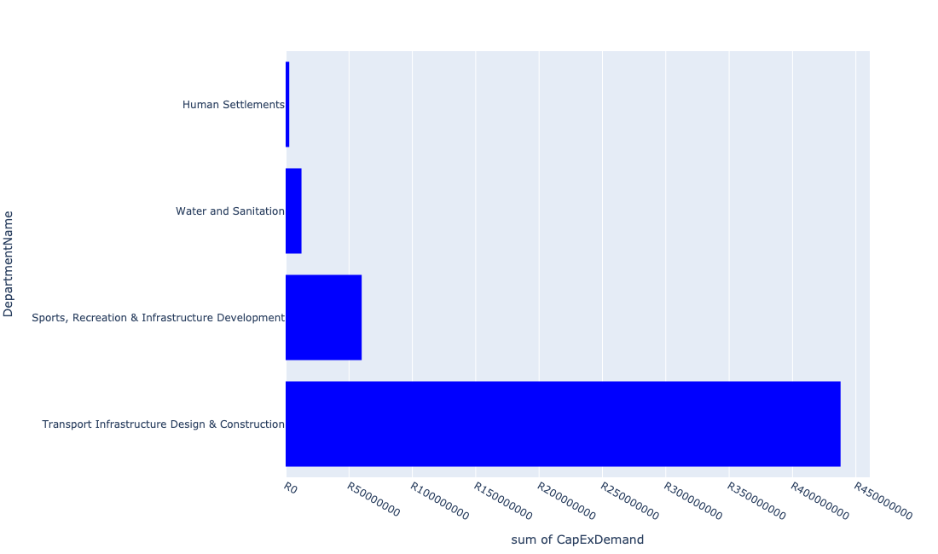

Table 5.89: Summary - Ward 89

|  |  |
| --- | --- |
| Item | Description |
| Total Capital Demand for Ward 89 - All Years | R513,275,801 Rank: 32 (1 = Highest) |
| Total Capital Demand for Ward 89 - MTREF | R89,634,700 Rank: 63 (1 = Highest) |
| Financial Years in which capital requirements are listed for Ward 89 | 2022, 2023, 2024, 2025, 2026, 2027, 2028, 2029 and 2030 |
| Financial Year with highest capital demand for Ward 89 | 2027 |
| Ward 89 intersecting feature used | Works Location |
| Total number of projects intersecting with Ward 89 | 7 Rank: 81 (1 = Highest) |

Table 5.90: All projects asking for budget in Ward 89

|  |  |  |  |
| --- | --- | --- | --- |
| Project ID | Project Name | Department | Project Budget |
| 712971915 | Revitalisation of the City-Development of Non-Motorised Transport Masterplan | Transport Infrastructure Design & Construction | R12,836 (0.00%) Budget spread across: 2027 |
| 712974603 | (712513) Soshanguve Extensions 3 and 4 | Transport Infrastructure Design & Construction | R100,212,956 (19.52%) Budget spread across: 2022, 2023, 2024, 2025, 2026, 2027, 2028, 2029 and 2030 |
| 712974601 | (712513) Soshanguve Extension 2 | Transport Infrastructure Design & Construction | R181,204,190 (35.30%) Budget spread across: 2022, 2023, 2024, 2025, 2026, 2027, 2028, 2029 and 2030 |
| 712975088 | (71212K) Upgrade existing Kopanong X03 Outfall Sewer (1/2) | Water and Sanitation | R12,500,000 (2.44%) Budget spread across: 2024, 2025, 2026 and 2027 |
| 712967135 | Klip kruisfontein multi-purpose sport facility | Sports, Recreation & Infrastructure Development | R60,000,000 (11.69%) Budget spread across: 2027 and 2028 |
| 712967603 | (710865) Construction of roads & stormwater - Soshanguve South X5 | Human Settlements | R2,845,819 (0.55%) Budget spread across: 2022, 2023 and 2024 |
| 712969551 | (712513) Soshanguve Block TT | Transport Infrastructure Design & Construction | R156,500,000 (30.49%) Budget spread across: 2022, 2023, 2024, 2025, 2026, 2027, 2028, 2029 and 2030 |

## Ward 90

Figure 5.179: Ward 90 Funding Requests

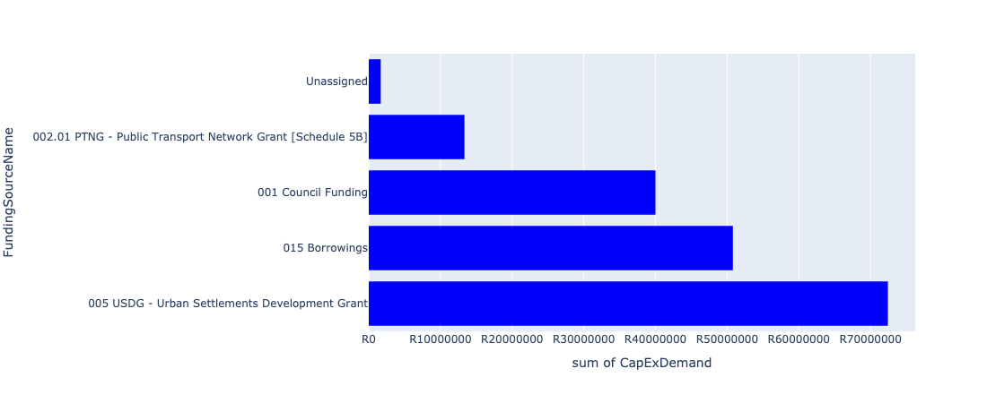

Figure 5.180: Ward 90 Departmental Requests

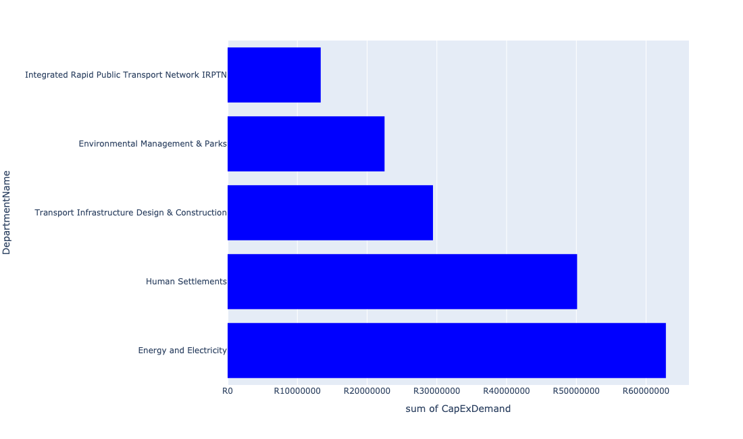

Table 5.90: Summary - Ward 90

|  |  |
| --- | --- |
| Item | Description |
| Total Capital Demand for Ward 90 - All Years | R168,236,377 Rank: 74 (1 = Highest) |
| Total Capital Demand for Ward 90 - MTREF | R80,949,651 Rank: 67 (1 = Highest) |
| Financial Years in which capital requirements are listed for Ward 90 | 2022, 2023, 2024, 2025, 2026, 2027, 2028, 2029 and 2030 |
| Financial Year with highest capital demand for Ward 90 | 2029 |
| Ward 90 intersecting feature used | Works Location |
| Total number of projects intersecting with Ward 90 | 14 Rank: 37 (1 = Highest) |

Table 5.91: All projects asking for budget in Ward 90

|  |  |  |  |
| --- | --- | --- | --- |
| Project ID | Project Name | Department | Project Budget |
| 712971915 | Revitalisation of the City-Development of Non-Motorised Transport Masterplan | Transport Infrastructure Design & Construction | R26,825 (0.02%) Budget spread across: 2027 |
| 712974118 | (712279) Rama City 132kV power line | Energy and Electricity | R2,838,023 (1.69%) Budget spread across: 2023, 2024 and 2025 |
| 712974614 | Upgrading of a tributary of the Sand Spruit, Rosslyn x 17 | Transport Infrastructure Design & Construction | R5,376,144 (3.20%) Budget spread across: 2025, 2026 and 2027 |
| 712974603 | (712513) Soshanguve Extensions 3 and 4 | Transport Infrastructure Design & Construction | R24,040,566 (14.29%) Budget spread across: 2022, 2023, 2024, 2025, 2026, 2027, 2028, 2029 and 2030 |
| 712967745 | (712591) Planning and Design of BRT Projects | Integrated Rapid Public Transport Network IRPTN | R13,346,788 (7.93%) Budget spread across: 2022, 2023, 2024 and 2025 |
| 712967596 | (710865) Construction of roads & stormwater - Thorntree View | Human Settlements | R35,953,850 (21.37%) Budget spread across: 2022, 2023 and 2024 |
| 712967603 | (710865) Construction of roads & stormwater - Soshanguve South X5 | Human Settlements | R14,154,181 (8.41%) Budget spread across: 2022, 2023 and 2024 |
| 712975006 | Security and Visitor infrastructure at Klipkruisfontein resort | Environmental Management & Parks | R22,500,000 (13.37%) Budget spread across: 2022, 2023, 2024 and 2025 |
| 712974195 | (712279) Rosslyn Switching Station | Energy and Electricity | R60,000,000 (35.66%) Budget spread across: 2028, 2029 and 2030 |

## Ward 91

Figure 5.181: Ward 91 Funding Requests

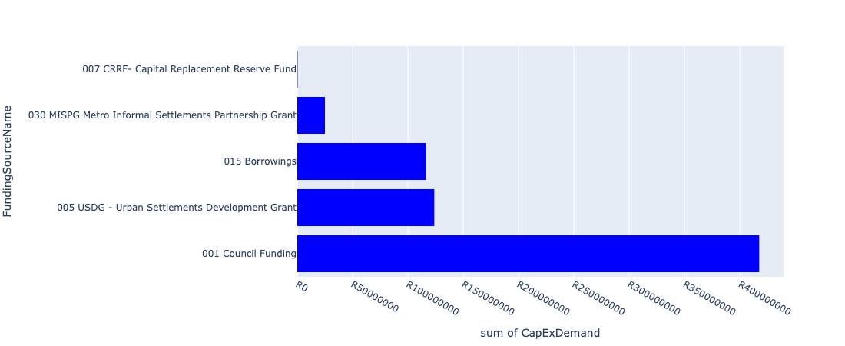

Figure 5.182: Ward 91 Departmental Requests

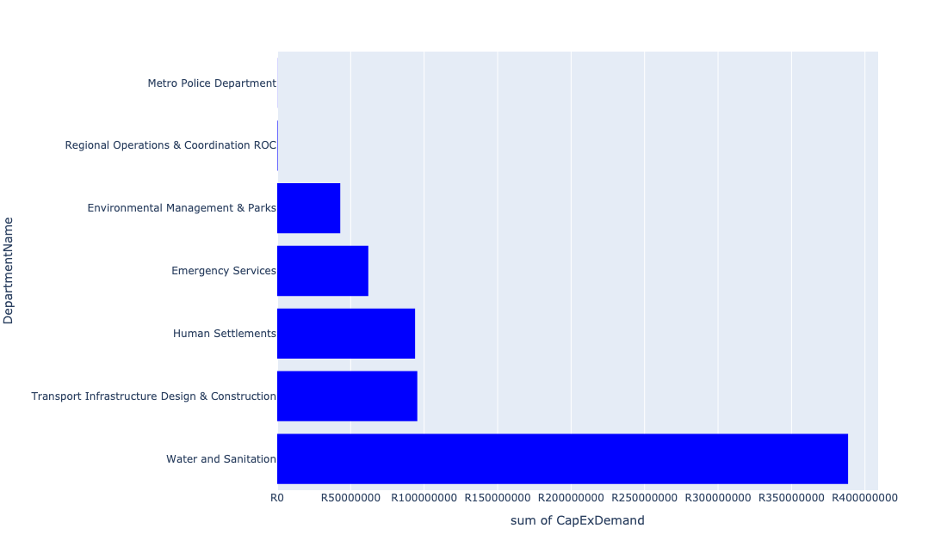

Table 5.91: Summary - Ward 91

|  |  |
| --- | --- |
| Item | Description |
| Total Capital Demand for Ward 91 - All Years | R672,319,365 Rank: 20 (1 = Highest) |
| Total Capital Demand for Ward 91 - MTREF | R331,356,159 Rank: 19 (1 = Highest) |
| Financial Years in which capital requirements are listed for Ward 91 | 2022, 2023, 2024, 2025, 2026, 2027, 2028, 2029 and 2030 |
| Financial Year with highest capital demand for Ward 91 | 2023 |
| Ward 91 intersecting feature used | Works Location |
| Total number of projects intersecting with Ward 91 | 24 Rank: 9 (1 = Highest) |

Table 5.92: All projects asking for budget in Ward 91

|  |  |  |  |
| --- | --- | --- | --- |
| Project ID | Project Name | Department | Project Budget |
| 712971915 | Revitalisation of the City-Development of Non-Motorised Transport Masterplan | Transport Infrastructure Design & Construction | R127,540 (0.02%) Budget spread across: 2027 |
| 712970748 | R6 Machinery and Equipment to ensure basic infrastructure reliability | Regional Operations & Coordination ROC | R337,759 (0.05%) Budget spread across: 2022 and 2023 |
| 712967133 | (712736) Fencing off Nature areas City Wide (Ecological Sensitive Purposes) | Environmental Management & Parks | R2,000,000 (0.30%) Budget spread across: 2022 and 2023 |
| 712975779 | (710865) Construction of roads & stormwater at Pretorius Park X20 | Human Settlements | R31,823,885 (4.73%) Budget spread across: 2022 and 2023 |
| 712975519 | Upgrade of Lion Camp at Rietvlei Nature Reserve | Environmental Management & Parks | R300,000 (0.04%) Budget spread across: 2022 |
| 712975440 | Sub-Project: TMPD Station - Pretorius Park | Metro Police Department | R92,686 (0.01%) Budget spread across: 2024 and 2025 |
| 712975233 | Development of Rietvlei conference Facility and Office park | Environmental Management & Parks | R552,617 (0.08%) Budget spread across: 2022, 2023, 2024 and 2025 |
| 712975230 | Provisioning of new taxi holding facility for the Wingate area. | Transport Infrastructure Design & Construction | R95,000,000 (14.13%) Budget spread across: 2022, 2023, 2024, 2025, 2026, 2027, 2028, 2029 and 2030 |
| 712975148 | (71212MOK) Mooikloof Bulk Outfall and connection to Moreleta system | Water and Sanitation | R71,500,000 (10.63%) Budget spread across: 2023, 2024, 2025 and 2026 |
| 712975103 | Upgrade of infrastructure at Rietvlei Nature Reserve | Environmental Management & Parks | R28,200,000 (4.19%) Budget spread across: 2022, 2023, 2024, 2025, 2026, 2027, 2028 and 2029 |
| 712975090 | (710411Y_R) Rietvlei PS and Rising system | Water and Sanitation | R31,000,000 (4.61%) Budget spread across: 2027, 2028 and 2029 |
| 712975089 | (710411Rit) 35 Ml/day Portion of Proposed Rietvlei WWTW | Water and Sanitation | R105,000,000 (15.62%) Budget spread across: 2029 and 2030 |
| 712975005 | Upgrade of infrastructure at Rietvlei Angling area | Environmental Management & Parks | R10,500,000 (1.56%) Budget spread across: 2022 and 2023 |
| 712974928 | (710863) Water provision - Pretorius Park | Human Settlements | R32,000,000 (4.76%) Budget spread across: 2022, 2023 and 2024 |
| 712974343 | (711921R) Rietvlei Water Purification Plant Refurbishment | Water and Sanitation | R50,000,000 (7.44%) Budget spread across: 2022, 2023 and 2024 |
| 712967795 | Construction of New Emergency Services Station Rietvlei | Emergency Services | R62,000,000 (9.22%) Budget spread across: 2028, 2029 and 2030 |
| 712967625 | (710863) Water provision - Garsfontein | Human Settlements | R0 (0.00%) Budget spread across: 2022 and 2023 |
| 712967271 | (712534U) Grootfontein Water Reservoir, tower and pipework | Water and Sanitation | R56,000,000 (8.33%) Budget spread across: 2022, 2023 and 2024 |
| 712967127 | (713040) Furniture and Equipment for offices, overnight accommodation and facilities within resorts | Environmental Management & Parks | R1,350,000 (0.20%) Budget spread across: 2022 and 2024 |
| 1472 | (712956) Upgrading of Garsfontein road | Transport Infrastructure Design & Construction | R211,467 (0.03%) Budget spread across: 2022, 2023, 2024, 2025 and 2026 |
| 1026 | (712534D) Mooikloof Reservoir and Bulk pipeline | Water and Sanitation | R75,000,000 (11.16%) Budget spread across: 2022, 2023, 2024 and 2025 |
| 712970769 | (710864) Sewer provision - Pretorius Park | Human Settlements | R30,000,000 (4.46%) Budget spread across: 2022, 2023 and 2024 |

## Ward 92

Figure 5.183: Ward 92 Funding Requests

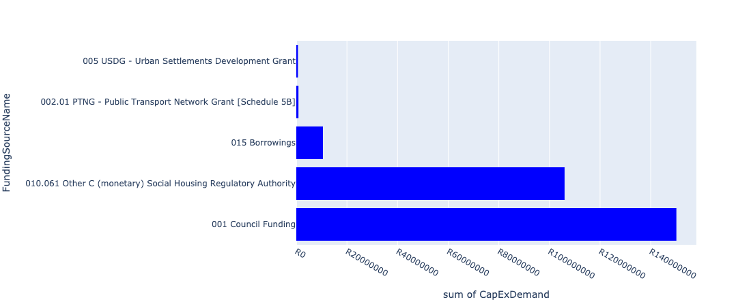

Figure 5.184: Ward 92 Departmental Requests

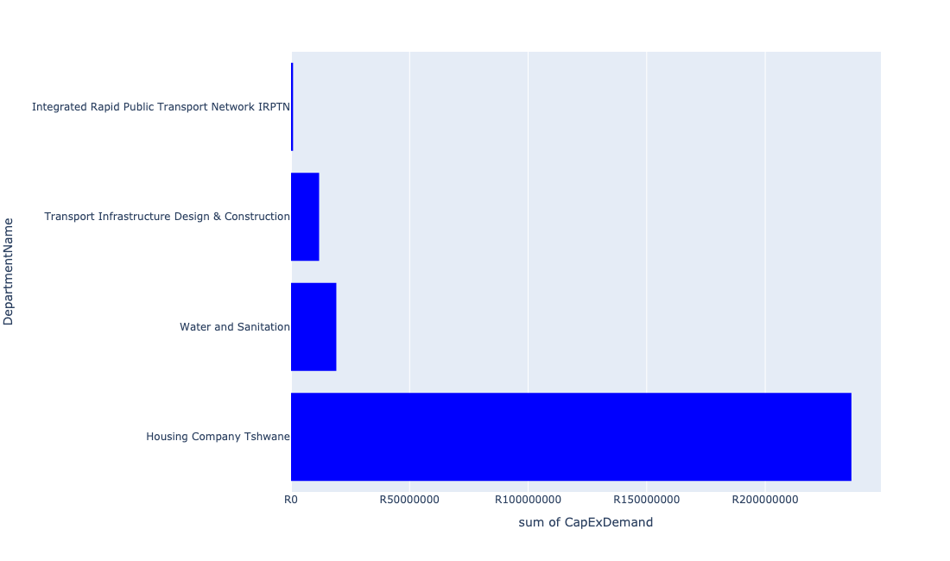

Table 5.92: Summary - Ward 92

|  |  |
| --- | --- |
| Item | Description |
| Total Capital Demand for Ward 92 - All Years | R157,159,266 Rank: 75 (1 = Highest) |
| Total Capital Demand for Ward 92 - MTREF | R145,606,666 Rank: 50 (1 = Highest) |
| Financial Years in which capital requirements are listed for Ward 92 | 2022, 2023, 2024, 2025, 2026, 2027, 2028, 2029 and 2030 |
| Financial Year with highest capital demand for Ward 92 | 2023 |
| Ward 92 intersecting feature used | Works Location |
| Total number of projects intersecting with Ward 92 | 12 Rank: 47 (1 = Highest) |

Table 5.93: All projects asking for budget in Ward 92

|  |  |  |  |
| --- | --- | --- | --- |
| Project ID | Project Name | Department | Project Budget |
| 712975019 | Decongestion of the inner city- Provisioning of New off street holding facilities within the inner city – CBD as per the 04 identified sites | Transport Infrastructure Design & Construction | R11,830,064 (7.53%) Budget spread across: 2022, 2023, 2024, 2025, 2026, 2027, 2028, 2029 and 2030 |
| 712967744 | (712591) Design, Supply, Installation, Commissioning and Operational Support Of Advanced Public Transport Management System (APTMS) | Integrated Rapid Public Transport Network IRPTN | R764,011 (0.49%) Budget spread across: 2022 |
| 712971915 | Revitalisation of the City-Development of Non-Motorised Transport Masterplan | Transport Infrastructure Design & Construction | R16,392 (0.01%) Budget spread across: 2027 |
| 712967743 | (712591) The Design, Supply, Installation, Operation and Maintenance of an automated fare Collection (AFC) System | Integrated Rapid Public Transport Network IRPTN | R86,882 (0.06%) Budget spread across: 2022, 2023, 2024 and 2025 |
| 712975573 | Stalshoogte | Housing Company Tshwane | R20,000,000 (12.73%) Budget spread across: 2022 and 2023 |
| 712975146 | (71212Arc) Upgrade existing Arcadia X8 Outfall Sewer | Water and Sanitation | R3,600,000 (2.29%) Budget spread across: 2023, 2024 and 2025 |
| 712974217 | Sunnyside Boundary Fence | Housing Company Tshwane | R650,000 (0.41%) Budget spread across: 2024 |
| 712974198 | Sunnyside: Construction of 264 Social Housing Units | Housing Company Tshwane | R215,690,817 (137.24%) Budget spread across: 2022, 2023 and 2024 |
| 712967840 | (712534H) Replacement and upgrading of bulk pipeline: Union Building - Jumbo Rally to Schoeman Street | Water and Sanitation | R15,500,002 (9.86%) Budget spread across: 2022, 2023 and 2024 |

## Ward 93

Figure 5.185: Ward 93 Funding Requests

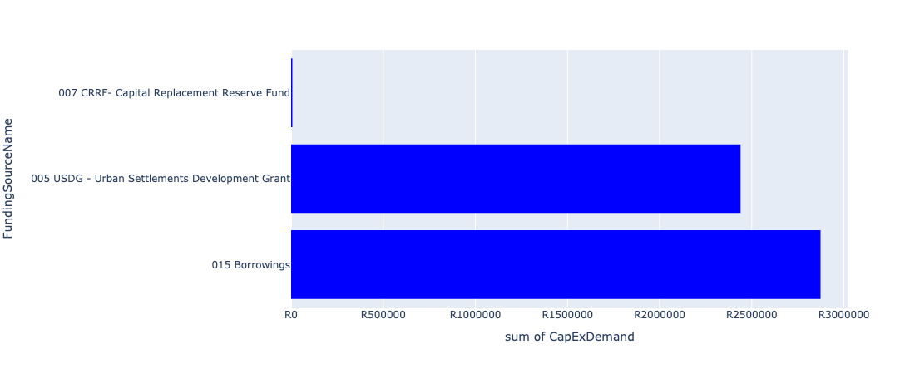

Figure 5.186: Ward 93 Departmental Requests

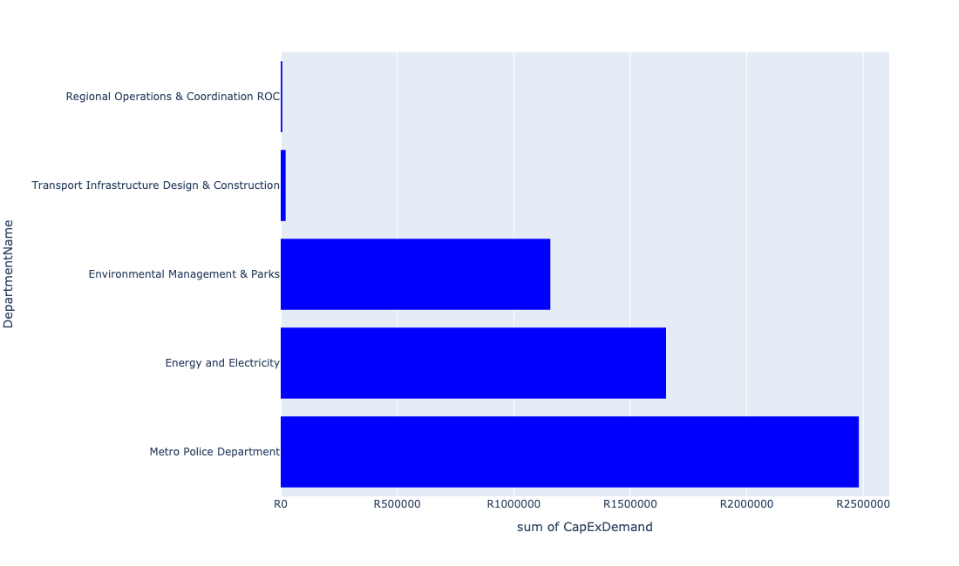

Table 5.93: Summary - Ward 93

|  |  |
| --- | --- |
| Item | Description |
| Total Capital Demand for Ward 93 - All Years | R5,319,655 Rank: 105 (1 = Highest) |
| Total Capital Demand for Ward 93 - MTREF | R2,930,548 Rank: 100 (1 = Highest) |
| Financial Years in which capital requirements are listed for Ward 93 | 2022, 2023, 2024, 2025, 2026 and 2027 |
| Financial Year with highest capital demand for Ward 93 | 2026 |
| Ward 93 intersecting feature used | Works Location |
| Total number of projects intersecting with Ward 93 | 9 Rank: 68 (1 = Highest) |

Table 5.94: All projects asking for budget in Ward 93

|  |  |  |  |
| --- | --- | --- | --- |
| Project ID | Project Name | Department | Project Budget |
| 712971915 | Revitalisation of the City-Development of Non-Motorised Transport Masterplan | Transport Infrastructure Design & Construction | R21,140 (0.40%) Budget spread across: 2027 |
| 712970748 | R6 Machinery and Equipment to ensure basic infrastructure reliability | Regional Operations & Coordination ROC | R6,747 (0.13%) Budget spread across: 2022 and 2023 |
| 712975437 | Sub-Project: TMPD Station - Mamelodi (Extension 10) | Metro Police Department | R2,480,945 (46.64%) Budget spread across: 2022, 2023 and 2024 |
| 712975391 | (712279) Mamelodi II 132/11kV Substation | Energy and Electricity | R1,653,681 (31.09%) Budget spread across: 2026 |
| 712969619 | (713044) Hatherley Cemetery | Environmental Management & Parks | R1,157,143 (21.75%) Budget spread across: 2022, 2023 and 2025 |

## Ward 94

Figure 5.187: Ward 94 Funding Requests

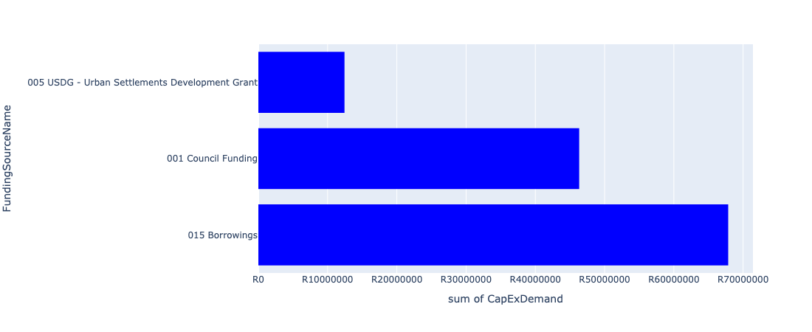

Figure 5.188: Ward 94 Departmental Requests

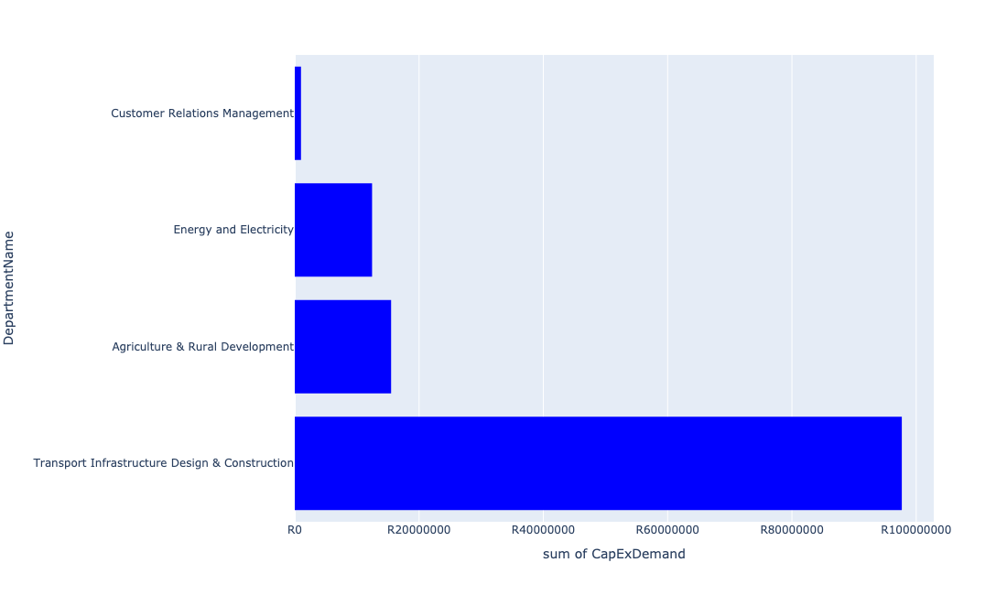

Table 5.94: Summary - Ward 94

|  |  |
| --- | --- |
| Item | Description |
| Total Capital Demand for Ward 94 - All Years | R126,618,800 Rank: 82 (1 = Highest) |
| Total Capital Demand for Ward 94 - MTREF | R79,998,302 Rank: 69 (1 = Highest) |
| Financial Years in which capital requirements are listed for Ward 94 | 2022, 2023, 2024, 2025, 2026, 2027, 2028, 2029 and 2030 |
| Financial Year with highest capital demand for Ward 94 | 2023 |
| Ward 94 intersecting feature used | Works Location |
| Total number of projects intersecting with Ward 94 | 8 Rank: 74 (1 = Highest) |

Table 5.95: All projects asking for budget in Ward 94

|  |  |  |  |
| --- | --- | --- | --- |
| Project ID | Project Name | Department | Project Budget |
| 712971915 | Revitalisation of the City-Development of Non-Motorised Transport Masterplan | Transport Infrastructure Design & Construction | R12,565 (0.01%) Budget spread across: 2027 |
| 712975536 | Refurbishment of Bodibeng customer care centre ( Soshanguve BB) | Customer Relations Management | R1,000,000 (0.79%) Budget spread across: 2023 |
| 712974542 | (712220) Soshanguve Block FF East Area 4 | Transport Infrastructure Design & Construction | R338,051 (0.27%) Budget spread across: 2022, 2023, 2024 and 2025 |
| 712974537 | (712220) Soshanguve Block FF East Area 3 | Transport Infrastructure Design & Construction | R52,000,000 (41.07%) Budget spread across: 2022, 2023, 2024 and 2025 |
| 712967304 | (713090) Development of Soshanguve Agricultural Park | Agriculture & Rural Development | R15,500,000 (12.24%) Budget spread across: 2022, 2023, 2024 and 2025 |
| 522 | (710657) Mabopane Station Modal Interchange | Transport Infrastructure Design & Construction | R45,330,692 (35.80%) Budget spread across: 2022, 2023, 2024, 2025, 2026, 2027, 2028, 2029 and 2030 |
| 712969084 | (712279) Soshanguve - JJ 132KV Power Line | Energy and Electricity | R12,437,491 (9.82%) Budget spread across: 2022, 2023 and 2024 |

## Ward 95

Figure 5.189: Ward 95 Funding Requests

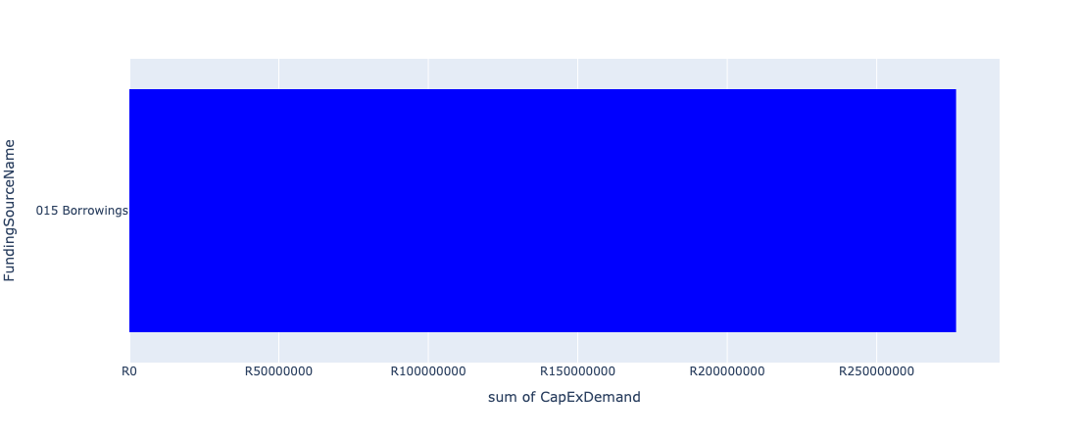

Figure 5.190: Ward 95 Departmental Requests

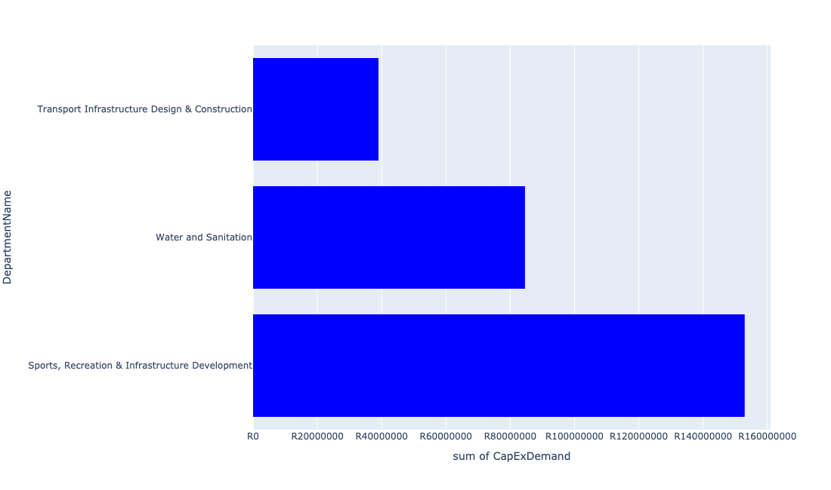

Table 5.95: Summary - Ward 95

|  |  |
| --- | --- |
| Item | Description |
| Total Capital Demand for Ward 95 - All Years | R276,546,067 Rank: 51 (1 = Highest) |
| Total Capital Demand for Ward 95 - MTREF | R92,211,886 Rank: 61 (1 = Highest) |
| Financial Years in which capital requirements are listed for Ward 95 | 2022, 2023, 2024, 2025, 2026, 2027, 2028, 2029, 2030 and 2031 |
| Financial Year with highest capital demand for Ward 95 | 2027 |
| Ward 95 intersecting feature used | Works Location |
| Total number of projects intersecting with Ward 95 | 7 Rank: 81 (1 = Highest) |

Table 5.96: All projects asking for budget in Ward 95

|  |  |  |  |
| --- | --- | --- | --- |
| Project ID | Project Name | Department | Project Budget |
| 712971915 | Revitalisation of the City-Development of Non-Motorised Transport Masterplan | Transport Infrastructure Design & Construction | R274,572 (0.10%) Budget spread across: 2027 |
| 712967139 | (712911) New Eersterust library | Sports, Recreation & Infrastructure Development | R38,938,850 (14.08%) Budget spread across: 2023 and 2024 |
| 876 | (712219) Flooding Backlogs: Stinkwater & New Eersterust Area | Transport Infrastructure Design & Construction | R26,042,469 (9.42%) Budget spread across: 2022, 2023, 2024, 2025, 2026, 2027, 2028, 2029 and 2030 |
| 582 | (710878N) Sewer reticulation Stinkwater Ext 2 to 8 | Water and Sanitation | R84,590,217 (30.59%) Budget spread across: 2023, 2024, 2025 and 2027 |
| 712967124 | (712941) Greening of Sports fields | Sports, Recreation & Infrastructure Development | R73,999,958 (26.76%) Budget spread across: 2022, 2023, 2024, 2025, 2026, 2027, 2028, 2029, 2030 and 2031 |
| 625 | (711264) Major S/ Water Drainage System: Matenteng | Transport Infrastructure Design & Construction | R12,700,000 (4.59%) Budget spread across: 2023 and 2024 |
| 14 | New Eersterust/Stinkwater multi-purpose sport facility | Sports, Recreation & Infrastructure Development | R40,000,000 (14.46%) Budget spread across: 2027 and 2028 |

## Ward 96

Figure 5.191: Ward 96 Funding Requests

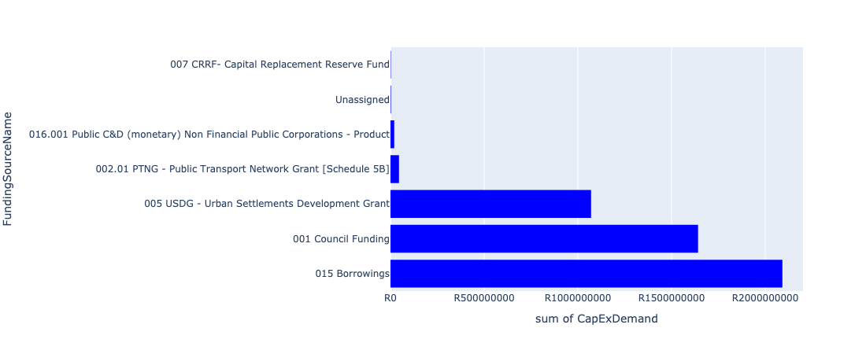

Figure 5.192: Ward 96 Departmental Requests

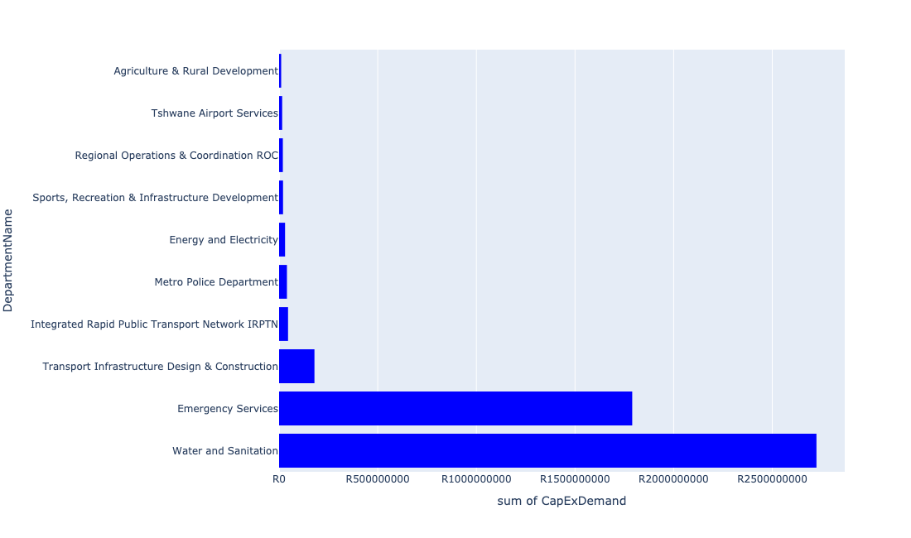

Table 5.96: Summary - Ward 96

|  |  |
| --- | --- |
| Item | Description |
| Total Capital Demand for Ward 96 - All Years | R4,848,741,819 Rank: 1 (1 = Highest) |
| Total Capital Demand for Ward 96 - MTREF | R972,968,812 Rank: 3 (1 = Highest) |
| Financial Years in which capital requirements are listed for Ward 96 | 2022, 2023, 2024, 2025, 2026, 2027, 2028, 2029, 2030, 2031, 2032, 2033 and 2034 |
| Financial Year with highest capital demand for Ward 96 | 2028 |
| Ward 96 intersecting feature used | Works Location |
| Total number of projects intersecting with Ward 96 | 34 Rank: 4 (1 = Highest) |

Table 5.97: All projects asking for budget in Ward 96

|  |  |  |  |
| --- | --- | --- | --- |
| Project ID | Project Name | Department | Project Budget |
| 712971915 | Revitalisation of the City-Development of Non-Motorised Transport Masterplan | Transport Infrastructure Design & Construction | R630,363 (0.01%) Budget spread across: 2027 |
| 712974614 | Upgrading of a tributary of the Sand Spruit, Rosslyn x 17 | Transport Infrastructure Design & Construction | R2,473,172 (0.05%) Budget spread across: 2025, 2026 and 2027 |
| 712967745 | (712591) Planning and Design of BRT Projects | Integrated Rapid Public Transport Network IRPTN | R45,372,695 (0.94%) Budget spread across: 2022, 2023, 2024 and 2025 |
| 712975531 | Construction of 90 meters safety overshoot | Tshwane Airport Services | R15,564,339 (0.32%) Budget spread across: 2022, 2023 and 2024 |
| 712975141 | (712121NDO3) New Doornpoort 5 Outfall Sewer (3/3) | Water and Sanitation | R3,000,000 (0.06%) Budget spread across: 2023, 2024 and 2025 |
| 712975140 | (712121NDO2) New Doornpoort 5 Outfall Sewer (2/3) | Water and Sanitation | R24,000,000 (0.49%) Budget spread across: 2023, 2024 and 2025 |
| 712975139 | (712121NDO1) New Doornpoort 5 Outfall Sewer (1/3) | Water and Sanitation | R4,000,000 (0.08%) Budget spread across: 2023, 2024 and 2025 |
| 712975118 | (712534ND) New Doornpoort- West1 Reservoir | Water and Sanitation | R65,000,000 (1.34%) Budget spread across: 2023, 2024, 2025, 2026 and 2027 |
| 712974538 | (710411D2) Rooiwal WWTW Phase 3: 50Ml/d extension | Water and Sanitation | R750,000,000 (15.47%) Budget spread across: 2024, 2025, 2026, 2027 and 2028 |
| 712974480 | RIMM: BON ACCORD QUARRY: PERIMETER FENCE | Regional Operations & Coordination ROC | R2,000,000 (0.04%) Budget spread across: 2022 |
| 712974448 | (710411D) Rooiwal WWTW Phase 2 : 80Ml/d Extensions and Extension of Sludge facility | Water and Sanitation | R1,715,000,000 (35.37%) Budget spread across: 2022, 2023, 2024, 2025, 2026, 2027, 2028 and 2029 |
| 712974347 | (714039) RIMM: Bon Accord | Regional Operations & Coordination ROC | R17,000,000 (0.35%) Budget spread across: 2022 |
| 712974282 | Upgrading of the Amandelboom low-level crossing in the Mimosa Spruit, Doornpoort | Transport Infrastructure Design & Construction | R21,000,000 (0.43%) Budget spread across: 2026, 2027 and 2028 |
| 712974173 | Major Stormwater Network 3B in Veronica Street, Montana | Transport Infrastructure Design & Construction | R51,208 (0.00%) Budget spread across: 2026 and 2027 |
| 712974167 | Upgrading of Stormwater network from Arbitus to Klippan Road, Montana Tuine | Transport Infrastructure Design & Construction | R29,800,000 (0.61%) Budget spread across: 2025, 2026 and 2027 |
| 712967285 | (711335DP) Roodeplaat WTP to Montana Reservoir bulk pipe line | Water and Sanitation | R24,903,450 (0.51%) Budget spread across: 2023, 2024 and 2025 |
| 712967085 | (714009) New Electricity Depot Region 2 | Energy and Electricity | R6,000,000 (0.12%) Budget spread across: 2022 |
| 712967069 | Establishment of TMPD Training Academy | Metro Police Department | R39,720,136 (0.82%) Budget spread across: 2022, 2023 and 2024 |
| 712967042 | Development of Rooiwal Agricultural Park | Agriculture & Rural Development | R10,500,000 (0.22%) Budget spread across: 2022, 2023, 2024 and 2025 |
| 1342 | (712920) Rainbow Junction and Rehabilitation of the Apies River | Transport Infrastructure Design & Construction | R13,242,771 (0.27%) Budget spread across: 2022, 2023, 2024, 2025 and 2026 |
| 631 | (711268) Montana Spruit: Channel Improvements | Transport Infrastructure Design & Construction | R112,000,000 (2.31%) Budget spread across: 2022, 2023, 2024, 2025, 2026, 2027, 2028, 2029 and 2030 |
| 445 | (710411D) Rooiwal WWTW Phase 1: Upgrading of Existing Infrastructure | Water and Sanitation | R138,000,000 (2.85%) Budget spread across: 2022 and 2023 |
| 183 | Construction of a Specialist Emergency Services Training Academy | Emergency Services | R1,790,000,000 (36.92%) Budget spread across: 2026, 2027, 2028, 2029, 2030, 2031, 2032, 2033 and 2034 |
| 712974145 | (712862) Demin Plant | Energy and Electricity | R4,000,000 (0.08%) Budget spread across: 2022 |
| 712974142 | (712862) Digital Valve Positioners | Energy and Electricity | R15,000,000 (0.31%) Budget spread across: 2022 |
| 712974141 | (712862) LED Digital Display | Energy and Electricity | R2,700,000 (0.06%) Budget spread across: 2022 |
| 712974140 | (712862) Oil Burner Spares | Energy and Electricity | R1,500,000 (0.03%) Budget spread across: 2022 |
| 712974139 | (712862) Oxygen Analysers | Energy and Electricity | R1,000,000 (0.02%) Budget spread across: 2022 |
| 712973855 | Rooiwal Community Centre and Swimming pool Upgrade of facilities, Security and Access control | Sports, Recreation & Infrastructure Development | R20,000,000 (0.41%) Budget spread across: 2027 and 2028 |

## Ward 97

Figure 5.193: Ward 97 Funding Requests

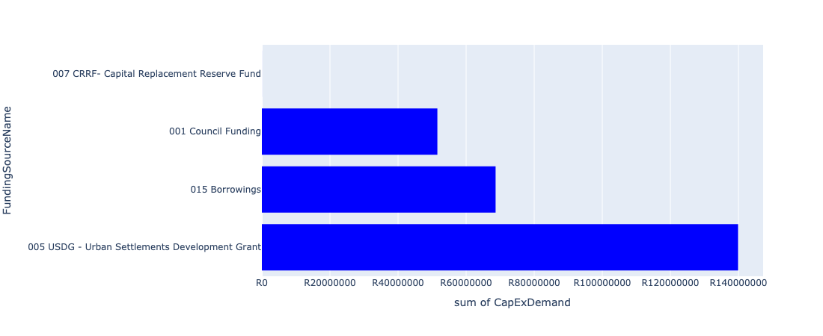

Figure 5.194: Ward 97 Departmental Requests

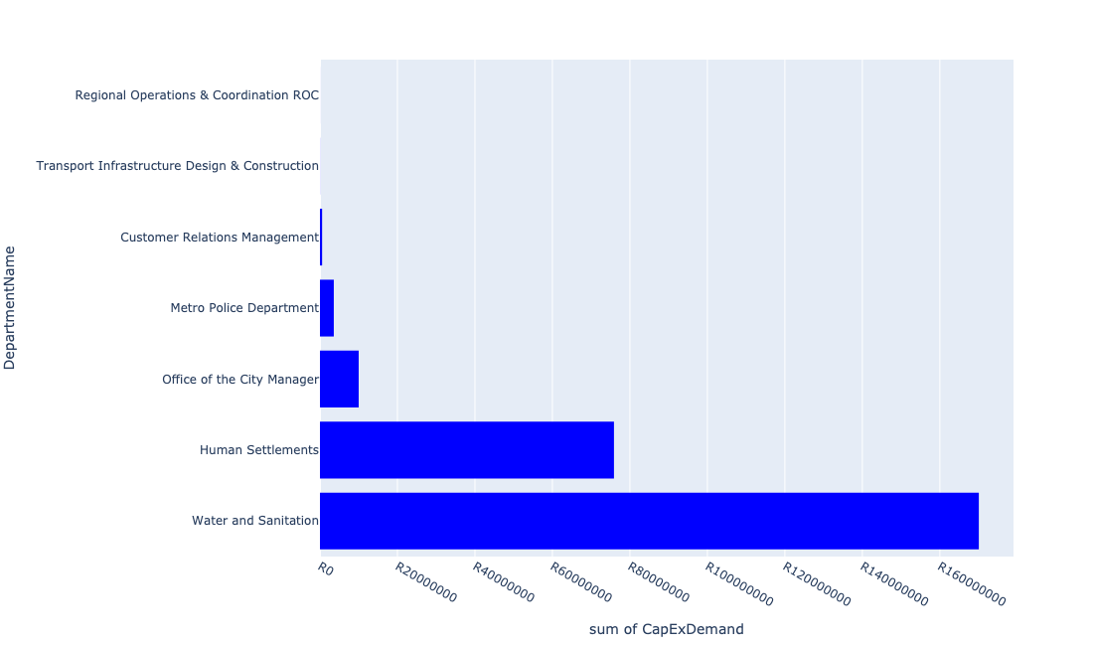

Table 5.97: Summary - Ward 97

|  |  |
| --- | --- |
| Item | Description |
| Total Capital Demand for Ward 97 - All Years | R260,114,001 Rank: 52 (1 = Highest) |
| Total Capital Demand for Ward 97 - MTREF | R214,018,720 Rank: 33 (1 = Highest) |
| Financial Years in which capital requirements are listed for Ward 97 | 2022, 2023, 2024, 2025, 2026 and 2027 |
| Financial Year with highest capital demand for Ward 97 | 2022 |
| Ward 97 intersecting feature used | Works Location |
| Total number of projects intersecting with Ward 97 | 17 Rank: 20 (1 = Highest) |

Table 5.98: All projects asking for budget in Ward 97

|  |  |  |  |
| --- | --- | --- | --- |
| Project ID | Project Name | Department | Project Budget |
| 712971915 | Revitalisation of the City-Development of Non-Motorised Transport Masterplan | Transport Infrastructure Design & Construction | R8,636 (0.00%) Budget spread across: 2027 |
| 712970748 | R6 Machinery and Equipment to ensure basic infrastructure reliability | Regional Operations & Coordination ROC | R8,865 (0.00%) Budget spread across: 2022 and 2023 |
| 712975437 | Sub-Project: TMPD Station - Mamelodi (Extension 10) | Metro Police Department | R3,574,005 (1.37%) Budget spread across: 2022, 2023 and 2024 |
| 712975546 | Construction of new Alaska and Stoffel Park customer care centre | Customer Relations Management | R555,623 (0.21%) Budget spread across: 2027 |
| 712967295 | (711335ML) Mamelodi R5 feeder main relocation | Water and Sanitation | R17,062,045 (6.56%) Budget spread across: 2023, 2024, 2025 and 2026 |
| 992 | (712518) Flooding backlog: Drainage canals along Hans Strydom Dr, Mamelodi x 4 and 5 | Transport Infrastructure Design & Construction | R15,128 (0.01%) Budget spread across: 2022, 2023 and 2024 |
| 712970780 | (710863) Mamelodi X11 | Human Settlements | R0 (0.00%) Budget spread across: 2022 |
| 712970774 | (710864) Mamelodi X11 | Human Settlements | R14,889,700 (5.72%) Budget spread across: 2022 |
| 712974901 | Mamelodi Hostels (TRUS) | Human Settlements | R61,000,000 (23.45%) Budget spread across: 2022 |
| 712967765 | (712970) Mamelodi Ext 11 water (Bulk and reticulation) and sanitation services | Water and Sanitation | R153,000,000 (58.82%) Budget spread across: 2022, 2023, 2024, 2025 and 2026 |
| 712969057 | (712533) (VPUU) Mamelodi East Multi-purpose (Indoor Sports) Centre | Office of the City Manager | R10,000,000 (3.84%) Budget spread across: 2022 |

## Ward 98

Figure 5.195: Ward 98 Funding Requests

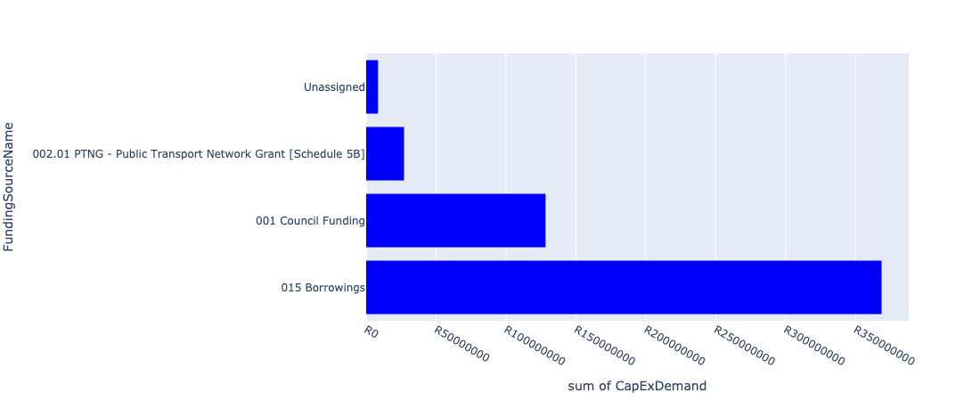

Figure 5.196: Ward 98 Departmental Requests

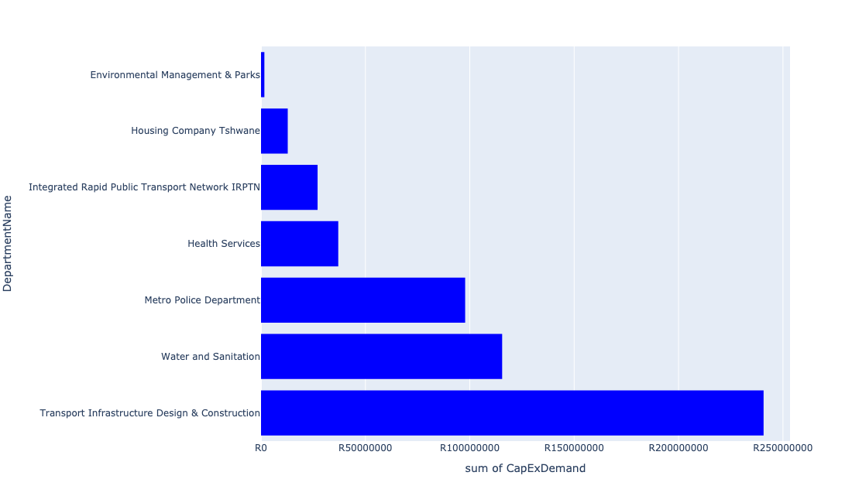

Table 5.98: Summary - Ward 98

|  |  |
| --- | --- |
| Item | Description |
| Total Capital Demand for Ward 98 - All Years | R532,503,264 Rank: 28 (1 = Highest) |
| Total Capital Demand for Ward 98 - MTREF | R243,167,622 Rank: 27 (1 = Highest) |
| Financial Years in which capital requirements are listed for Ward 98 | 2022, 2023, 2024, 2025, 2026, 2027, 2028, 2029, 2030 and 2031 |
| Financial Year with highest capital demand for Ward 98 | 2024 |
| Ward 98 intersecting feature used | Works Location |
| Total number of projects intersecting with Ward 98 | 17 Rank: 20 (1 = Highest) |

Table 5.99: All projects asking for budget in Ward 98

|  |  |  |  |
| --- | --- | --- | --- |
| Project ID | Project Name | Department | Project Budget |
| 712971915 | Revitalisation of the City-Development of Non-Motorised Transport Masterplan | Transport Infrastructure Design & Construction | R58,753 (0.01%) Budget spread across: 2027 |
| 712967745 | (712591) Planning and Design of BRT Projects | Integrated Rapid Public Transport Network IRPTN | R27,094,638 (5.09%) Budget spread across: 2022, 2023, 2024 and 2025 |
| 712975456 | Upgrade of infrastructure of Magalies mountain | Environmental Management & Parks | R1,606,363 (0.30%) Budget spread across: 2022, 2023, 2024, 2025, 2026, 2027, 2028, 2029, 2030 and 2031 |
| 712967069 | Establishment of TMPD Training Academy | Metro Police Department | R80,279,864 (15.08%) Budget spread across: 2022, 2023 and 2024 |
| 712975773 | (712900) Upgrading of existing Tactical Training facilities (Akasia) | Metro Police Department | R17,500,000 (3.29%) Budget spread across: 2022, 2023 and 2024 |
| 712975147 | (71212DRTC) Dorandia, Rosslyn, Theresa Park, Clarina Outfall Sewer upgrade | Water and Sanitation | R115,500,000 (21.69%) Budget spread across: 2023, 2024, 2025, 2026 and 2027 |
| 712974497 | Upgrading of internal access roads from gravel to asphalt and storm water control in Klerksoord Area | Transport Infrastructure Design & Construction | R5,000,000 (0.94%) Budget spread across: 2022, 2023 and 2024 |
| 712974493 | Construction of major roads and stormwater networks along all roads in Klerksoord AH | Transport Infrastructure Design & Construction | R135,000,000 (25.35%) Budget spread across: 2023, 2024, 2025 and 2029 |
| 712974459 | Construction of Major Stormwater Network 10A and 10B, Willem Cruywagen Street, Theresapark | Transport Infrastructure Design & Construction | R9,000,000 (1.69%) Budget spread across: 2027, 2028 and 2029 |
| 712967191 | Animal Impounding Station in Tshwane Northern Areas | Health Services | R37,000,000 (6.95%) Budget spread across: 2025, 2026, 2027 and 2028 |
| 585 | (710902) Rehabilitation Of Roads | Transport Infrastructure Design & Construction | R74,434,225 (13.98%) Budget spread across: 2022, 2023, 2024, 2025, 2026, 2027, 2028, 2029 and 2030 |
| 712973996 | Clarina Residential Estates (160 Units) Alternative Accommodation | Housing Company Tshwane | R12,800,000 (2.40%) Budget spread across: 2023 |
| 712973710 | Construction of a ±900m stormwater system in Karenpark (Akasia SMP - Network 3A) 4 | Transport Infrastructure Design & Construction | R17,229,421 (3.24%) Budget spread across: 2027, 2028, 2029 and 2030 |

## Ward 99

Figure 5.197: Ward 99 Funding Requests

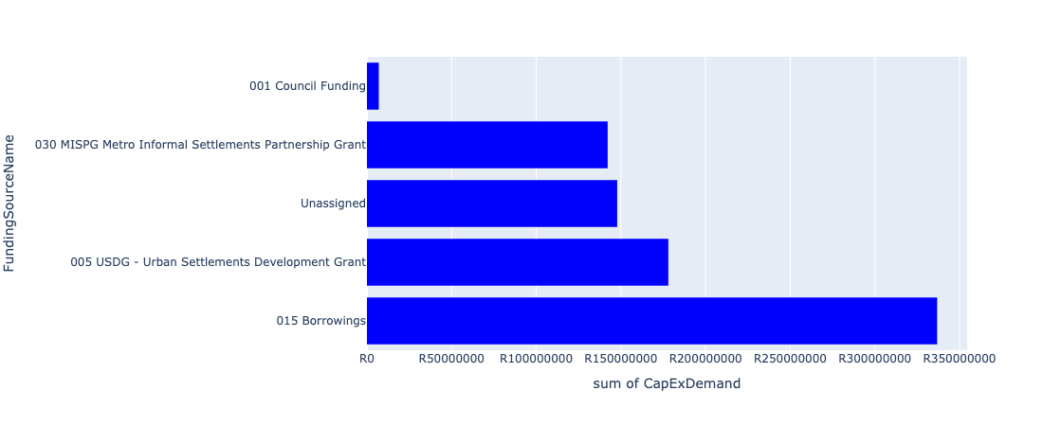

Figure 5.198: Ward 99 Departmental Requests

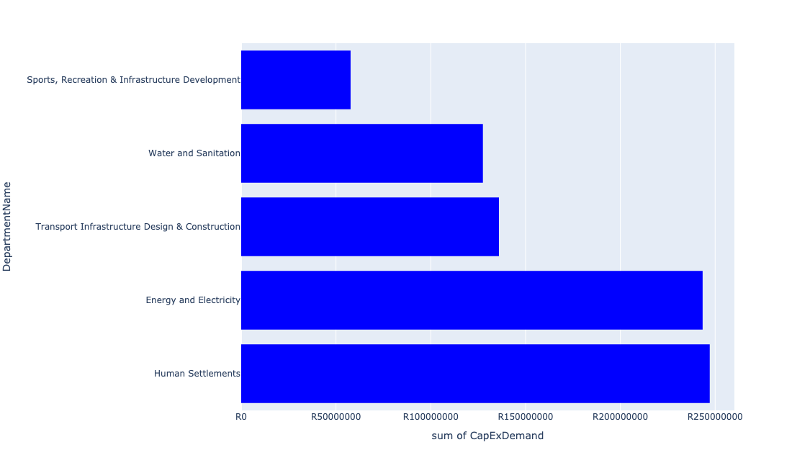

Table 5.99: Summary - Ward 99

|  |  |
| --- | --- |
| Item | Description |
| Total Capital Demand for Ward 99 - All Years | R784,104,820 Rank: 17 (1 = Highest) |
| Total Capital Demand for Ward 99 - MTREF | R553,151,175 Rank: 9 (1 = Highest) |
| Financial Years in which capital requirements are listed for Ward 99 | 2022, 2023, 2024, 2025, 2026, 2027, 2028, 2029 and 2030 |
| Financial Year with highest capital demand for Ward 99 | 2024 |
| Ward 99 intersecting feature used | Works Location |
| Total number of projects intersecting with Ward 99 | 19 Rank: 15 (1 = Highest) |

Table 5.100: All projects asking for budget in Ward 99

|  |  |  |  |
| --- | --- | --- | --- |
| Project ID | Project Name | Department | Project Budget |
| 712971915 | Revitalisation of the City-Development of Non-Motorised Transport Masterplan | Transport Infrastructure Design & Construction | R953,645 (0.12%) Budget spread across: 2027 |
| 712975445 | Creative Hub and Incubation (Region 5), Ward 100 Refilwe Community Hall. | Sports, Recreation & Infrastructure Development | R10,000,000 (1.28%) Budget spread across: 2026 |
| 712975341 | (712279) Refilwe 132/11kV Substation | Energy and Electricity | R100,000,000 (12.75%) Budget spread across: 2023 and 2024 |
| 712975145 | (712121NHS) New Hammanskraal South Outfall Sewer (2/2) | Water and Sanitation | R7,000,000 (0.89%) Budget spread across: 2028, 2029 and 2030 |
| 712974384 | (710864) Sewer reticulation - Refilwe X10 | Human Settlements | R38,700,900 (4.94%) Budget spread across: 2022, 2023 and 2024 |
| 712974380 | (710863) Water provision - Refilwe ext 10 | Human Settlements | R30,235,473 (3.86%) Budget spread across: 2022, 2023 and 2024 |
| 712967178 | (712916) Upgrade Refilwe Stadium | Sports, Recreation & Infrastructure Development | R47,700,000 (6.08%) Budget spread across: 2022 and 2023 |
| 453 | (710411R) New Lewzene Waste Water Treatment Works (10Ml/d) | Water and Sanitation | R55,000,000 (7.01%) Budget spread across: 2023, 2024 and 2025 |
| 441 | (710411L) Cullinan/ Refilwe WWTW: Effluent Pump Station, pipeline and 2 Ml/d extension | Water and Sanitation | R65,500,000 (8.35%) Budget spread across: 2023, 2024, 2025 and 2026 |
| 712967595 | (710865) Construction of roads & stormwater - Refilwe Manor X9 | Human Settlements | R130,000,000 (16.58%) Budget spread across: 2022, 2023 and 2024 |
| 712972962 | (710863) Water provision - Refilwe X7 | Human Settlements | R22,714,802 (2.90%) Budget spread across: 2022, 2023 and 2024 |
| 712972960 | (710864) Sewer reticulation - Refilwe X7 | Human Settlements | R20,500,000 (2.61%) Budget spread across: 2022 and 2023 |
| 712969598 | (710863) Refilwe Manor 10ml reservoir | Human Settlements | R5,000,000 (0.64%) Budget spread across: 2022 |
| 712969561 | (712944) Upgrading of roads and stormwater systems in Refilwe | Transport Infrastructure Design & Construction | R135,000,000 (17.22%) Budget spread across: 2022, 2023, 2024, 2025, 2026, 2027, 2028, 2029 and 2030 |
| 712969195 | (710556) Region 5 (Public Lighting) | Energy and Electricity | R68,000,000 (8.67%) Budget spread across: 2023, 2024, 2025, 2026, 2027, 2028, 2029 and 2030 |
| 712969125 | (710178) Electricity for All - Region 5 | Energy and Electricity | R75,400,000 (9.62%) Budget spread across: 2022, 2023, 2024 and 2025 |

## Ward 100

Figure 5.199: Ward 100 Funding Requests

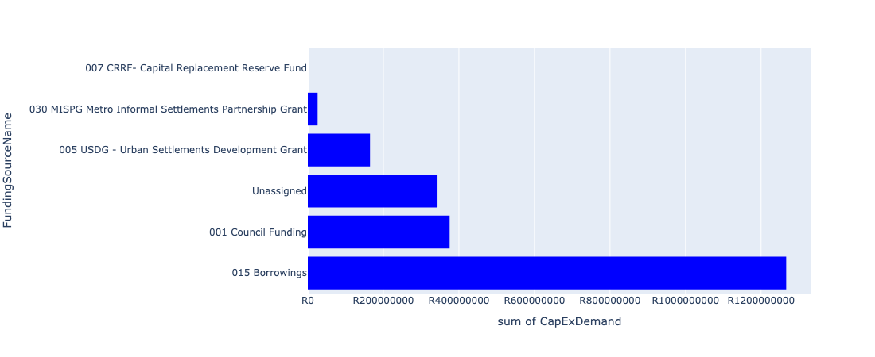

Figure 5.200: Ward 100 Departmental Requests

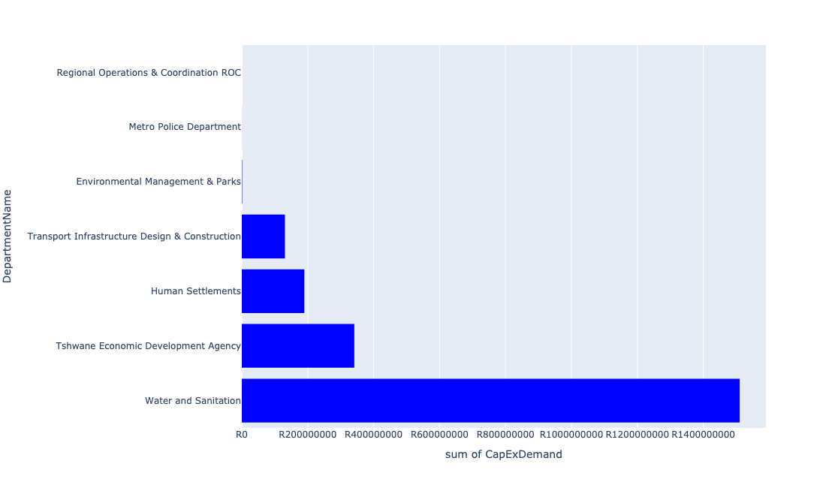

Table 5.100: Summary - Ward 100

|  |  |
| --- | --- |
| Item | Description |
| Total Capital Demand for Ward 100 - All Years | R1,942,013,476 Rank: 3 (1 = Highest) |
| Total Capital Demand for Ward 100 - MTREF | R917,894,761 Rank: 4 (1 = Highest) |
| Financial Years in which capital requirements are listed for Ward 100 | 2022, 2023, 2024, 2025, 2026, 2027, 2028, 2029 and 2030 |
| Financial Year with highest capital demand for Ward 100 | 2022 |
| Ward 100 intersecting feature used | Works Location |
| Total number of projects intersecting with Ward 100 | 26 Rank: 8 (1 = Highest) |

Table 5.101: All projects asking for budget in Ward 100

|  |  |  |  |
| --- | --- | --- | --- |
| Project ID | Project Name | Department | Project Budget |
| 712971915 | Revitalisation of the City-Development of Non-Motorised Transport Masterplan | Transport Infrastructure Design & Construction | R904,429 (0.05%) Budget spread across: 2027 |
| 712970748 | R6 Machinery and Equipment to ensure basic infrastructure reliability | Regional Operations & Coordination ROC | R0 (0.00%) Budget spread across: 2022 and 2023 |
| 712975437 | Sub-Project: TMPD Station - Mamelodi (Extension 10) | Metro Police Department | R185,098 (0.01%) Budget spread across: 2022, 2023 and 2024 |
| 712969619 | (713044) Hatherley Cemetery | Environmental Management & Parks | R1,157,143 (0.06%) Budget spread across: 2022, 2023 and 2025 |
| 712975031 | (712121FR) Future Rayton Bulk Outfall Sewer | Water and Sanitation | R32,500,000 (1.67%) Budget spread across: 2023, 2024, 2025 and 2026 |
| 712974383 | (710864) Sewer reticulation - Pienaarspoort | Human Settlements | R66,800,000 (3.44%) Budget spread across: 2022 and 2023 |
| 712974381 | (710863) Water provision - Pienaarspoort Extension 20 | Human Settlements | R46,200,000 (2.38%) Budget spread across: 2022 and 2023 |
| 712967289 | (711335OR) New Kameelfontein Down feeder Main pipeline (Bulk supply from the existing Baviaanspoort Reservoir to the east and north areas of Roodeplaat Dam) | Water and Sanitation | R35,000,000 (1.80%) Budget spread across: 2022, 2023 and 2024 |
| 1456 | (712945) Upgrading of roads and stormwater systems in Rayton | Transport Infrastructure Design & Construction | R55,000,000 (2.83%) Budget spread across: 2022, 2023 and 2024 |
| 267 | (710026) Replacement Of Worn-Out Water Network Pipes | Water and Sanitation | R1,443,000,000 (74.30%) Budget spread across: 2022, 2023, 2024, 2025, 2026, 2027, 2028, 2029 and 2030 |
| 712974053 | (710868) Expropriation of servitude at Pienaarspoort X21 | Human Settlements | R10,000,000 (0.51%) Budget spread across: 2022 |
| 712974041 | Tshwane Agro-Processing Hub | Tshwane Economic Development Agency | R341,306,806 (17.57%) Budget spread across: 2022 |
| 712970776 | (710864) Sewer provision - Pienaarspoort X20 | Human Settlements | R66,800,000 (3.44%) Budget spread across: 2022, 2023 and 2024 |
| 712969571 | (712946) Upgrading of roads and stormwater systems in Cullinan - Phase 1 | Transport Infrastructure Design & Construction | R75,000,000 (3.86%) Budget spread across: 2022, 2023, 2025 and 2026 |

## Ward 101

Figure 5.201: Ward 101 Funding Requests

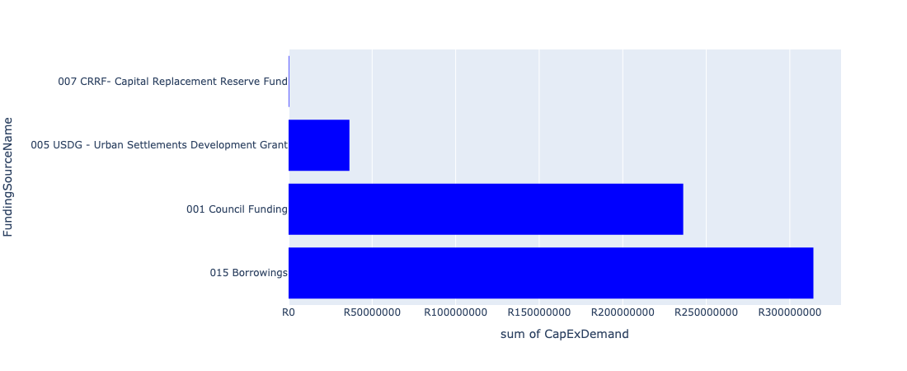

Figure 5.202: Ward 101 Departmental Requests

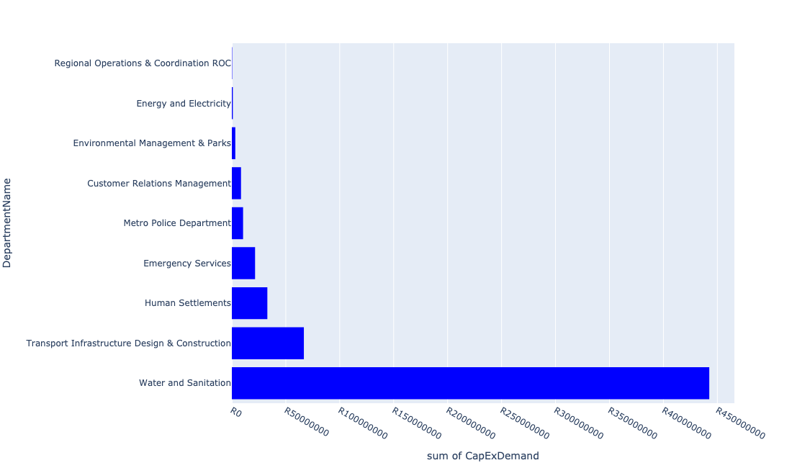

Table 5.101: Summary - Ward 101

|  |  |
| --- | --- |
| Item | Description |
| Total Capital Demand for Ward 101 - All Years | R576,174,114 Rank: 24 (1 = Highest) |
| Total Capital Demand for Ward 101 - MTREF | R170,339,228 Rank: 44 (1 = Highest) |
| Financial Years in which capital requirements are listed for Ward 101 | 2022, 2023, 2024, 2025, 2026, 2027, 2028, 2029 and 2030 |
| Financial Year with highest capital demand for Ward 101 | 2030 |
| Ward 101 intersecting feature used | Works Location |
| Total number of projects intersecting with Ward 101 | 19 Rank: 15 (1 = Highest) |

Table 5.102: All projects asking for budget in Ward 101

|  |  |  |  |
| --- | --- | --- | --- |
| Project ID | Project Name | Department | Project Budget |
| 712971915 | Revitalisation of the City-Development of Non-Motorised Transport Masterplan | Transport Infrastructure Design & Construction | R272,543 (0.05%) Budget spread across: 2027 |
| 712970748 | R6 Machinery and Equipment to ensure basic infrastructure reliability | Regional Operations & Coordination ROC | R318,772 (0.06%) Budget spread across: 2022 and 2023 |
| 712975779 | (710865) Construction of roads & stormwater at Pretorius Park X20 | Human Settlements | R32,913,725 (5.71%) Budget spread across: 2022 and 2023 |
| 712975440 | Sub-Project: TMPD Station - Pretorius Park | Metro Police Department | R10,419,725 (1.81%) Budget spread across: 2024 and 2025 |
| 1472 | (712956) Upgrading of Garsfontein road | Transport Infrastructure Design & Construction | R284,812 (0.05%) Budget spread across: 2022, 2023, 2024, 2025 and 2026 |
| 712975542 | Construction of Pretorius park customer care centre | Customer Relations Management | R8,497,143 (1.47%) Budget spread across: 2030 |
| 712975386 | (712279) Wapadrand 132/11kV Substation | Energy and Electricity | R905,424 (0.16%) Budget spread across: 2028 and 2029 |
| 712975121 | (712534Do) Donkerhoek LL Res (Phase 2) | Water and Sanitation | R55,000,000 (9.55%) Budget spread across: 2029 and 2030 |
| 712975101 | (711335GL) Extension of existing pipe to Zwartkoppies Reservoir +Res (Phase 1) | Water and Sanitation | R36,000,000 (6.25%) Budget spread across: 2023, 2024, 2025 and 2026 |
| 712975095 | (710411Y_O) Olympus booster Pump station and pipework | Water and Sanitation | R12,000,000 (2.08%) Budget spread across: 2025 and 2026 |
| 712975066 | Upgrade of PTA East Cemetery | Environmental Management & Parks | R3,200,000 (0.56%) Budget spread across: 2025 and 2026 |
| 712974468 | Enlargement of bridges and spruit channel improvements of the Zwavelpoort Spruit, Zwavelkloof Estate | Transport Infrastructure Design & Construction | R51,200,000 (8.89%) Budget spread across: 2025, 2026 and 2027 |
| 712974283 | Spruit channel improvements and rehabilitation of the Tweefontein Spruit in Boardwalk Meander | Transport Infrastructure Design & Construction | R7,000,000 (1.21%) Budget spread across: 2026 and 2027 |
| 712974168 | Upgrading of Major Stormwater Drainage System in Lipizzaner Road, Tijger Valley | Transport Infrastructure Design & Construction | R8,000,000 (1.39%) Budget spread across: 2025, 2026 and 2027 |
| 712967794 | Construction of New Emergency Services Station Shere / The Willows | Emergency Services | R21,532,958 (3.74%) Budget spread across: 2025, 2026 and 2027 |
| 246 | (710023) Lengthening Of Network & Supply Pipelines | Water and Sanitation | R273,500,000 (47.47%) Budget spread across: 2022, 2023, 2024, 2025, 2026, 2027, 2028, 2029 and 2030 |
| 712974087 | (712121SL) Silver Lakes outfall sewer upgrade | Water and Sanitation | R66,000,000 (11.45%) Budget spread across: 2022, 2023, 2024, 2025 and 2026 |

## Ward 102

Figure 5.203: Ward 102 Funding Requests

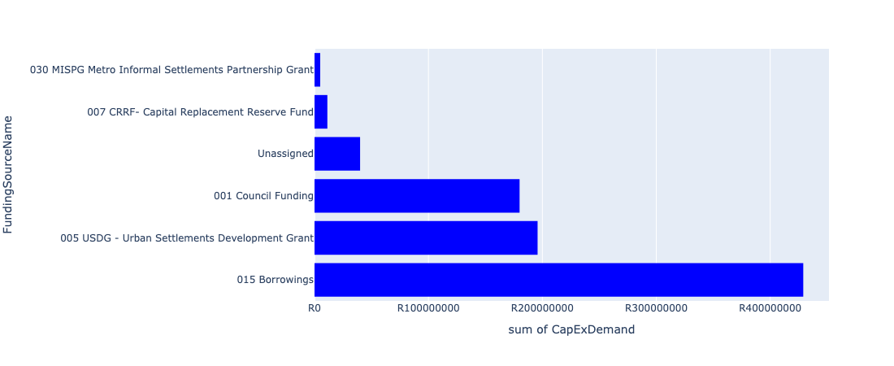

Figure 5.204: Ward 102 Departmental Requests

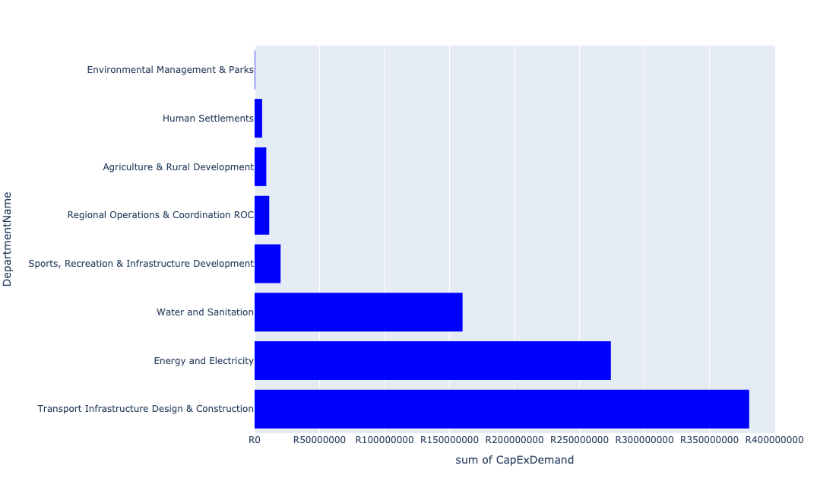

Table 5.102: Summary - Ward 102

|  |  |
| --- | --- |
| Item | Description |
| Total Capital Demand for Ward 102 - All Years | R821,064,279 Rank: 16 (1 = Highest) |
| Total Capital Demand for Ward 102 - MTREF | R349,562,247 Rank: 17 (1 = Highest) |
| Financial Years in which capital requirements are listed for Ward 102 | 2022, 2023, 2024, 2025, 2026, 2027, 2028, 2029 and 2030 |
| Financial Year with highest capital demand for Ward 102 | 2023 |
| Ward 102 intersecting feature used | Works Location |
| Total number of projects intersecting with Ward 102 | 15 Rank: 31 (1 = Highest) |

Table 5.103: All projects asking for budget in Ward 102

|  |  |  |  |
| --- | --- | --- | --- |
| Project ID | Project Name | Department | Project Budget |
| 712971915 | Revitalisation of the City-Development of Non-Motorised Transport Masterplan | Transport Infrastructure Design & Construction | R502,033 (0.06%) Budget spread across: 2027 |
| 712975004 | Security and visitor infrastructure Upgrade at Die Draai Resort Region 7 | Environmental Management & Parks | R399,538 (0.05%) Budget spread across: 2022 |
| 712970748 | R6 Machinery and Equipment to ensure basic infrastructure reliability | Regional Operations & Coordination ROC | R1,262,709 (0.15%) Budget spread across: 2022 and 2023 |
| 712974797 | Zithobeni 8 pump station | Human Settlements | R800,000 (0.10%) Budget spread across: 2022 |
| 712974549 | (712121G) Zwavelpoort Outfall Sewer Pipeline – Phase1 | Water and Sanitation | R160,000,000 (19.49%) Budget spread across: 2022, 2023, 2024, 2025 and 2026 |
| 712967701 | (710178) Electricity for All - Region 6 | Energy and Electricity | R81,600,000 (9.94%) Budget spread across: 2022, 2023, 2024 and 2025 |
| 712967177 | (712883) Upgrading of Zithobeni Sport Stadium | Sports, Recreation & Infrastructure Development | R20,000,000 (2.44%) Budget spread across: 2023 |
| 712967162 | Development of Kleinzonderhout Agricultural Park | Agriculture & Rural Development | R9,000,000 (1.10%) Budget spread across: 2022 and 2023 |
| 1307 | (712893) Upgrading of Road from gravel to tar in Zithobeni Ward 102 | Transport Infrastructure Design & Construction | R185,000,000 (22.53%) Budget spread across: 2022, 2023, 2024, 2025, 2026, 2027, 2028, 2029 and 2030 |
| 712973836 | R6 Installation of Electric and Security Fencing at Regional Facilities / Depots | Regional Operations & Coordination ROC | R10,000,000 (1.22%) Budget spread across: 2022 and 2023 |
| 712972938 | (710864) Sewer provision - Zithobeni Heights : Bulk Sewer | Human Settlements | R5,000,000 (0.61%) Budget spread across: 2022 |
| 712970852 | (712947) Improvement of dirt road leading to Clover hill club, Bronkhorstspruit dam | Transport Infrastructure Design & Construction | R195,000,000 (23.75%) Budget spread across: 2022, 2023, 2024, 2025, 2026, 2027, 2028, 2029 and 2030 |
| 712969194 | (710556) Region 6 (Public Lighting) | Energy and Electricity | R192,500,000 (23.45%) Budget spread across: 2022, 2023, 2024, 2025, 2026, 2027, 2028, 2029 and 2030 |

## Ward 103

Figure 5.205: Ward 103 Funding Requests

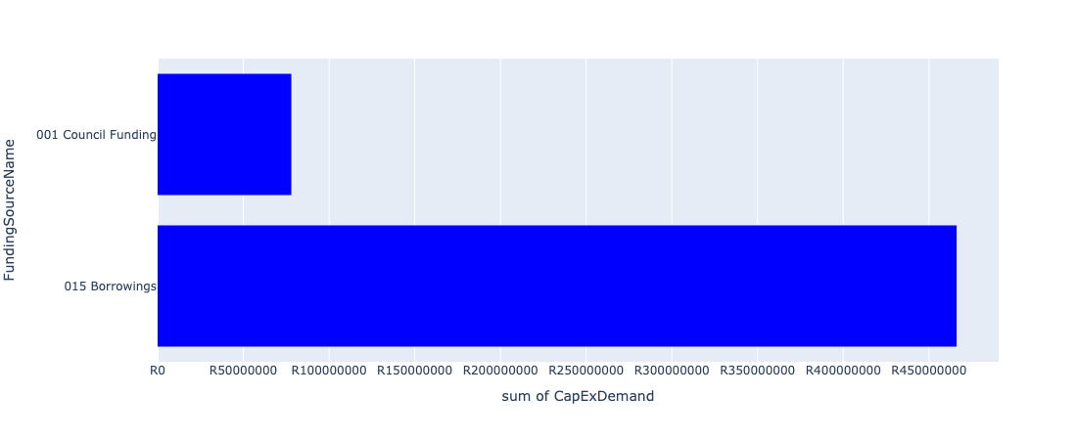

Figure 5.206: Ward 103 Departmental Requests

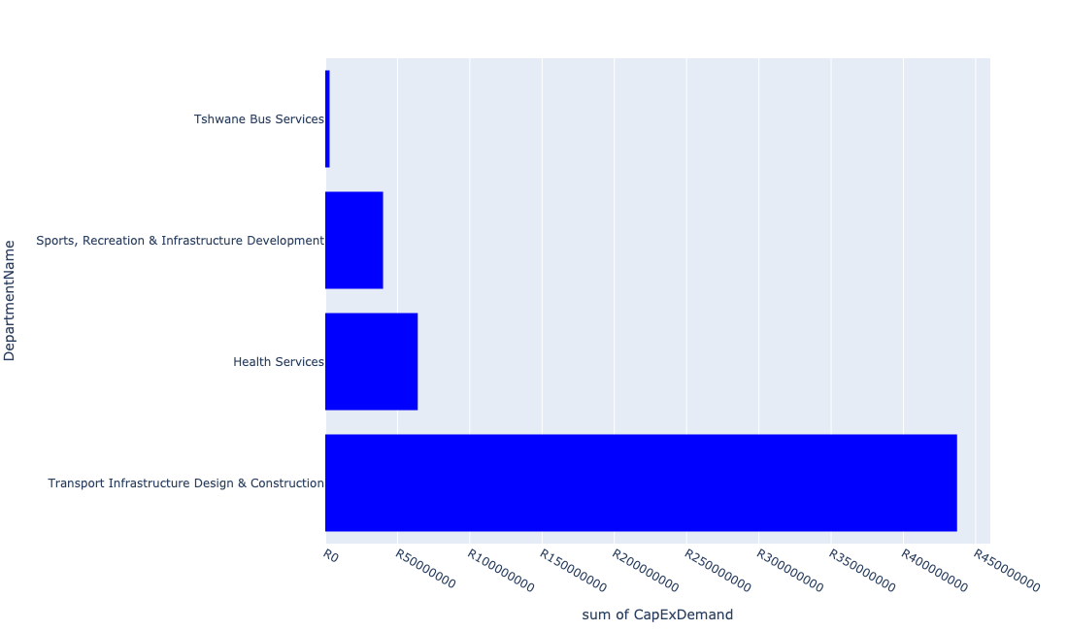

Table 5.103: Summary - Ward 103

|  |  |
| --- | --- |
| Item | Description |
| Total Capital Demand for Ward 103 - All Years | R514,129,299 Rank: 30 (1 = Highest) |
| Total Capital Demand for Ward 103 - MTREF | R153,000,000 Rank: 46 (1 = Highest) |
| Financial Years in which capital requirements are listed for Ward 103 | 2022, 2023, 2024, 2025, 2026, 2027, 2028, 2029 and 2030 |
| Financial Year with highest capital demand for Ward 103 | 2025 |
| Ward 103 intersecting feature used | Works Location |
| Total number of projects intersecting with Ward 103 | 9 Rank: 68 (1 = Highest) |

Table 5.104: All projects asking for budget in Ward 103

|  |  |  |  |
| --- | --- | --- | --- |
| Project ID | Project Name | Department | Project Budget |
| 712971915 | Revitalisation of the City-Development of Non-Motorised Transport Masterplan | Transport Infrastructure Design & Construction | R129,299 (0.03%) Budget spread across: 2027 |
| 712975439 | Creative Hub and Incubator ( Region 7) | Sports, Recreation & Infrastructure Development | R10,000,000 (1.95%) Budget spread across: 2027 |
| 712974527 | Upgrading of road from gravel to tar in Rethabiseng | Transport Infrastructure Design & Construction | R67,000,000 (13.03%) Budget spread across: 2022, 2023, 2024, 2025, 2026, 2027, 2028, 2029 and 2030 |
| 712967837 | Upgrading of Rethabiseng Clinic | Health Services | R64,000,000 (12.45%) Budget spread across: 2029, 2030 and 2031 |
| 712967138 | Ekangala community library | Sports, Recreation & Infrastructure Development | R30,000,000 (5.84%) Budget spread across: 2024 and 2025 |
| 82 | (714000) Bus Depot at Ekangala | Tshwane Bus Services | R3,000,000 (0.58%) Budget spread across: 2022, 2023, 2024, 2025 and 2026 |
| 712970842 | (712894) Upgrading of Road from gravel to tar in Ekangala (Ward 103 and 104) | Transport Infrastructure Design & Construction | R370,000,000 (71.97%) Budget spread across: 2022, 2023, 2024, 2025, 2026, 2027, 2028, 2029 and 2030 |

## Ward 104

Figure 5.207: Ward 104 Funding Requests

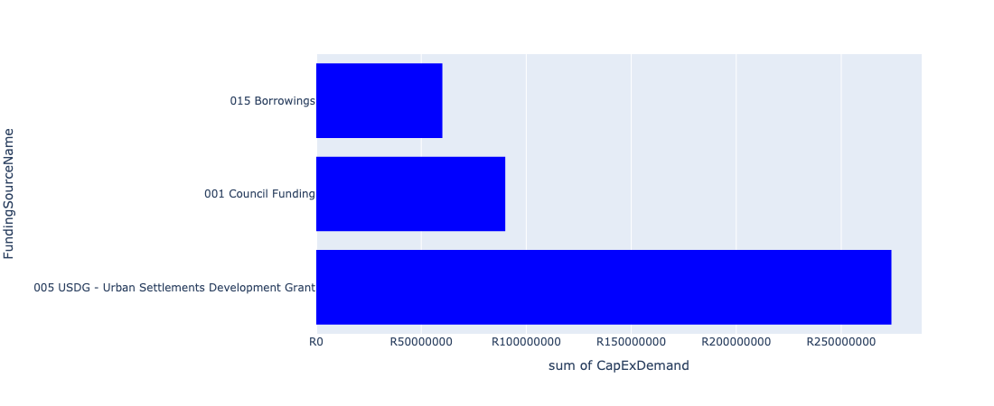

Figure 5.208: Ward 104 Departmental Requests

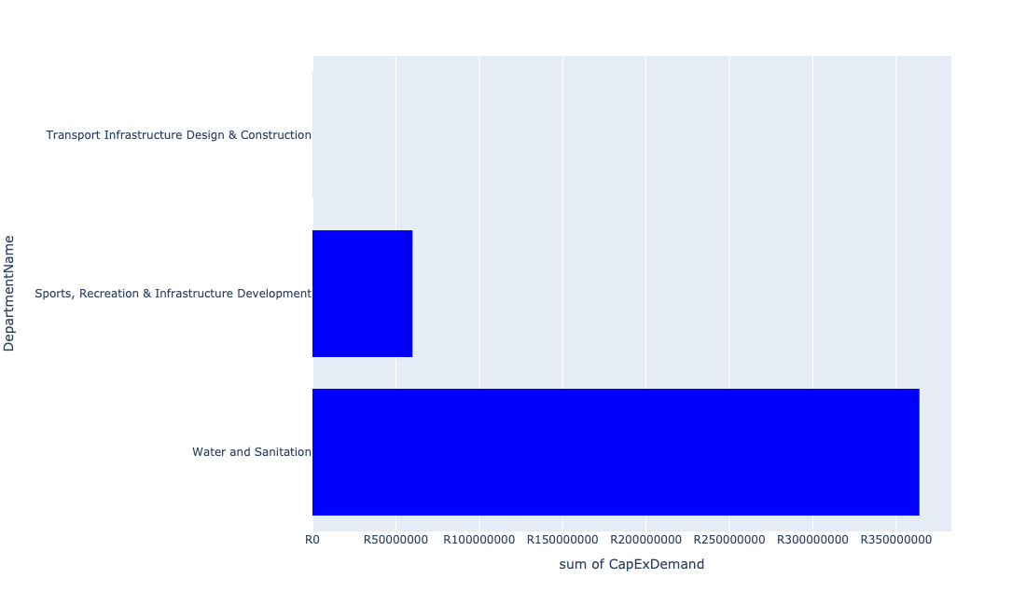

Table 5.104: Summary - Ward 104

|  |  |
| --- | --- |
| Item | Description |
| Total Capital Demand for Ward 104 - All Years | R423,953,430 Rank: 36 (1 = Highest) |
| Total Capital Demand for Ward 104 - MTREF | R308,200,000 Rank: 22 (1 = Highest) |
| Financial Years in which capital requirements are listed for Ward 104 | 2022, 2023, 2024, 2025, 2026 and 2027 |
| Financial Year with highest capital demand for Ward 104 | 2023 |
| Ward 104 intersecting feature used | Works Location |
| Total number of projects intersecting with Ward 104 | 5 Rank: 96 (1 = Highest) |

Table 5.105: All projects asking for budget in Ward 104

|  |  |  |  |
| --- | --- | --- | --- |
| Project ID | Project Name | Department | Project Budget |
| 712971915 | Revitalisation of the City-Development of Non-Motorised Transport Masterplan | Transport Infrastructure Design & Construction | R53,430 (0.01%) Budget spread across: 2027 |
| 712974345 | (710411K) Ekangala WWTW: Upgrade of existing infrastructure | Water and Sanitation | R50,000,000 (11.79%) Budget spread across: 2022 and 2023 |
| 712967136 | (712917) Upgrade Ekangala stadium | Sports, Recreation & Infrastructure Development | R60,000,000 (14.15%) Budget spread across: 2023 and 2024 |
| 578 | (710878) Ekangala Block A - F sewer reticulation and toilets | Water and Sanitation | R313,900,000 (74.04%) Budget spread across: 2022, 2023, 2024, 2025 and 2026 |

## Ward 105

Figure 5.209: Ward 105 Funding Requests

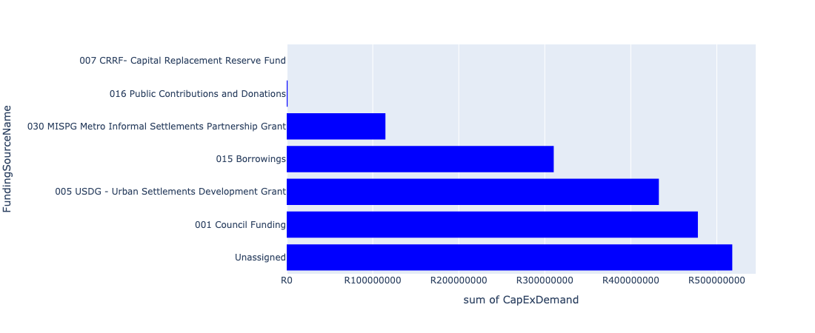

Figure 5.210: Ward 105 Departmental Requests

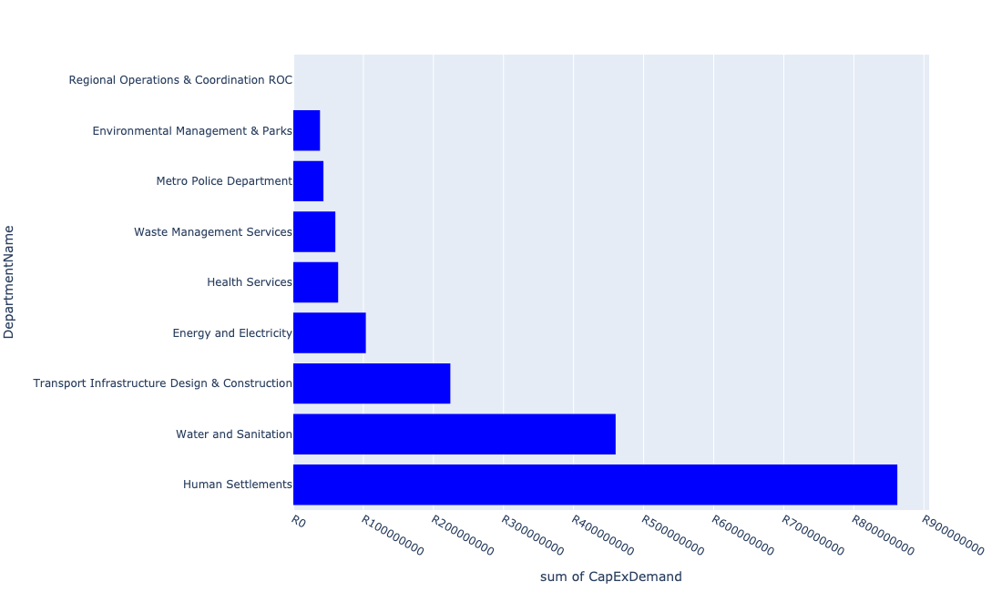

Table 5.105: Summary - Ward 105

|  |  |
| --- | --- |
| Item | Description |
| Total Capital Demand for Ward 105 - All Years | R1,805,276,167 Rank: 4 (1 = Highest) |
| Total Capital Demand for Ward 105 - MTREF | R1,122,288,782 Rank: 2 (1 = Highest) |
| Financial Years in which capital requirements are listed for Ward 105 | 2022, 2023, 2024, 2025, 2026, 2027, 2028, 2029 and 2030 |
| Financial Year with highest capital demand for Ward 105 | 2025 |
| Ward 105 intersecting feature used | Works Location |
| Total number of projects intersecting with Ward 105 | 30 Rank: 5 (1 = Highest) |

Table 5.106: All projects asking for budget in Ward 105

|  |  |  |  |
| --- | --- | --- | --- |
| Project ID | Project Name | Department | Project Budget |
| 712971915 | Revitalisation of the City-Development of Non-Motorised Transport Masterplan | Transport Infrastructure Design & Construction | R119,624 (0.01%) Budget spread across: 2027 |
| 712975482 | Rehabilitation of Wetlands - Bronkhorstspruit Town Wetland | Environmental Management & Parks | R1,500,000 (0.08%) Budget spread across: 2022, 2023, 2024 and 2025 |
| 712975232 | Development of Visitor and security infrastructure at Bronkhorstspruit dam angling area | Environmental Management & Parks | R34,999,999 (1.94%) Budget spread across: 2022, 2023, 2024 and 2025 |
| 712975227 | Bronkhorstspruit Public Transport Facility (Investigate an ideal location and provide for a new taxi rank at Bronkhorstspruit) | Transport Infrastructure Design & Construction | R99,000,000 (5.48%) Budget spread across: 2022, 2023, 2024, 2025, 2026, 2027, 2028, 2029 and 2030 |
| 712975004 | Security and visitor infrastructure Upgrade at Die Draai Resort Region 7 | Environmental Management & Parks | R1,600,462 (0.09%) Budget spread across: 2022 |
| 712967850 | (711921F) Bronkhorstspruit Water Purification Plant Refurbishment | Water and Sanitation | R10,000,000 (0.55%) Budget spread across: 2022 |
| 712967635 | (710863) Water provision - Zithobeni Heights Phase 1 | Human Settlements | R15,000,000 (0.83%) Budget spread across: 2022 and 2023 |
| 712967634 | (710863) Water provision - Zithobeni Heights X13 | Human Settlements | R100,000,000 (5.54%) Budget spread across: 2022 and 2023 |
| 712967633 | (710863) Zithobeni X8&9 - Bulk water main line | Human Settlements | R50,000,000 (2.77%) Budget spread across: 2022, 2023 and 2024 |
| 712967623 | (710863) Water provision - Zithobeni X8 | Human Settlements | R10,000,000 (0.55%) Budget spread across: 2022 and 2023 |
| 712967618 | (710864) Sewer provision - Zithobeni X8 | Human Settlements | R7,145,436 (0.40%) Budget spread across: 2022 |
| 712967270 | (711921E) Bronkhorstbaai: Refurbishment and upgrade of Water Purification Plant | Water and Sanitation | R91,000,000 (5.04%) Budget spread across: 2022 and 2023 |
| 712967174 | New Bronkhorstspruit Clinic | Health Services | R64,000,000 (3.55%) Budget spread across: 2024, 2025 and 2026 |
| 661 | (711335) Bulk feeder main pipeline from Bronkhorstspruit WTP to Ekandustria Reservoir | Water and Sanitation | R75,000,000 (4.15%) Budget spread across: 2022, 2023, 2024 and 2025 |
| 452 | (710411E) Godrich WWTW: New 10 Ml/day BNR | Water and Sanitation | R284,000,000 (15.73%) Budget spread across: 2023, 2024, 2025 and 2027 |
| 7 | Establishment of Metro Police Office - Region 7 | Metro Police Department | R43,000,000 (2.38%) Budget spread across: 2023, 2024 and 2025 |
| 712967601 | (710865) Construction of roads & stormwater - Zithobeni X8&9 | Human Settlements | R302,320,646 (16.75%) Budget spread across: 2022, 2023, 2024, 2025 and 2026 |
| 712967600 | (710865) Construction of roads & stormwater - Zithobeni Heights | Human Settlements | R377,590,000 (20.92%) Budget spread across: 2022, 2023 and 2024 |
| 712970845 | (712895) Upgrading of Road from gravel to tar in Ekangala Ward 105 | Transport Infrastructure Design & Construction | R125,000,000 (6.92%) Budget spread across: 2022, 2023, 2025, 2026, 2028, 2029 and 2030 |
| 712970748 | R6 Machinery and Equipment to ensure basic infrastructure reliability | Regional Operations & Coordination ROC | R0 (0.00%) Budget spread across: 2022 and 2023 |
| 712969618 | (713043) Development of waste transfer stations | Waste Management Services | R60,000,000 (3.32%) Budget spread across: 2022, 2023, 2024 and 2025 |
| 712969193 | (710556) Region 7 (Public Lighting) | Energy and Electricity | R31,500,000 (1.74%) Budget spread across: 2022, 2023, 2024, 2025, 2027, 2028, 2029 and 2030 |
| 712969123 | (710178) Electricity for All - Region 7 | Energy and Electricity | R57,000,000 (3.16%) Budget spread across: 2024 and 2025 |
| 712969075 | (712279) Bronkhorstspruit 132/11kv substation | Energy and Electricity | R15,000,000 (0.83%) Budget spread across: 2022 |

## Ward 106

Figure 5.211: Ward 106 Funding Requests

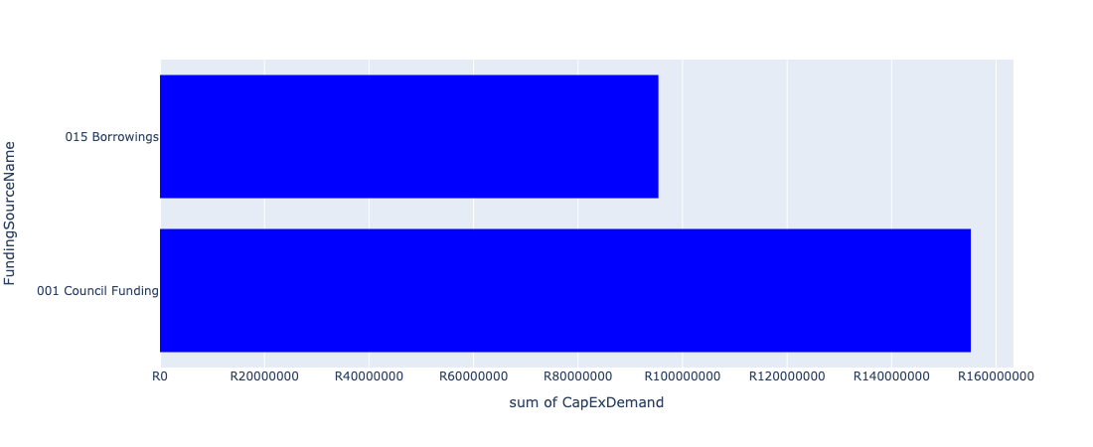

Figure 5.212: Ward 106 Departmental Requests

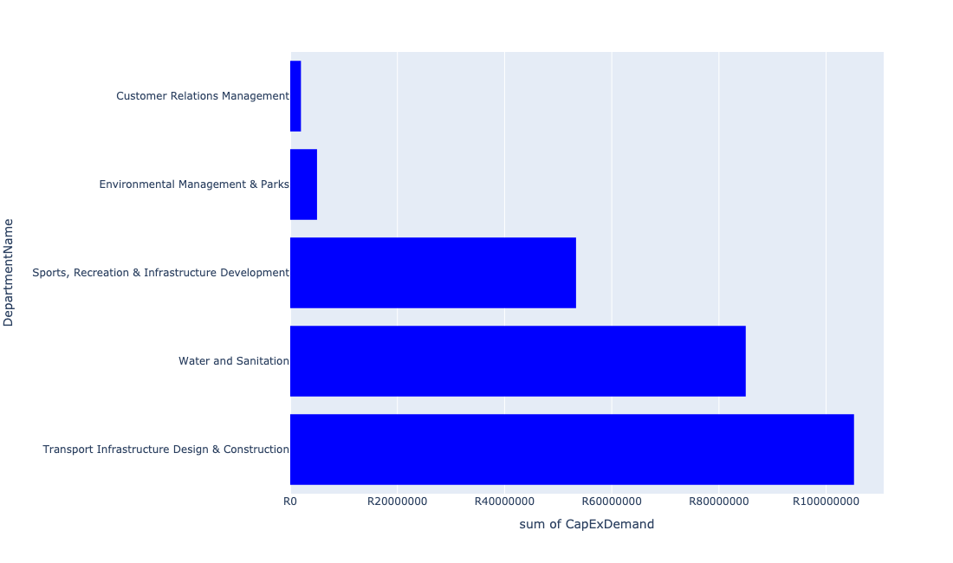

Table 5.106: Summary - Ward 106

|  |  |
| --- | --- |
| Item | Description |
| Total Capital Demand for Ward 106 - All Years | R242,036,148 Rank: 54 (1 = Highest) |
| Total Capital Demand for Ward 106 - MTREF | R45,874,611 Rank: 82 (1 = Highest) |
| Financial Years in which capital requirements are listed for Ward 106 | 2022, 2023, 2024, 2025, 2026, 2027, 2028, 2029 and 2030 |
| Financial Year with highest capital demand for Ward 106 | 2026 |
| Ward 106 intersecting feature used | Works Location |
| Total number of projects intersecting with Ward 106 | 11 Rank: 54 (1 = Highest) |

Table 5.107: All projects asking for budget in Ward 106

|  |  |  |  |
| --- | --- | --- | --- |
| Project ID | Project Name | Department | Project Budget |
| 712971915 | Revitalisation of the City-Development of Non-Motorised Transport Masterplan | Transport Infrastructure Design & Construction | R44,708 (0.02%) Budget spread across: 2027 |
| 712975228 | Olivienhoutbosch Public Transport Facility (Provisioning of new taxi ranking facility at Olivienhoutbosch ) | Transport Infrastructure Design & Construction | R93,158,105 (38.49%) Budget spread across: 2022, 2023, 2024, 2025, 2026, 2027, 2028, 2029 and 2030 |
| 712975414 | Olievenhoutbosch Cultural Centre | Sports, Recreation & Infrastructure Development | R13,333,334 (5.51%) Budget spread across: 2027 |
| 712975256 | Erf 5426 -Upgrade of Olievenhoutbosch Park | Environmental Management & Parks | R5,000,000 (2.07%) Budget spread across: 2022 |
| 712975168 | Construction of major and minor stormwater drainage networks in Olievenhoutbosch X21 and X37. | Transport Infrastructure Design & Construction | R12,000,000 (4.96%) Budget spread across: 2028 and 2029 |
| 712974200 | Refurbishment of Olievenhoutbosch customer care walk in centre | Customer Relations Management | R2,000,000 (0.83%) Budget spread across: 2022 |
| 712967278 | (712534PR) Pretorius rand reservoir | Water and Sanitation | R85,000,000 (35.12%) Budget spread across: 2023, 2024, 2025, 2026 and 2027 |
| 712967166 | (711432) Olievenhoutbosch multi-purpose sport facility | Sports, Recreation & Infrastructure Development | R40,000,000 (16.53%) Budget spread across: 2025 and 2026 |

## Ward 107

Figure 5.213: Ward 107 Funding Requests

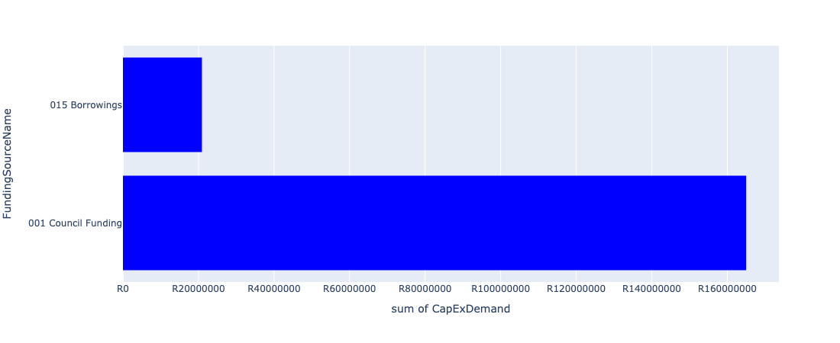

Figure 5.214: Ward 107 Departmental Requests

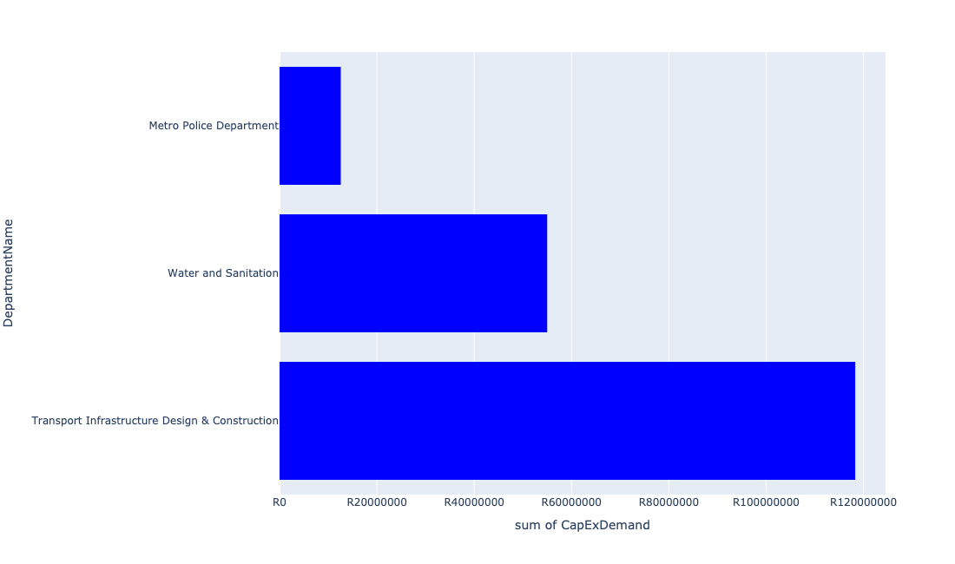

Table 5.107: Summary - Ward 107

|  |  |
| --- | --- |
| Item | Description |
| Total Capital Demand for Ward 107 - All Years | R173,696,127 Rank: 70 (1 = Highest) |
| Total Capital Demand for Ward 107 - MTREF | R20,964,151 Rank: 93 (1 = Highest) |
| Financial Years in which capital requirements are listed for Ward 107 | 2022, 2023, 2024, 2025, 2026, 2027, 2028, 2029 and 2030 |
| Financial Year with highest capital demand for Ward 107 | 2030 |
| Ward 107 intersecting feature used | Works Location |
| Total number of projects intersecting with Ward 107 | 6 Rank: 89 (1 = Highest) |

Table 5.108: All projects asking for budget in Ward 107

|  |  |  |  |
| --- | --- | --- | --- |
| Project ID | Project Name | Department | Project Budget |
| 712971915 | Revitalisation of the City-Development of Non-Motorised Transport Masterplan | Transport Infrastructure Design & Construction | R15,163 (0.01%) Budget spread across: 2027 |
| 712975413 | Sub-Project: TMPD Station - Kwaggasrand / Atteridgeville | Metro Police Department | R12,579,112 (7.24%) Budget spread across: 2023 |
| 712974540 | Construction of major storm water Network 2A in the vicinity of Motheberebe Street, AtteridgevilleProject | Transport Infrastructure Design & Construction | R2,309,918 (1.33%) Budget spread across: 2025 and 2026 |
| 712975229 | Saulsville Public Transport Facility | Transport Infrastructure Design & Construction | R109,980,901 (63.32%) Budget spread across: 2022, 2023, 2024, 2025, 2026, 2027, 2028, 2029 and 2030 |
| 712975029 | (710411Sc) Schurveberg WWTW: New 25 Ml/day BNR Module | Water and Sanitation | R55,000,000 (31.66%) Budget spread across: 2029 and 2030 |
| 712974552 | Construction of major storm water Networks 1A and 1C in the vicinity of Mahwane Street, Atteridgeville | Transport Infrastructure Design & Construction | R6,000,000 (3.45%) Budget spread across: 2025 and 2026 |